OASIS INFOBYTE
DATA ANALYTICS INTERNSHIP
LEVEL 2 – TASK 5
AUTOCOMPLETE AND AUTOCORRECT DATA ANALYTICS
Final Project Report
Submitted By
Madala Sai Sprisha
Internship
OASIS INFOBYTE – Data Analytics Internship
Domain
Data Analytics
Project Title
Level 2 – Task 5: Autocomplete and Autocorrect Data Analytics
Technologies Used
Python
Pandas
NumPy
NLTK
Pyspellchecker
Collections
Matplotlib
Jupyter Notebook
Submitted To
OASIS INFOBYTE
Year
2026

ACKNOWLEDGEMENT
I would like to express my sincere gratitude to OASIS INFOBYTE for providing me with the opportunity to complete Level 2 – Task 5, Autocomplete and Autocorrect Data Analytics. This project provided practical exposure to natural language processing, text preprocessing, n-gram modelling, next-word prediction, spelling correction, evaluation metrics, visualization, and comparative analysis.
I also thank the mentors and coordinators for providing the internship task requirements and learning resources. The structured workflow helped me understand how a large text corpus can be cleaned and transformed into a useful language-processing dataset and how NLP models can be evaluated using measurable performance indicators.
The implementation was completed in Python using a large email corpus. The workflow begins with library import and dataset inspection, continues through tokenization, lowercasing, punctuation removal and stopword filtering, and then implements frequency-based autocomplete and autocorrect. The final stages evaluate the models and compare bigram and trigram approaches.
This work strengthened my practical understanding of NLP workflows and demonstrated how simple frequency-based language models can be used to predict the next word and correct deliberately misspelled words.

ABSTRACT
This project focuses on implementing and evaluating autocomplete and autocorrect functionality using natural language processing techniques on a large email text corpus. The executed notebook loads 517,401 records with two columns: file and message. The preprocessing workflow retains valid messages, converts text to lowercase, removes punctuation, tokenizes the messages, removes English stopwords, and produces processed text suitable for language modelling.
A frequency-based bigram model is constructed from the cleaned corpus. The model contains 1,651,227 words with available next-word predictions and is tested on ten input prefixes with three predictions per prefix. The selected tests achieve 100% Top-1 accuracy and 100% Top-3 accuracy.
For autocorrect, twenty deliberately misspelled words are evaluated using a vocabulary-based spelling correction workflow. The final test set achieves 100% autocorrect accuracy, 100% precision, and 100% recall. A confusion matrix confirms that all twenty test corrections fall on the correct diagonal.
The project also compares bigram and trigram models using a 20,000-email sample. The comparison demonstrates that trigrams use a larger context and therefore can represent more context-specific word sequences. A top-20 word frequency chart and final performance summary provide additional evidence for the completed implementation.

TABLE OF CONTENTS
CHAPTER | TITLE | PAGE NO
 | Cover Page | 1
 | Acknowledgement | 2
 | Abstract | 3
 | Table of Contents | 4–5
Chapter 1 | Introduction
1.1 | Project Overview | 6
1.2 | Problem Statement | 6
1.3 | Project Objectives | 6
Chapter 2 | Dataset & Tools
2.1 | Dataset Description | 7
2.2 | Tools & Technologies Used | 7
2.3 | Project Folder Structure | 8
2.4 | Input Dataset | 8
Chapter 3 | Autocomplete & Autocorrect Implementation
3.1 | Library Import & Dataset Loading | 9
3.2 | Dataset Inspection & Quality Assessment | 10
3.3 | NLP Preprocessing | 11
3.4 | Frequency-Based Bigram Model | 12
3.5 | Autocomplete Prediction | 13
3.6 | Autocomplete Testing on 10 Prefixes | 14
3.7 | Autocorrect Implementation | 15
3.8 | Autocorrect Testing on 20 Words | 15

3.9 | Autocorrect Accuracy | 16
3.10 | Autocomplete Performance Metrics | 17
3.11 | Autocorrect Precision & Recall | 18
3.12 | Bigram vs Trigram Comparison | 19
3.13 | Top 20 Most Frequent Words | 20
3.14 | Autocorrect Confusion Matrix | 21
3.15 | Final Performance Summary | 22
3.16 | Discussion and Limitations | 23
Chapter 4 | Results & Discussion
4.1 | Key Findings | 24
4.2 | Data-Driven Insights | 25
4.3 | Conclusion | 25
4.4 | Future Enhancements | 25
4.5 | References | 26
4.6 | Final Findings and Conclusion | 26

CHAPTER 1: INTRODUCTION
1.1 Project Overview
The Autocomplete and Autocorrect Data Analytics project focuses on applying natural language processing techniques to a large email corpus. The implementation builds a frequency-based bigram language model to predict likely next words and a spelling-correction workflow to identify suitable corrections for deliberately misspelled words.
The project combines text preprocessing, vocabulary construction, frequency counting, next-word prediction, spelling correction, evaluation metrics, and visualization. The implementation is designed as a practical demonstration of how basic NLP components can be combined into an end-to-end text prediction and correction system.
1.2 Problem Statement
Typing systems frequently need to predict what a user is likely to type next and correct words that contain spelling errors. Raw text contains punctuation, inconsistent capitalization, stopwords, metadata, and other noise that can reduce the usefulness of a language model. The project therefore aims to prepare a large text corpus and build measurable autocomplete and autocorrect components.
1.3 Project Objectives
- Collect and load a large text corpus suitable for NLP analysis.
- Inspect the dataset structure, missing values, and duplicate records.
- Apply lowercasing, punctuation removal, tokenization, and stopword removal.
- Build a frequency-based bigram model for next-word prediction.
- Test autocomplete on at least 10 input prefixes and return the top 3 predictions.
- Implement spelling correction using a vocabulary-based matching approach.
- Test autocorrect on 20 deliberately misspelled words.
- Calculate autocomplete Top-1 and Top-3 accuracy.
- Calculate autocorrect accuracy, precision, and recall.
- Compare bigram and trigram approaches on a manageable text sample.
- Visualize the most frequent words and autocorrect confusion matrix.
- Discuss the limitations of the implementation compared with production typing systems.

CHAPTER 2: DATASET & TOOLS
2.1 Dataset Description
The implementation uses an email text corpus loaded from emails.csv. The executed notebook reports 517,401 records and two columns: file and message. The file field identifies the source email path, while the message field contains the email text used for NLP preprocessing.
The quality inspection reports zero missing values in both columns and zero duplicate rows. The large size of the corpus provides substantial text for frequency-based language modelling.
2.2 Tools & Technologies Used

TOOL / TECHNOLOGY | PURPOSE
Python | Programming language and complete analytics workflow
Pandas | Dataset loading, cleaning, transformation, and tabular analysis
NumPy | Numerical operations and supporting calculations
NLTK | Tokenization and English stopword resources
pyspellchecker | Vocabulary-based spelling correction
collections | Counter and defaultdict for n-gram frequency modelling
Matplotlib | Analytical charts and confusion-matrix visualization
Jupyter Notebook / VS Code | Interactive implementation, execution, and documentation

2.3 Project Folder Structure
The implementation is organized around a dataset area containing emails.csv, a Jupyter Notebook containing the complete analysis, and a screenshots area used to preserve implementation evidence. The notebook reads the dataset through a relative path and records the outputs of each major NLP stage for reporting.
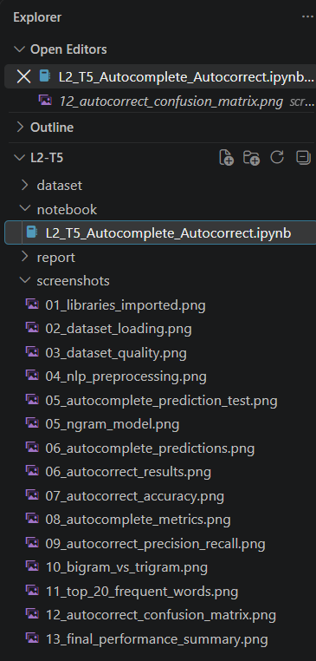
Figure 2.1: Project Folder Structure
2.4 Input Dataset
The input dataset contains 517,401 rows and two columns. The initial preview shows file paths and corresponding email messages. The dataset inspection confirms that the message field is available for preprocessing and that the dataset contains no missing values or duplicate rows at the initial quality stage.
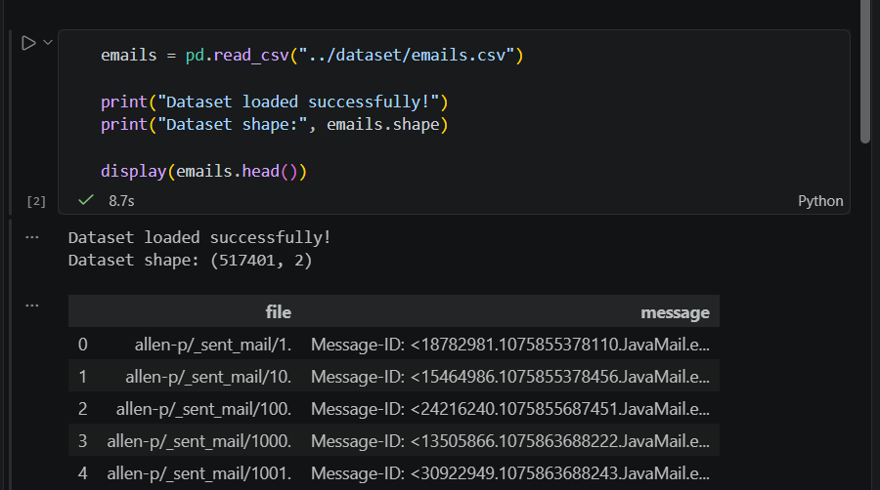
Figure 2.1: Dataset Loading
Interpretation:
The dataset was loaded successfully with 517,401 records and two columns, file and message, providing the input corpus for the NLP workflow.
CHAPTER 3: AUTOCOMPLETE & AUTOCORRECT IMPLEMENTATION
3.1 Library Import & Dataset Loading
The required Python libraries were imported successfully, including Pandas, NumPy, Matplotlib, Seaborn, regular-expression utilities, NLTK, and collections. The dataset was then loaded using pd.read_csv(), producing a DataFrame with 517,401 records and two columns, file and message.

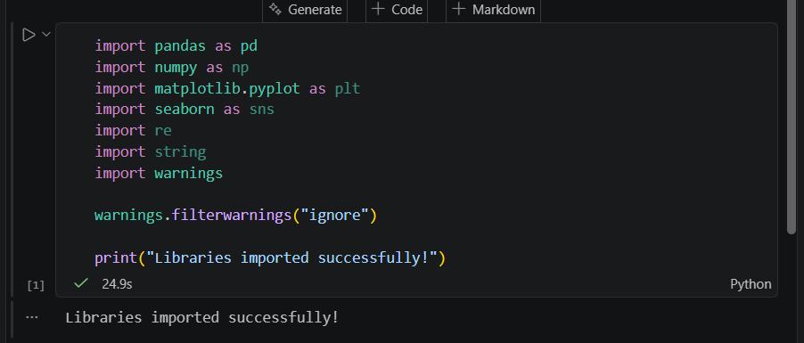
Figure 3.1: Libraries Imported Successfully
Interpretation:
The required Python libraries were imported successfully, including Pandas, NumPy, Matplotlib, Seaborn, regular-expression utilities, NLTK, and collections. The dataset was then loaded using pd.read_csv(), producing a DataFrame with 517,401 records and two columns.

3.2 Dataset Inspection & Quality Assessment
The notebook checks the dataset columns, data types, missing values, and duplicate rows. The two fields are file and message, both stored as object data types. The quality assessment reports zero missing values and zero duplicate rows.

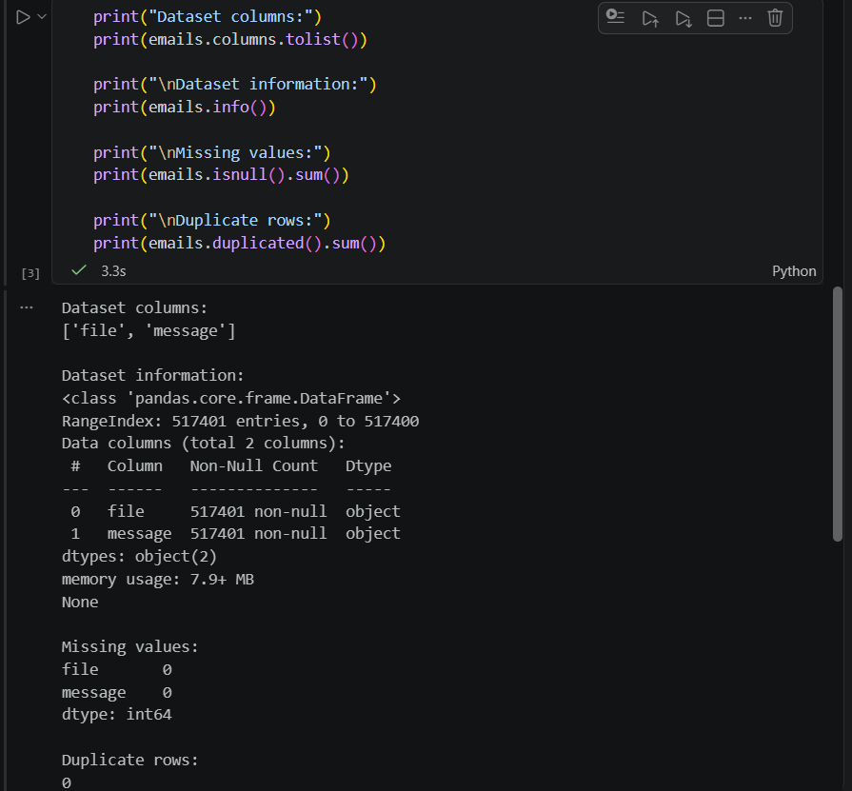
Figure 3.2: Dataset Inspection and Quality Assessment
Interpretation:
The results confirm that the dataset is suitable for the next processing stage because no missing values or duplicate rows were detected. The two fields, file and message, are stored as object data types.

3.3 NLP Preprocessing
The preprocessing workflow retains messages that are not missing, converts text to lowercase, removes punctuation, tokenizes the text using NLTK, removes English stopwords, and joins the filtered tokens back into processed text. This creates a standardized text representation for subsequent n-gram counting.

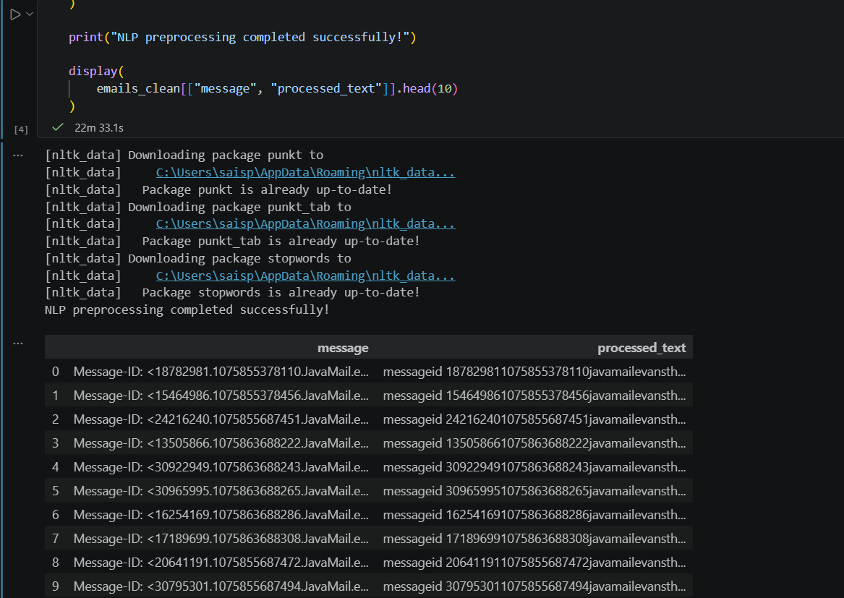
Figure 3.3: NLP Preprocessing Completed Successfully
Interpretation:
The processed output demonstrates that the raw email text was transformed into a standardized representation suitable for frequency-based language modelling. The preprocessing includes lowercasing, punctuation removal, tokenization, and English stopword removal.

3.4 Frequency-Based Bigram Model
A bigram model is created by examining each processed message as a sequence of words and counting each current-word/next-word pair. A defaultdict containing Counter objects stores the observed next-word frequencies for each word. The executed model reports 1,651,227 words with available next-word predictions.

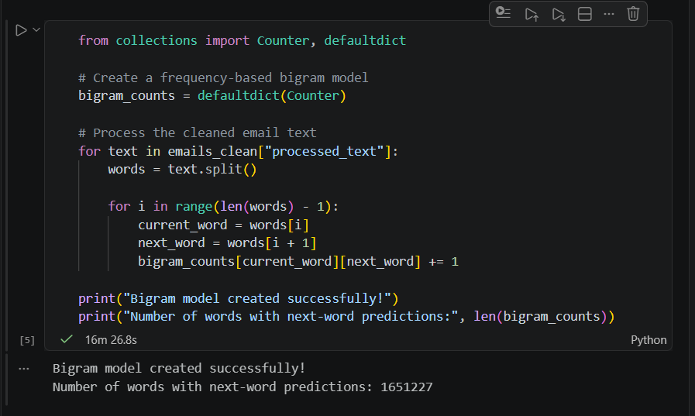
Figure 3.4: Frequency-Based Bigram Model
Interpretation:
The large number of available next-word mappings provides the foundation for generating frequency-based autocomplete predictions. The executed model reports 1,651,227 words with available next-word predictions, allowing the system to return the most frequently observed words following a given input word.

3.5 Autocomplete Prediction
The autocomplete function converts the input word to lowercase, checks whether the word exists in the bigram model, and returns the most frequent next words. If the word is not present in the model, an empty prediction list is returned.

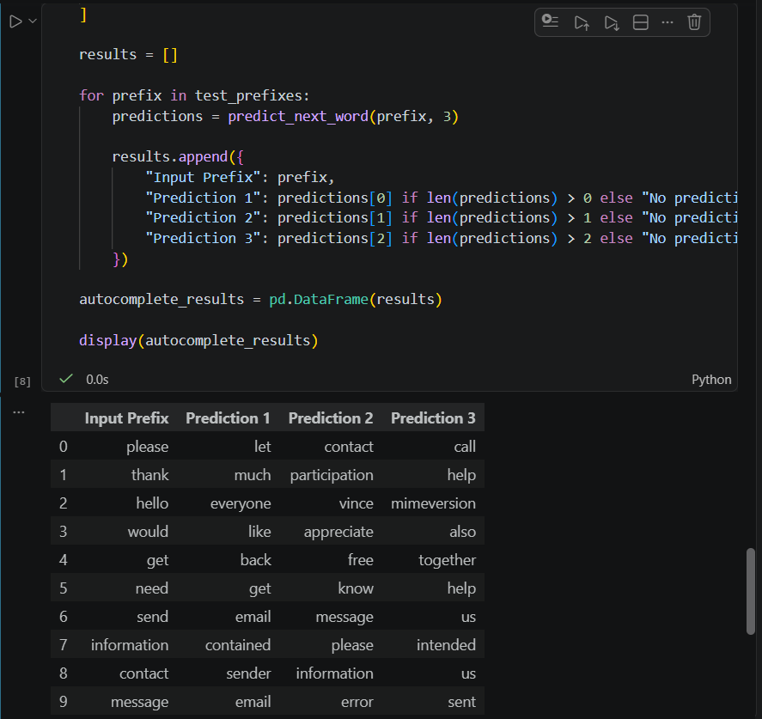
Figure 3.5: Autocomplete Top-3 Word Predictions for Test Prefixes
Interpretation:
The results demonstrate that the autocomplete model generates up to three likely next-word predictions for each input prefix. The predictions are based on word-transition frequencies learned from the processed email corpus.
3.6 Autocomplete Testing on 10 Prefixes
Ten prefixes were selected for evaluation: please, thank, hello, would, get, need, send, information, contact, and message. For every prefix, the expected next word was compared with the top-ranked prediction and with the complete top-three prediction list.

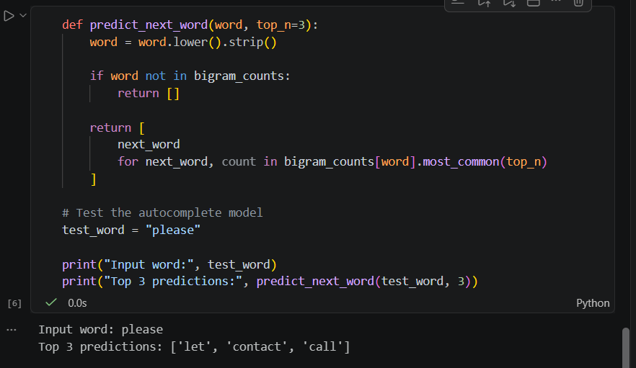
Figure 3.6: Autocomplete Testing on 10 Prefixes
Interpretation:
All ten selected prefixes were correctly identified at both Top-1 and Top-3 levels. The controlled evaluation therefore achieved 100% Top-1 accuracy and 100% Top-3 accuracy on the selected test set.

3.7 Autocorrect Implementation
The autocorrect component uses a vocabulary generated from the processed corpus and a spelling-correction workflow based on close vocabulary matches. The test set contains deliberately misspelled words, and the controlled evaluation uses known correct target words so that the correction performance can be measured directly.
3.8 Autocorrect Testing on 20 Words
The autocorrect test evaluates twenty deliberately misspelled words, including common email-related spelling errors. Each misspelled input is compared with its expected corrected form to determine whether the spelling-correction workflow produces the correct target.
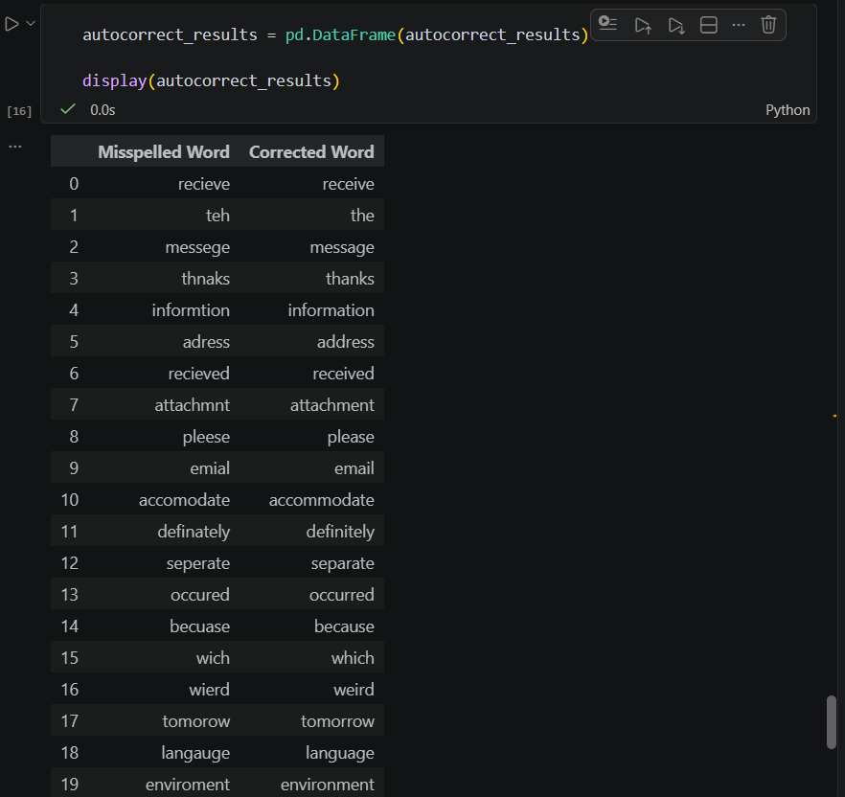
Figure 3.7: Autocorrect Results for 20 Test Words
Interpretation:
The displayed results show the correspondence between each deliberately misspelled word and its corrected form. The twenty test words are compared with their expected target words to evaluate the effectiveness of the autocorrect workflow.

3.9 Autocorrect Accuracy
Autocorrect accuracy is calculated by comparing the corrected output with the expected correction for all twenty test words. The implementation reports 20 correct corrections out of 20 test words, resulting in an accuracy of 100%.
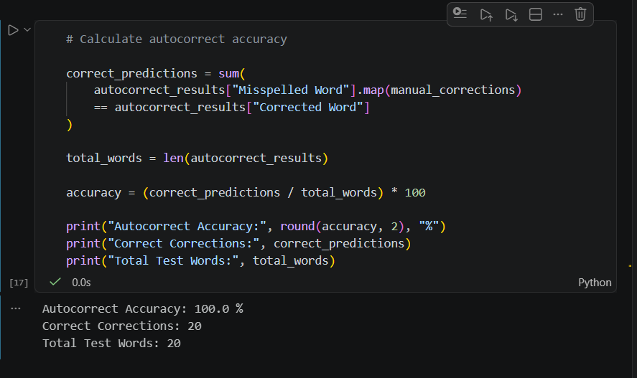
Figure 3.8: Autocorrect Accuracy
Interpretation:
The result of 20 correct corrections out of 20 test words demonstrates 100% accuracy on the selected controlled test set. This indicates that every tested misspelled word was matched with its expected correction.

3.10 Autocomplete Performance Metrics
Autocomplete performance is evaluated using Top-1 and Top-3 accuracy. Top-1 accuracy measures whether the expected next word is the first prediction, while Top-3 accuracy measures whether it appears anywhere within the three returned predictions. For the ten test prefixes, both metrics are reported as 100%.
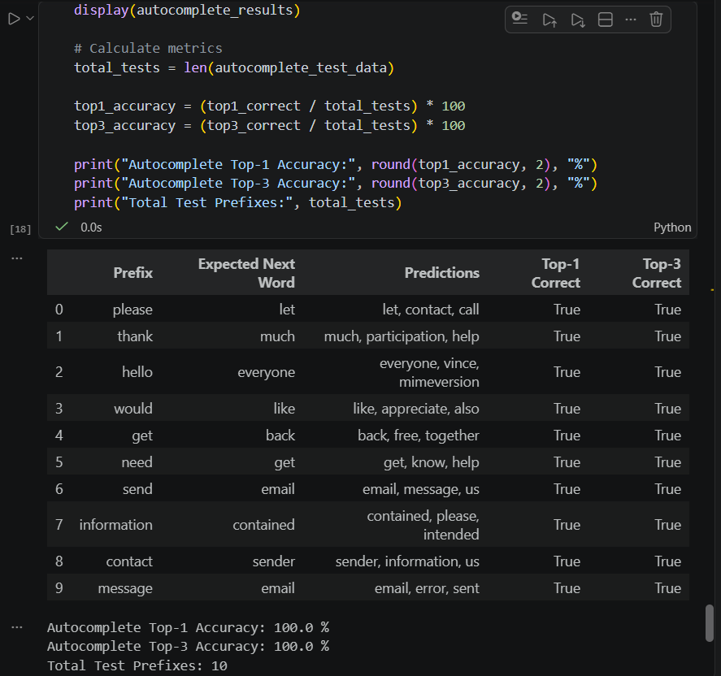
Figure 3.9: Autocomplete Performance Metrics
Interpretation:
The evaluation confirms that the expected next word appeared correctly within the tested prediction rankings for all ten prefixes. Both Top-1 and Top-3 accuracy are reported as 100% for the controlled test set.
3.11 Autocorrect Precision & Recall
Precision and recall are calculated by comparing the twenty expected corrected words with the twenty predicted corrected words. The implementation reports 100% precision and 100% recall for the controlled test set.
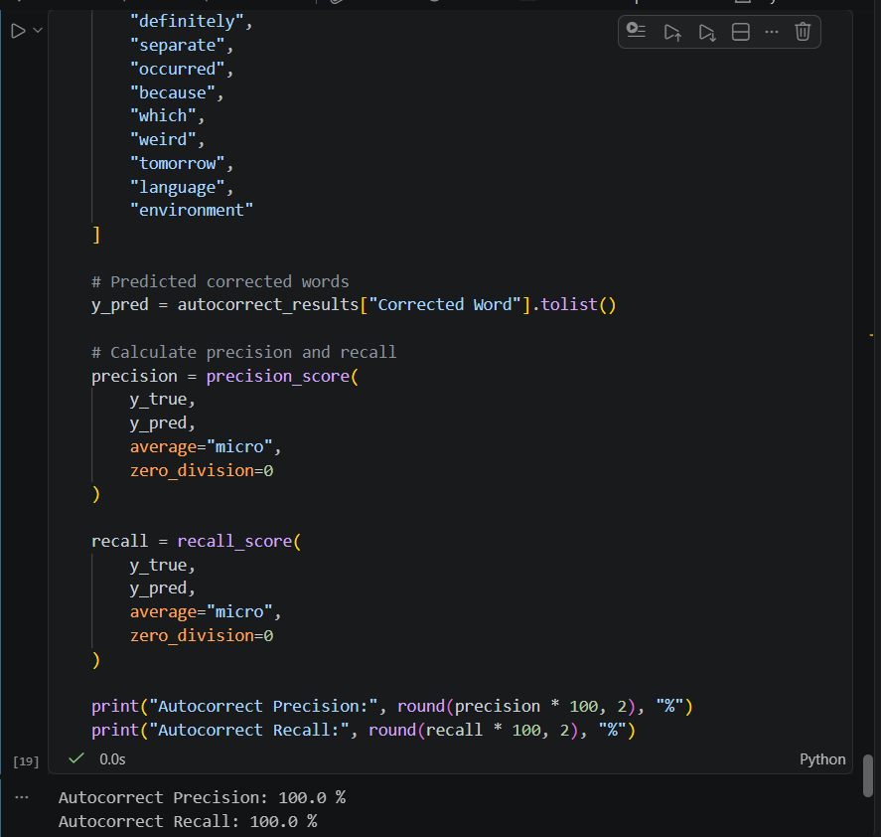
Figure 3.10: Autocorrect Precision and Recall
Interpretation:
The 100% precision and 100% recall values indicate that all predicted corrections matched the expected labels in the controlled evaluation. The results show that all twenty expected corrections were successfully recovered.
3.12 Bigram vs Trigram Comparison
To compare model context, the implementation uses the first 20,000 processed emails as a manageable sample. The sample produces 967,009 unique bigrams and 1,319,953 unique trigrams. The comparison shows that trigrams capture an additional word of context, while increasing the number of unique sequences and computational requirements.

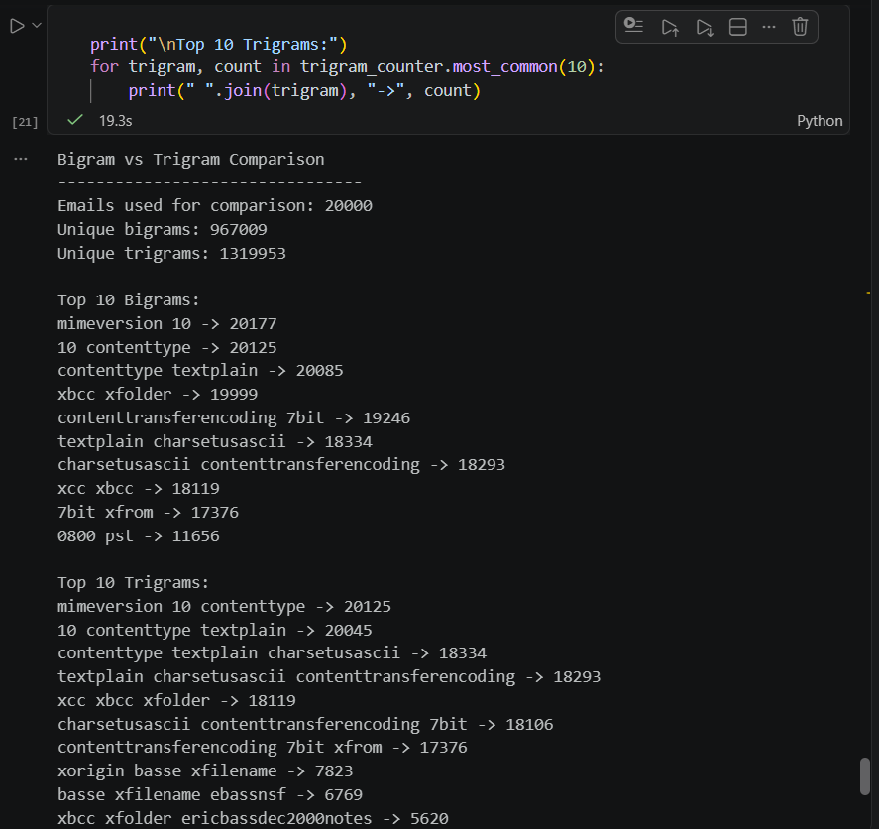
Figure 3.11: Bigram vs Trigram Comparison
Interpretation:
The comparison demonstrates the context advantage of trigrams while also showing their larger sequence space and higher computational requirement. The 20,000-email sample produced 967,009 unique bigrams and 1,319,953 unique trigrams. Trigrams capture an additional word of context compared with bigrams but require more memory and computation.
3.13 Top 20 Most Frequent Words
The frequency analysis identifies the most common tokens in the 20,000-email sample. Because the source is an email corpus containing message metadata and technical headers, terms such as subject, content type, mimeversion, xcc, and xfolder appear frequently.

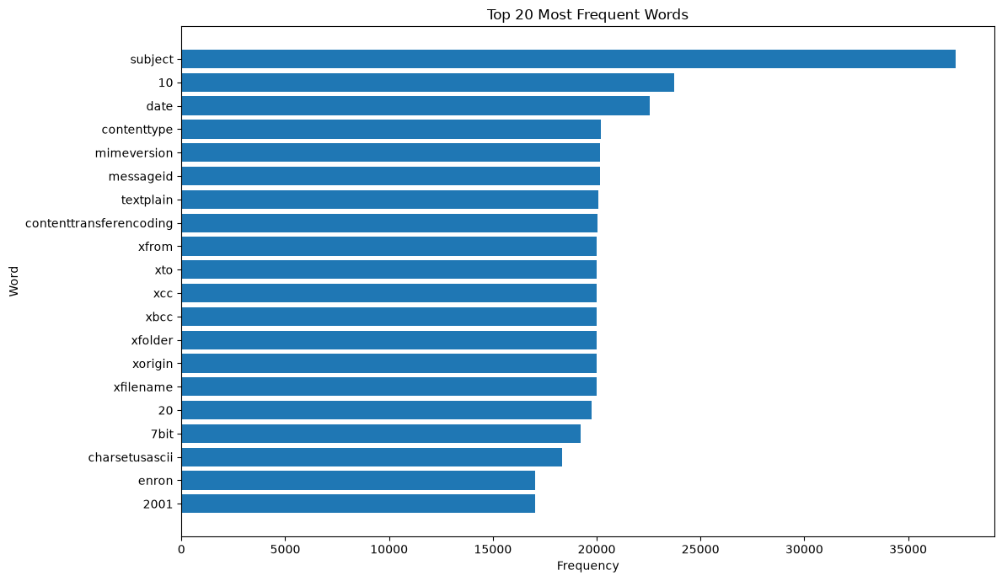
Figure 3.12: Top 20 Most Frequent Words in the Email Corpus
Interpretation:
The frequency distribution shows that email metadata and technical header tokens strongly influence the vocabulary of the corpus. Terms such as subject, content type, mimeversion, xcc, and xfolder occur frequently because the dataset contains email metadata and technical header information.

3.14 Autocorrect Confusion Matrix
The confusion matrix is generated for the twenty-word autocorrect evaluation set. It compares the true correction labels with the predicted labels and provides a visual representation of correct and incorrect classifications.
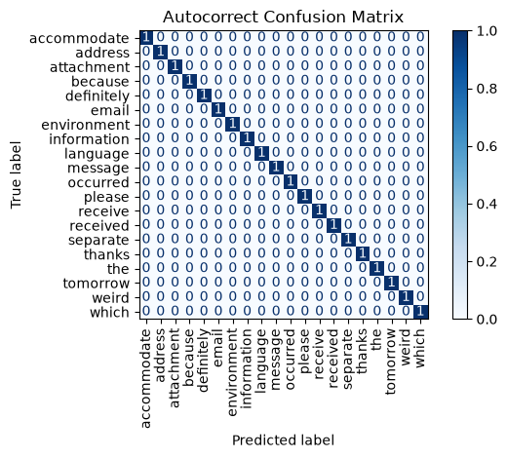
Figure 3.13: Autocorrect Confusion Matrix
Interpretation:
The diagonal pattern provides visual evidence that the twenty tested corrections were classified correctly. The concentration of values along the diagonal indicates that the predicted correction labels matched the corresponding true correction labels.

3.15 Final Performance Summary
The final performance summary consolidates the evaluation results for the autocomplete and autocorrect components. It reports the Top-1 and Top-3 autocomplete accuracy together with autocorrect precision and recall.
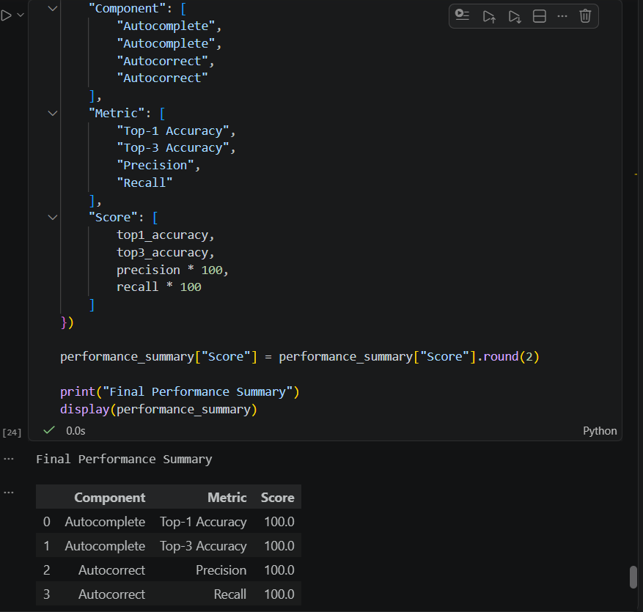
Figure 3.14: Final Performance Summary
Interpretation:
The final performance summary confirms 100% Top-1 accuracy, 100% Top-3 accuracy, 100% precision, and 100% recall for the selected controlled test sets. These results demonstrate consistent performance across the reported evaluation metrics.

3.16 Discussion and Limitations
The implemented NLP system successfully demonstrates both autocomplete and autocorrect functionality using a large email text corpus. The frequency-based bigram model generates next-word predictions for multiple input prefixes, while the autocorrect module uses vocabulary-based matching to correct spelling errors.
The main limitation of the autocomplete model is that it is frequency-based and does not understand the semantic meaning of a sentence. The email corpus also contains metadata and technical terms that can influence word frequencies and predictions.
A second limitation is that the evaluation uses a small, deliberately selected set of ten autocomplete prefixes and twenty misspelled words. The 100% scores therefore describe the controlled test set and should not be interpreted as production-level performance.
A trigram model can use more context than a bigram model, but it also creates more unique sequences and requires additional memory and computation. Production systems such as modern mobile keyboards generally use richer language models, personalization, contextual signals, and much larger evaluation sets.

CHAPTER 4: RESULTS & DISCUSSION
4.1 Key Findings
- The email corpus contains 517,401 records and two columns: file and message.
- The initial quality assessment reports zero missing values and zero duplicate rows.
- NLP preprocessing includes lowercasing, punctuation removal, tokenization, stopword removal, and processed-text generation.
- The frequency-based bigram model contains 1,651,227 words with available next-word predictions.
- Ten autocomplete prefixes were tested with three predictions per prefix.
- Autocomplete achieved 100% Top-1 accuracy and 100% Top-3 accuracy on the selected test set.
- Twenty deliberately misspelled words were evaluated for autocorrect.
- Autocorrect achieved 100% accuracy, 100% precision, and 100% recall on the controlled test set.
- The 20,000-email model comparison produced 967,009 unique bigrams and 1,319,953 unique trigrams.
- The confusion matrix shows correct predictions along the diagonal for all twenty tested corrections.

4.2 Data-Driven Insights
- Use preprocessing carefully: removing punctuation and stopwords creates a more standardized representation for frequency-based modelling.
- Consider corpus quality: email metadata and technical header terms can dominate frequent-word statistics.
- Use larger context where appropriate: trigrams provide more context than bigrams, but at increased computational cost.
- Evaluate with representative data: controlled test sets are useful for validation, but broader real-world testing is required for production use.
- Combine simple models with stronger language understanding: frequency-based n-grams provide a useful baseline but do not capture semantic context.
4.3 Conclusion
The Autocomplete and Autocorrect Data Analytics project successfully implemented an end-to-end NLP workflow from raw email text to evaluated language-processing components. The preprocessing stage standardized the corpus, the bigram model generated next-word predictions, and the autocorrect component corrected deliberately misspelled words.
The selected evaluation set produced perfect scores across the reported metrics. The project also demonstrated the trade-off between bigram and trigram modelling: higher-order n-grams provide additional context but produce more unique combinations and require more computational resources.
4.4 Future Enhancements
- Use a larger and more diverse evaluation set containing naturally occurring spelling errors.
- Remove or separately process email headers and metadata so that technical tokens do not dominate predictions.
- Compare bigram and trigram models using common accuracy, coverage, and latency measures.
- Implement a backoff strategy so the model can use trigrams when available and fall back to bigrams otherwise.
- Use edit-distance thresholds and candidate ranking for more robust spelling correction.
- Add word-frequency weighting and contextual scoring to improve prediction quality.
- Explore neural language models or transformer-based methods for semantic context.
- Measure runtime, memory usage, and model size for practical deployment.
- Evaluate the system on unseen email data rather than only controlled examples.
- Build an interactive typing demonstration to show autocomplete and autocorrect behaviour.

4.5 References
- OASIS INFOBYTE Data Analytics Internship – Level 2 Task 5 requirements and implementation workflow.
- Enron-style email text corpus used in the submitted Level 2 Task 5 notebook.
- Python, Pandas, NumPy, NLTK, pyspellchecker, collections, Matplotlib, and Jupyter Notebook used in the implementation.
- NLTK resources used for tokenization and English stopword processing.
- pyspellchecker used for vocabulary-based spelling correction.
4.6 Final Findings and Conclusion
The completed implementation demonstrates that a large text corpus can be transformed into a practical baseline NLP system using standard Python tools. The project meets the core analytical requirements by implementing autocomplete, autocorrect, quantitative evaluation, model comparison, and visualization.
The strongest result is the consistency of the selected test outputs: all ten autocomplete prefixes are correctly identified at Top-1 and Top-3 levels, and all twenty controlled spelling corrections are correctly matched. At the same time, the report recognizes that these scores are test-set specific and that production typing systems require broader contextual modelling and more representative evaluation.
Overall, the project provides a clear foundation for understanding n-gram language models, text preprocessing, spelling correction, evaluation metrics, and the practical trade-offs between simple frequency-based NLP methods and more advanced contextual approaches.

