**CITS3002 Computer Networks – Socket Programming Report**

Hello, test sentence.

1. *How would you scale up your solution to handle many more clients?*

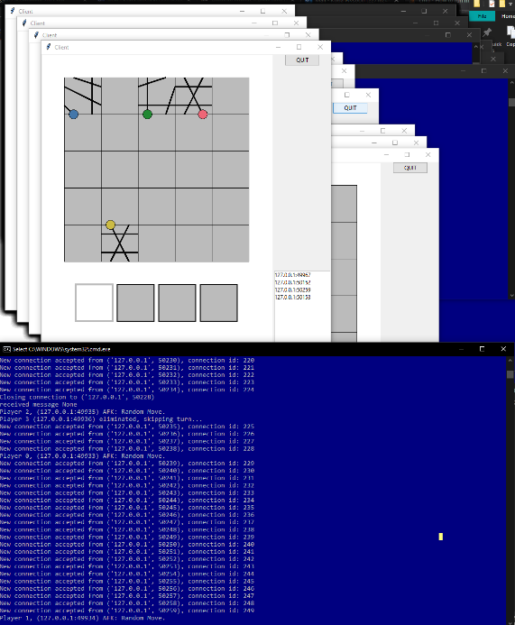After performing some tests, the server was able to handle over 200 clients connected to it simultaneously, with little performance drawback. Despite this being many people to play one tiles game, to scale up my solution, I would not use the selector method of dealing with multiple connections. I would rather opt for an event driven method. This will shave some processing time where the loop goes over each client, checking their game state. To implement more active players, I would redesign the way the server stores data relating to each client. There are multiple lists, dictionaries and flags holding various game-state defining values, which could possible be reduced to a slimmer data structure.

<- 250 connected clients

1. *How could you deal with identical messages arriving simultaneously on the same socket?*
2. *With reference to your project, what are some of the key differences between designing network programs, and other programs you have developed?*
3. *What are the limitations of your current implementation (e.g. Scale, performance, complexity)?*

*Clients who disconnect before making a turn crash, brute force random turn is inefficient. Less space with a slimmer designed data structure.*

1. *Are there any other implementations outside the scope of this project you would like to mention?*
2. *Any other notable things to discuss.*