LAB 2

2274802010922 – Ô Bảo Trí

Câu 1.

db["orders"].find()

Kết quả:

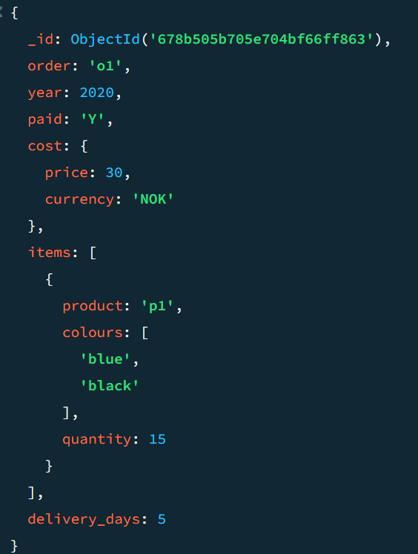

{

_id: ObjectId('678b505b705e704bf66ff864'),

order: 'o2',

year: 2020,

paid: 'Y',

cost: {

price: 13,

currency: 'EUR'

},

items: [

{

product: 'p2',

colours: [

'white'

],

quantity: 4

},

{

product: 'p3',

colours: [

'white',

'black'

],

quantity: 1

}

],

delivery_days: 4

}

{

_id: ObjectId('678b505b705e704bf66ff865'),

order: 'o3',

year: 2018,

paid: 'N',

cost: {

price: 33,

currency: 'EUR'

},

items: [

{

product: 'p3',

colours: [

'blue',

'black'

],

quantity: 4

}

],

delivery_days: 4

}

{

_id: ObjectId('678b505b705e704bf66ff866'),

order: 'o4',

year: 2017,

paid: 'Y',

cost: {

price: 17,

currency: 'NOK'

},

items: [

{

product: 'p2',

colours: [

'pink',

'black'

],

quantity: 14

},

{

product: 'p4',

colours: [

'white'

],

quantity: 1

}

],

delivery_days: 2

}

{

_id: ObjectId('678b505b705e704bf66ff867'),

order: 'o5',

year: 2020,

paid: 'Y',

cost: {

price: 19,

currency: 'NOK'

},

items: [

{

product: 'p1',

quantity: 15

}

],

delivery_days: 3

}

Câu 2.



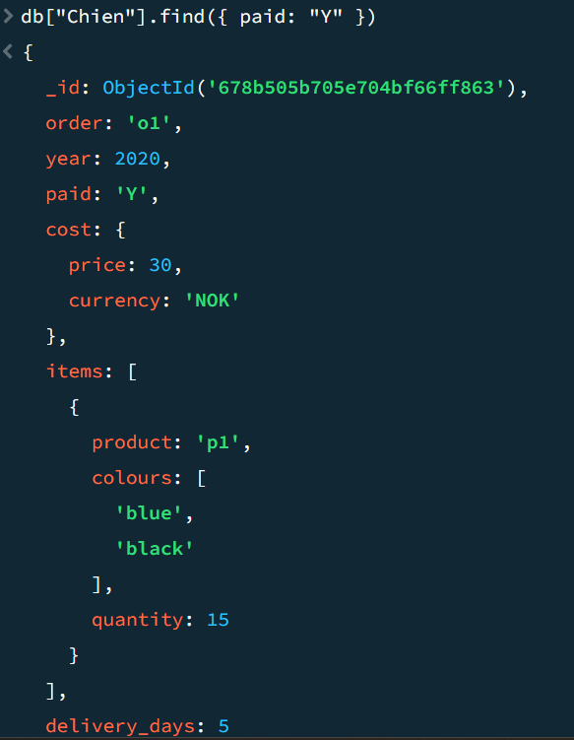



Câu 3.

db["orders"].find({paid:"Y",year:{$lt:2019}})

{

_id: ObjectId('678b505b705e704bf66ff866'),

order: 'o4',

year: 2017,

paid: 'Y',

cost: {

price: 17,

currency: 'NOK'

},

items: [

{

product: 'p2',

colours: [

'pink',

'black'

],

quantity: 14

},

{

product: 'p4',

colours: [

'white'

],

quantity: 1

}

],

delivery_days: 2

}

Câu 4. Cho biết các documents unpaid hoặc những orders trước 2019

Câu 5. Cho biết các documents có price là NOK

db["orders"].find({"cost.currency":"NOK"})

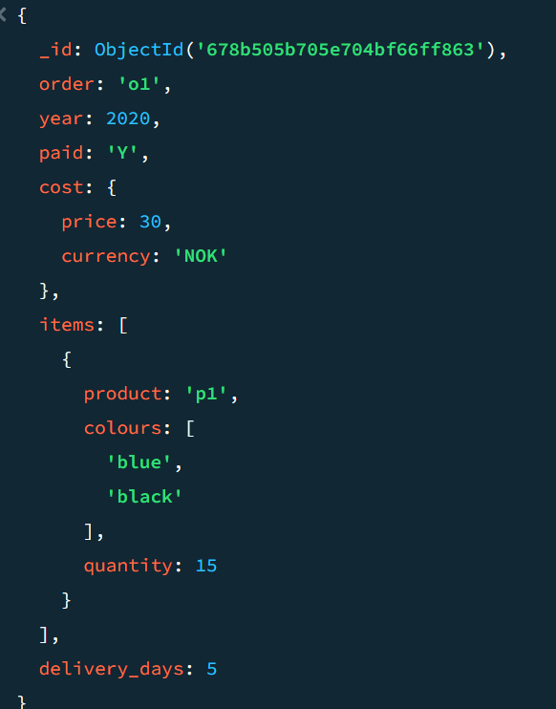

Câu 6. Cho biết các documents có price nhỏ hơn 18 NOK

db["orders"].find({$and:[{"cost.price":{$lt:18},"cost.currency":"NOK"}]})

Câu 7. Cho biết các documents có sản phẩm "p2"

db["orders"].find({"items.product":"p2"})

8. Cho biết các documents có số lượng sản phẩm lớn hơn 10 và nhỏ hơn 15

db["orders"].find({

"items.quantity": { $gt: 10, $lt: 15 }

})

9. Cho biết các documents có số lượng sản phẩm nhỏ hơn 13

db["orders"].find({

"items.quantity": { $lt: 13 }

})

10. Cho biết các documents có màu blue

db["orders"].find({"items.colours":"blue"})

11. Cho biết màu đầu tiên của các documents

12. Cho biết tổng số ngày giao hàng

13. Cho biết các documents nhóm theo year

14. Cho biết các documents không có màu

db["orders"].find({

$or: [

{ "items.colours": { $exists: false } },

{ "items.colours": { $size: 0 } }

]

})

15. Cho biết tổng số ngày giao hàng trước năm 2020

