08 - Manage resource locks (5 min)

Task 1: Add a Lock to the resource group and test deletion
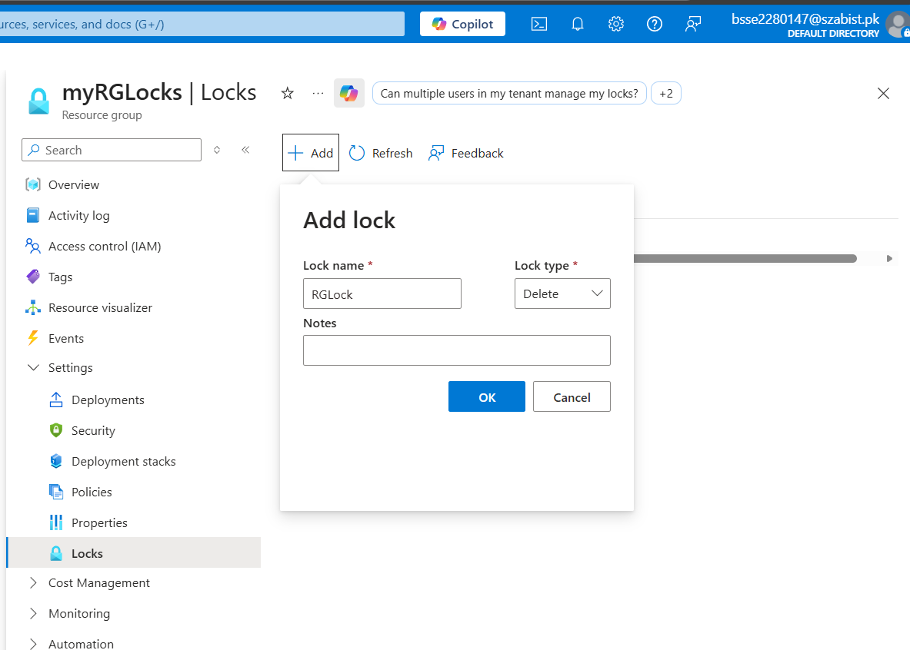

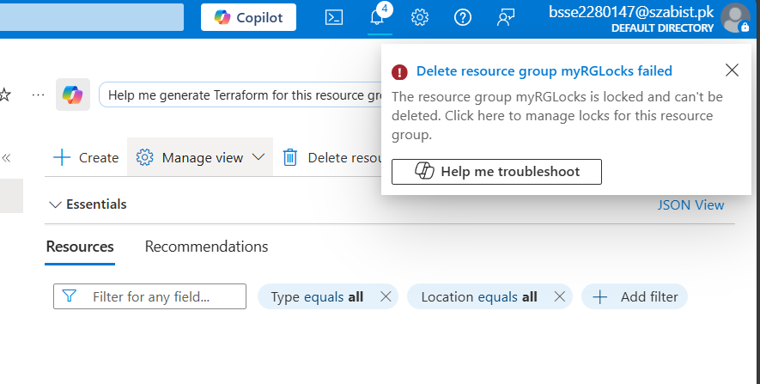

Task 2: Test deleting a member of the resource group
In this task, we will test if the resource lock protects a storage account in the resource group.
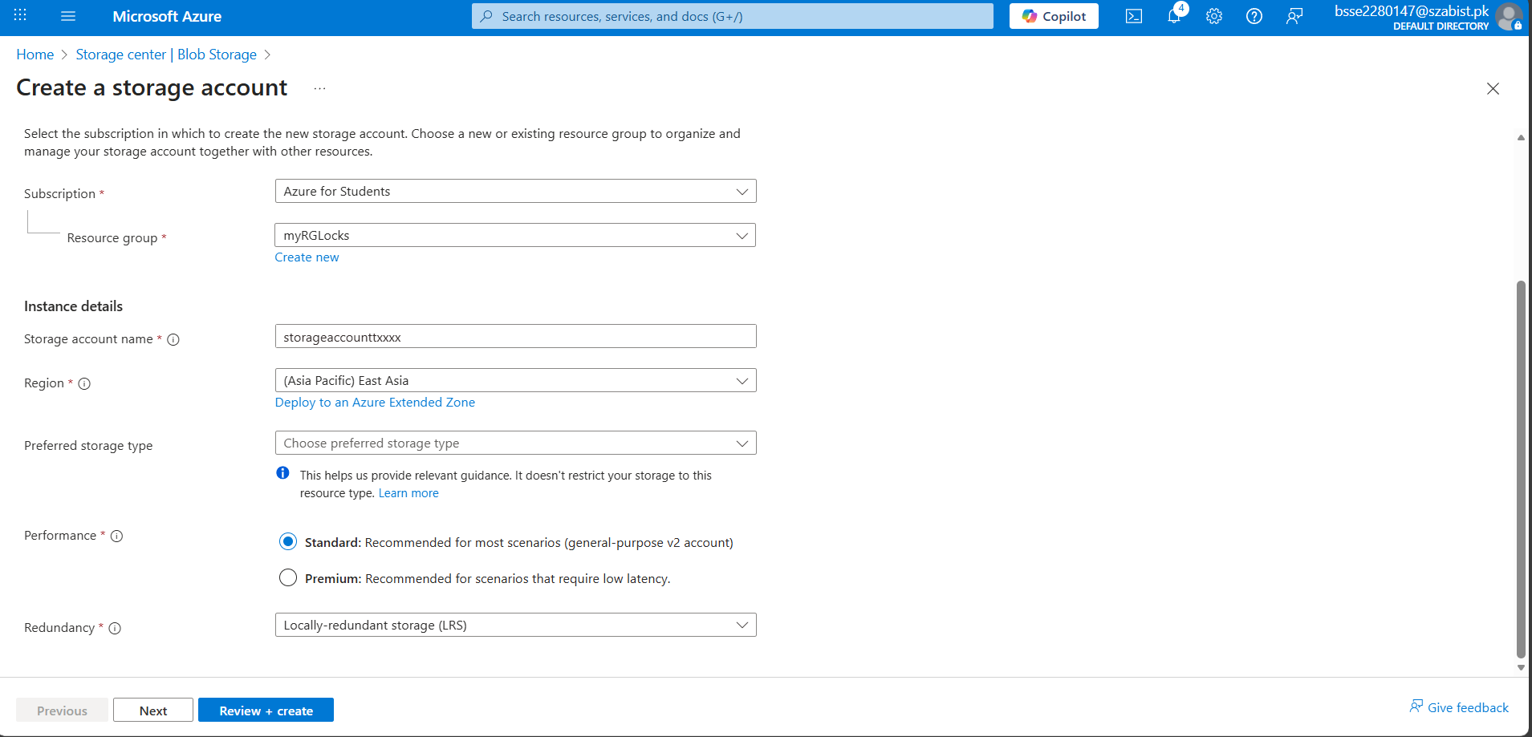
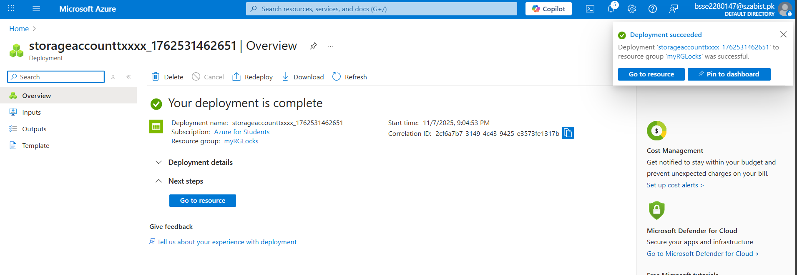
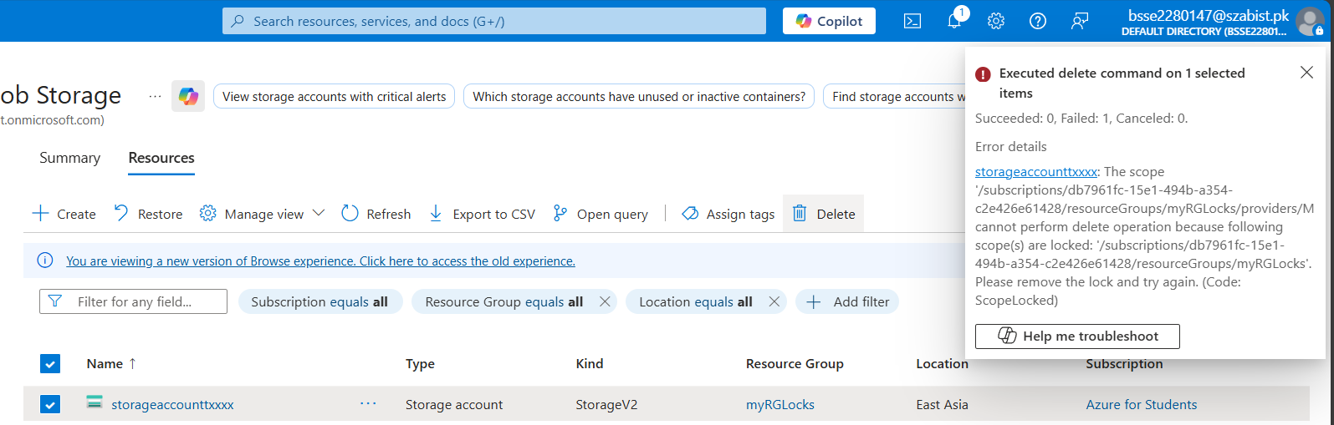

Task 3: Remove the resource lock
