**PROJECT BASED REPORT**

**ON**

**VISUAL QUESTION ANSWERING**

(CSE V SEMESTER)

2021-2022



**SUBMITTED BY -**

Ms. SANA AFREEN

University Roll No: 2014831

C.S.E – VI – SEMESTER

DEPARTMENT OF COMPUTER SCIENCE AND ENGINEERING

**GRAPHIC ERA DEEMED TO BE UNIVERSITY, DEHRADUN**

**CONTENTS:**

* Abstract
* Introduction

-Problem Staement

* Methodology
* Implementation
* Result and Discussion
* Conclusion and Future work

**ABSTRACT**

In this project, we create a Image Classifier of our own which can distinguish whether a given pic is of a dog or cat or something else depending upon your fed data. To achieve our goal, we use one of the famous machine learning algorithms out there which is used for Image Classification i.e. Convolutional Neural Network or CNN. So basically, what is CNN – as we know it’s a machine learning algorithm for machines to understand the features of the image with foresight and remember the features to guess whether the name of the new image fed to the machine.

**PROBLEM STATEMENT:**

The main goal of this project is to develop a system that can identify images of cats and dogs. The input image will be analyzed and then the output is predicted. The Dogs vs Cats dataset can be downloaded from the Kaggle website. The dataset contains a set of images of cats and dogs. Our main aim here is for the model to learn various distinctive features of cat and dog. Once the training of the model is done it will be able to differentiate images of cat and dog.



* **PLATFORM USE:**

**Google COLAB:**

Colaboratory is a free Jupyter notebook environment that requires no setup and runs entirely in the cloud.

Jupyter notebook, hosted in Colaboratory. It is not a static page, but an interactive environment that lets you write and execute code in Python and other languages.

* **LIBRARIES USED:**

**Keras:**  Keras is a deep learning API written in Python, running on top of the machine learning platform TensorFlow. It was developed with a focus on enabling fast experimentation. Being able to go from idea to result as fast as possible is key to doing good research.

* **os** — to read files and directory structure
* **numpy** — for some matrix math outside of TensorFlow
* **matplotlib.pyplot** — to plot the graph and display images in our training and validation data

**Methodology:**

* **MODEL IDEA**

The model consists of convolution blocks with a max pool layer in each of them.

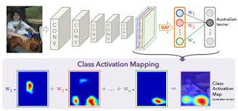

**ACCURACY:**

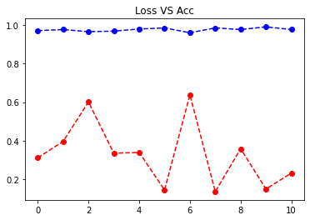

**CODE IMPLEMENTATION:**

**https://github.com/2286-SANA/Image_Classification_using_CNN**

**RESULT:**

results we get after training our network.

The image is of cat

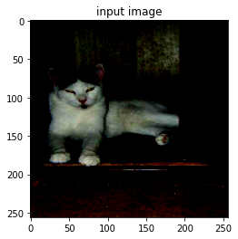

The image is of Dog

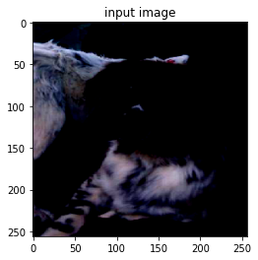

**Conclusion :**

Image classification is an interesting and challenging task for the researchers. In this survey, we looked at various datasets,and several methods for this task. We compared the results,and identified a number future work that can be done in this area.

**Future Work:**

Image classification task can be a part of an agent which is in an interactive environment, and should answer the questions from humans. In this task, the agent should be able to navigate through the environment, acquire understanding of The environment, interact with the environment, and be able to plan and execute a series of actions. A image classification system can be part of an intelligent agent which is designed to address the interactive answering challenge. The authors of collected an interactive question answering dataset, which is based on a simulated environment. This dataset can facilitate future research in the area of interactive question answering.

**THANK YOU________________________**