|  |  |  |  |  |  |  |  |  |  |  |  |  |  |  |  |  |  |  |  |  |  |  |  |  |  |  |  |  |  |  |  |  |  |  |  |  |  |  |  |  |  |  |  |  |  |  |  |  |  |  |  |  |  |  |  |  |  |  |  |  |  |  |  |  |  |  |  |  |
| --- | --- | --- | --- | --- | --- | --- | --- | --- | --- | --- | --- | --- | --- | --- | --- | --- | --- | --- | --- | --- | --- | --- | --- | --- | --- | --- | --- | --- | --- | --- | --- | --- | --- | --- | --- | --- | --- | --- | --- | --- | --- | --- | --- | --- | --- | --- | --- | --- | --- | --- | --- | --- | --- | --- | --- | --- | --- | --- | --- | --- | --- | --- | --- | --- | --- | --- | --- | --- |
| |  |  |  |  | | --- | --- | --- | --- | | **S.No** | **Program** | **Date** | **Sign.** | | 1 | Create a Simple Admission Form for University Admission. | 11/03/22 |  | | 2 | Write a Simple HTML Script to make timetable. | 11/03/22 |  | | 3 | Write a Program in HTML to implement a frame. | 25/03/22 |  | | 4 | Write a Program in HTML to implement a table. | 25/03/22 |  | | 5 | Write a JS function to check weather an ‘input’ is an integer or not. | 01/04/22 |  | | 6 | Write a JS function to move a circle from top to bottom with 50px. | 01/04/22 |  | | 7 | Write a JS Program to draw a smiley using {moveto() function}. | 01/04/22 |  | | 8 | Write a JS Program to calculate the volume of cube using form. | 01/04/22 |  | | 9 | Write a JS for loop that iterate from 0 to 100 and check  the number is perfect square or not and display a message in console. | 08/04/22 |  | | 10 | Write a JS function to check whether a given value is an valid password & mail-id not. | 08/04/22 |  | | 11 | Write a PHP program for student registration. | 06/05/22 |  | | 12 | Write a PHP program to open a text file in ‘W’ Mode and inserting the text into a file and then read the text from file. | 06/05/22 |  | | 13 | Write a PHP program to implement include and require. | 06/05/22 |  | | 14 | Write a PHP program to connect a database and check the connection is successful or not. | 13/05/22 |  | | 15 | Write a PHP program to create, insert, update, delete data in database using SQL queries. | 13/05/22 |  | | 16 | Write a JQUERY program to display JSON data. | 13/05/22 |  | |

**Program 11:**

Write a PHP program for student registration.

Php file:

|  |
| --- |
| <!DOCTYPE html>    <html>  <head>    <meta name="viewport" content="width=device-width, initial-scale=1">    <style>    body{  font-family: Calibri, Helvetica, sans-serif;  background-color: grey;    }    .container {  padding: 50px;    background-color: #f7dc6f ;    }  input[type=text], textarea {    width: 100%;  padding: 15px;    margin: 5px 0 22px 0;  display: inline-block;  border: none;    background: #f1f1f1;    } div { |

|  |
| --- |
| padding: 10px 0;    }  hr {  border: 1px solid #f1f1f1;  margin-bottom: 25px;    }    .registerbtn {  background-color: #4CAF50;  color: white;  padding: 16px 20px;  margin: 8px 0;  border: none;  cursor: pointer;  width: 100%;  opacity: 0.9;    }  </style>    </head>  <body>  <form target = "_blank" method="post" action="studentregister.php" id = "my_form">    <div class="container">    <center> <h1>Registeration Form</h1> </center>    <hr>    <label> <b>Fullname</b> </label>    <input type="text" name="name" placeholder= "Fullname" size="50" required />  <label for="email"><b>Email</b></label>    <input type="text" placeholder="Enter Email" name="email" required>  <label for="age"><b>Age</b></label> |
| <input type="text" placeholder="Enter Age" name="age" required>    <div>    <label>    <b>Gender : </b>    </label><br>    <input type="radio" value="Male" name="gender" checked > Male  <input type="radio" value="Female" name="gender"> Female  <input type="radio" value="Other" name="gender"> Other  <button type="submit" class="registerbtn">Register</button>  </div>  <label>    </form> <script> const form = document.getElementById('my_form'); form.addEventListener('submit', function handleSubmit(event) { form.submit(); event.preventDefault(); form.reset();  });  </script>      </body>    </html> |

|  |
| --- |
| <!DOCTYPE HTML>  <html>  <head>    <meta name="viewport" content="width=device-width, initial-scale=1">    <style>    body{    font-family: Calibri, Helvetica, sans-serif; color: black; font-height:34px;  background-color: grey; |
| }  </style>  </head>  <body>  <?php    $fullname = $email = $gender = $age = "";  if ($_SERVER["REQUEST_METHOD"] == "POST") {    $fullname = test_input($_POST["name"]);    $email = test_input($_POST["email"]);    $gender = test_input($_POST["gender"]);    $age = test_input($_POST["age"]);  echo "<br>";  } function test_input($data) {    $data = trim($data);    $data = stripslashes($data);    $data = htmlspecialchars($data);  return $data;    }    ?> <?php if($fullname==""||$email==""||$age==""||$gender=="")  {  echo "Enter details again.<br>";  } else {  echo "$fullname have successfully registered.<br>";  }  ?>  </body>  </html> |

Output:

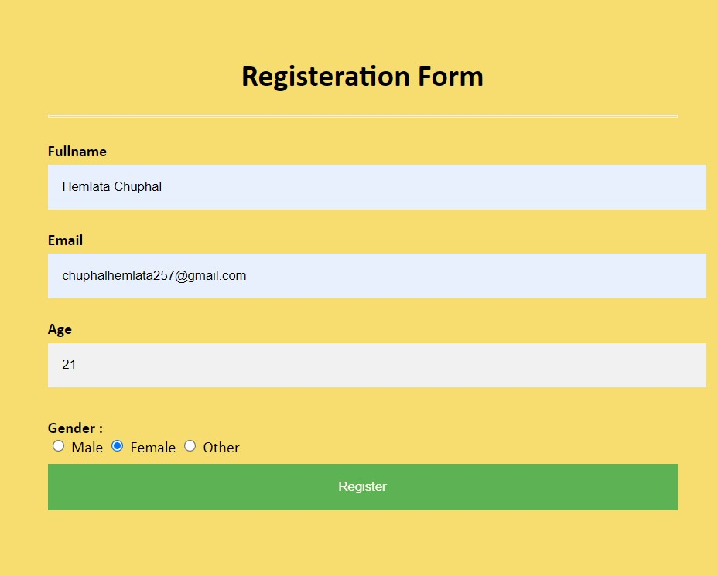

20

abc123@gmail.com

Sana Afreen



Sana Afreen have successfully registered.

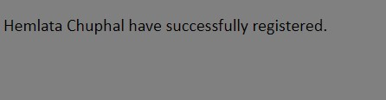

**Program 12:**

Write a PHP program to open a text file in ‘W’ Mode and inserting the text into a file and then read the text from file.

|  |
| --- |
| <!DOCTYPE HTML>  <body>  <?php  $myfile = fopen("newfile.txt", "w") or die("Unable to open file!");  $txt = "Writing to a text file.\n"; fwrite($myfile, $txt); $txt = "Web Program\n"; fwrite($myfile, $txt); $txt = "Ds Program\n"; fwrite($myfile, $txt); fclose($myfile);  $myfile = fopen("newfile.txt", "r") or die("Unable to open file!"); while(!feof($myfile))  { echo fgets($myfile) . "<br>";  } fclose($myfile);  ?>  </body>  </html> |

Output:

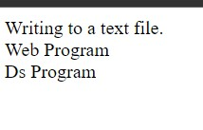

**Program 13:**

Write a PHP program to implement include and require.

Using Include:

<html>

<body>

<h1>Welcome to my home page!</h1>

<p>Using Include</p>

<?php include 'intro.php';?>

</body>

</html>

Intro.php

<?php echo "Using include in php <br>";

?>

**Output:**

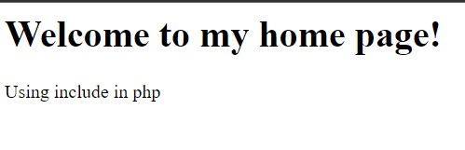

**Using require:**

|  |
| --- |
| <html>  <body>  <h1>Welcome to my home page!</h1>  <?php require 'intro.php';  ?>  </body>  </html> |

Intro.php:

<?php echo "Using include in php <br>";

?>

**Output:**

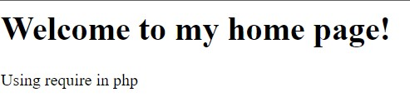

**Program 14:**

Write a PHP program to connect a database and check the connection is successful or not.

|  |
| --- |
| <?php  //echo "welcome to mysql database<br>";    // connect to the database  $servername="localhost";  $username="root";  $password="";  // create a connection  $conn=mysqli_connect($servername,$username,$password);  $sql="CREATE DATABASE hemdatabase1";  $result = mysqli_query($conn,$sql);  if($result)  { echo "db was created successfully";  } else{ echo "db was not created successfully because of error".mysqli_error($conn);  }  if(!$conn)  { die("sorry we failed to connect: ". mysqli_connect_error());  } else { echo "connection was successful";  }  ?> |

**Output:**

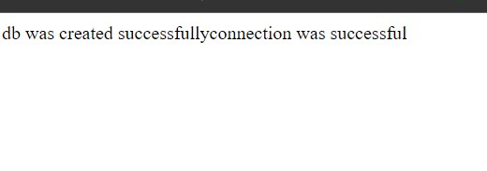

**Program 15:**

Write a PHP program to create, insert, update, delete data in database using SQL queries.

|  |
| --- |
| <?php  //echo "welcome to mysql database<br>";    // connect to the database  $servername="localhost";  $username="root";  $password="";  $database="hemdatabase1";    // create a connection    $conn=mysqli_connect($servername,$username,$password,$database); if(!$conn)  { die("sorry we failed to connect: ". mysqli_connect_error());  } else { echo "connection was successful";  }    $sql="CREATE TABLE `t2` (`SNO` INT NOT NULL AUTO_INCREMENT , `NAME` VARCHAR(22) NOT  NULL , `DEST` VARCHAR(12) NOT NULL , PRIMARY KEY (`SNO`))";  $result = mysqli_query($conn,$sql);  if($result)  {  echo "table was created successfully";  } else{  echo "Table was not created successfully because of error".mysqli_error($conn); }    $sql = "INSERT INTO t2 (`sno`,`name`, `dest`) VALUES ('1','hemlata', 'geu')";  $result = mysqli_query($conn, $sql);  // Add a new trip to the Trip table in the database if($result){ echo "The record has been inserted successfully successfully!<br>";  } else{ echo "The record was not inserted successfully because of this error ---> ".  mysqli_error($conn); |
| } echo "After Inserting a new row";  $sql1 = "SELECT * FROM `t2`";  $result = mysqli_query($conn, $sql1);  $num = mysqli_num_rows($result); $num = mysqli_num_rows($result); echo $num . " records found in the DataBase<br>";  $no=1; if($num> 0){ while($row = mysqli_fetch_assoc($result)){ echo $no . ". Hello ".$row['NAME']." address ".$row['DEST'];  //echo $row['NAME']; echo "<br>";  $no = $no +1;  }  }  $sql2 = "UPDATE 't2' SET `name`='hem' WHERE `sno`=1";  $result = mysqli_query($conn, $sql2);  if($result){ echo "The record has been updated successfully successfully!<br>";  } else{ echo "The record was not updated successfully because of this error ---> ".  mysqli_error($conn);  }  Usage of WHERE Clause to fetch data from the database  $num = mysqli_num_rows($result); echo $num . " records found in the DataBase<br>";  $no=1; if($num> 0){ while($row = mysqli_fetch_assoc($result)){  echo $no . ". Hello ".$row['NAME']." address ".$row['DEST'];  //echo $row['NAME']; echo "<br>";  $no = $no +1;  }  }  $sql3 = "DELETE FROM t2 WHERE `dest`='geu'"; $result = mysqli_query($conn, $sql3); if($result){ echo "The record has been deleted successfully!<br>";  } else{ echo "The record was not deleted successfully because of this error ---> ".  mysqli_error($conn);  }    ?> |

**Output:**

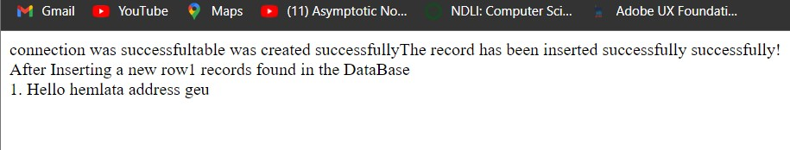

**Program 16:**

Write a JQUERY program to display JSON data.

|  |
| --- |
| <!DOCTYPE html>  <html lang="en">    <head>  <title>The jQuery Example</title>  <script src =  "https://ajax.googleapis.com/ajax/libs/jquery/2.1.3/jquery.min.js"></script>    <script>  $(document).ready(function() {    $("#driver").click(function(event){  $.getJSON('newInput.json', function(jd) {  $('#stage').html('<p> Name: ' + jd.name + '</p>');  $('#stage').append('<p>Age : ' + jd.age+ '</p>'); $('#stage').append('<p> Sex: ' + jd.sex+ '</p>');  });  });  });  </script>  </head>    <body>  <h1>read json data</h1>  <div id ="load-data"></div>        <div id = "stage" style = "background-color:#cc0;">  STAGE  </div>    <input type = "button" id = "driver" value = "Load Data" /> |

<!-- <script src="https://code.jquery.com/jquery-3.6.0.slim.min.js" integrity="sha256u7e5khyithlIdTpu22PHhENmPcRdFiHRjhAuHcs05RI=" crossorigin="anonymous"></script> -->

</body>

</html>

**Output:**

