

软件测试实验报告2

学生姓名 白玛桑布
学院名称 软件学院
专 业 软件工程
学 号 3015218050
Selenium上机实验说明
- 安装SeleniumIDE插件
- 学会使用SeleniumIDE录制脚本和导出脚本
- 访问https://psych.liebes.top/st使用学号登录系统（账户名为学号，密码为学号后6位），进入系统后可以看到该同学的git地址。
- 编写Selenium Java WebDriver程序，测试input.xlsx表格中的学号和git地址的对应关系是否正确。

- 将测试代码提交到github上（4月15日23:59:59前）。

学会使用Selenium
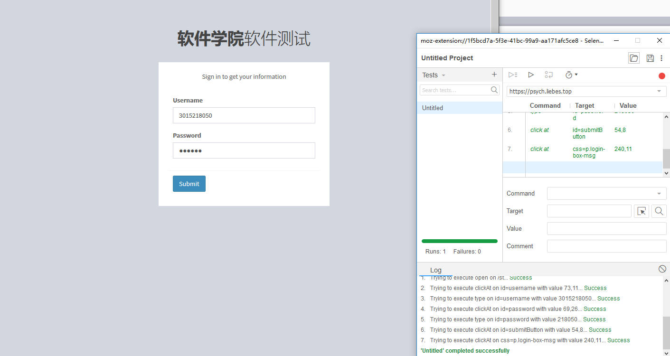
浏览网页并导出代码
package qqq;

import java.util.regex.Pattern;
import java.util.concurrent.TimeUnit;
import org.junit.*;
import static org.junit.Assert.*;
import static org.hamcrest.CoreMatchers.*;
import org.openqa.selenium.*;
import org.openqa.selenium.firefox.FirefoxDriver;
import org.openqa.selenium.support.ui.Select;

public class 1 {
private WebDriver driver;
private String baseUrl;
private boolean acceptNextAlert = true;
private StringBuffer verificationErrors = new StringBuffer();

@Before
public void setUp() throws Exception {
driver = new FirefoxDriver();
baseUrl = "https://www.duba.com/";
driver.manage().timeouts().implicitlyWait(30, TimeUnit.SECONDS);
}

@Test
public void test1() throws Exception {
driver.get(baseUrl + "/?un_454973_1");
driver.findElement(By.xpath("(//a[contains(text(),‘鐧惧害‘)])[2]")).click();
driver.findElement(By.id("kw")).click();
driver.findElement(By.id("kw")).clear();
driver.findElement(By.id("kw")).sendKeys("浠ｇ爜");
driver.findElement(By.id("su")).click();
driver.findElement(By.linkText("缂栫▼浠ｇ爜澶у叏")).click();
driver.findElement(By.linkText("浠ｇ爜澶у叏_鐧惧害鐧剧")).click();
}

@After
public void tearDown() throws Exception {
driver.quit();
String verificationErrorString = verificationErrors.toString();
if (!"".equals(verificationErrorString)) {
fail(verificationErrorString);
}
}

private boolean isElementPresent(By by) {
try {
driver.findElement(by);
return true;
} catch (NoSuchElementException e) {
return false;
}
}

private boolean isAlertPresent() {
try {
driver.switchTo().alert();
return true;
} catch (NoAlertPresentException e) {
return false;
}
}

private String closeAlertAndGetItsText() {
try {
Alert alert = driver.switchTo().alert();
String alertText = alert.getText();
if (acceptNextAlert) {
alert.accept();
} else {
alert.dismiss();
}
return alertText;
} finally {
acceptNextAlert = true;
}
}
}

测试

package qqq;

import static org.junit.Assert.assertEquals;
import static org.junit.Assert.fail;
import java.io.FileNotFoundException;
import java.io.IOException;
import java.nio.charset.Charset;
import java.util.Arrays;
import java.util.Collection;
import java.util.NoSuchElementException;
import java.util.concurrent.TimeUnit;

import org.junit.After;
import org.junit.Before;
import org.junit.Test;
import org.junit.runner.RunWith;
import org.junit.runners.Parameterized;
import org.junit.runners.Parameterized.Parameters;
import org.openqa.selenium.Alert;
import org.openqa.selenium.By;
import org.openqa.selenium.NoAlertPresentException;
import org.openqa.selenium.WebDriver;
import org.openqa.selenium.firefox.FirefoxDriver;

import org.openqa.selenium.WebElement;
import org.openqa.selenium.firefox.*;

import com.csvreader.CsvReader;

import java.util.List;

@RunWith(Parameterized.class)
public class test {
private WebDriver driver;
private String baseUrl;
private boolean acceptNextAlert = true;
private StringBuffer verificationErrors = new StringBuffer();
private String id,pwd,github;

public test(String id,String github)
{
this.id = id;

this.github = github;
this.pwd = id.substring(4);
System.out.println(this.id+" "+this.github+" "+this.pwd);

}

@Before
public void setUp() throws Exception {
driver = new FirefoxDriver();
baseUrl = "https://psych.liebes.top";
driver.manage().timeouts().implicitlyWait(30, TimeUnit.SECONDS);
driver.get(baseUrl+"/st");
}

@Parameters
public static Collection<Object[]> getData() throws Exception
{
Object[][] obj = new Object[117][];
CsvReader r = new CsvReader("F://input.csv",‘,‘,
Charset.forName("GBK"));
//System.out.println(r);
int count = 0;
r.readHeaders();
while(r.readRecord())
{
obj[count] = new Object[]{r.get("id"), r.get("git") };
count++;
//System.out.println(r.get("git"));
}
System.out.println(count);
return Arrays.asList(obj);
}

@Test
public void test10() throws Exception {

driver.findElement(By.id("username")).clear();
driver.findElement(By.id("username")).sendKeys(this.id);
driver.findElement(By.id("password")).clear();
driver.findElement(By.id("password")).sendKeys(this.pwd);
driver.findElement(By.id("submitButton")).click();
//driver.findElement(By.cssSelector("p.login-box-msg")).click();

assertEquals(this.github, driver.findElement(By.cssSelector("p.login-box-msg")).getText());
}

@After
public void tearDown() throws Exception {
driver.quit();
String verificationErrorString = verificationErrors.toString();
if (!"".equals(verificationErrorString)) {
fail(verificationErrorString);
}
}

private boolean isElementPresent(By by) {
try {
driver.findElement(by);
return true;
} catch (NoSuchElementException e) {
return false;
}
}

private boolean isAlertPresent() {
try {
driver.switchTo().alert();
return true;
} catch (NoAlertPresentException e) {
return false;
}
}

private String closeAlertAndGetItsText() {
try {
Alert alert = driver.switchTo().alert();
String alertText = alert.getText();
if (acceptNextAlert) {
alert.accept();
} else {
alert.dismiss();
}
return alertText;
} finally {
acceptNextAlert = true;
}
}
}

