An Internship Report
Of
Unstop Campus Ambassador Program
Submitted
To
School of Computer Science and Engineering
IILM University, Greater Noida, U.P.

In partial fulfilment of the requirement of degree of
B-Tech (CSE)

By
Roll Number of Student:- 25SCS1003002291
Name of Student: Harsh Kumar
Batch: 2025-2029

CANDIDATE'S DECLARATION

I, HARSH KUMAR, do hereby declare that the internship report titled "UNSTOP CAMPUS AMBASSADOR PROGRAM" has been completed by me to fulfil the requirement for the award of the degree of Bachelor of Technology in Computer Science and Engineering. All the references have been quoted and I have not taken as such any material from any other source. I affirm that this report is my own and has not been submitted to any other institute for any degree/diploma requirement, and further I shall be solely responsible for any kind of copyright violation in this regard.
Signature:-
Student Name: HARSH KUMAR
Roll No.: 25SCS1003002291

ACKNOWLEDGEMENT

I am using this opportunity to express my gratitude to everyone who supported me throughout the Internship Program. I am thankful for their aspiring guidance, invaluably constructive criticism and friendly advice during this work. I am sincerely grateful to them for sharing their truthful and illuminating views on a number of issues related to this work.
I would like to thank Unstop (Formerly Dare2Compete) and its Founder & CEO, Mr. Ankit Aggarwal, for providing me the opportunity and the structured platform to serve as a Campus Ambassador and gain hands-on exposure in event organization and student outreach. I am also thankful to my institute, IILM University, Greater Noida, and the faculty of the School of Computer Science and Engineering for their continuous support and encouragement.
I express my gratitude to my parents for their blessings.
Signature:
Student Name: HARSH KUMAR
Roll No.: 25SCS1003002291

TABLE OF CONTENTS

1. Candidate's Declaration i
2. Acknowledgement ii
3. Internship Completion Certificate -
4. Project/Work Description
4.1 Introduction 1
4.2 Organization Profile 1
4.3 Role and Responsibilities 2
4.4 Objectives 2
4.5 Scope of the Internship 3
4.6 Tools and Platforms Used 3
4.7 Work Done / Methodology 4
4.8 Learning Outcomes 5
4.9 Certificates of Completion and Communication Proof 6
5. Conclusion 7
6. Bibliography/References 8

3. Internship Completion Certificate
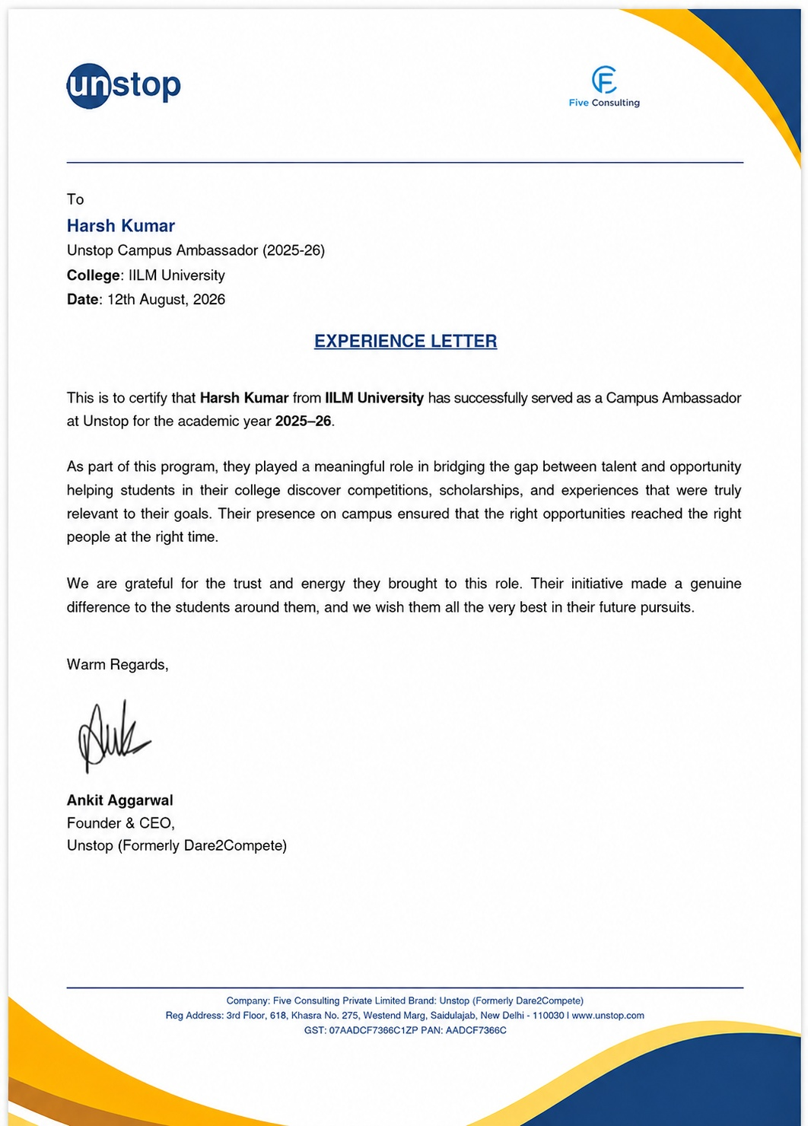

Internship Offer Letter

unstop
Flive Consulting Private Limited | Brand: Unstop (Formerly Dare2Compete)
To
Harsh Kumar
Unstop Campus Ambassador (2025-26)
College: IILM University
Date: 16th June, 2026
INTERNSHIP OFFER LETTER

Dear Harsh,
Congratulations! We are pleased to offer you the role of Campus Ambassador at Unstop (Formerly Dare2Compete) for IILM University, for the academic year 2025–26.
As a Campus Ambassador, you will represent Unstop on your campus, organize events and awareness sessions, and help fellow students discover competitions, scholarships, and opportunities relevant to their goals. You will also serve as the primary point of contact between the student community and the Unstop team throughout the program.
This is a great opportunity to build your leadership, communication, and organizational skills while making a real difference to students around you. We are confident that your energy and initiative will add great value to the program.
Please confirm your acceptance of this offer at your earliest convenience. We look forward to having you onboard and to your active participation in bridging the gap between talent and opportunity at your college.
Warm Regards,
Ankit Aggarwal
Founder & CEO,
Unstop (Formerly Dare2Compete)

Company: Flive Consulting Private Limited Brand: Unstop (Formerly Dare2Compete)
Reg Address: 3rd Floor, 618, Khasra No. 275, Westend Marg, Saidulajab, New Delhi - 110030 | www.unstop.com
GST: 07AADCF7366C1ZP PAN: AADCF7366C

4. Project/Work Description

4.1 Introduction
This report presents a detailed account of the internship undertaken by Harsh Kumar (Roll No. 25SCS1003002291, 3rd Semester, Section 2CSE7, Session 2025–2029) as a Campus Ambassador with Unstop (Formerly Dare2Compete), a leading platform connecting students with competitions, scholarships, and career opportunities. The internship was carried out from 1 July 2026 to 31 July 2026 as part of the requirement of the Bachelor of Technology (Computer Science and Engineering) programme at IILM University, Greater Noida. The primary aim of this internship was to bridge the gap between Unstop's platform and the student community by organizing events and promoting awareness of the opportunities available on it.
The internship required active coordination with peers and faculty, planning of event logistics, and consistent outreach to maximize student participation. On successful completion of the internship period, a Certificate of Completion was awarded by Unstop.

4.2 Organization Profile
Unstop (Formerly Dare2Compete) is a platform operated by Flive Consulting Private Limited that bridges the gap between students and opportunities by hosting competitions, hackathons, scholarships, and other career-building events. Through its Campus Ambassador Program, Unstop enables students across colleges to represent the platform on their campuses, helping peers discover and participate in opportunities relevant to their goals.

4.3 Role and Responsibilities
As a Campus Ambassador, the primary responsibility was to act as a bridge between Unstop and the student community at IILM University, ensuring timely and effective communication of opportunities available on the platform. Key responsibilities included:
- Organizing events and awareness sessions on campus to promote Unstop's competitions, scholarships, and opportunities.
- Coordinating with peers and faculty to plan and execute event logistics.
- Promoting participation among students and encouraging sign-ups on the Unstop platform.
- Acting as a point of contact between the student body and the Unstop team for queries and updates.

4.4 Objectives
- To promote Unstop's competitions, scholarships, and career opportunities among students.
- To plan and execute on-campus events and awareness sessions effectively.
- To build and strengthen communication between the student body and the Unstop team.
- To encourage maximum student sign-ups and participation on the platform.
- To develop organizational, leadership, and public outreach skills.

4.5 Scope of the Internship
The scope of this internship covered campus-level promotion and outreach activities for the Unstop platform. It included planning and coordinating awareness sessions and events, liaising with faculty and peers for logistics, and driving student engagement with competitions, hackathons, and scholarships listed on Unstop. The role was primarily execution and communication focused, aimed at increasing the platform's visibility and adoption within IILM University.

4.6 Tools and Platforms Used
- Platform: Unstop (Formerly Dare2Compete) website and app
- Communication: WhatsApp, Email, Social Media (Instagram/LinkedIn)
- Coordination: Google Forms/Sheets for event registration and tracking
- Outreach: Posters, campus announcements, and word-of-mouth promotion

4.7 Work Done / Methodology
During the internship period, the primary focus of the work was organizing events on campus. The methodology followed a structured approach:
- Requirement Analysis: Identifying upcoming opportunities on Unstop relevant to students at IILM University.
- Planning: Preparing event schedules and awareness session plans in coordination with faculty.
- Promotion: Creating awareness through campus announcements, social media, and peer networks.
- Coordination: Working with fellow students to ensure smooth execution of events.
- Follow-up: Encouraging sign-ups and participation, and addressing student queries.
- Reporting: Sharing updates and outcomes with the Unstop team.
This required consistent follow-up and coordination to ensure that events were well-attended and that information about competitions and scholarships reached the maximum number of students.

4.8 Learning Outcomes
The internship provided valuable exposure to real-world responsibilities beyond the classroom. Key learnings from this experience include:
- Practical experience in event planning and coordination.
- Improved communication and public outreach skills.
- Better understanding of campus-level marketing and student engagement strategies.
- Development of organizational and time-management skills while balancing academics with ambassador responsibilities.

4.9 Certificates of Completion and Communication Proof
The Internship Offer Letter and the Internship Completion Certificate issued by Unstop, confirming successful completion of the Campus Ambassador Program, are attached in Chapter 3 of this report.

5. Conclusion
The internship as a Campus Ambassador with Unstop was a rewarding experience that offered practical exposure to event organization and student outreach. It helped in bridging the gap between talent and opportunity on campus, ensuring that relevant competitions and scholarships reached the student community. This experience has contributed positively to the development of communication, coordination, and leadership skills, which will be valuable in future academic and professional endeavors.

6. Bibliography/References
- Unstop (Formerly Dare2Compete) — https://unstop.com
- IILM University, Greater Noida — Official Website

