Week-6

**1.Define SPA and its benefits**

A Single Page Application (SPA) is a web application or website that interacts with the user by dynamically rewriting the current page, rather than loading entire new pages from the server.

**2.Define React and identify its working**

React is a JavaScript library developed by Facebook for building user interfaces, especially single-page applications (SPAs). It allows developers to create reusable UI components and efficiently update and render the right components when data changes.

**3.Identify the differences between SPA and MPA**

**SPA MPA**

|  |  |
| --- | --- |
| Loads a single HTML page and updates content dynamically | Loads a new HTML page from the server for each user interaction |

|  |  |  |
| --- | --- | --- |
|  | Faster after the initial load (due to less data transfer) | Slower, since each action reloads the full page |

|  |  |
| --- | --- |
| Seamless and smooth, without full page reload | Page reload occurs with each navigation |
| **Exercise-1:** |  |

**Steps to create:**

**1.Create React App Using npx:**

npx create-react-app myfirstreact

**2.Edit App.js File in VSCode :**

import React from 'react';

function App() {

return (

<div>

<h1>Welcome to the session </h1>

</div>

);

}

**3. Start the React App**

npm start in terminal

**4.View in Browser**

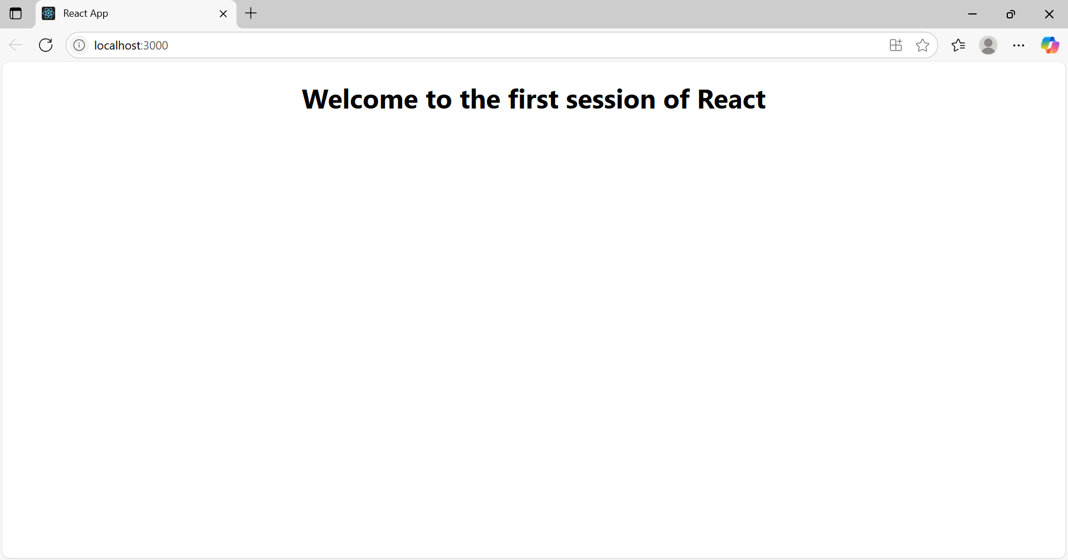

**Exercise-2:**

Create a react app for Student Management Portal named StudentApp and create a component named Home which will display the Message “Welcome to the Home page of Student Management Portal”. Create another component named About and display the Message “Welcome to the About page of the Student Management Portal”. Create a third component named Contact and display the Message “Welcome to the Contact page of the Student Management Portal”. Call all the three components.

**1.**create project folder as **studentapp**

**2.**Inside src create subfolder **components**

**3.create components**

* Home.js
* About.js
* Contact.js

**Home.js:**

import React from 'react';

function Home() {

return (

<div>

<h2>Welcome to the Home page of Student Management Portal</h2>

</div>

);

}

export default Home;

**About.js:**

import React from 'react';

function About() {

return (

<div>

<h2>Welcome to the About page of the Student Management Portal</h2>

</div>

);

}

export default About;

**Contact.js:**

import React from 'react';

function Contact() {

return (

<div>

<h2>Welcome to the Contact page of the Student Management Portal</h2>

</div>

);

}

export default Contact;

**App.js:**

import React from 'react';

import Home from './Components/Home';

import About from './Components/About';

import Contact from './Components/Contact';

function App() {

return (

<div>

<h1>Student Management Portal</h1>

<Home />

<About />

<Contact />

</div>

);

}

export default App;

**output:**

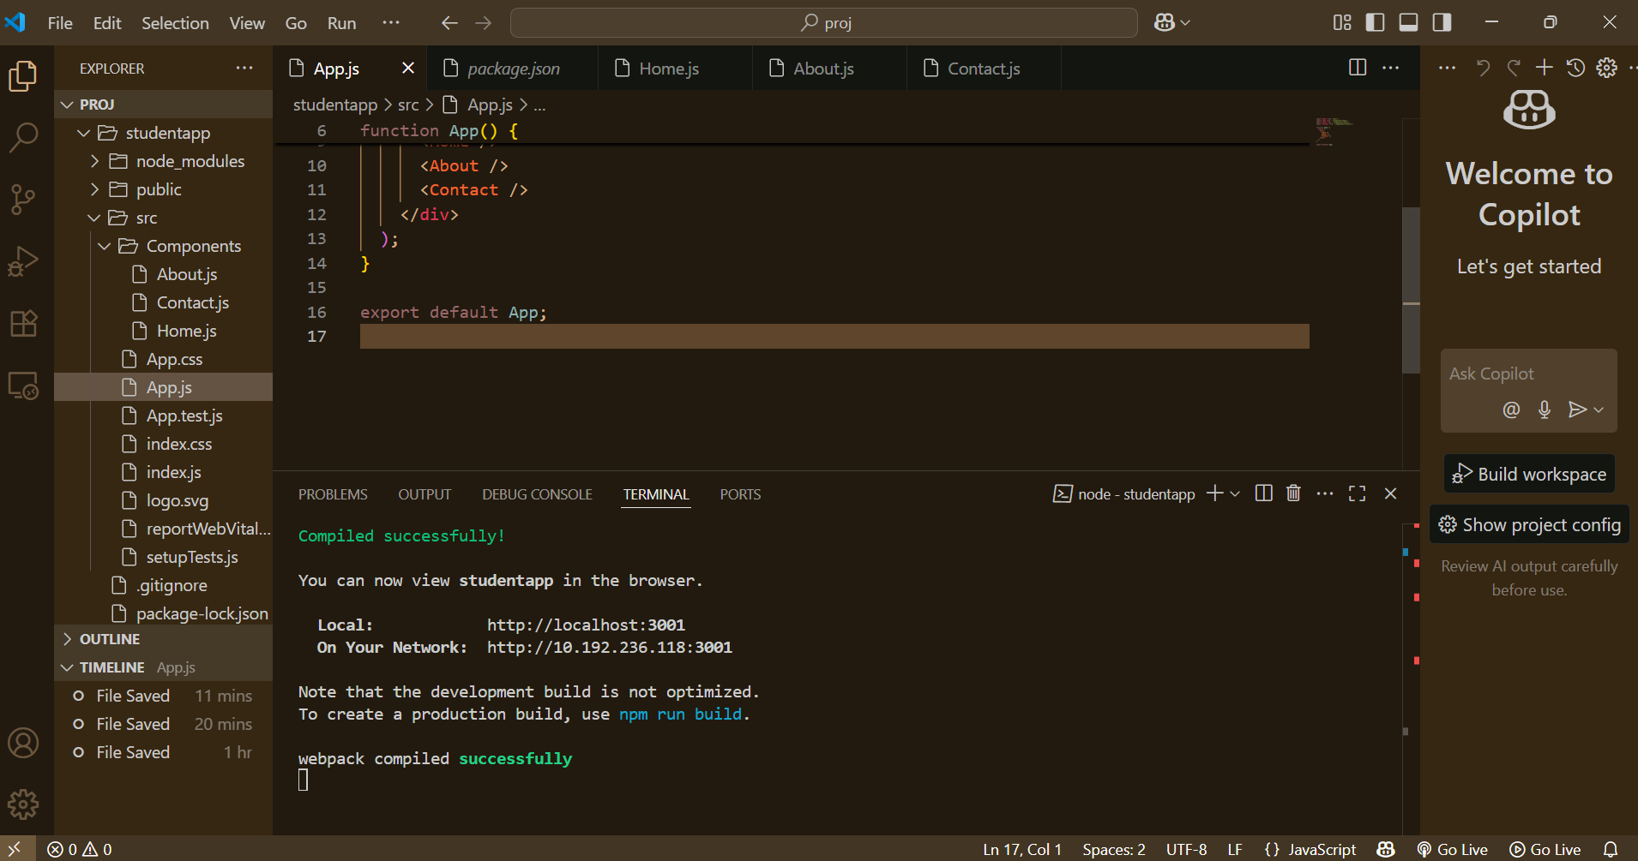

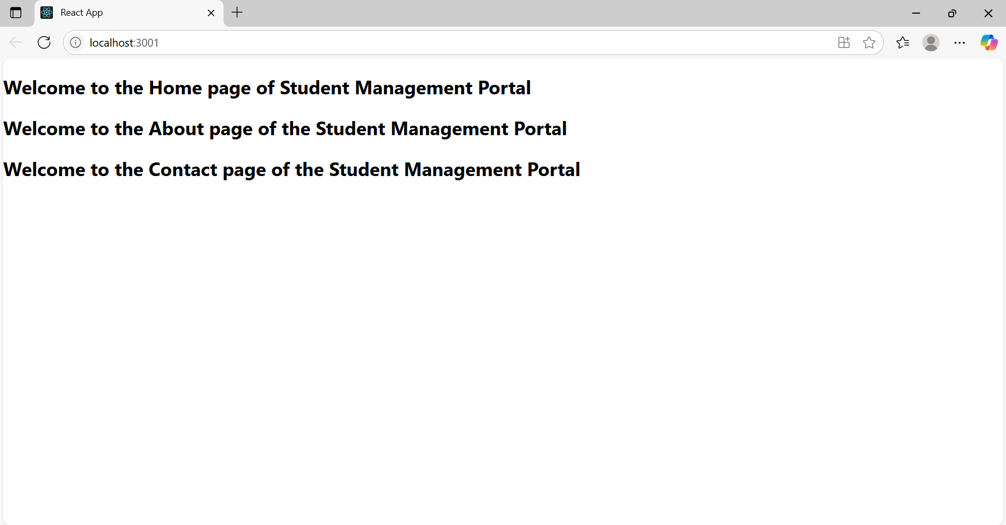

**Exercise-3:**

1.Create a React project named “**scorecalculatorapp”** .

2. Create a new folder under Src folder with the name **“Components”.** Add a new file named “CalculateScore.js”

3.added a new file name as **Calculatescore**

**CalculatorScore.js:**

import React from 'react';

import '../Stylesheets/mystyle.css';

function CalculateScore() {

const name = "Sparkle";

const school = "ABC Public School";

const total = 284;

const maxScore = 300;

const percentage = ((total / maxScore) * 100).toFixed(2);

return (

<div className="student-container">

<h1 className="main-heading">Student Details:</h1>

<p><span className="label">Name:</span> <span className="blue-text">{name}</span></p>

<p><span className="label">School:</span> <span className="red-text">{school}</span></p>

<p><span className="label">Total:</span> <span className="magenta-text">{total} Marks</span></p>

<p><span className="label">Score:</span><span className="green-text">{percentage}%</span></p>

</div>

);

}

export default CalculateScore;

**mystyle.css:**

.student-container {

text-align: center;

margin-top: 60px;

font-family: Arial, sans-serif;

}

.main-heading {

color: brown;

font-size: 32px;

font-weight: bold;

}

.label {

font-weight: bold;

}

.blue-text {

color: blue;

}

.red-text {

color: red;

}

.magenta-text {

color: mediumvioletred;

}

.green-text {

color: green;

}

**App.js:**

import React from 'react';

import CalculateScore from './Components/CalculateScore';

function App() {

return (

<div>

<CalculateScore />

</div>

);

}

export default App;

**output:**

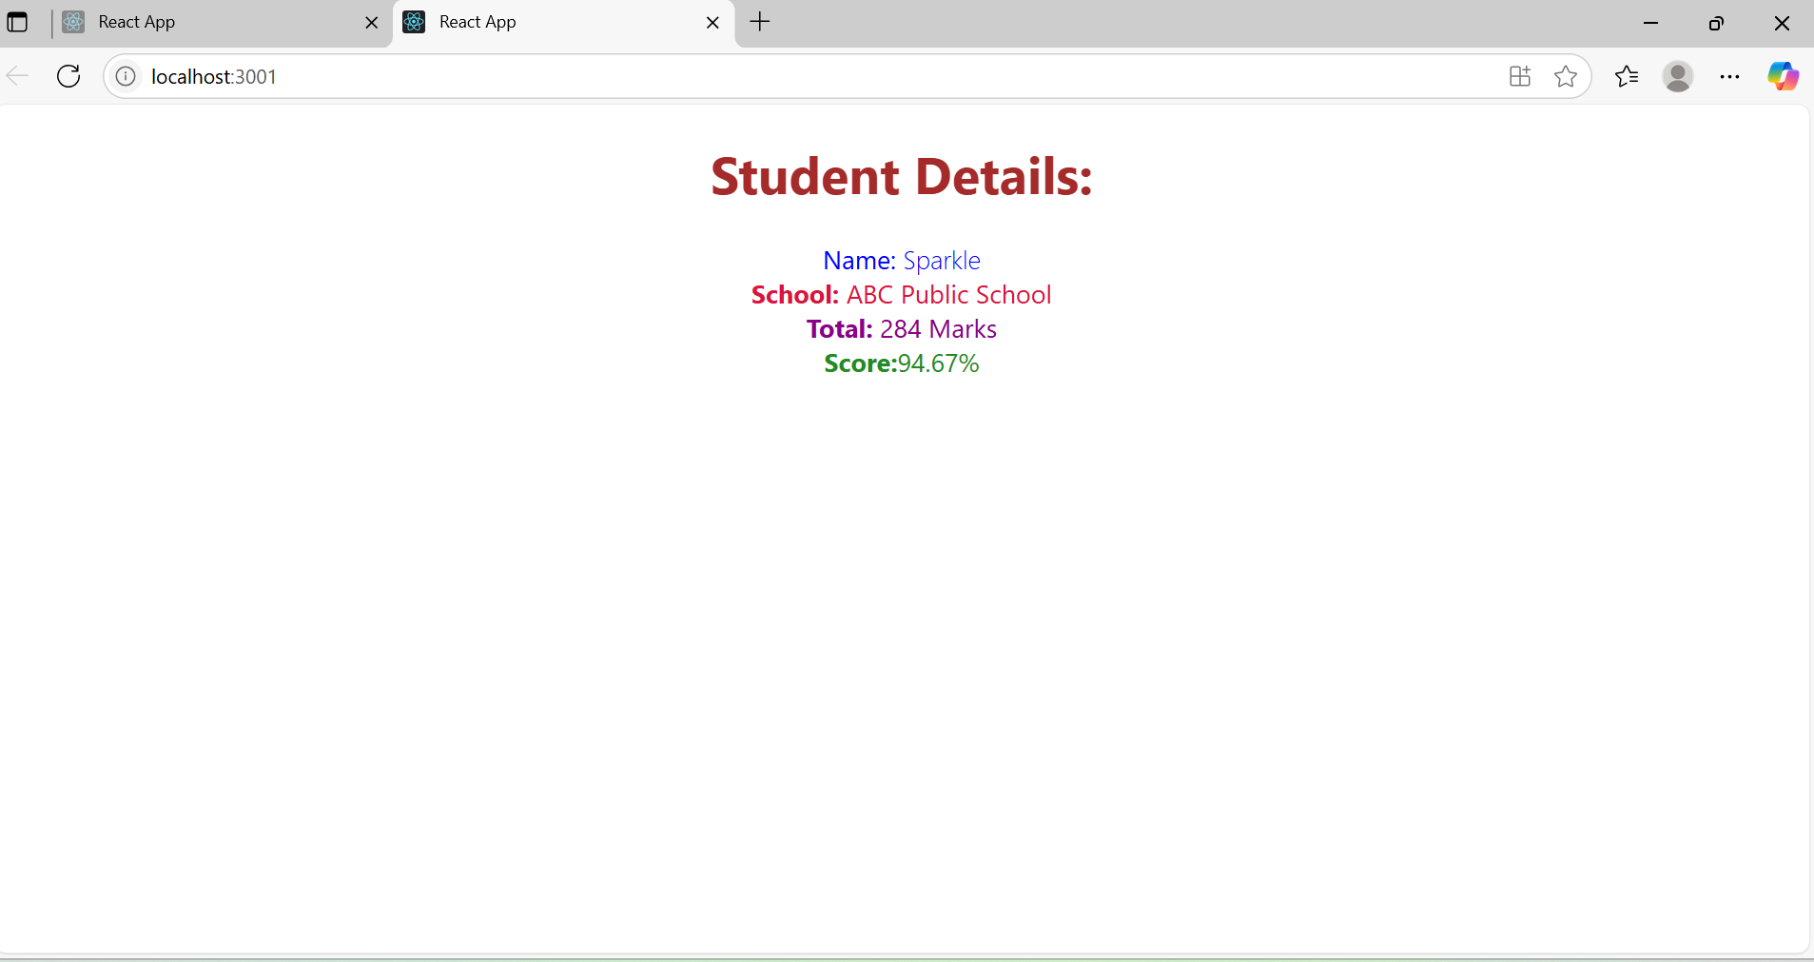

**Exercise-4:**

1. Create a new react application using create-react-app tool with the name as “blogapp”

2. Create a new file named as Post.js in src folder

**Post.js:**

import React from 'react';

function Post(props) {

return (

<div className="post">

<h3>{props.title}</h3>

<p>{props.body}</p>

</div>

);

}

export default Post;

**posts.js:**

import React, { Component } from 'react';

import Post from './Post';

class Posts extends Component {

constructor(props) {

super(props);

this.state = {

posts: [],

error: null

};

}

loadPosts = () => {

fetch('https://jsonplaceholder.typicode.com/posts')

.then((response) => {

if (!response.ok) {

throw new Error("Network response was not ok");

}

return response.json();

})

.then((data) => this.setState({ posts: data }))

.catch((err) => this.setState({ error: err.message }));

};

componentDidMount() {

this.loadPosts();

}

componentDidCatch(error, info) {

alert("An error occurred: " + error);

}

render() {

const { posts, error } = this.state;

if (error) {

return <p style={{ color: 'red' }}>Error: {error}</p>;

}

return (

<div>

<h2>Blog Posts</h2>

{posts.slice(0, 10).map((post) => (

<Post key={post.id} title={post.title} body={post.body} />

))}

</div>

);

}

}

export default Posts;

**App.js:**

import React from 'react';

import Posts from './Posts';

function App() {

return (

<div className="App">

<h1>My Blog App</h1>

<Posts />

</div>

);

}

export default App;

**output:**

