**EVALUATE AND SELL VEHICLE**

**Use case Name** **:** Evaluate and Sell Vehicles

**Team Name** **:** Group - 3

**Team members :** Sahithi, Jaswanth, Prasad, Jahnavi

**Abstract :**

This application is designed to simplify the process of selling a vehicle by guiding the seller through submitting personal and vehicle details, automatically estimating the vehicle’s value, and routing the case to a technical expert for live inspection. Based on the inspection report, an admin finalizes the selling price, which is then shared with the seller. The seller can accept the price to proceed with listing the vehicle, or choose to reject or negotiate. In case of negotiation, the updated price is reviewed again by the admin. The system ensures a smooth, end-to-end workflow for vehicle evaluation, price fixation, and listing.

**Scope: (list the requirements one by one)**

* User can enter car details such as:
  + Make and model
  + Year of manufacture
  + Kilometres driven
  + Transmission (Manual/Automatic)
  + Ownership type (First/Second/Third owner, etc.)
* System evaluates car price using:
  + A pre-defined Decision Table or Expression
  + Factors like age, condition, km driven, and ownership type
* Display the estimated car value to the user after evaluation.
* Vehicle will be manually inspected for correctness of price
* Users may negotiate the final price after inspection
* Option to list the car for sale, if the user agrees with the price.

**Design:**

**Application Name** **:** AutoValuate

**Organization Name** **:** MyOrg

**Application structure: (Framework or Implementation)**

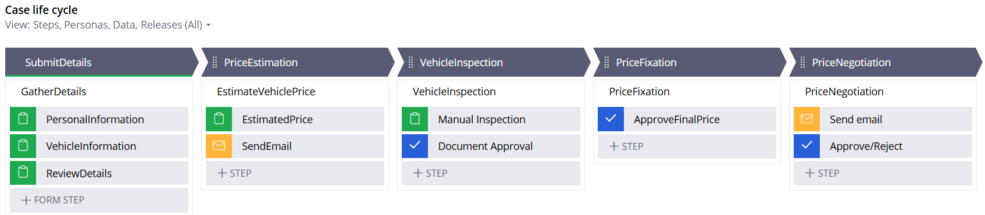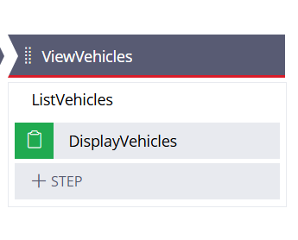

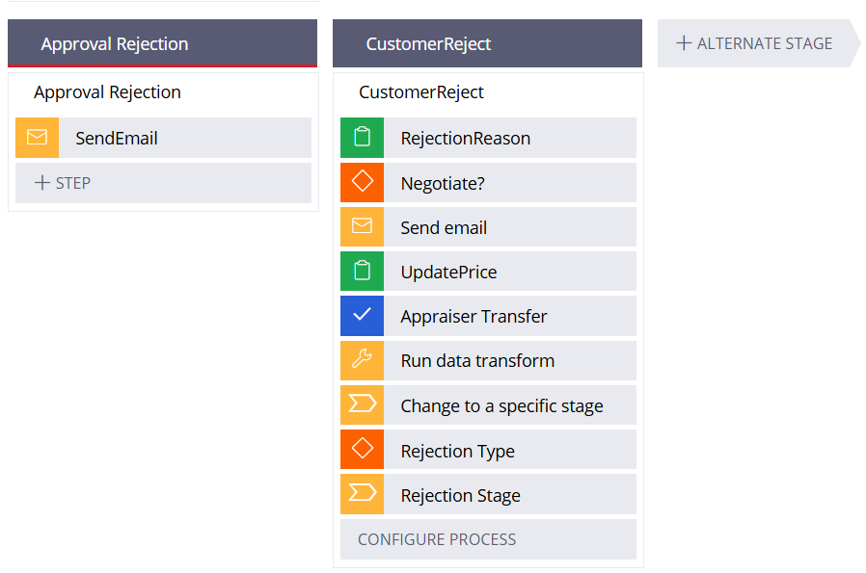

**Data Model Design:**

* We require 3 data objects:
* Person - Name, Email, Phone, Address
  + Vehicle - Year, VIN, Photos, Registration Number, Mileage,

Vehicle type, Color, transmission (Picklist - manual, auto, EV),

Ownership Type (Drop Down - 1st, 2nd, more), Asking price.

* + MakeModel - ParentKey, Key, Type (Picklist – Model, Make)
  + Item - Item Name, Category, Condition, Comment, Photo.
  + Inspection - Inspection related fields for checking manual inspection.
  + AutoValuate Home – HomePagePhotos (to display some photos in seller screen)

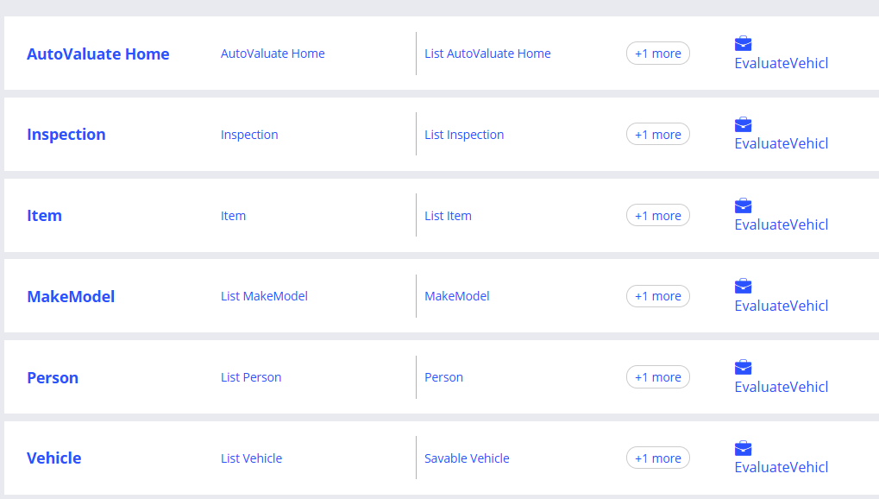

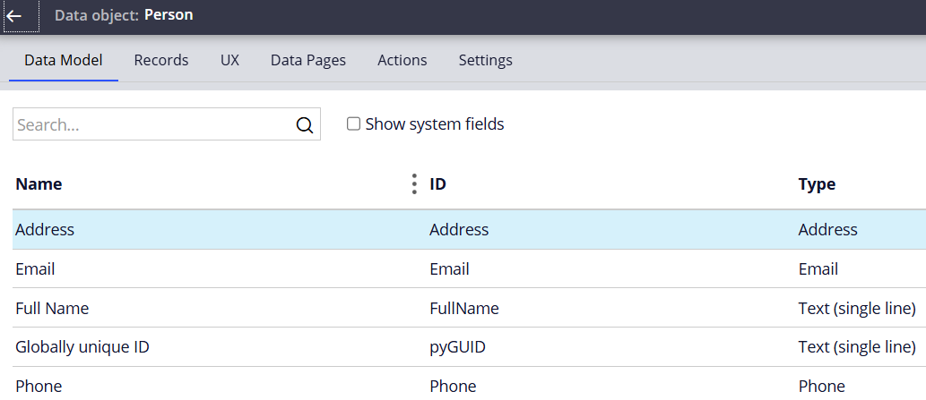

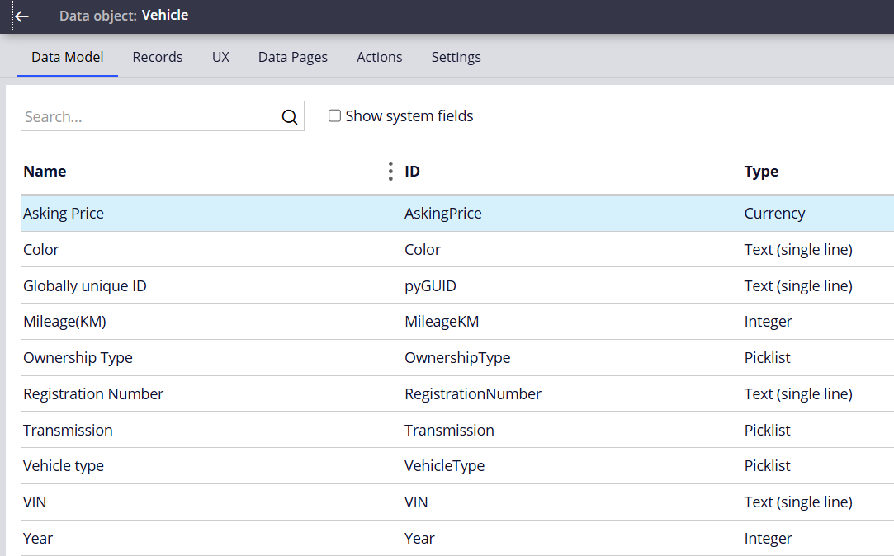

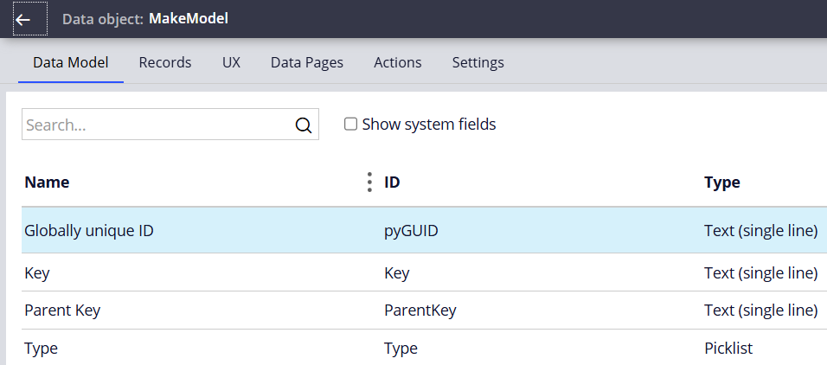

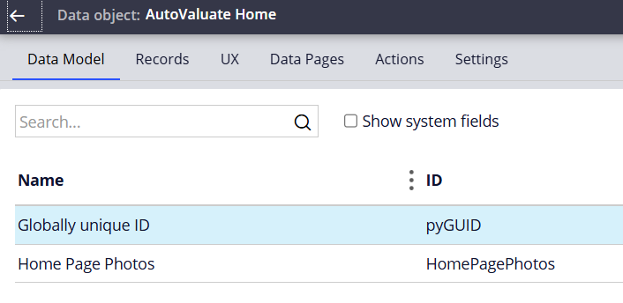



**Enterprise Class Structure Diagram**

* **Org Layer (org class) :** MyOrg
* **Integration Layer (org level integration) :** MyOrg- Int-
* **Data Layer (org level data classes) :** MyOrg-Data-
* **App Layer (application class) :** MyOrg-AutoValu
* **Data layer (app level data classes)** **:** MyOrg-AutoValu-Data-
* **Int layer (app level integration)** **:** MyOrg-AutoValu-Int-
* **Work layer (work class)** **:** MyOrg-AutoValu-Work-
  + **Case type classes :** MyOrg-AutoValu-Work-EvaluateVehicle

**Portal Design**

* Seller portal
* Appraiser portal
* Documentation specialist portal
* Sales Coordinator portal
* Inspector portal

**Personas and channels:** (Web channel)

* Appraiser

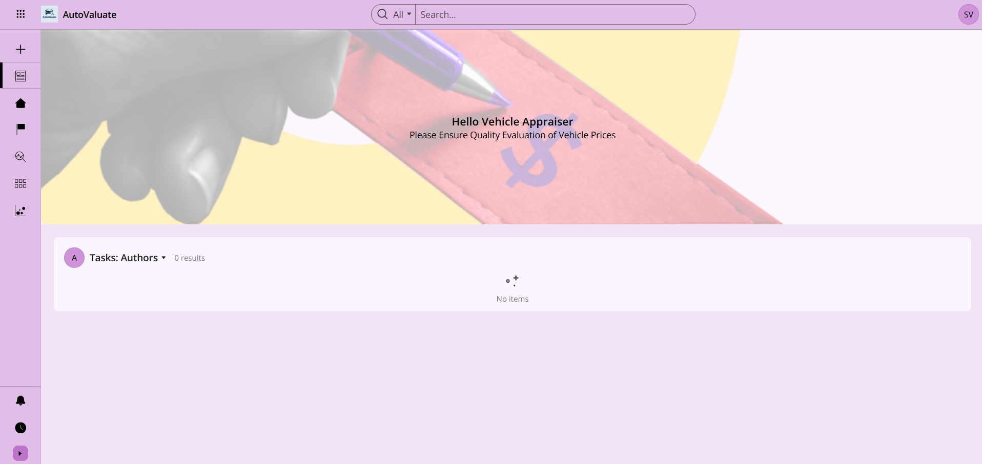

* Seller

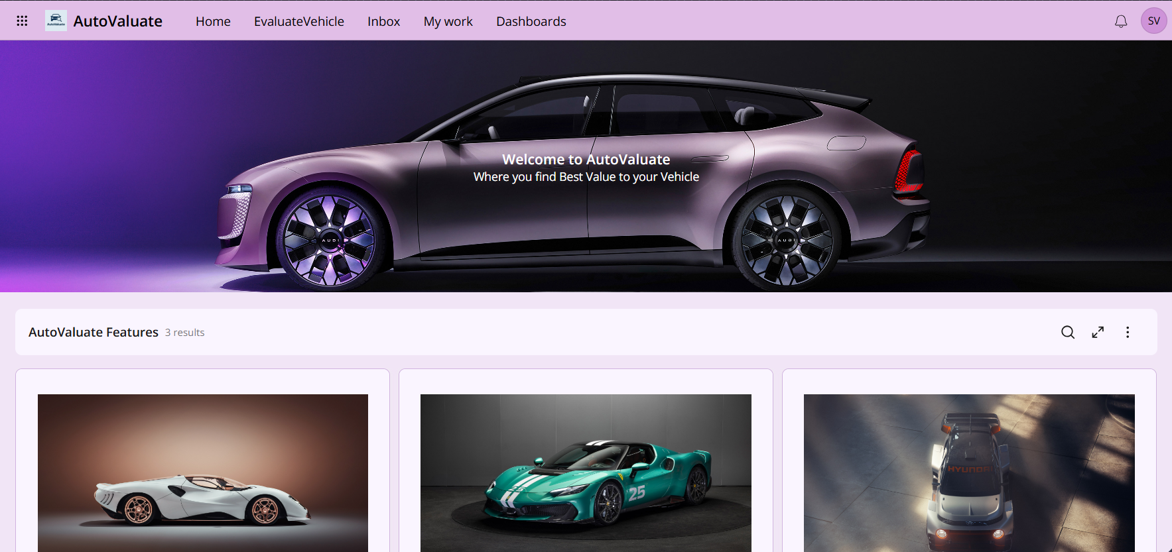

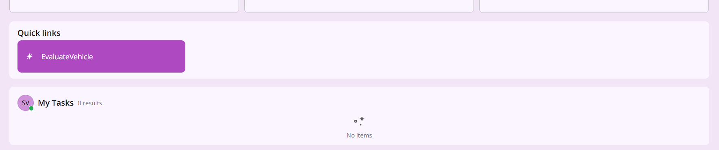

* Documentation specialist

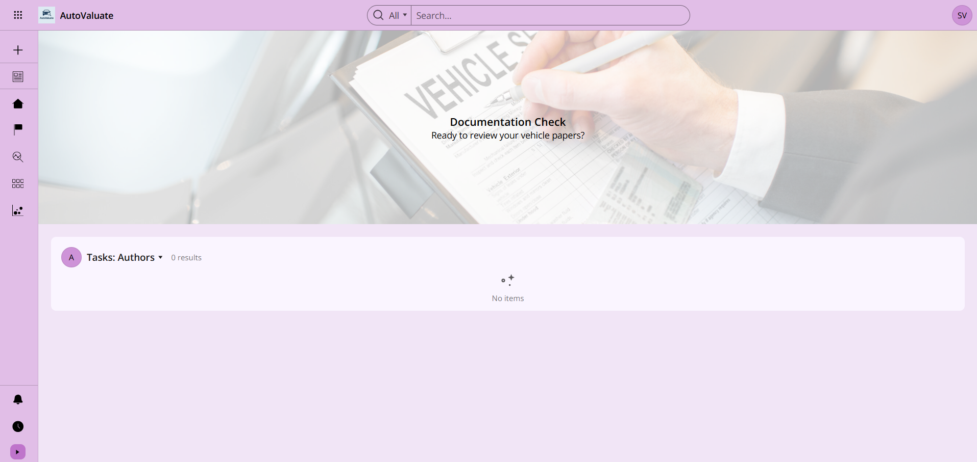

* Inspector

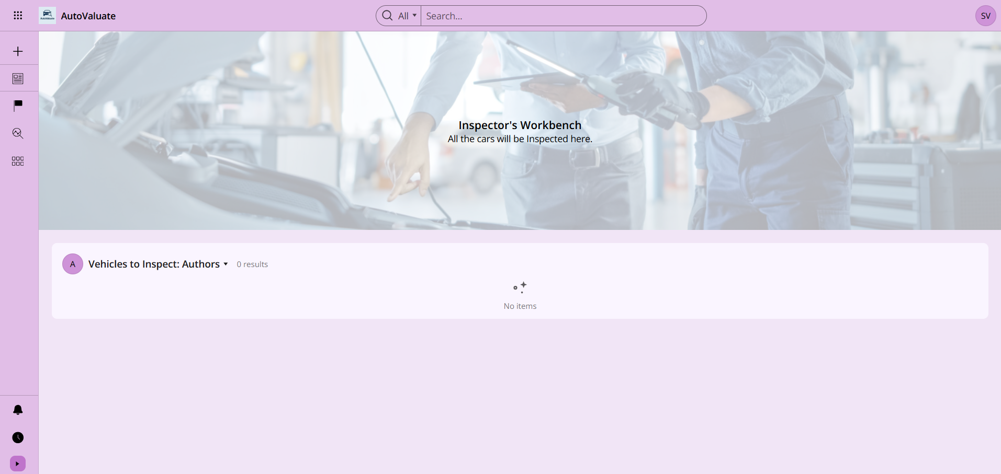

* Sales Coordinator

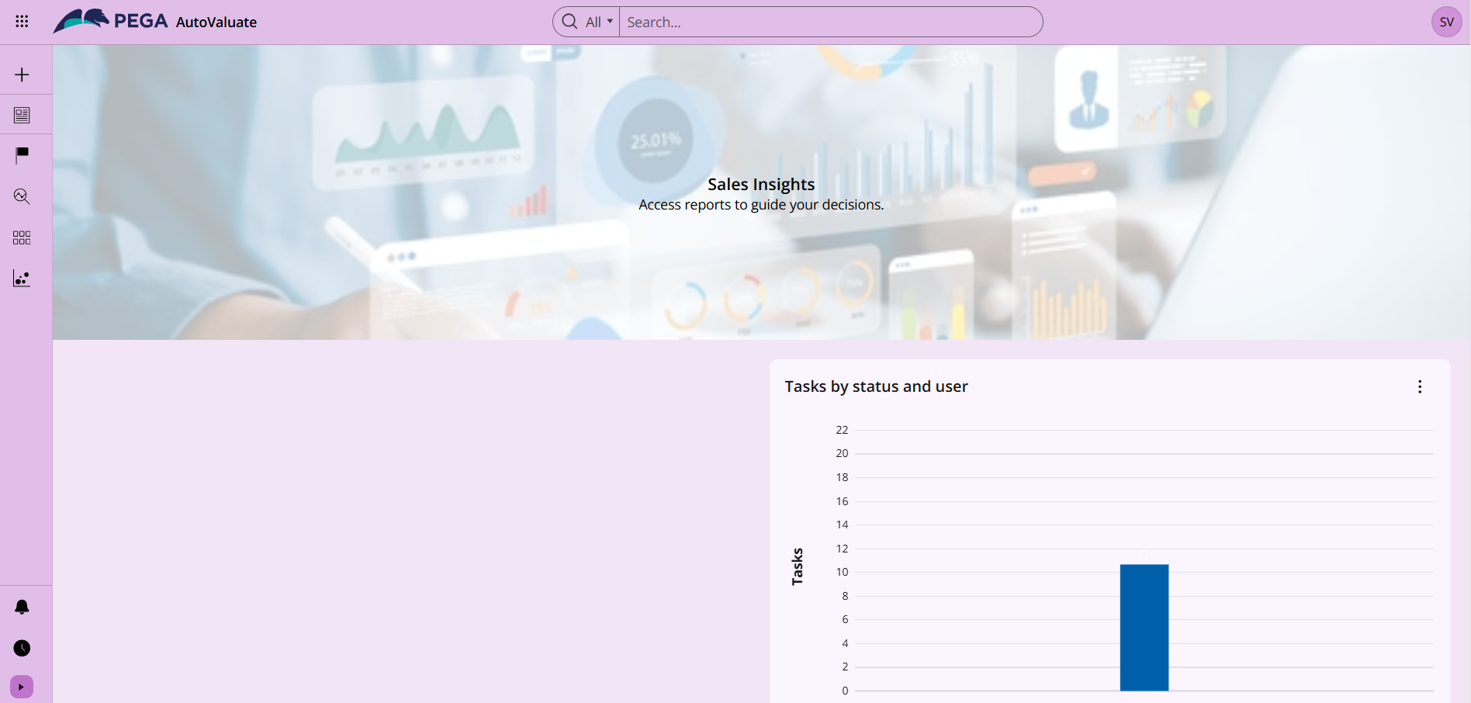

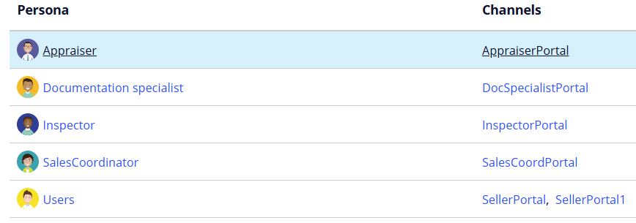

**Report Design:**

* Pending listings for review
* Average **turnaround time** from listing → offer → sale
* Cars evaluated but **not listed** for sale
* List of cars marked as “Sold”
* Number of cars **actively listed**
* Total number of cars evaluated

**User details:**

* List the different **access groups**
  + AutoValu:Users (Seller)
  + AutoValu:Appraiser
  + AutoVal:SalesCoordinator
  + AutoValu:DocumentSpecialist
  + AutoValu: Inspector

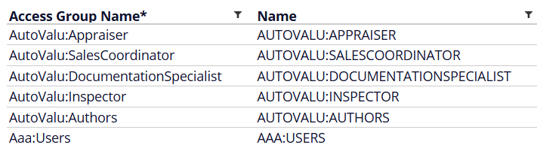

* **Work groups**
  + Appraiser Group
  + Document Specialist Group
  + Sales Coordinator Group
  + Inspector Group

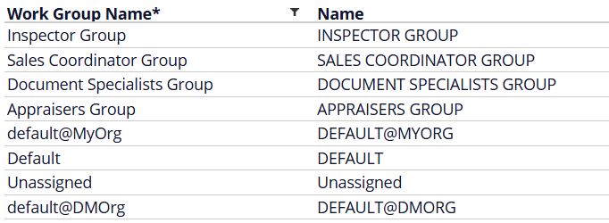

* **Work queue**
  + Appraiser Queue
  + Sales Coordinator Queue
  + Document Specialist Queue
  + Inspector Queue

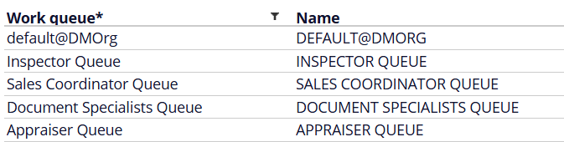

* **Sample operator ID’s**
  + Inspector@AutoValuate.com
  + SalesCoordinator@AutoValuate.com
  + DocumentationSpecialist@AutoValuate.com
  + [Appraiser@AutoValuate.com](mailto:Appraiser@AutoValuate.com)
  + carsseller@abc.com : A@1234567890

**Password:** PegaCSA@1

Pega@1234

