27-05-2025(MONGODB)
NAME: Ch.Eswara Balaji
1)Available databases
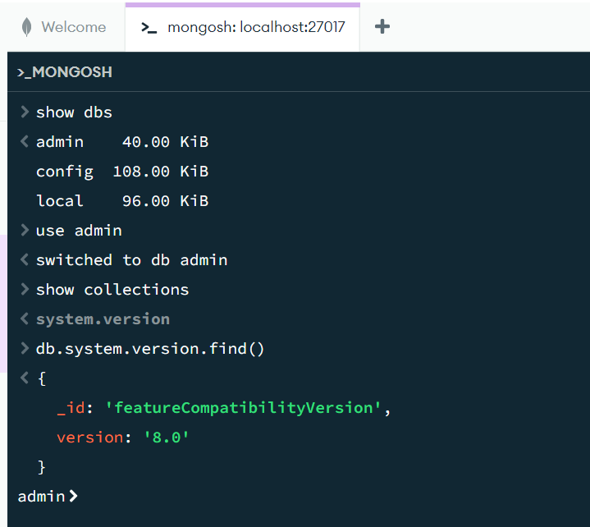
2)Adding database
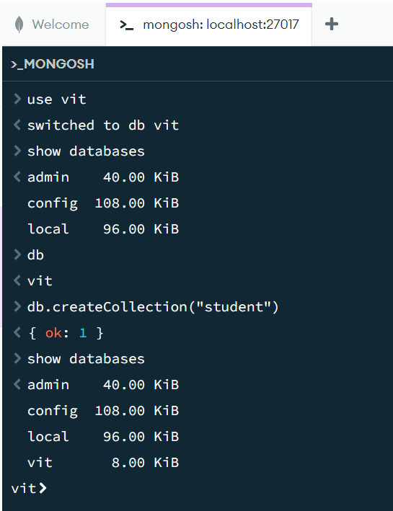
3)Droping the collections
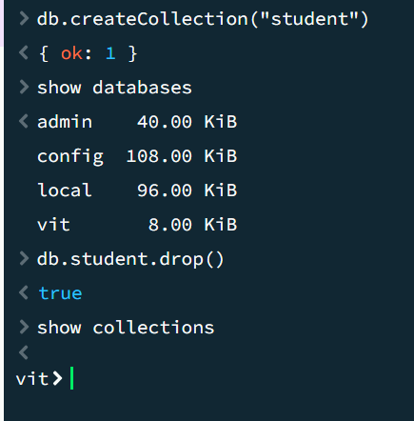
4)Inserting the single data into vit dbs collections
