**Experiment 6**

**Student Name: Muzamil UID: 22BCS10759**

|  |  |
| --- | --- |
| **Branch: CSE**  **Semester: 6**  **Subject Name: Java with Lab** | **Section/Group:641/B**  **Date of Performance:05/03/25**  **Subject Code: 22CSH-359** |

1. **Aim:** Develop Java programs using lambda expressions and stream operations for sorting, filtering,

and processing large datasets efficiently.

1. **Objective:** 
   * Develop Java programs using lambda expressions and stream operations for sorting, filtering, and processing large datasets efficiently.

* + Implement easy, medium, and hard-level tasks involving sorting employees, filtering and sorting students, and processing products using streams.

1. **Implementation/Code:**

**a.** import java.util.*; class Employee { String name; int age; double salary;

Employee(String name, int age, double salary) { this.name = name; this.age = age; this.salary = salary;

}

@Override public String toString() { return name + " - Age: " + age + ", Salary: " + salary;

}

}

public class EmployeeSort { public static void main(String[] args) { List<Employee> employees = Arrays.asList( new Employee("Ayush", 20, 90000), new Employee("Vinay", 22, 100000),

new Employee("Prakul", 23, 70000)

);

employees.sort(Comparator.comparing(emp -> emp.name)); System.out.println("Sorted by Name: " + employees); employees.sort(Comparator.comparingInt(emp -> emp.age)); System.out.println("Sorted by Age: " + employees); employees.sort(Comparator.comparingDouble(emp -> emp.salary));

System.out.println("Sorted by Salary: " + employees);

}

}

**b.** import java.util.*; import java.util.stream.Collectors; class Student { private String name; private double marks; public Student(String name, double marks) { this.name = name; this.marks = marks;

}

public String getName() { return name;

}

public double getMarks() { return marks;

}

}

public class StudentFilter { public static void main(String[] args) { List<Student> students = List.of( new Student("Ayush", 85), new Student("Rajeev", 70), new Student("Vinay", 90), new Student("David", 60), new Student("Prakul", 80)

);

List<String> topStudents = students.stream()

.filter(s -> s.getMarks() > 75)

.sorted(Comparator.comparingDouble(Student::getMarks).reversed())

.map(Student::getName)

.collect(Collectors.toList());

System.out.println("Top Students: " + topStudents);

}

}

**c.** import java.util.*; import java.util.stream.Collectors; class Product { String name; String category; double price; public Product(String name, String category, double price) { this.name = name; this.category = category; this.price = price;

}

@Override public String toString() { return name + " ($" + price + ")";

}

}

public class ProductProcessor { public static void main(String[] args) { List<Product> products = Arrays.asList( new Product("Laptop", "Electronics", 1200), new Product("Phone", "Electronics", 800), new Product("TV", "Electronics", 1500), new Product("Shirt", "Clothing", 50), new Product("Jeans", "Clothing", 70), new Product("Blender", "Appliances", 200), new Product("Toaster", "Appliances", 100)

);

Map<String, List<Product>> productsByCategory = products.stream()

.collect(Collectors.groupingBy(p -> p.category)); System.out.println("Products grouped by category:"); productsByCategory.forEach((category, productList) ->

System.out.println(category + ": " + productList));

Map<String, Optional<Product>> mostExpensiveByCategory = products.stream()

.collect(Collectors.groupingBy( p -> p.category,

Collectors.maxBy(Comparator.comparingDouble(p -> p.price))

));

System.out.println("\nMost expensive product in each category:"); mostExpensiveByCategory.forEach((category, product) -> System.out.println(category + ": " + product.orElse(null))); double averagePrice = products.stream()

.mapToDouble(p -> p.price)

.average()

.orElse(0);

System.out.println("\nAverage price of all products: $" + averagePrice);

}

}

1. **Output:**



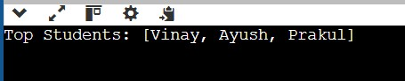

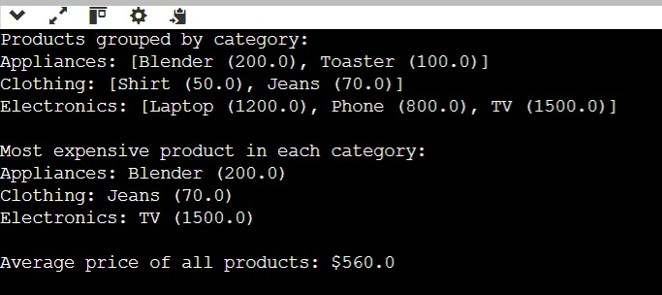

1. **Learning Outcome:** 
   * Understand and implement **lambda expressions** for sorting objects in a list based on different attributes.
   * Utilize **Java Streams API** to perform operations like **filtering, sorting, and mapping** efficiently on large datasets.
   * Learn **Comparator and method references** to simplify object comparisons for sorting.
   * Apply **grouping and aggregation functions** using Collectors.groupingBy() and Collectors.maxBy() for processing categorized data.
   * Gain hands-on experience in computing **statistical values** like the **average** from a dataset using mapToDouble() and average().
   * Improve **code efficiency and readability** by using **functional programming** techniques in Java.