# **Software Require ments Specification**

# **for**

# **E-TICKETING**

Version 1.0 approved

Prepared by:

1. K Sohan - 22bd1a05b5

2. M Akshit - 22bd1a05b8

3. Md Afreed - 22bd1a05ba

4. Mohammed Shahed - 22bd1a05be

5. Kalyan - 22bd1a05bt

**Keshav Memorial Institute of Technology**

23-9-2024

***Page 1***

### Table of Contents

Table of Contents ii

Revision History ii

1. Introduction 1
   1. Purpose 1
   2. Document Conventions 1
   3. Intended Audience and Reading Suggestions 1
   4. Product Scope 2
   5. References 2
2. Overall Description 3
   1. Product Perspective 3
   2. Product Functions 3
   3. User Classes and Characteristics 4
   4. Operating Environment 4
   5. Design and Implementation Constraints 5
   6. User Documentation 5
   7. Assumptions and Dependencies 6
3. External Interface Requirements 6
   1. User Interfaces 6
   2. Hardware Interfaces 7
   3. Software Interfaces 7
   4. Communications Interfaces 8
4. System Features 8
   1. System Feature 1 8
   2. System Feature 2 (and so on) 8
5. Other Nonfunctional Requirements 9
   1. Performance Requirements 9
   2. Safety Requirements

10

* 1. Security Requirements

10

* 1. Software Quality Attributes

11

* 1. Business Rules

11

1. Other Requirements

12

**Appendix A: Glossary 12**

**Appendix B: Analysis Models 12**

**Appendix** C**: To Be Determined List 13**

**Revision History**

|  |  |  |  |
| --- | --- | --- | --- |
| Name | Date | Reason For Changes | Version |
| Week-1 | 23-09-24 | SRS creation | 1.0 |
|  |  |  |  |

### Introduction

#### Purpose

The purpose of this document is to deﬁne the functional and non-functional requirements of an E-Ticketing Sys- tem. The system allows users to book, manage, and validate tickets for various events, travel, or services through a web and mobile platform.

#### Document Conventions

This Software Requirements Specification (SRS) follows specific typographical conventions and format- ting standards for clarity. All section headings are bolded and use a larger font size to indicate the document structure, while the body text is written in a standard 12pt font for readability. Key terms and mandatory requirements are bolded (e.g., shall) to highlight their importance, and examples or definitions are italicized. Every requirement statement has its own priority: shall for mandatory, should for recommended, and may for optional. Higher-level requirements do not automatically pass their priorities to detailed requirements; each requirement is explicitly assigned its priority

#### Intended Audience and Reading Suggestions

Intended Audience:

image1.pngThis SRS is intended for:

* image2.pngimage2.pngProject Managers: For project planning and resource allocation. Developers: To implement the system based on requirements.
* image1.pngQA Engineers: To test the system against the speciﬁed requirements.
* System Administrators: To understand maintenance and operational needs. Clients and End-Users: To verify that the system meets business and user needs. UX/UI De- signers: To design interfaces that align with user requirements.
* image1.pngReading Suggestions:



* image1.pngProject Managers and Clients: Focus on the Overall Description and Product Features. Devel- opers and Test Engineers: Focus on Functional and Non-Functional Requirements. System Ad- ministrators: Review Operational Constraints and Security Requirements.
* UX/UI Designers: Focus on User Characteristics and Usability.

#### Product Scope

The E-Ticketing System is designed to provide a seamless platform for users to search, book, and manage tickets for events, travel, and services. It allows users to select seats (where applicable), make secure online payments, and receive electronic tickets with QR codes for validation. Accessible via web and mobile, the system aims to streamline the ticketing process while offering administra- tors tools to manage events, pricing, availability, and analytics. The system ensures convenience, se- curity, and scalability to handle high-demand ticketing needs eﬃciently.

* 1. **References**

ISO/IEC/IEEE 29148:2011 - Systems and software engineering — Life cycle processes — Require- ments engineering. This standard provides comprehensive guidelines for the requirements engi- neering process, ensuring clarity and completeness in documentation.

ISO/IEC 25010:2011 - Systems and software engineering — Systems and software Quality Require- ments and Evaluation (SQuaRE) — Quality model. This standard deﬁnes a model for evaluating soft- ware product quality.

## Overall Description

#### Product Perspective

The E-Ticketing System is envisioned as a standalone, cloud-based application that integrates seamlessly with various third-party services, including payment gateways and QR code scanning systems. It serves as a compre- hensive platform for users to book tickets for events and travel, providing an intuitive interface across both web and mobile devices. The system is designed to accommodate high traﬃc volumes, ensuring real-time updates on ticket availability to prevent overbooking. It will support multiple event types, offering features like seat selec- tion, promotional discounts, and user notiﬁcations. Administrators will have dedicated tools for managing events, monitoring ticket sales, and analyzing user data, thereby enhancing operational eﬃciency.

Overall, the E-Ticketing System aims to deliver a user-friendly experience while ensuring robust backend func- tionality and security, aligning with modern industry standards for online ticketing solutions.

#### Product Functions

The E-Ticketing System provides a range of essential functions to ensure a seamless experience for users and administrators. Users can register and log in via email or social media, search for events based on various criteria, and book tickets, including seat selection when applicable. The system integrates with multiple payment gateways for secure online transactions, automatically generating electronic tickets with unique QR codes upon payment confirmation. Event staff can validate these tickets through QR code scanning, while users receive notifications for booking confirmations and reminders. Administrators have access to management tools to create and oversee events, adjust pricing, and analyze ticket sales data, while users can manage their profiles and view their booking history. Together, these functions create a comprehensive platform for efficient ticketing.

* 1. **U****ser Classes and Characteristics**

The E-Ticketing System caters to several user classes, each with distinct characteristics and needs. End users are tech-savvy individuals seeking a user-friendly platform for purchasing tickets to events and services, requiring secure payment options and timely notiﬁcations. Admin users are event organizers or system administrators responsible for managing the platform; they need robust tools for creating events, monitoring sales, and ana- lyzing user data. Event staff are personnel at venues who require eﬃcient QR code scanning tools for ticket val- idation and real-time ticket status updates. Lastly, marketing and sales teams focus on promoting events and maximizing ticket sales, needing access to marketing tools and analytics to assess campaign effectiveness. To- gether, these user classes interact with the system to ensure a seamless ticketing experience.

#### Operating Environment

The E-Ticketing System is designed to function in a versatile operating environment that supports both web and mobile applications. It is accessible through popular web browsers (such as Chrome, Firefox, and Safari) on desktop and laptop computers, ensuring compatibility across different operating systems (Windows, macOS, Linux). The mobile application will be developed for both Android and iOS platforms, providing a native experi- ence optimized for smartphones and tablets. The system will utilize cloud-based infrastructure to ensure scala- bility and availability, allowing it to handle high traﬃc volumes during peak events. Additionally, it will integrate with third-party services, including payment gateways and QR code scanning systems, ensuring secure transac- tions and eﬃcient ticket validation. Security protocols, such as SSL encryption, will be implemented to protect user data and payment information, creating a secure environment for all transactions.

#### Design and Implementation Constraints

The E-Ticketing System faces several design and implementation constraints that must be considered during development. Firstly, compliance with Payment Card Industry Data Security Standards (PCI DSS) is essential to ensure secure handling of payment information, necessitating robust encryption and security protocols. Addi- tionally, the system must be designed to support high concurrency, capable of handling up to 100,000 simulta- neous users, requiring eﬃcient load balancing and resource allocation. The user interface should adhere to ac- cessibility standards (such as WCAG 2.1) to ensure usability for individuals with disabilities, which may limit de- sign choices. Integration with various third-party APIs for payment processing and QR code scanning imposes constraints on system architecture and data exchange protocols.

Furthermore, the system should be built to allow for future scalability to accommodate additional features and increased user demand without major redesigns. Lastly, all components must be developed with cross-platform compatibility in mind to ensure seamless performance across web and mobile devices.

#### User Documentation

The User Documentation for the E-Ticketing System provides essential guidance for users to effectively navigate the platform. It includes:

1. Getting Started: Instructions on creating an account, logging in, and re- setting passwords.
2. Browsing Events: Guidance on searching for events by category, date, or location, and using ﬁlters to ﬁnd speciﬁc tickets.
3. Booking Tickets: Step-by-step details on selecting tickets, including seat selection, and completing the secure payment process.
4. Managing Your Proﬁle: Information on updating personal details, managing pay- ment methods, and viewing booking history.
5. Ticket Validation: Instructions for event staff on using QR code scanning for ticket validation.
6. Troubleshooting and FAQs: Solutions to common issues and answers to fre- quently asked questions about ticket policies and technical support.
7. Contact Support: Details on how to reach customer service for additional assistance.

#### Assumptions and Dependencies

The E-Ticketing System is based on several key assumptions and dependencies:

1. User Accessibility: Users have reliable internet access and compatible devices.
2. Payment Gateway Reliability: The system depends on third-party payment gateways for secure transactions.
3. Event Organizer Cooperation: Accurate and timely event information will be provided by organizers.
4. Compliance with Standards: The system will adhere to legal requirements and accessibility standards.
5. Scalability of Infrastructure: The cloud-based infrastructure must accommodate high traﬃc during peak times.
6. Integration with APIs: The functionality of third-party APIs for QR codes and ticket validation is assumed to be stable.
7. User Technical Proﬁciency: Users are expected to have basic technical skills to navigate the platform effectively.

## External Interface Requirements

#### User Interfaces

The E-Ticketing System features user-friendly interfaces for both web and mobile platforms.

1. image3.pngWeb Interface:

image3.pngResponsive Design: Adapts to various screen sizes, ensuring usability on desktops and tablets.

image3.pngimage3.pngIntuitive Navigation: Easy access to event browsing, profile management, and support. Search Functionality: Filters and search bars for quick event discovery.

Streamlined Booking: Simplified ticket booking process with seat selection and payment options.

1. image3.pngMobile Interface:

image3.pngNative App Design: Optimized for Android and iOS with touch-friendly interactions. Quick Access: Easy access to tickets and bookings with notifications for reminders.

1. image3.pngAccessibility Features:

Compliance with WCAG 2.1 standards to support users with disabilities.

1. image3.pngAdmin Interface:

A dedicated dashboard for managing events, sales monitoring, and data analysis.

These interfaces aim to deliver an efficient and engaging user experience

#### Hardware Interfaces

The E-Ticketing System includes key hardware interfaces to ensure eﬃcient operation:

1. User Devices: Supports standard input devices (keyboards, mice) for computers and touchscreens for smartphones.
2. QR Code Scanners: Handheld scanners for event staff and mobile device cameras for scanning QR codes in the app.
3. Printers: Integration with thermal printers for on-site ticket printing if necessary.
4. Payment Terminals: Compatibility with POS systems for processing payments on-site.

These interfaces facilitate smooth interactions across various

#### Software Interfaces

The E-Ticketing System utilizes key software interfaces to ensure smooth operations:

1. Payment Gateway APIs: Integration with services like PayPal and Stripe for secure online payments.
2. QR Code Generation APIs: Third-party services for creating unique QR codes for e-ticket validation.
3. Event Management Software: Synchronization with existing platforms for real-time event details and ticket availability.
4. User Authentication Services: Use of OAuth for secure login via social media or email.
5. Analytics Tools: Integration with analytics platforms to monitor ticket sales and user engagement.

These interfaces enhance the system's functionality and user experience.

#### Communications Interfaces

The E-Ticketing System utilizes key communication interfaces to facilitate user interaction:

1. Email Notiﬁcations: Automated emails for booking conﬁrmations and event reminders.
2. SMS Notiﬁcations: Text alerts for important updates sent to users.
3. In-App Messaging: Real-time notiﬁcations within the mobile app regarding bookings.
4. Web APIs: RESTful APIs for data exchange with third-party services.
5. Customer Support Chat: Live chat integration for direct user assistance.

These interfaces ensure timely communication among users, administrators, and external services.

### **4.System Features**

The E-Ticketing System offers a range of features designed to enhance user experience and streamline ticket management:

1. image3.pngUser Registration and Profile Management:

Simple account creation and management, allowing users to update personal information and payment methods.

1. image3.pngEvent Search and Discovery:

Advanced search functionality with filters for date, location, and category, enabling users to easily find relevant events.

1. image3.pngTicket Booking and Payment:

Intuitive ticket selection process with options for seat selection, followed by secure payment processing through multiple gateways.

1. image3.pngE-Ticket Generation:

Automatic generation of electronic tickets with unique QR codes for validation.

1. image3.pngTicket Validation:

QR code scanning functionality for event staff to validate tickets at entry points, ensur- ing security and efficiency.

1. image3.pngUser Notifications:

Automated email and SMS notifications for booking confirmations, reminders, and up- dates about events.

1. image3.pngAdmin Dashboard:

Comprehensive management tools for event creation, sales monitoring, and analytics, allowing administrators to track performance.

1. image3.pngPromotional Features:

Options for discount codes and promotional campaigns to enhance ticket sales and user engagement.

1. image3.pngMobile App Access:

A dedicated mobile application providing users with easy access to their tickets and event in- formation on the go.

These features collectively create a robust platform for users and administrators, ensuring an efficient and enjoyable ticketing experience.

## Other Nonfunctional Requirements

#### Performance Requirements

The E-Ticketing System has key performance requirements to ensure optimal user experience:

1. Response Time: Actions like searching and booking should respond in under 2 seconds.
2. Concurrent Users: Support for at least 100,000 simultaneous users during peak times.
3. Uptime: Maintain 99.9% uptime for high availability.
4. Load Handling: Eﬃciently manage sudden traﬃc spikes without performance degradation.
5. Data Processing Speed: QR code validation should occur in under 1 second.
6. Scalability: Designed to scale horizontally to accommodate increased demand and new features.

These requirements ensure a responsive and reliable platform for users.

#### Safety Requirements

The E-Ticketing System has essential safety requirements to protect users and data:

1. Data Encryption: Sensitive information must be encrypted in transit and at rest using standards like TLS and AES.
2. User Authentication: Multi-factor authentication (MFA) should be implemented for added security during logins.
3. Access Control: Role-based access controls to limit sensitive data access to authorized personnel only.
4. Regular Security Audits: Routine security assessments to identify and address vulnerabilities.
5. Incident Response Plan: A plan to quickly address data breaches or security incidents.
6. Regulatory Compliance: Adherence to data protection regulations, such as GDPR and PCI DSS.

These requirements ensure the protection of user data and maintain system

#### Security Requirements

Other Nonfunctional Requirements: Security Requirements

The E-Ticketing System includes essential security requirements to protect user data:

1. Data Protection: Secure storage and processing of user data, accessible only to authorized personnel.
2. Secure Payment Processing: Compliance with PCI DSS for safe handling of payment transactions.
3. User Authentication: Strong password policies and multi-factor authentication (MFA) for enhanced security.
4. Session Management: Secure session practices, including automatic timeouts to prevent hijacking.
5. Vulnerability Management: Regular updates and patches to protect against known vulnerabilities.
6. Audit Trails: Comprehensive logging of user activities for monitoring and forensic analysis.
7. Incident Response: A clear protocol for addressing security breaches and communicating effectively.

These requirements are crucial for maintaining the conﬁdentiality and integrity of the system.

#### Software Quality Attributes

The E-Ticketing System is designed with key quality attributes:

1. Usability: Intuitive interface for easy navigation and task completion.
2. Reliability: High availability with minimal downtime for user access.
3. Scalability: Efficient handling of increased loads during peak times.
4. Security: Strong measures to protect user data and transactions.
5. Maintainability: Easy updates and modifications for quick issue resolution.
6. Performance: Fast response times for smooth user experience.
7. Interoperability: Effective integration with external services and APIs.

These attributes ensure the system meets user expectations and operates effectively.

#### Business Rules

The E-Ticketing System follows key business rules:

1. User Registration: Accounts must be created with valid email addresses and strong passwords.
2. Ticket Availability: Tickets are sold on a ﬁrst-come, ﬁrst-served basis, with purchase limits per user.
3. Payment Processing: Payments must be completed within a speciﬁed time (e.g., 15 minutes) to secure tickets.
4. Refund Policy: Refunds are issued only for canceled events or speciﬁed conditions.
5. Ticket Transferability: Tickets can be transferred, subject to veriﬁcation and organizer policies.
6. Age Restrictions: Users must conﬁrm eligibility for age-restricted events.
7. Promotional Codes: Discount codes have expiration dates and speciﬁc usage conditions.
8. Payment Processing: Payments must be completed within a speciﬁed time (e.g., 15 minutes) to secure tickets.
9. Refund Policy: Refunds are issued only for canceled events or speciﬁed conditions.
10. Ticket Transferability: Tickets can be transferred, subject to veriﬁcation and organizer policies.
11. Age Restrictions: Users must conﬁrm eligibility for age-restricted events.
12. Promotional Codes: Discount codes have expiration dates and speciﬁc usage conditions.

These rules ensure clarity and consistency in the system's operations.

## 6. Other Requirements

The E-Ticketing System includes additional requirements to enhance functionality:

1. Localization: Support for multiple languages and regional settings.
2. Backup and Recovery: Regular data backups and a recovery plan for data loss.
3. Compliance: Adherence to laws and regulations, such as GDPR.
4. Documentation: Maintenance of comprehensive user and system documentation.
5. Performance Monitoring: Tools for monitoring system performance and user engagement.
6. Integration Capabilities: Support for integration with third-party applications and services.
7. Accessibility: Compliance with accessibility standards (e.g., WCAG) for users with disabilities.

These requirements ensure a robust and user-friendly E-Ticketing System. 4o mini

## Appendix A: Glossary

image1.png

E-Ticket: An electronic ticket containing a unique QR code for entry.

image1.pngimage1.pngimage1.pngUser: Any individual interacting with the system, including buyers and organizers. Payment Gateway: A service for processing online transactions.

image1.pngQR Code: A scannable code for accessing ticket information.

image1.pngAdmin Dashboard: The interface for administrators to manage events and sales. Promotional Code: A code that provides discounts on ticket purchases.

## Appendix B: Analysis Models

image1.png

Use Case Diagram: Shows user interactions like searching events and booking tickets.

image1.pngimage1.pngEntity-Relationship Diagram (ERD): Depicts relationships between entities such as users, events, and tickets. Data Flow Diagram (DFD): Illustrates data movement in the system during transactions and admin actions.

## Appendix C: To Be Determined List

Third-Party Integrations: Finalize payment processing and QR code generation services. Event Organizer Requirements: Clarify speciﬁc needs from event organizers.

Mobile App Features: Deﬁne features for the mobile application.

Performance Metrics: Establish metrics for system performance and user satisfaction. Compliance Checks: Identify regulatory requirements for different regions.

**UML DIAGRAM**

CLASS DIAGRAM

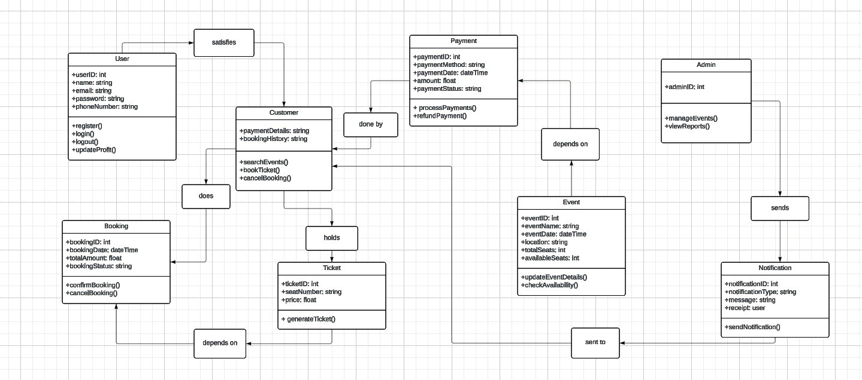

# **Use Case Diagram**

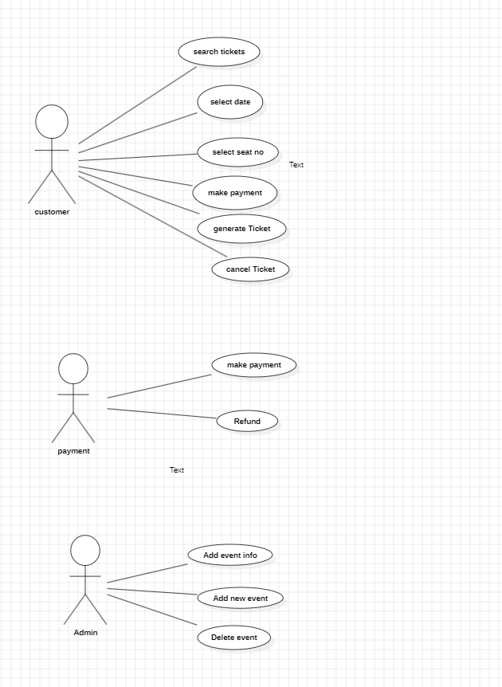

**Component Diagram**

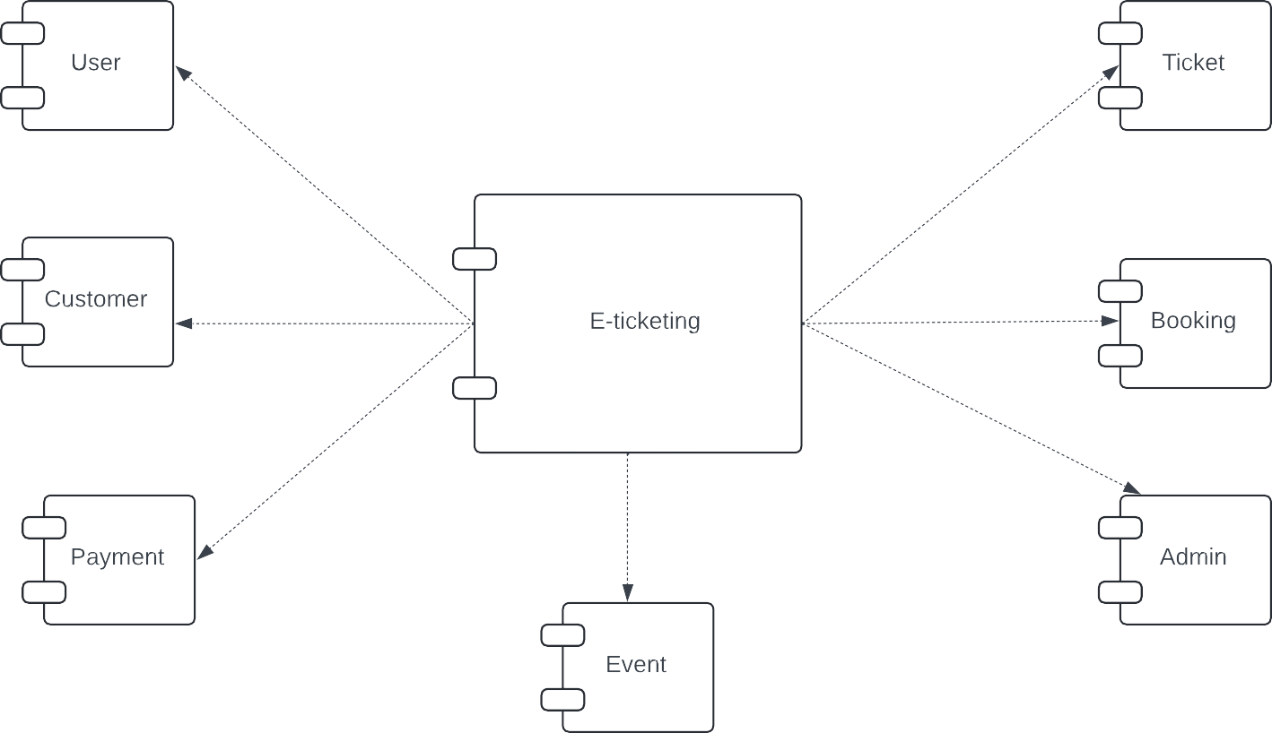

**Sequential Diagram**

