**GIT COMMANDS**

1.**git pwd**:it shows the present working directory

2.**ls**:lists all the files and directories in the current working directoryScreenshot 2024-10-21 at 10.48.25 AM.png

3.**vi**:it is used to create a fileScreenshot 2024-10-18 at 2.45.34 PM.png

4.**ls**:after creating a file in the folder ls shows the files presentScreenshot 2024-10-18 at 2.45.47 PM.png

5.**cat**:it shows the contents of the file

6.**git status**:it shows the status of the file like staged,unstaged,untracked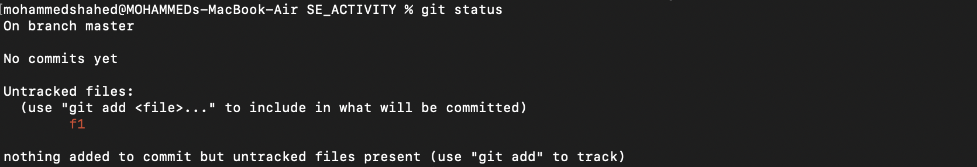

7.**git init**:used to create a new git repository

Syntax:git init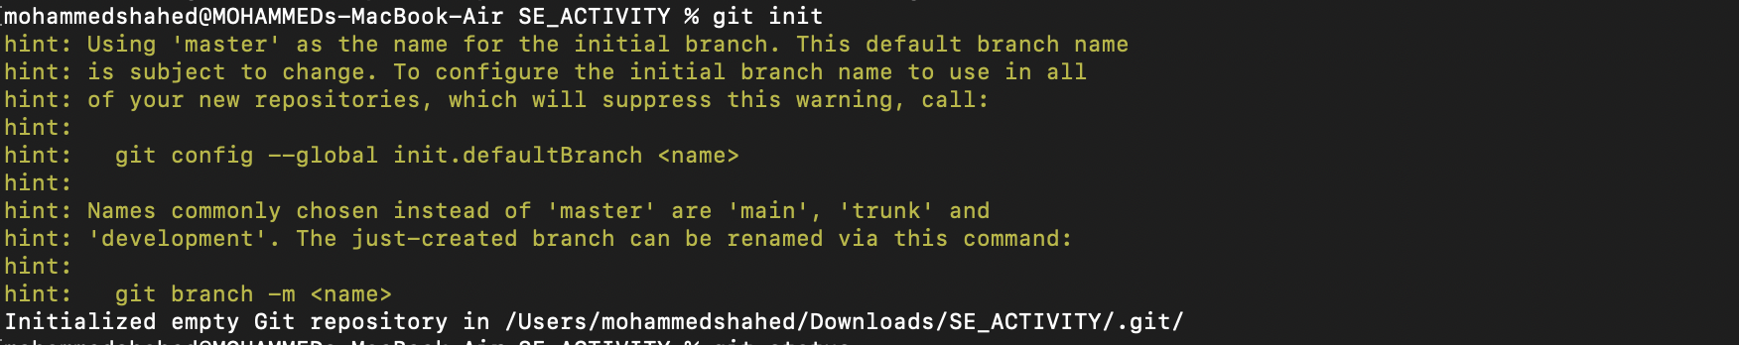

8.**git status**:it shows the status of the file like staged,unstaged,untracked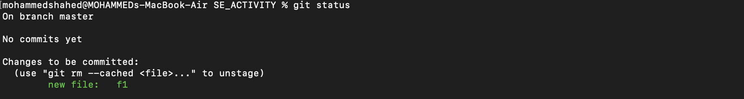

9.**git add**:stages all changes in the current directoryScreenshot 2024-10-18 at 2.47.35 PM.png

10.**git config --global user.email**:sets the global email for all the repositories for that particular pcScreenshot 2024-10-18 at 2.48.36 PM.png

11.**git config –global user.name**::sets the global username for all the repositories for that particular pcScreenshot 2024-10-18 at 2.48.44 PM.png

12.**git config - -global - -list**:it shows the global git configurations like global username,email that we have set for the paticular pc

13.**git commit**:used to record changes that have been staged in your repository's history.

Syntax:git commit -m “message”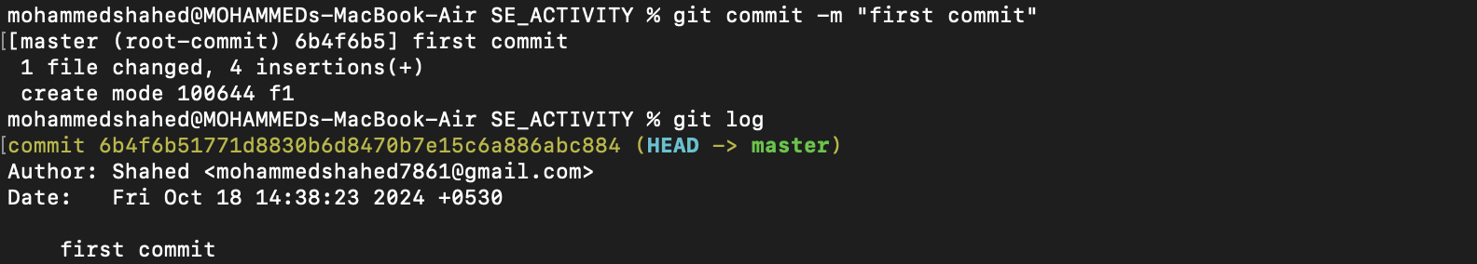

14**.git log**:used to view the commit history of a Git repository

15.**git log - -online**: used to display the commit history in a condensed format, showing each commit on a single lineScreenshot 2024-10-18 at 2.49.16 PM.png

16.**git revert**:used to undo the changes made in the previous commit.

17.**git —version**: used to check the current git version.