Exercise 2: Factory Method for Document Creation

Approach and Understanding:

In this task, I created a system to **open different types of documents** like Word, PDF, and Excel using the **Factory Method Pattern.**

The question asked me to:

* Create document types like Word, PDF, and Excel.
* Build a **factory setup** to create these documents easily.
* Test the system to prove that I can open different documents using factories.

# Code

import java.util.Scanner; interface D {

void show();

}

class W implements D { public void show() {

System.out.println("word is open.");

}

}

class P implements D { public void show() {

System.out.println("pdf is open.");

}

}

class E implements D { public void show() {

System.out.println("excel is open.");

}

}

abstract class F {

public abstract D make();

}

class WF extends F {

public D make() { return new W(); }

}

class PF extends F {

public D make() { return new P(); }

}

class EF extends F {

public D make() { return new E(); }

}

public class Y {

public static void main(String[] a) { Scanner s = new Scanner(System.in);

System.out.print("Pick one: "); String ch = s.nextLine();

F z = null ;

if (ch.equalsIgnoreCase("word")) { z = new WF();

} else if (ch.equalsIgnoreCase("pdf")) { z = new PF();

} else if (ch.equalsIgnoreCase("excel")) { z = new EF();

} else {

System.out.println("not found"); s.close();

return;

}

D d = z.make();

d.show();

s.close();

}

}

# OUTPUT:

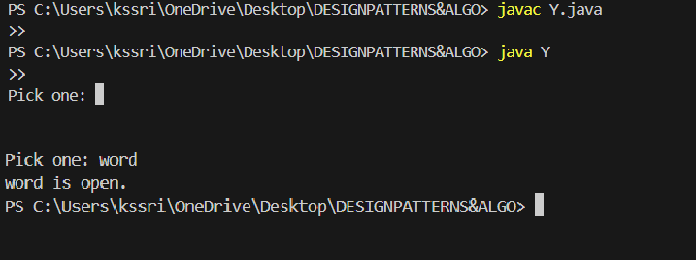

NO TEXT IS CREATE SO THAT IS NOT FOUND

