Exercise 4: Payment Adapter System

Approach and Understanding:

In this problem, I have to create a payment system that can connect to **different payment companies** like X and Y.

The issue is that each payment company has **its own style** of processing payments. So, to **make everything work smoothly in one system**, I used the **Adapter Pattern.**

# Code

import java.util.Scanner; interface p {

void pay(double v);

}

class xsys {

public void xdo(double a) { System.out.println("Paid by X: " + a);

}

}

class ysys {

public void ydo(double a) { System.out.println("Paid by Y: " + a);

}

}

class xad implements p { xsys u;

public xad(xsys u) { this.u = u; } public void pay(double v) {

u.xdo(v);

}

}

class yad implements p { ysys u;

public yad(ysys u) { this.u = u; }

public void pay(double v) { u.ydo(v);

}

}

public class runpay {

public static void main(String[] z) { Scanner s = new Scanner(System.in);

System.out.print("payment type x/y: "); String t = s.nextLine();

System.out.print("enter the amount: "); double n = s.nextDouble();

p p1 = null;

if (t.equalsIgnoreCase("x")) { p1 = new xad(new xsys());

} else if (t.equalsIgnoreCase("y")) { p1 = new yad(new ysys());

}

if (p1 != null) {

p1.pay(n);

} else {

System.out.println("payment type wrong");

}

s.close();

}

}

# OUTPUT:

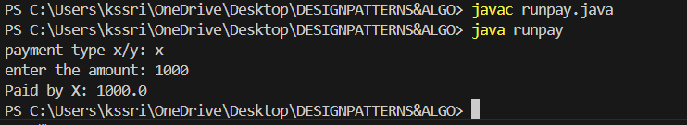

Wrong payment type

