Exercise 5: Multi-Channel Notification System Using Decorator Pattern

Approach and Understanding:

In this problem, I created a system that lets the user **send notifications in different ways**

like:

* Email
* SMS
* Slack

The **main goal** is to allow the user to:

Type their own message

Select how they want to send the message (email only, email + SMS, email + Slack, or all three)

**Code**

import java.util.Scanner; interface p {

void s(String m);

}

class e implements p { public void s(String m) {

System.out.println("mail: " + m);

}

}

abstract class b implements p { protected p x;

public b(p x) { this.x = x; }

public void s(String m) { x.s(m); }

}

class sms extends b {

public sms(p x) { super(x); } public void s(String m) {

super.s(m);

smsDo(m);

}

private void smsDo(String m) { System.out.println("sms: " + m);

}

}

class slk extends b {

public slk(p x) { super(x); }

public void s(String m) { super.s(m);

slkDo(m);

}

private void slkDo(String m) { System.out.println("slack: " + m);

}

}

public class app {

public static void main(String[] y) { Scanner s = new Scanner(System.in);

System.out.print("Enter the message: "); String msg = s.nextLine();

System.out.println("1: mail only"); System.out.println("2: mail + sms"); System.out.println("3: mail + slack"); System.out.println("4: mail + sms + slack");

System.out.print("pick: "); int c = s.nextInt();

p n = null;

if (c == 1) { n = new e(); }

else if (c == 2) { n = new sms(new e()); } else if (c == 3) { n = new slk(new e()); }

else if (c == 4) { n = new sms(new slk(new e())); } else { System.out.println("wrong pick"); }

if (n != null) {

n.s(msg);

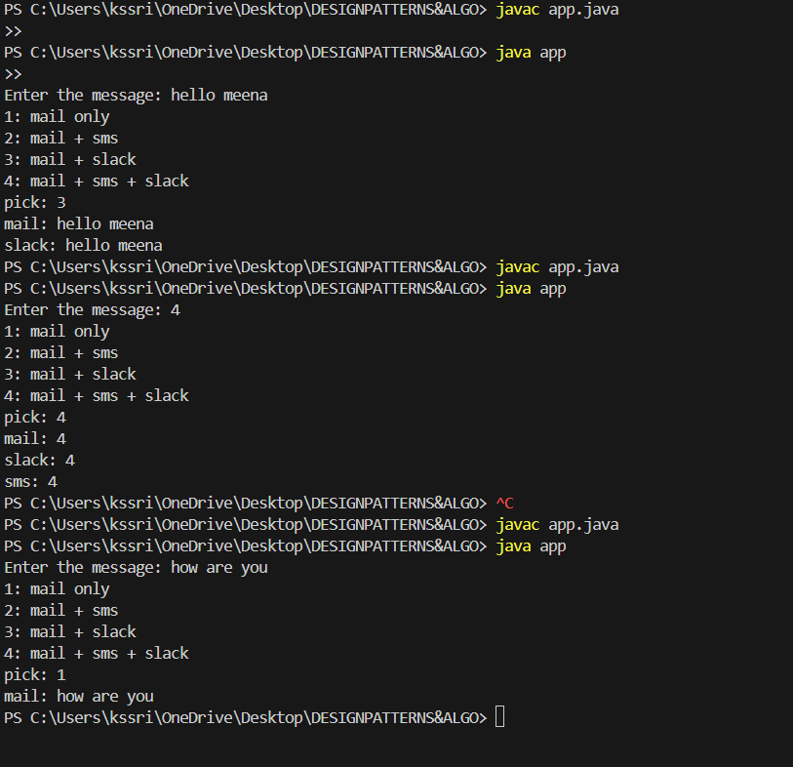

}

s.close();

}

}

**OUTPUT:**