**Exercise 6: Cursors**

**Scenario 1:** Generate monthly statements for all customers.

* + **Question:** Write a PL/SQL block using an explicit cursor **GenerateMonthlyStatements** that retrieves all transactions for the current month and prints a statement for each customer.

**CODE:**

INSERT INTO transactions (txn_id, account_id, txn_type, amount, txn_date)

VALUES (5, 101, 'deposit', 500, SYSDATE);

INSERT INTO transactions (txn_id, account_id, txn_type, amount, txn_date)

VALUES (6, 101, 'withdraw', 200, SYSDATE);

INSERT INTO transactions (txn_id, account_id, txn_type, amount, txn_date)

VALUES (7, 102, 'deposit', 1000, SYSDATE);

COMMIT;

DECLARE

CURSOR txn_cursor IS

SELECT account_id, txn_type, amount, txn_date

FROM transactions

WHERE EXTRACT(MONTH FROM txn_date) = EXTRACT(MONTH FROM SYSDATE)

AND EXTRACT(YEAR FROM txn_date) = EXTRACT(YEAR FROM SYSDATE);

v_account_id transactions.account_id%TYPE;

v_type transactions.txn_type%TYPE;

v_amount transactions.amount%TYPE;

v_date transactions.txn_date%TYPE;

BEGIN

OPEN txn_cursor;

LOOP

FETCH txn_cursor INTO v_account_id, v_type, v_amount, v_date;

EXIT WHEN txn_cursor%NOTFOUND;

DBMS_OUTPUT.PUT_LINE('Account: ' || v_account_id ||

', Type: ' || v_type ||

', Amount: ₹' || v_amount ||

', Date: ' || TO_CHAR(v_date, 'DD-MON-YYYY'));

END LOOP;

CLOSE txn_cursor;

END;

/

**OUTPUT:**

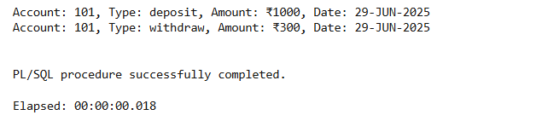

**Scenario 2:** Apply annual fee to all accounts.

* + **Question:** Write a PL/SQL block using an explicit cursor **ApplyAnnualFee** that deducts an annual maintenance fee from the balance of all accounts.

**CODE:**

DECLARE

CURSOR acc_cursor IS

SELECT accountid, balance FROM accounts;

v_acc_id accounts.accountid%TYPE;

v_balance accounts.balance%TYPE;

BEGIN

OPEN acc_cursor;

LOOP

FETCH acc_cursor INTO v_acc_id, v_balance;

EXIT WHEN acc_cursor%NOTFOUND;

UPDATE accounts

SET balance = balance - 100

WHERE accountid = v_acc_id;

DBMS_OUTPUT.PUT_LINE('₹100 annual fee deducted from Account: ' || v_acc_id);

END LOOP;

CLOSE acc_cursor;

COMMIT;

END;

/

**OUTPUT:**

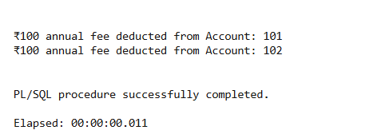

**Scenario 3:** Update the interest rate for all loans based on a new policy.

* + **Question:** Write a PL/SQL block using an explicit cursor **UpdateLoanInterestRates** that fetches all loans and updates their interest rates based on the new policy.

**CODE:**

BEGIN

EXECUTE IMMEDIATE 'DROP TABLE loans';

EXCEPTION

WHEN OTHERS THEN NULL;

END;

/

CREATE TABLE loans (

loan_id NUMBER PRIMARY KEY,

customer_id NUMBER,

amount NUMBER(10,2),

interest_rate NUMBER(5,2)

);

INSERT INTO loans VALUES (1, 1, 50000, 9.5);

INSERT INTO loans VALUES (2, 2, 80000, 10.0);

INSERT INTO loans VALUES (3, 3, 100000, 11.5);

COMMIT;

DECLARE

CURSOR loan_cursor IS

SELECT loan_id, interest_rate FROM loans;

v_loan_id loans.loan_id%TYPE;

v_rate loans.interest_rate%TYPE;

BEGIN

OPEN loan_cursor;

LOOP

FETCH loan_cursor INTO v_loan_id, v_rate;

EXIT WHEN loan_cursor%NOTFOUND;

IF v_rate < 10 THEN

UPDATE loans

SET interest_rate = v_rate + 1

WHERE loan_id = v_loan_id;

ELSE

UPDATE loans

SET interest_rate = v_rate + 0.5

WHERE loan_id = v_loan_id;

END IF;

DBMS_OUTPUT.PUT_LINE('Updated Loan ID ' || v_loan_id || ' to new rate.');

END LOOP;

CLOSE loan_cursor;

COMMIT;

END;

/

**OUTPUT:**

