**Exercise 7: Packages**

**Scenario 1: Group all customer-related procedures and functions into a package.**

* **Question: Create a package CustomerManagement with procedures for adding a new customer, updating customer details, and a function to get customer balance.**

**CODE:**

CREATE OR REPLACE PACKAGE CustomerManagement AS

PROCEDURE AddCustomer (

p_custid NUMBER,

p_name VARCHAR2,

p_dob DATE

);

PROCEDURE UpdateCustomer (

p_custid NUMBER,

p_name VARCHAR2

);

FUNCTION GetCustomerDOB (

p_custid NUMBER

) RETURN DATE;

END CustomerManagement;

/

CREATE OR REPLACE PACKAGE BODY CustomerManagement AS

PROCEDURE AddCustomer (

p_custid NUMBER,

p_name VARCHAR2,

p_dob DATE

) IS

BEGIN

INSERT INTO Customers (Customer_ID, Name, DOB, LastModified)

VALUES (p_custid, p_name, p_dob, SYSDATE);

COMMIT;

DBMS_OUTPUT.PUT_LINE('Customer added successfully.');

EXCEPTION

WHEN DUP_VAL_ON_INDEX THEN

DBMS_OUTPUT.PUT_LINE('Error: Customer ID already exists.');

END;

PROCEDURE UpdateCustomer (

p_custid NUMBER,

p_name VARCHAR2

) IS

BEGIN

UPDATE Customers

SET Name = p_name,

LastModified = SYSDATE

WHERE Customer_ID = p_custid;

COMMIT;

DBMS_OUTPUT.PUT_LINE('Customer updated successfully.');

END;

FUNCTION GetCustomerDOB (

p_custid NUMBER

) RETURN DATE IS

v_dob DATE;

BEGIN

SELECT DOB INTO v_dob

FROM Customers

WHERE Customer_ID = p_custid;

RETURN v_dob;

EXCEPTION

WHEN NO_DATA_FOUND THEN

RETURN NULL;

END;

END CustomerManagement;

/

**OUTPUT:**

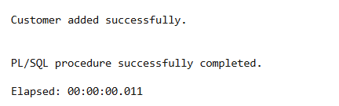

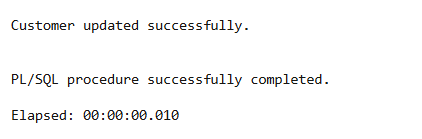

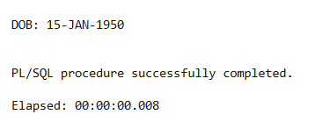

**Scenario 2: Create a package to manage employee data.**

* **Question: Write a package EmployeeManagement with procedures to hire new employees, update employee details, and a function to calculate annual salary.**

**CODE:**

CREATE TABLE Employees (

Employee_ID NUMBER PRIMARY KEY,

Name VARCHAR2(100),

Salary NUMBER(10,2),

Department VARCHAR2(50),

HireDate DATE

);

CREATE OR REPLACE PACKAGE EmployeeManagement AS

PROCEDURE HireEmployee (

p_empid NUMBER,

p_name VARCHAR2,

p_position VARCHAR2,

p_salary NUMBER,

p_department VARCHAR2

);

PROCEDURE UpdateEmployee (

p_empid NUMBER,

p_salary NUMBER

);

FUNCTION AnnualSalary (

p_empid NUMBER

) RETURN NUMBER;

END EmployeeManagement;

/

CREATE OR REPLACE PACKAGE BODY EmployeeManagement AS

PROCEDURE HireEmployee (

p_empid NUMBER,

p_name VARCHAR2,

p_position VARCHAR2,

p_salary NUMBER,

p_department VARCHAR2

) IS

BEGIN

INSERT INTO Employees (Employee_ID, Name, Salary, Department, HireDate)

VALUES (p_empid, p_name, p_salary, p_department, SYSDATE);

COMMIT;

DBMS_OUTPUT.PUT_LINE('Employee hired successfully.');

EXCEPTION

WHEN DUP_VAL_ON_INDEX THEN

DBMS_OUTPUT.PUT_LINE('Error: Employee ID already exists.');

END;

PROCEDURE UpdateEmployee (

p_empid NUMBER,

p_salary NUMBER

) IS

BEGIN

UPDATE Employees

SET Salary = p_salary

WHERE Employee_ID = p_empid;

COMMIT;

DBMS_OUTPUT.PUT_LINE('Employee salary updated.');

END;

FUNCTION AnnualSalary (

p_empid NUMBER

) RETURN NUMBER IS

v_salary NUMBER;

BEGIN

SELECT Salary INTO v_salary

FROM Employees

WHERE Employee_ID = p_empid;

RETURN v_salary * 12;

EXCEPTION

WHEN NO_DATA_FOUND THEN

RETURN NULL;

END;

END EmployeeManagement;

/

**OUTPUT:**

**BEGIN**

**EmployeeManagement.UpdateEmployee(3, 45000);**

**END;**

**/**

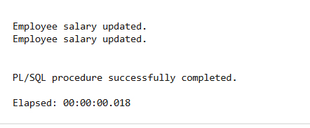

**BEGIN**

**EmployeeManagement.HireEmployee(1, 'Meena', 'Manager', 60000, 'HR');**

**EmployeeManagement.HireEmployee(2, 'Sri', 'Analyst', 50000, 'Finance');**

**EmployeeManagement.HireEmployee(3, 'Harini', 'Clerk', 40000, 'Admin');**

**END;**

**/**

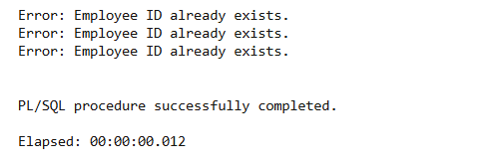

**BEGIN**

**DBMS_OUTPUT.PUT_LINE(EmployeeManagement.AnnualSalary(1));**

**END;**

**/**

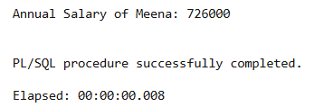

**Scenario 3: Group all account-related operations into a package.**

* **Question: Create a package AccountOperations with procedures for opening a new account, closing an account, and a function to get the total balance of a customer across all accounts.**

**CODE:**

CREATE OR REPLACE PACKAGE AccountOperations AS

PROCEDURE OpenAccount (

p_accid NUMBER,

p_custid NUMBER,

p_type VARCHAR2,

p_balance NUMBER

);

PROCEDURE CloseAccount (

p_accid NUMBER

);

FUNCTION TotalBalance (

p_custid NUMBER

) RETURN NUMBER;

END AccountOperations;

/

CREATE OR REPLACE PACKAGE BODY AccountOperations AS

PROCEDURE OpenAccount (

p_accid NUMBER,

p_custid NUMBER,

p_type VARCHAR2,

p_balance NUMBER

) IS

BEGIN

INSERT INTO Accounts (AccountID, CustomerID, AccountType, Balance, LastModified)

VALUES (p_accid, p_custid, p_type, p_balance, SYSDATE);

COMMIT;

DBMS_OUTPUT.PUT_LINE('Account opened successfully.');

END;

PROCEDURE CloseAccount (

p_accid NUMBER

) IS

BEGIN

DELETE FROM Accounts

WHERE AccountID = p_accid;

COMMIT;

DBMS_OUTPUT.PUT_LINE('Account closed successfully.');

END;

FUNCTION TotalBalance (

p_custid NUMBER

) RETURN NUMBER IS

v_total NUMBER;

BEGIN

SELECT SUM(Balance) INTO v_total

FROM Accounts

WHERE CustomerID = p_custid;

RETURN v_total;

EXCEPTION

WHEN NO_DATA_FOUND THEN

RETURN 0;

END;

END AccountOperations;

/

**OUTPUT:**

