|  |  |
| --- | --- |
| **Exp No: 1- A**  **Date: 29/ 11/22** | **DRAW FLOWCHART AND WRITE ALGORITHM FOR**  **THE FOLLOWING PROBLEM** |

**STUDENT GRADE ANALYSIS**

**Aim:**

To draw flowchart and write algorithm for the following problem.

**ALGORITHM:**

**STEP 1:** Start.

**STEP 2:** Get the Number of students (N)

**STEP 3:** Assign i = 0.

**STEP 4:** Check for the condition i < N.

**4.1:** If True, Get Name, Roll.no and Marks m1, m2, m3, m4, m5.

**4.2:** Calculate Total = m1 + m2 + m3 + m4 + m5 and Average = Total / 5

**4.3:** Display Name and Roll Number.

**4.4:** Check for condition avg >= 30 and avg < 50.

**4.4.1:** If True Display the message your grade is c" and increase i value by 1.

**4.5:** Check for condition avg > 50 and avg < 80

**4.5.1:** If True Display the message "You grade is B" and increase i value by 1.

**4.6:** Check for the condition avg > 80 and avg ≤ 100

**4.6.1:** If True Display the message. "Your grade is A" and increase i value by 1.

**4.7:** Check for the condition avg < 30

**4.7.1:** If True Display the message "Your grade is D".

**STEP 5:** If False, goto step 9

**STEP 6:** Stop.

**FLOWCHART:**

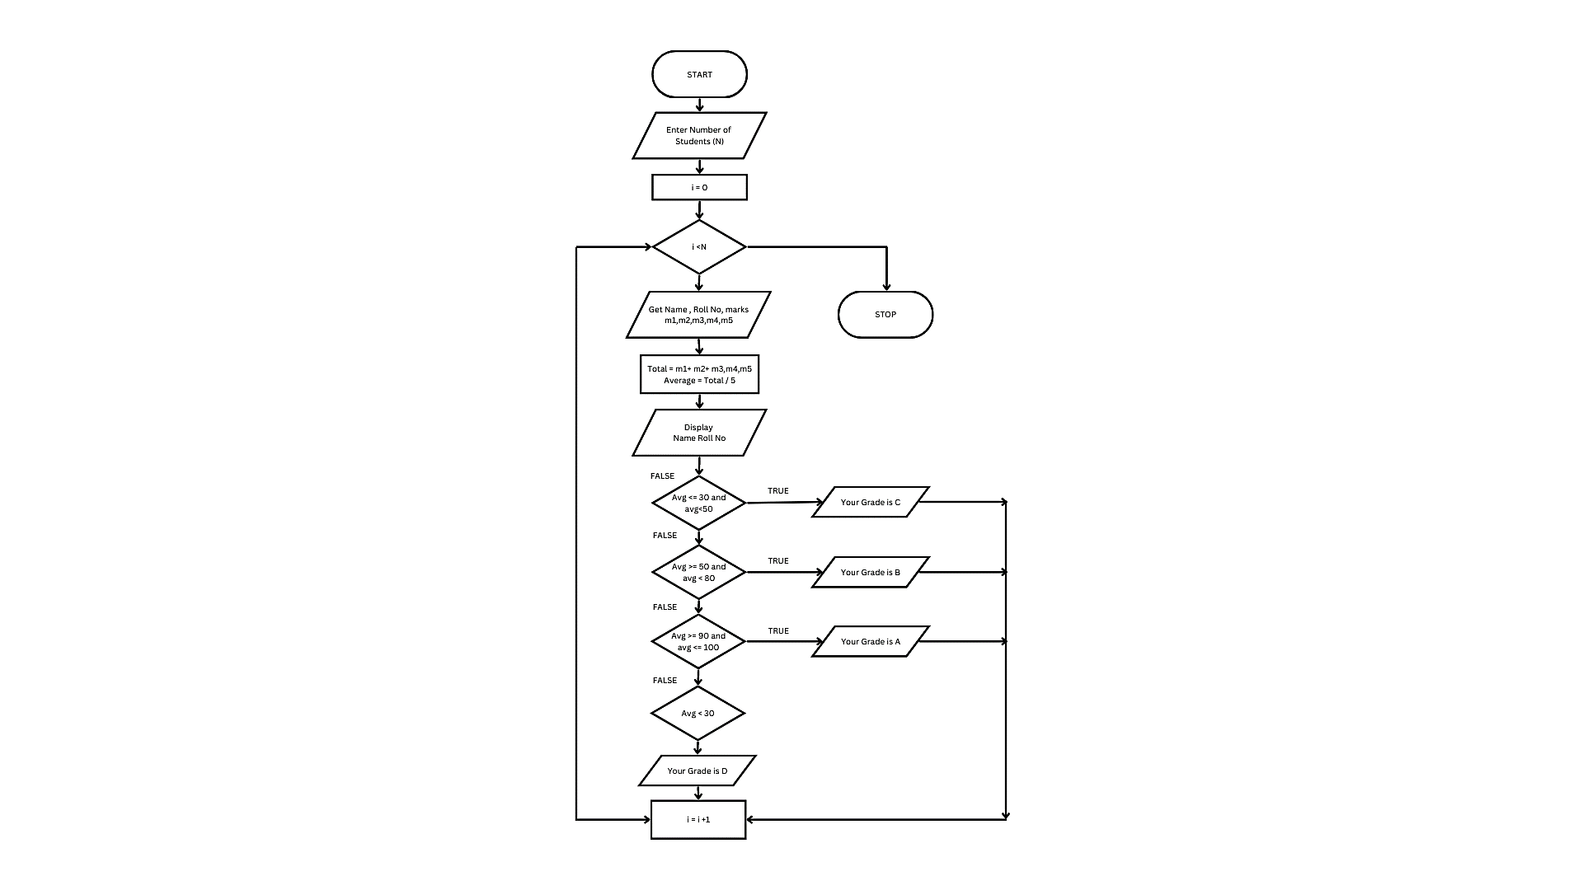

**RESULT:**

Thus, the algorithm and flowchart are written for the given problem.

|  |  |
| --- | --- |
| **Exp No: 1- B**  **Date: 29/ 11/22** | **DRAW FLOWCHART AND WRITE ALGORITHM FOR**  **THE FOLLOWING PROBLEM** |

**CALCULATING ELECTRIC BILL**

**AIM:**

To draw flowchart and write algorithm for calculating the electric bill.

**ALGORITHM:**

**STEP 1:** Start.

**STEP 2:** Enter Current Unit (CU).

**STEP 3:** Enter Old Unit (OU).

**STEP 4:** Calculate N = CU - OU

**STEP 5:** Check for the condition N<=100 If true.

**5.1**: Calculate E.C using formula. FC = 0, DC = 0, EC= 0

**5.2:** Calculate the Total charges = FC + DC + EC

**5.3:** Display amount needed to pay and go to stop.

**STEP 6:** Check for condition N<=200 If true.

**6.1**: Calculate E.C using formula FC = 20 ,DC = 18, EC = ( N – 100 ) * 1.5

**6.2:** Calculate the Total charges = FC + DC + EC

**6.3:** Display amount needed to pay and go to stop.

**STEP 7:** Check condition N<=500 of take.

**7.1:** Calculate EC using formula. FC = 73, DC = 48, EC = ( N - 100) * 3.5

**7.2:** Calculate the Total charges = FC + DC + EC

**7.3:** Display amount need to pay and goto stop.

**STEP 5:** Check for the condition N>500 If true.

**5.1:** Calculate the E.C using FC=75, DC=100, EC = (400 * 4.5) + (N - 500) * 6

**5.2:** Calculate Total charges = FC + DC + EC

**5.3:** Display the amount need to pay and go to stop

**STEP 7:** Stop.

**FLOWCHART:**

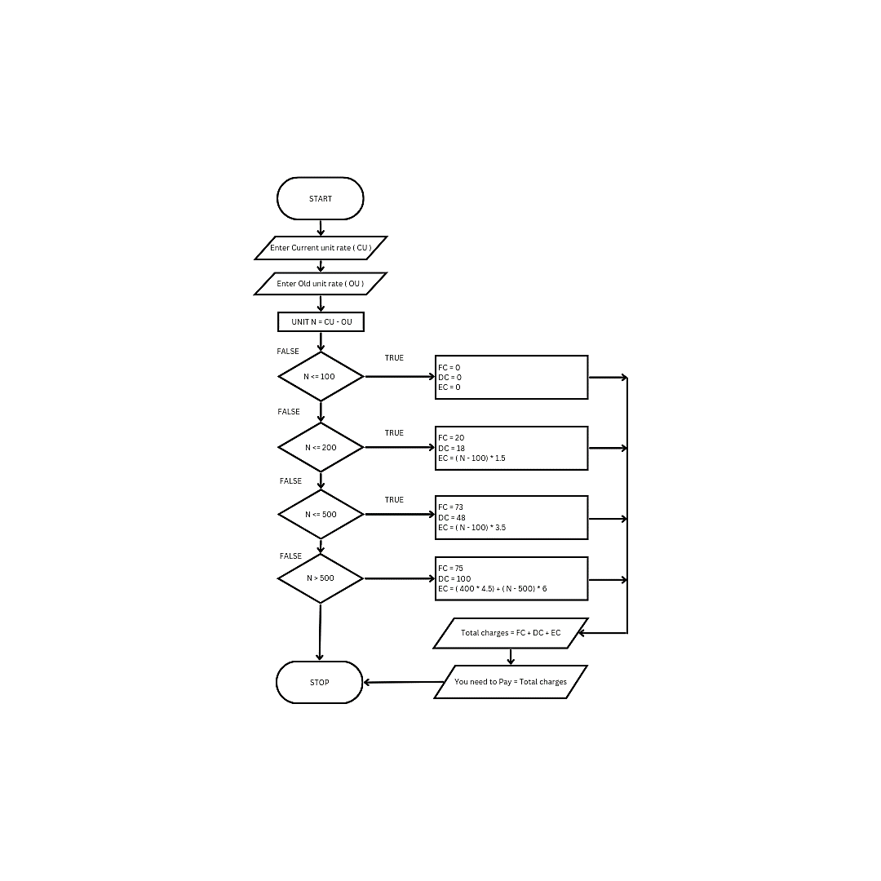

**RESULT:**

Thus, the algorithm and the flowchart is written for the given problem.

|  |  |
| --- | --- |
| **Exp No: 1- C**  **Date: 29/ 11/22** | **DRAW FLOWCHART AND WRITE ALGORITHM FOR**  **THE FOLLOWING PROBLEM** |

**CALCULATE WEIGHT OF IRON ROD**

**AIM:**

To draw flowchart and write algorithm for calculating the weight of a steel Rod.

**ALGORITHM:**

**STEP 1:** Start.

**STEP 2:** Get the number of Iron nods.

**STEP 3:** Initialize the value I and weight as 0.

**STEP 4:** Chock for the condition i = n.

**4.1:** of true, get the diameter of the rod.

**4.2:** Calculate the weight-unit-weight using the formula d*2 /162 = W

**4.3:** Calculate the weight using the formula.

No. of rods x weight - Tw

**4.4:** Calculate total weight = TW+W.

**4.5:** Increment the value of i by 1 goto step 4.

**4.1:** If false display the total weight.

**STEP 5:** Stop

**FLOWCHART:**

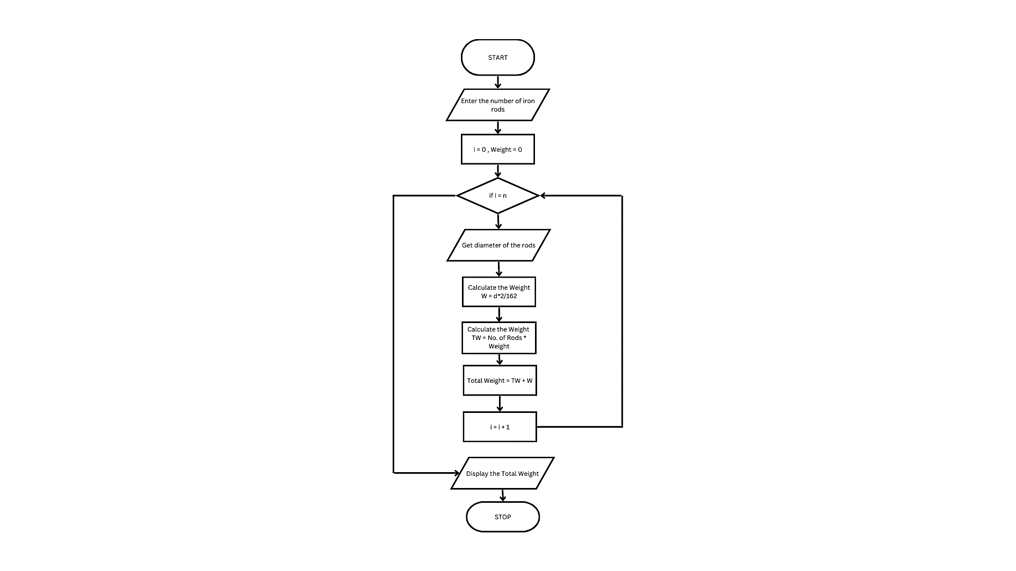

**RESULT:**

Thus, the algorithm and the flowchart is given for the problem.

|  |  |
| --- | --- |
| **Exp No: 1- D**  **Date: 29/ 11/22** | **DRAW FLOWCHART AND WRITE ALGORITHM FOR**  **THE FOLLOWING PROBLEM** |

**CALCULATE WEIGHT OF A MOTORBIKE**

**AIM:**

To draw flowchart and write algorithm for calculating weight of a motorbike.

**ALGORITHM:**

**STEP 1:** Start.

**STEP 2:** Get gross vehicle weight Rating GVWR

**STEP 3:** Get Dry weight (DW)

**STEP 4:** Get Fuel weight (FW)

**STEP 5:** Get Raider weight (RW)

**STEP 6:** Get Passenger weight (PW)

**STEP 7:** Calculate Total weight = DW+FW+RW+PW

**STEP 8:** Get Load.

**STEP 9:** Calculate safe weight. GVWR-Load-weight.

**STEP 10:** Check the condition safe weight >=0.

**10.1:** If true, print the message “You have a safe load and you can drive" goto stop.

**10.2:** If false, print the message "Reduce the load and then drive”.

**10.2.1:** GOTO step 8.

**STEP 11:** Stop.

**FLOWCHART:**

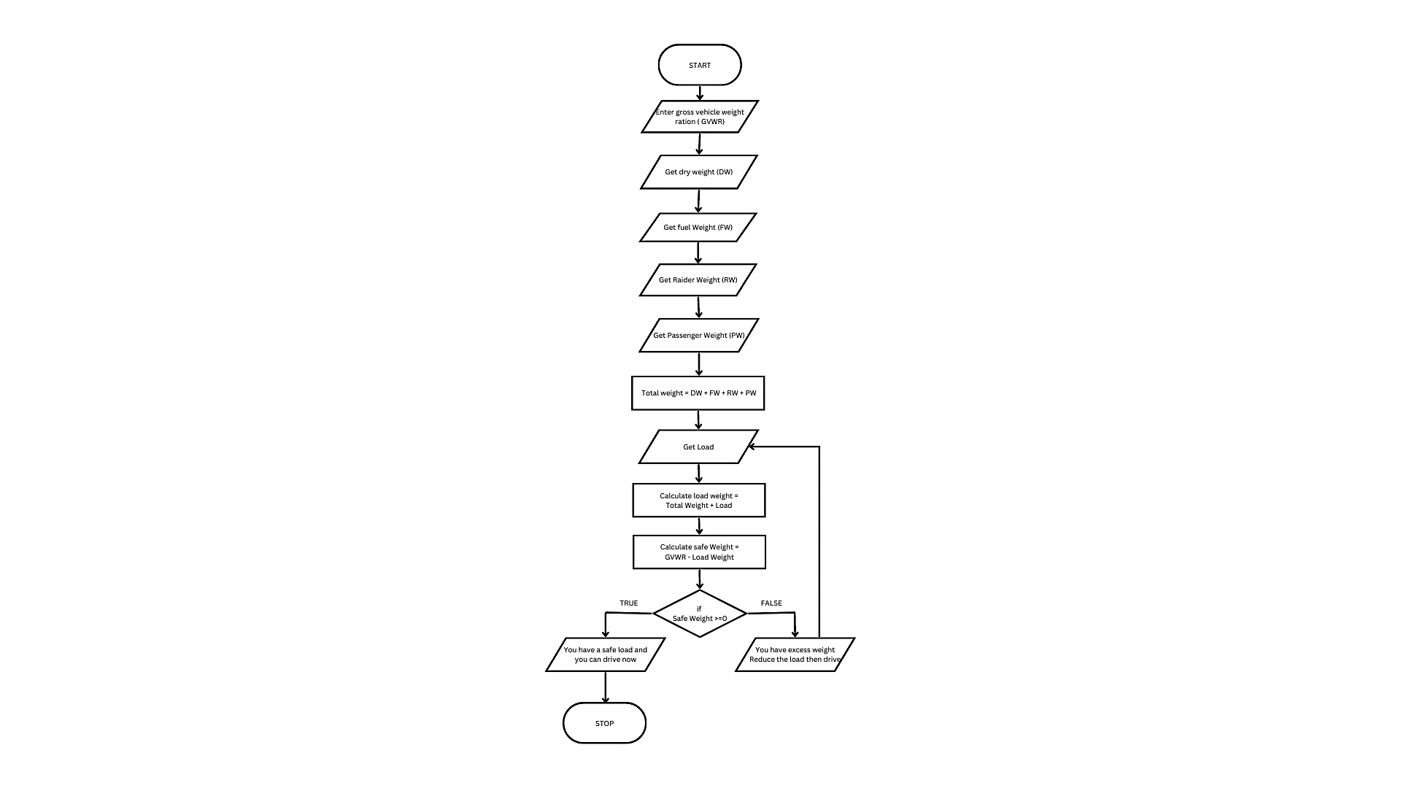

**RESULT:**

Thus, the flowchart and the algorithm is written for the problem.

|  |  |
| --- | --- |
| **Exp No: 1- E**  **Date: 29/ 11/22** | **DRAW FLOWCHART AND WRITE ALGORITHM FOR**  **THE FOLLOWING PROBLEM** |

**CALCULATE ELECTRIC CURRENT IN 3 PHASE A/C CIRCUIT**

**AIM:**

To draw flowchart and write algorithm. to- calculate electrical current in 3 phase AC circuit.

**ALGORITHM:**

**STEP 1:** Start

**STEP 2:** Get value of pf (power factor)

**STEP 3:** Get value of Current (I).

**STEP 4:** Get value of voltage (V)

**STEP 5:** Calculate P using the formula P= √3*pf*I*V.

**STEP 6:** Display the value of P.

**STEP 7:** Stop

**FLOWCHART:**

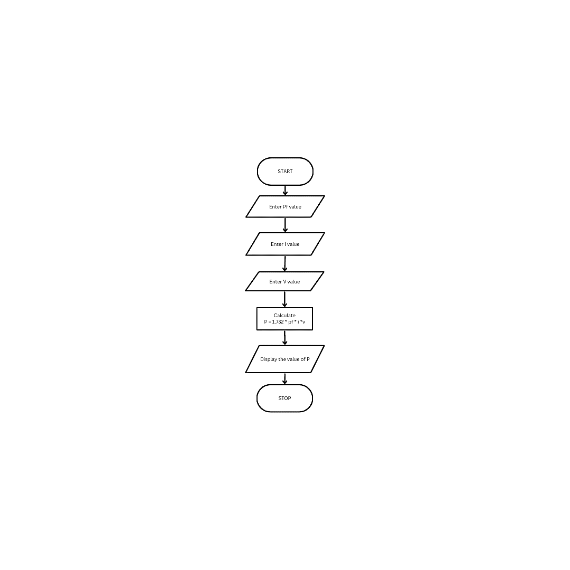

**RESULT:**

Thus the flowchart and the algorithm is written for the given problem.

|  |  |
| --- | --- |
| **Exp No: 1- F**  **Date: 29/ 11/22** | **DRAW FLOWCHART AND WRITE ALGORITHM FOR**  **THE FOLLOWING PROBLEM** |

**RETAIL SHOP.**

**AIM:**

To draw the flowchart and write the algorithm for the retail shop billing.

**ALGORITHM:**

**STEP 1:** Start

**STEP 2:** Get the Bill number.

**STEP 3:** Get costumer Customer name and phone number

**STEP 4:** Get the value of total No. of Items purchased.

**STEP 5:** Initialize the values for i =0, Total =0, Net Amount = 0 and Gross=0.

**STEP 6:** Check if condition i<=n.

**6.1:** If true, get Item name, Price, Quantity and the discount.

**6.2:** Calculate the Gross = Price * quantity

Calculate the Disc = Gross * Discount%

Calculate the Net Amount = Gross-Disc

**6.3:** Calculate the Total = Total + Net Amount.

**6.4:** Increment the value of i and goto step 6.

**STEP 7:** If False, get the GST value.

**STEP 8:** Calculate GST Amount = ( Gross * GST% ) / 100.

Calculate the BILL Price = Net Amount + GST Amount

**STEP 9:** Display the Bill Amount

**STEP 10:** Stop.

**FLOWCHART:**

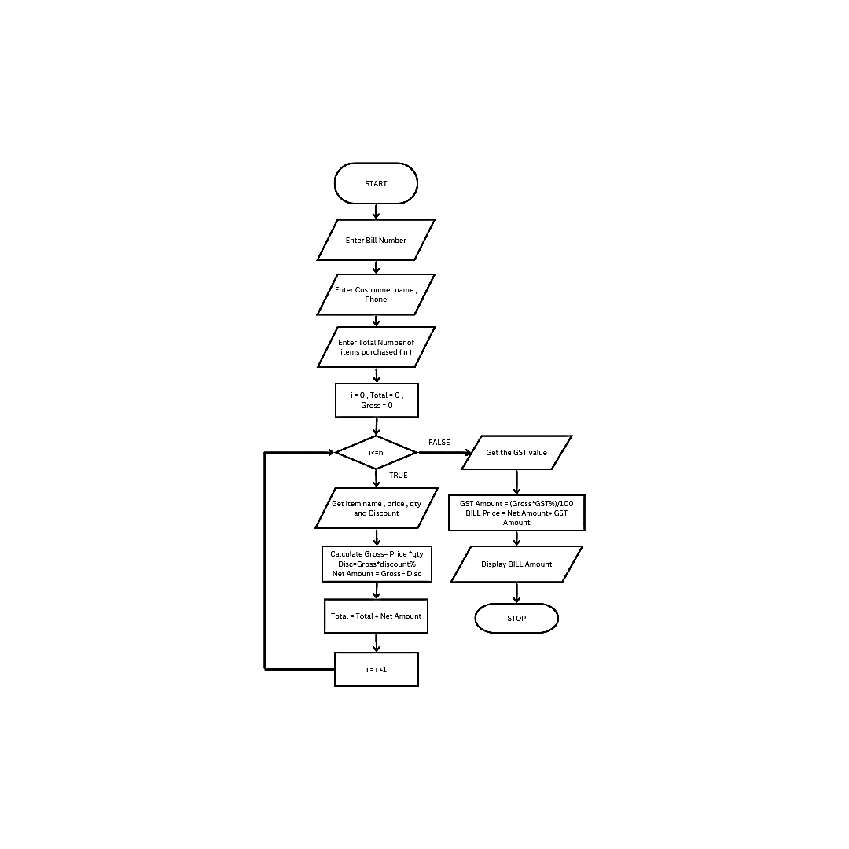

**RESULT:**

Thus, the flowchart and the algorithm is written for the problem

|  |  |
| --- | --- |
| **Exp No: 1- G**  **Date: 29/ 11/22** | **DRAW FLOWCHART AND WRITE ALGORITHM FOR**  **THE FOLLOWING PROBLEM** |

**SINE SERIES.**

**AIM:**

To draw flowchart and write algorithm for the sine series.

**ALGORITHM**:

**STEP 1:** Start.

**STEP 2:** Get the value of x.

**STEP 3:** Initialize the values of 1=1, sine =0 and import moth.

**STEP 4:** Get the value of N.

**STEP 5:** Check weather value do i less than N

**5.1:** If condition is true, convent a to radians and adding it to y.

**5.1.1:** Let value of s be (-1) to the power i

**5.1.2:** Now calculate the series using the formula.

Sine = sine + ((y**2* i +1))/ math factorial (21+4) S.

**5.1.3:** Increment value of i by 1.

**5.2**: If condition is false display sine.

**STEP 6:** Stop.

**FLOWCHART:**

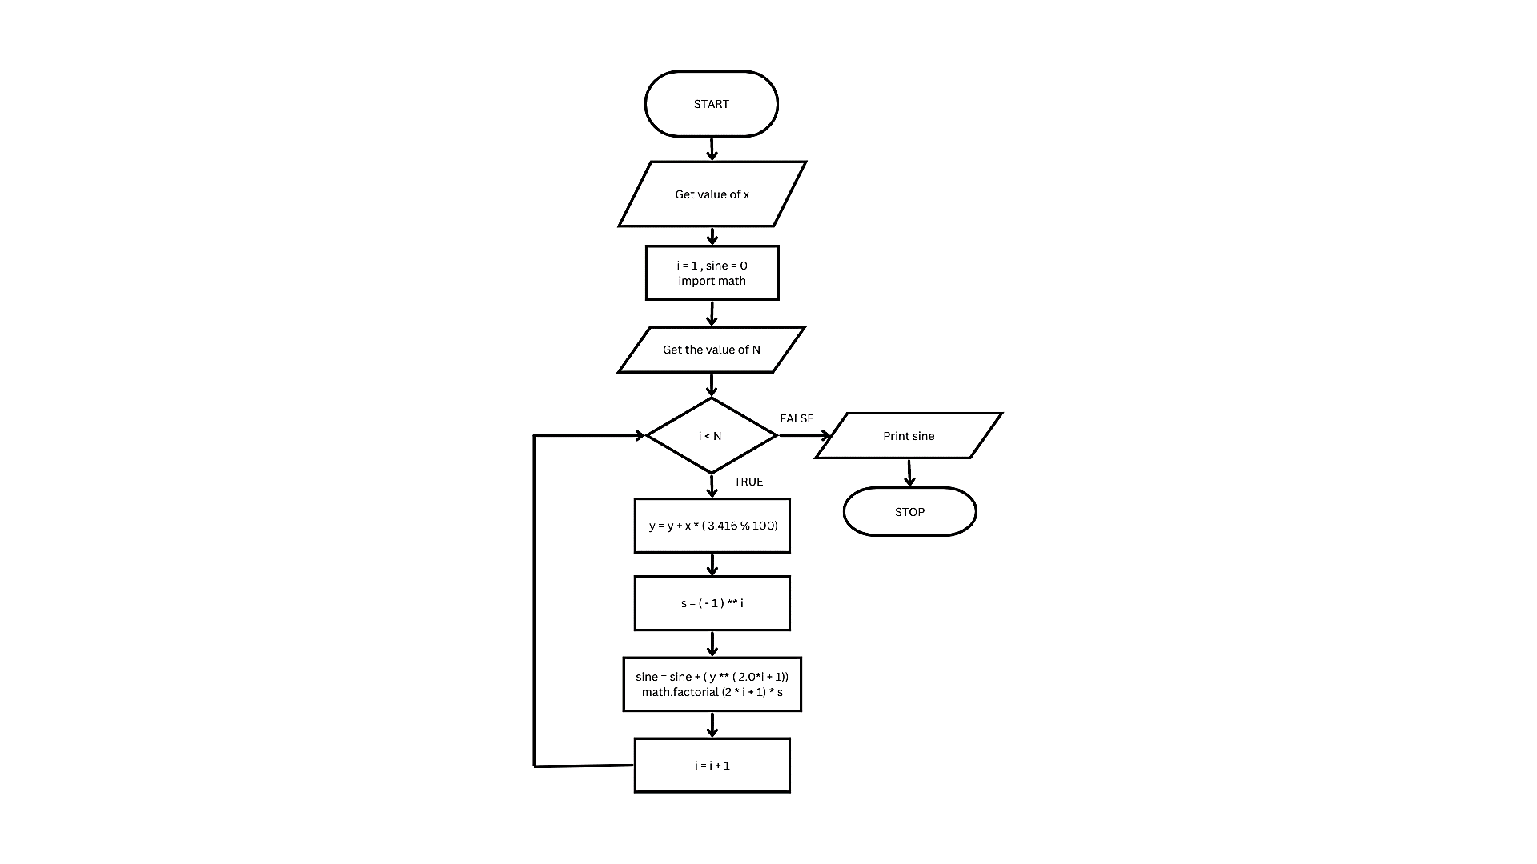

**RESULT:**

Thus, the flowchart and the algorithm is written for the problem

**FLOWCHART:**

* Flowchart A graphical representation of the logic for the problem solving.
* The purpose of the flowchart is making the logic of the program in a visual representation
* Flowcharts is a diagram made up of boxes, diamonds, and other shapes, connected by arrows.
* Each shape represents a step-in process and arrows show the order in which they occur.

|  |  |
| --- | --- |
|  | OVAL – TERMINAL SYMBOL |
|  | Parallelogram - Input/ Output symbol |
|  | Rectangle - Process symbol |
|  | Diamond - Decision symbol |
|  | Arrow lines - Flow lines |
|  | To represent a function |
|  | Circle - Connector |

**TOOLS USED TO DRAW FLOWCHART**

1. **Smart Draw**
2. **Canva**
3. **Diagrams.net**
4. **Licidchart**
5. **Visme**
6. **Zenflowchart**
7. **Visual Paradiagram**
8. **Creatly**
9. **Google Draw**