Health Data Information and Management System Web Application

CONTENT
Abstract
1.INTRODUCTION
1.1 Motivation
1.2 Problem Statement
1.3 Objective of the Project
1.4 Scope
1.5 Project Introduction
2.LITERATURE SURVEY
2.1 Related Work
3. SYSTEM ANALYSIS
3.1 Existing System
3.2 Disadvantages
3.3 Proposed System
3.4 Advantages
3.5 work Flow of Proposed system
4. REQUIREMENT ANALYSIS
4.1 Function and non-functional requirements
4.2 Hardware Requirements
4.3 Software Requirements
4.4 Architecture
5. SYSTEM DESIGN
5.1 Introduction of Input design
5.2 UML Diagram(class, use case, sequence, collaborative, deployment, activity, ER diagram and Component diagram)
5.3 Data Flow Diagram
6. IMPLEMENTATION AND RESULTS
6.1 Modules
  - Output Screens
7. SYSTEM STUDY AND TESTING
7.1 Feasibility study
7.2 Types of test & Test Cases
8. CONCLUSION
9. FUTURE ENHANCEMENT
10. REFERENCES

ABSTRACT:
The healthcare website aims to streamline the interaction between patients and doctors through a comprehensive, user-friendly platform. Patients can register and log in to the system, where they can send appointment requests to doctors, track the status of their appointments, and access or download their medical reports. On the other hand, doctors can register and log in to the system to manage appointments, provide consultation dates, and upload reports for patients to view and download. The platform seeks to enhance the convenience, efficiency, and accessibility of healthcare services, allowing both patients and doctors to interact and manage medical concerns seamlessly in a digital environment.
Keywords: Healthcare website, patient registration, doctor registration, appointment scheduling, medical reports, online consultation, healthcare platform, patient-doctor interaction, report download, telemedicine, healthcare technology, digital healthcare, appointment management, healthcare system.
- INTRODUCTION
1.1 Motivation:
The motivation behind this healthcare website is to bridge the gap between patients and doctors by leveraging digital technology to enhance accessibility, efficiency, and convenience in healthcare. Traditional systems often involve delays in appointments, limited access to medical information, and communication barriers. By providing a user-friendly platform that facilitates symptom analysis, appointment scheduling, and secure access to medical reports, this website aims to reduce these challenges, offering a more streamlined healthcare experience for both patients and healthcare providers. Ultimately, the goal is to improve patient outcomes through timely consultations and better management of healthcare information.
1.2 Problem Statement:
The problem addressed by this healthcare website is the inefficiency and lack of accessibility in communication between patients and doctors, which often results in delays in diagnosis, treatment, and appointment management. Patients frequently encounter difficulties in accessing timely consultations and medical information, while doctors face challenges in organizing appointments and securely sharing medical reports. This platform seeks to solve these issues by offering a unified system where patients can easily input symptoms, receive initial disease predictions, schedule appointments, and access medical reports. At the same time, doctors can efficiently manage appointments, provide consultation dates, and upload reports, thereby enhancing the healthcare experience for both patients and doctors in a seamless, digital environment.
1.3 Objective of the Project:
The objective of the healthcare website is to provide a seamless and efficient platform that facilitates interaction between patients and doctors. The system allows patients to register, log in, input symptoms for disease prediction, request appointments, and access their medical reports. Doctors can manage appointments, provide consultation dates, and upload reports for patients. The platform aims to enhance healthcare accessibility, convenience, and efficiency, ensuring both patients and doctors can engage with medical services in a streamlined, digital environment.
1.4 Scope:
The scope of this healthcare website is to enable efficient interaction between patients and doctors. Patients can register, input symptoms for disease prediction, schedule appointments, and access medical reports. Doctors can manage appointments, provide consultation dates, and upload reports. The platform aims to streamline communication, simplify appointment management, and improve access to healthcare services, all through an intuitive and secure digital interface.
1.5 Project Introduction:
The increasing demand for accessible, efficient, and reliable healthcare has driven the need for digital solutions that bridge the gap between patients and healthcare professionals. Traditional methods of seeking medical attention often involve long waiting times, limited access to healthcare providers, and logistical challenges. In response to these issues, a healthcare website has been developed to create a seamless interaction between patients and doctors through an integrated digital platform. This platform allows patients to register, log in, input symptoms for disease prediction, send appointment requests, track appointment statuses, and access their medical reports at any time, ensuring they stay informed about their health.
For doctors, the platform provides an efficient system for managing patient appointments, setting consultation dates, and securely uploading medical reports, ensuring that patients have easy access to their health information. This digital approach eliminates the need for in-person visits for routine consultations and report retrieval, making healthcare services more accessible, particularly for individuals with limited mobility or those living in remote areas.
The main goal of this healthcare website is to improve the convenience and efficiency of healthcare delivery. By utilizing technology, the platform simplifies the process of seeking medical advice, scheduling appointments, and managing health records. This ultimately enhances the patient experience and supports healthcare providers in their daily operations. The platform marks a significant step in the digital transformation of healthcare, offering a user-friendly solution that meets the evolving needs of modern healthcare systems.
- LITERATURE SURVEY
2.1 Related Work:
- Moore, J. E., & Eysenbach, G. (2019). Telemedicine: A guide to the future of healthcare.
Outcome: This book provides an in-depth exploration of telemedicine, including its history, current applications, and future trends.
- Wootton, R. (2012). Telemedicine in the National Health Service.
Outcome: The article discusses the role of telemedicine in public healthcare systems and how it facilitates patient-doctor communication.
- Laranjo, L., et al. (2018). Chatbots in healthcare: A systematic review.
Outcome: A systematic review of how chatbots are being integrated into healthcare settings for initial diagnosis, symptom checking, and patient support.
- Fadhil, A., et al. (2020). Conversational agents in healthcare: A survey.
Outcome: This paper surveys the development and use of conversational agents (chatbots) in healthcare, focusing on their potential and limitations.
- Kvedar, J. C., et al. (2014). Telemedicine: A new frontier in the delivery of healthcare.
Outcome: An article discussing how telemedicine can improve patient-doctor interactions and streamline healthcare delivery.
- Berner, E. S. (2017). Clinical decision support systems: Theory and practice.
Outcome: This book explores clinical decision support systems (CDSS) and how they enhance healthcare practices, including patient interactions and decision-making.
- Häyrinen, K., Saranto, K., & Nykänen, P. (2008). Definition, structure, content, use and impacts of electronic health records: A review of the research literature.
Outcome: A comprehensive review of the role and impact of electronic health records (EHRs) on patient care and information sharing.
- Gartner, W. J., et al. (2020). Digital health platforms and EHR: Transforming the patient experience.
Outcome: This article discusses how digital health platforms enhance patient experiences by improving appointment scheduling, medical record management, and communication.
- Buntin, M. B., Burke, M. F., & Hoaglin, M. C. (2011). The benefits of health information technology: A review of the recent literature shows predominantly positive results.
Outcome: A review of literature examining the benefits and outcomes of health information technologies in improving healthcare services.
- Kellermann, A. L., & Jones, S. S. (2013). What it will take to achieve the as-yet-unfulfilled promises of health information technology.
Outcome: This article evaluates the promises and challenges of health information technology and its future potential in enhancing healthcare delivery.
3. SYSTEM ANALYSIS
3.1 Existing System
Existing healthcare systems generally offer basic features like appointment booking and teleconsultation but often lack integrated symptom analysis and disease prediction tools. Patients usually rely on separate platforms for symptom checking, while doctors manage appointments and reports through disconnected systems. Many platforms don't provide easy access to medical reports or direct communication between patients and doctors, leading to inefficiencies in care and interaction. Although some systems include symptom checkers or virtual consultations, they lack the comprehensive features needed for a seamless, unified healthcare experience.
3.2 Disadvantages
- Fragmented User Experience: Patients and doctors must navigate multiple platforms or systems for different tasks (e.g., symptom checking, appointment booking, report access), which can lead to confusion and inefficiency.
- Limited Integration: The lack of integration between symptom analysis, disease prediction, and appointment scheduling hampers the ability to provide a holistic view of patient care, often resulting in delayed diagnoses or unnecessary consultations.
- Inefficient Communication: Without a unified communication channel, patients and doctors may struggle to connect quickly, leading to delays in responses, missed appointments, or unclear information exchange.
- Accessibility Issues: Patients may find it difficult to access medical reports or track their health status, particularly if systems are not designed to be user-friendly or responsive across devices.
- Reduced Quality of Care: The disjointed nature of many healthcare platforms may lead to fragmented patient records, increasing the risk of miscommunication, incorrect diagnoses, or redundant treatments.
3.3 Proposed System:
The proposed healthcare platform facilitates seamless interaction between patients and doctors. Patients can register, log in, input symptoms for disease prediction, request appointments, track their status, and access or download their medical reports. Doctors can manage appointments, set consultation dates, and upload medical reports for patients. The system aims to improve healthcare efficiency, convenience, and accessibility by enabling digital consultations and streamlining appointment management.
3.4 Advantages
- Convenience: Patients can access healthcare services anytime and from anywhere, eliminating the need for in-person visits for initial consultations.
- Improved Efficiency: The chatbot quickly analyzes symptoms and provides disease predictions, saving time for both patients and doctors.
- Streamlined Appointment Management: Patients can easily request, track, and manage appointments with doctors, while doctors can efficiently schedule and manage patient consultations.
- Access to Medical Reports: Patients can view, download, and keep track of their medical reports digitally, improving record management and accessibility.
- Enhanced Communication: Direct links to doctors and instant access to consultation scheduling ensure smooth communication between patients and healthcare providers.
- Increased Accessibility: The platform ensures healthcare services are accessible to people in remote areas, reducing the need for physical travel.

3.5 work Flow of Proposed system

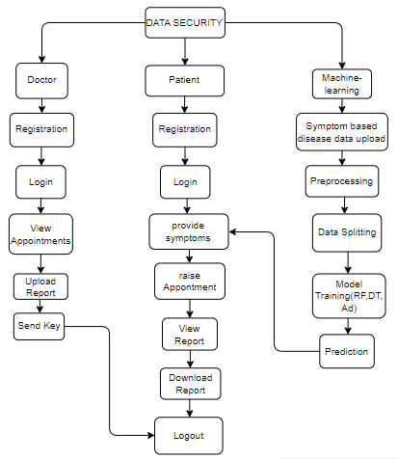
4. REQUIREMENT ANALYSIS
4.1 Functional and non-functional requirements
Requirement’s analysis is very critical process that enables the success of a system or software project to be assessed. Requirements are generally split into two types: Functional and non-functional requirements.
Functional Requirements: These are the requirements that the end user specifically demands as basic facilities that the system should offer. All these functionalities need to be necessarily incorporated into the system as a part of the contract. These are represented or stated in the form of input to be given to the system, the operation performed and the output expected. They are basically the requirements stated by the user which one can see directly in the final product, unlike the non-functional requirements.
Examples of functional requirements:
- Authentication of user whenever he/she logs into the system
- System shutdown in case of a cyber-attack
- A verification email is sent to user whenever he/she register for the first time on some software system.
Non-functional requirements: These are basically the quality constraints that the system must satisfy according to the project contract. The priority or extent to which these factors are implemented varies from one project to other. They are also called non-behavioral requirements.
They basically deal with issues like:
- Portability
- Security
- Maintainability
- Reliability
- Scalability
- Performance
- Reusability
- Flexibility
Examples of non-functional requirements:
- Emails should be sent with a latency of no greater than 12 hours from such an activity.
- The processing of each request should be done within 10 seconds
- The site should load in 3 seconds whenever of simultaneous users are > 10000
  - Hardware Requirements

Processor - I3/Intel Processor
Hard Disk - 160GB
Key Board - Standard Windows Keyboard
Mouse - Two or Three Button Mouse
Monitor - SVGA
RAM - 8GB
  - Software Requirements:
Operating System : Windows 7/8/10
Server side Script : HTML, CSS, Bootstrap & JS
Programming Language : Python
Libraries : Django, Pandas, Mysql.connector, Os, Smtplib, Numpy
IDE/Workbench : VS Code
Technology : Python 3.6+
Server Deployment : Xampp Server
Database : MySQL

SYSTEM DESIGN:

Input Design:
In an information system, input is the raw data that is processed to produce output. During the input design, the developers must consider the input devices such as PC, MICR, OMR, etc.
Therefore, the quality of system input determines the quality of system output. Well-designed input forms and screens have following properties −
- It should serve specific purpose effectively such as storing, recording, and retrieving the information.
- It ensures proper completion with accuracy.
- It should be easy to fill and straightforward.
- It should focus on user’s attention, consistency, and simplicity.
- All these objectives are obtained using the knowledge of basic design principles regarding −
  - What are the inputs needed for the system?
  - How end users respond to different elements of forms and screens.

Objectives for Input Design:
The objectives of input design are −
- To design data entry and input procedures
- To reduce input volume
- To design source documents for data capture or devise other data capture methods
- To design input data records, data entry screens, user interface screens, etc.
- To use validation checks and develop effective input controls.
Output Design:
The design of output is the most important task of any system. During output design, developers identify the type of outputs needed, and consider the necessary output controls and prototype report layouts.

Objectives of Output Design:
The objectives of input design are:
- To develop output design that serves the intended purpose and eliminates the production of unwanted output.
- To develop the output design that meets the end user’s requirements.
- To deliver the appropriate quantity of output.
- To form the output in appropriate format and direct it to the right person.
- To make the output available on time for making good decisions.
  - Architecture:
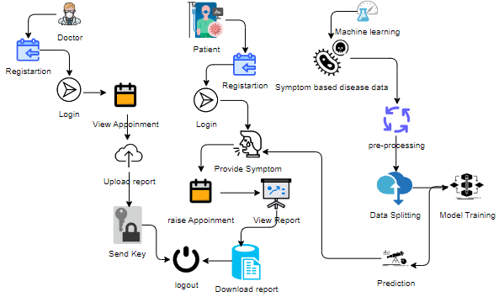

5. SYSTEM DESIGN
5.1 Introduction of Input Design:
In an information system, input is the raw data that is processed to produce output. During the input design, the developers must consider the input devices such as PC, MICR, OMR, etc.
Therefore, the quality of system input determines the quality of system output. Well-designed input forms and screens have following properties −
- It should serve specific purpose effectively such as storing, recording, and retrieving the information.
- It ensures proper completion with accuracy.
- It should be easy to fill and straightforward.
- It should focus on user’s attention, consistency, and simplicity.
- All these objectives are obtained using the knowledge of basic design principles regarding −
  - What are the inputs needed for the system?
  - How end users respond to different elements of forms and screens.

Objectives for Input Design:
The objectives of input design are −
- To design data entry and input procedures
- To reduce input volume
- To design source documents for data capture or devise other data capture methods
- To design input data records, data entry screens, user interface screens, etc.
- To use validation checks and develop effective input controls.
Output Design:
The design of output is the most important task of any system. During output design, developers identify the type of outputs needed, and consider the necessary output controls and prototype report layouts.

Objectives of Output Design:
The objectives of input design are:
- To develop output design that serves the intended purpose and eliminates the production of unwanted output.
- To develop the output design that meets the end user’s requirements.
- To deliver the appropriate quantity of output.
- To form the output in appropriate format and direct it to the right person.
- To make the output available on time for making good decisions.
5.2 UML Diagrams:
5.2.1 Use Case Diagram:
A use case diagram in the Unified Modeling Language (UML) is a type of behavioral diagram defined by and created from a Use-case analysis. Its purpose is to present a graphical overview of the functionality provided by a system in terms of actors, their goals (represented as use cases), and any dependencies between those use cases. The main purpose of a use case diagram is to show what system functions are performed for which actor. Roles of the actors in the system can be depicted.

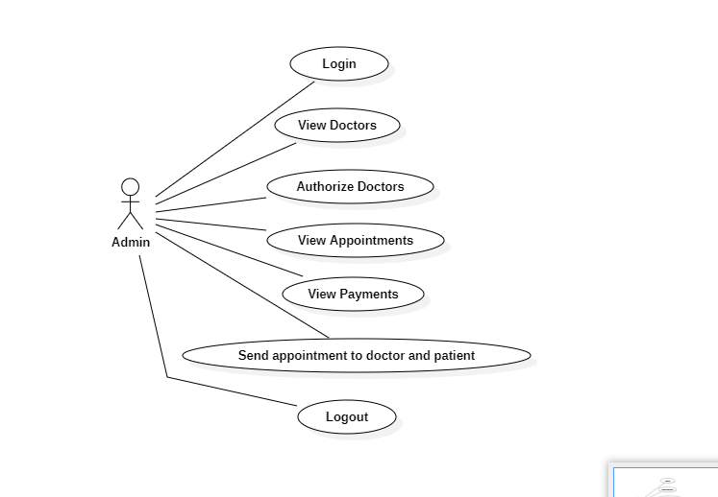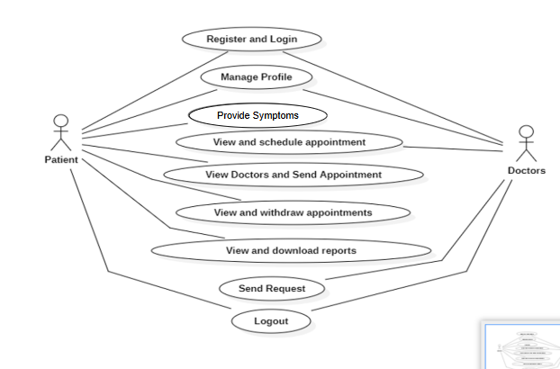

5.2.2 Class Diagram:
In software engineering, a class diagram in the Unified Modelling Language (UML) is a type of static structure diagram that describes the structure of a system by showing the system's classes, their attributes, operations (or methods), and the relationships among the classes. It explains which class contains information.

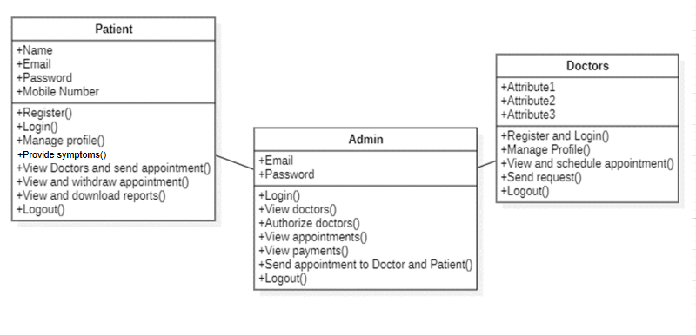
5.2.3 Sequence Diagram:
A sequence diagram in Unified Modelling Language (UML) is a kind of interaction diagram that shows how processes operate with one another and in what order. It is a construct of a Message Sequence Chart. Sequence diagrams are sometimes called event diagrams, event scenarios, and timing diagrams.

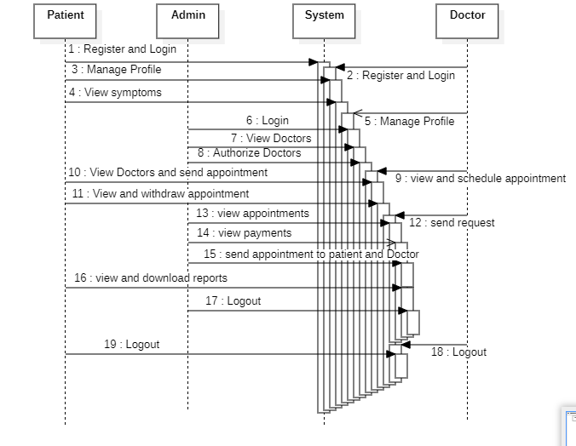
5.2.4 Collaboration Diagram:
In collaboration diagram the method call sequence is indicated by some numbering technique as shown below. The number indicates how the methods are called one after another. We have taken the same order management system to describe the collaboration diagram. The method calls are similar to that of a sequence diagram. But the difference is that the sequence diagram does not describe the object organization whereas the collaboration diagram shows the object organization. 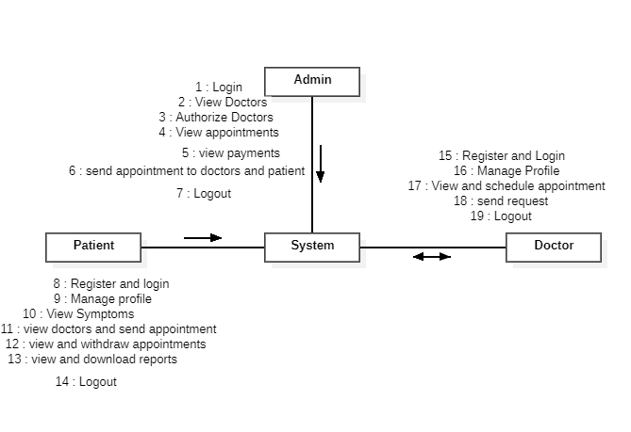
5.2.5 Deployment Diagram
Deployment diagram represents the deployment view of a system. It is related to the component diagram. Because the components are deployed using the deployment diagrams. A deployment diagram consists of nodes. Nodes are nothing but physical hardware’s used to deploy the application.
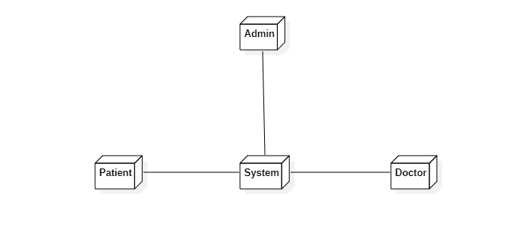
5.2.6 Activity Diagram:
Activity diagrams are graphical representations of workflows of stepwise activities and actions with support for choice, iteration and concurrency. In the Unified Modelling Language, activity diagrams can be used to describe the business and operational step-by-step workflows of components in a system. An activity diagram shows the overall flow of control.
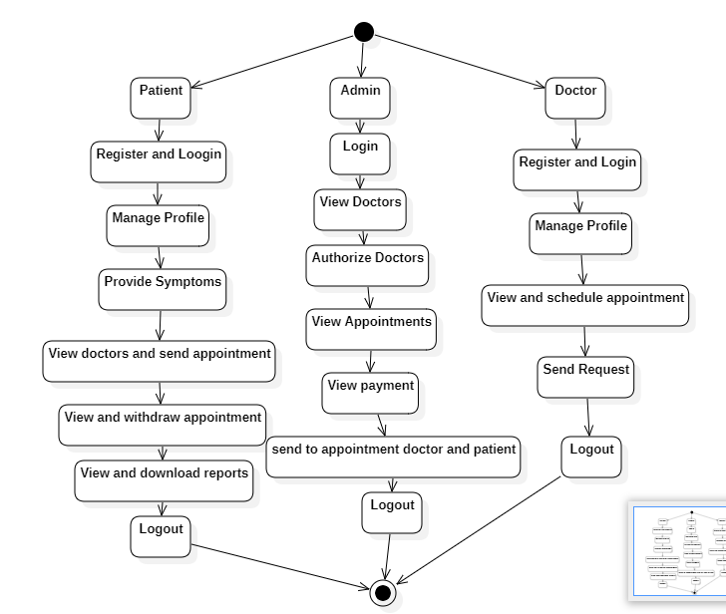
5.2.7 Component Diagram:
A component diagram, also known as a UML component diagram, describes the organization and wiring of the physical components in a system. Component diagrams are often drawn to help model implementation details and double-check that every aspect of the system's required functions is covered by planned development.
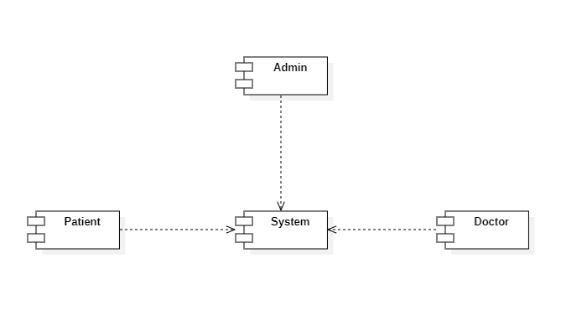

5.2.8 ER Diagram:
An Entity–relationship model (ER model) describes the structure of a database with the help of a diagram, which is known as Entity Relationship Diagram (ER Diagram). An ER model is a design or blueprint of a database that can later be implemented as a database. The main components of E-R model are: entity set and relationship set.
An ER diagram shows the relationship among entity sets. An entity set is a group of similar entities and these entities can have attributes. In terms of DBMS, an entity is a table or attribute of a table in database, so by showing relationship among tables and their attributes, ER diagram shows the complete logical structure of a database. Let’s have a look at a simple ER diagram to understand this concept.
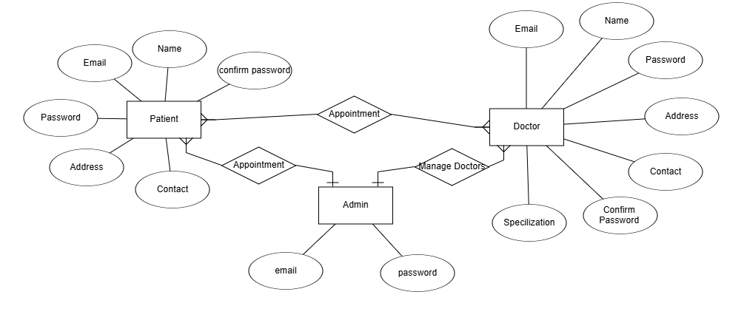
5.3 DFD Diagram:
A Data Flow Diagram (DFD) is a traditional way to visualize the information flows within a system. A neat and clear DFD can depict a good amount of the system requirements graphically. It can be manual, automated, or a combination of both. It shows how information enters and leaves the system, what changes the information and where information is stored. The purpose of a DFD is to show the scope and boundaries of a system as a whole. It may be used as a communications tool between a systems analyst and any person who plays a part in the system that acts as the starting point for redesigning a system.
Level 0:
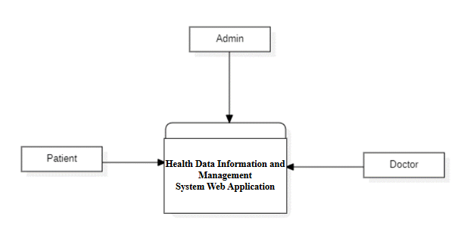
Level 1 Diagram:
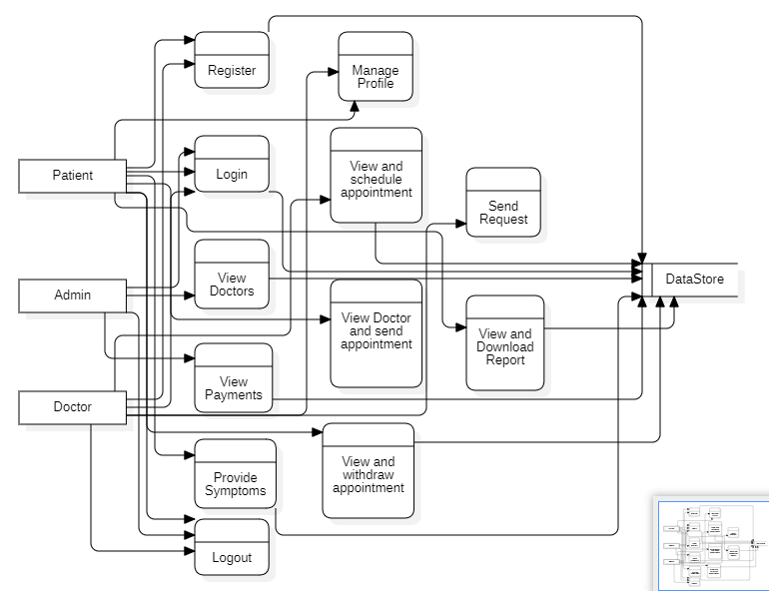

Level 2 Diagram:
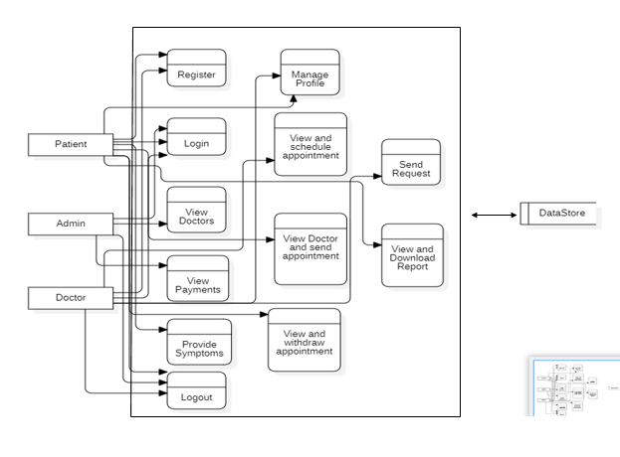

MODULES/IMPLEMENTATION
6.1 MODULES:

Patient Module
• Register & Login
- Patients can register, log in with credentials, and verify accounts.
• Manage Profile
- Update personal details and medical history.
• Provide Symptoms:
- Here User can provide symptoms
• View & Schedule Appointment
- View available doctors, select a time slot, and schedule appointments.
• View Doctors & Send Appointment Request
- View doctor profiles and request appointments.
• View & Withdraw Appointment
- View upcoming appointments and cancel if needed.
• View & Download Reports
- Access and download medical reports.
• Logout
- Log out securely from the system.

Admin Module
- Login: The admin logs in with their credentials.
- View Doctors: The admin views a list of all doctors and checks their profiles.
- Authorize Doctors: If new doctors have registered, the admin reviews their information and approves or rejects them based on the provided credentials and platform policies.
- View Appointments: The admin checks the list of pending, confirmed, or canceled appointments. If needed, they can reschedule, approve, or cancel specific appointments.
- Manage Availability: The admin can check doctor schedules and adjust any time slots that may need to be changed due to high demand or doctor unavailability.
- Generate Reports: At the end of the week or month, the admin can generate reports on platform usage, doctor performance, and patient satisfaction to ensure everything is working efficiently.
Doctor Module:
• Register & Login
- Doctors can register by providing their professional details (name, qualification, specialization, etc.).
- Secure login with credentials to access their dashboard.
• Manage Profile
- Doctors can update their profile details like contact information, qualifications, specialization, and work experience.
- Ability to change their password and upload relevant documents.
• View & Schedule Appointment
- Doctors can view their scheduled appointments, along with patient details.
- They can manage availability and schedule appointments accordingly.
• Send Request
- Doctors can send requests to the system to update their availability or other profile details.
- Requests can also be made for accepting or rejecting patient appointment requests.
• Logout
- Doctors can securely log out of their account once their session is complete.

6.2 Results:

8. SYSTEM STUDY AND TESTING
8.1 Feasibility Study
The feasibility of the project is analysed in this phase and business proposal is put forth with a very general plan for the project and some cost estimates. During system analysis the feasibility study of the proposed system is to be carried out. This is to ensure that the proposed system is not a burden to the company. For feasibility analysis, some understanding of the major requirements for the system is essential.
Three key considerations involved in the feasibility analysis are
- Economic feasibility
- Technical feasibility
- Social feasibility
Economic Feasibility
This study is carried out to check the economic impact that the system will have on the organization. The amount of fund that the company can pour into the research and development of the system is limited. The expenditures must be justified. Thus the developed system as well within the budget and this was achieved because most of the technologies used are freely available. Only the customized products had to be purchased.

Technical Feasibility
This study is carried out to check the technical feasibility, that is, the technical requirements of the system. Any system developed must not have a high demand on the available technical resources. This will lead to high demands on the available technical resources. This will lead to high demands being placed on the client. The developed system must have a modest requirement, as only minimal or null changes are required for implementing this system.
Social Feasibility
The aspect of study is to check the level of acceptance of the system by the user. This includes the process of training the user to use the system efficiently. The user must not feel threatened by the system, instead must accept it as a necessity. The level of acceptance by the users solely depends on the methods that are employed to educate the user about the system and to make him familiar with it. His level of confidence must be raised so that he is also able to make some constructive criticism, which is welcomed, as he is the final user of the system.
System Testing
The purpose of testing is to discover errors. Testing is the process of trying to discover every conceivable fault or weakness in a work product. It provides a way to check the functionality of components, sub-assemblies, assemblies and/or a finished product It is the process of exercising software with the intent of ensuring that the
Software system meets its requirements and user expectations and does not fail in an unacceptable manner. There are various types of test. Each test type addresses a specific testing requirement.

8.2 Types of Tests

8.2.1 Unit testing
Unit testing involves the design of test cases that validate that the internal program logic is functioning properly, and that program inputs produce valid outputs. All decision branches and internal code flow should be validated. It is the testing of individual software units of the application .it is done after the completion of an individual unit before integration. This is a structural testing, that relies on knowledge of its construction and is invasive. Unit tests perform basic tests at component level and test a specific business process, application, and/or system configuration. Unit tests ensure that each unique path of a business process performs accurately to the documented specifications and contains clearly defined inputs and expected results.

8.2.2 Integration testing
Integration tests are designed to test integrated software components to determine if they actually run as one program. Testing is event driven and is more concerned with the basic outcome of screens or fields. Integration tests demonstrate that although the components were individually satisfaction, as shown by successfully unit testing, the combination of components is correct and consistent. Integration testing is specifically aimed at exposing the problems that arise from the combination of components.
Software integration testing is the incremental integration testing of two or more integrated software components on a single platform to produce failures caused by interface defects.
The task of the integration test is to check that components or software applications, e.g. components in a software system or – one step up – software applications at the company level – interact without error.
Test Results: All the test cases mentioned above passed successfully. No defects encountered.

Acceptance Testing
User Acceptance Testing is a critical phase of any project and requires significant participation by the end user. It also ensures that the system meets the functional requirements.
Test Results: All the test cases mentioned above passed successfully. No defects encountered.

8.2.3 Functional testing
Functional tests provide systematic demonstrations that functions tested are available as specified by the business and technical requirements, system documentation, and user manuals.
Functional testing is centered on the following items:
Valid Input : identified classes of valid input must be accepted.
Invalid Input : identified classes of invalid input must be rejected.
Functions : identified functions must be exercised.
Output : identified classes of application outputs must be exercised.
Systems/Procedures: interfacing systems or procedures must be invoked.
Organization and preparation of functional tests is focused on requirements, key functions, or special test cases. In addition, systematic coverage pertaining to identify Business process flows; data fields, predefined processes, and successive processes must be considered for testing. Before functional testing is complete, additional tests are identified and the effective value of current tests is determined.

8.2.4 White Box Testing
White Box Testing is a testing in which in which the software tester has knowledge of the inner workings, structure and language of the software, or at least its purpose. It is purpose. It is used to test areas that cannot be reached from a black box level.

8.2.5 Black Box Testing
Black Box Testing is testing the software without any knowledge of the inner workings, structure or language of the module being tested. Black box tests, as most other kinds of tests, must be written from a definitive source document, such as specification or requirements document, such as specification or requirements document. It is a testing in which the software under test is treated, as a black box. you cannot “see” into it. The test provides inputs and responds to outputs without considering how the software works.
Test objectives
- All field entries must work properly.
- Pages must be activated from the identified link.
- The entry screen, messages and responses must not be delayed.
Features to be tested
- Verify that the entries are of the correct format
- No duplicate entries should be allowed
- All links should take the user to the correct page.
- TEST CASES:
Input | Output | Result
Input text files | A novel Approach to Enhance Doctor Availability and Appointments Using Digital Technology | Success

- Test cases Model building:
S.NO | Test cases | I/O | Expected O/T | Actual O/T | P/F
1 | Register Students, Company | Enter name, email, password, conform password, contact, address. | Registered successfully. | Registered successfully | P
2 | Login Students, Company | Enter email, password. | Login successful | Login successful | P
3 | Login Students, Company | Enter email, password. | Login successful | Login fail | F
4 | Add Derive details | Enter date of conduct, marks, exam stage, salary, job description. | Data added successfully | Data added successfully | P
5 | Add Exam | Enter MCQ, coding test | Data added successfully | Fail to add data | F

- CONCLUSION:
In conclusion, the healthcare platform effectively bridges the gap between patients and doctors, offering a streamlined and efficient digital environment for managing healthcare services. By integrating features such as symptom-based disease prediction, doctor appointment management, and secure access to medical reports, the platform enhances the user experience for both patients and healthcare professionals. This system not only simplifies communication and appointment scheduling but also provides timely access to crucial medical information. Ultimately, the platform aims to improve the overall convenience, efficiency, and accessibility of healthcare, contributing to a more connected and effective healthcare experience for all users.
10. FUTURE ENHANCEMENT
In the future, a healthcare platform can be significantly enhanced by incorporating advanced technologies to improve user experience. One potential enhancement is the integration of diagnostic tools that predict diseases based on symptoms and recommend personalized treatments, medications, and lifestyle changes.
Additionally, telemedicine features like video consultations could be added, enabling real-time doctor-patient interactions. This would make healthcare more accessible, particularly in remote areas. A personalized health dashboard could help patients track vital health metrics, receive medication reminders, and stay proactive in managing their health. Incorporating a virtual health assistant could provide continuous support and guidance based on the patient’s health data.
An Electronic Health Record (EHR) system could also be integrated to provide seamless access to a patient’s complete medical history and reports. Smart appointment scheduling could optimize doctor-patient availability and reduce waiting times.
Blockchain technology could ensure enhanced security and privacy of patient data, safeguarding sensitive health information and ensuring that it is securely shared only with authorized parties. Blockchain could also enhance transparency in medical transactions, such as prescriptions and insurance claims.
Additionally, integrating wearable device data with the platform could provide real-time health insights, tracking activity, sleep patterns, and other vital signs. Social features like health communities or peer support networks could also help patients connect with others facing similar health challenges, improving engagement and motivation in managing chronic conditions.
With all these advancements, the healthcare platform could provide a highly personalized, secure, and efficient experience for both patients and healthcare providers.
11. REFERANCES
1. Moore, J. E., & Eysenbach, G. (2019). Telemedicine: A guide to the future of healthcare. Springer.
This book provides an in-depth exploration of telemedicine, including its history, current applications, and future trends.
2. Wootton, R. (2012). Telemedicine in the National Health Service. Journal of Telemedicine and Telecare, 18(4), 193-197. This article discusses the role of telemedicine in public healthcare systems and how it facilitates patient-doctor communication.
3. Laranjo, L., et al. (2018). Chatbots in healthcare: A systematic review. Journal of the American Medical Informatics Association, 25(5), 794-804. A systematic review of how chatbots are being integrated into healthcare settings for initial diagnosis, symptom checking, and patient support.
4. Fadhil, A., et al. (2020). Conversational agents in healthcare: A survey. Journal of Healthcare Engineering, 2020, 1-17. This paper surveys the development and use of conversational agents (chatbots) in healthcare, focusing on their potential and limitations.
5. Kvedar, J. C., et al. (2014). Telemedicine: A new frontier in the delivery of healthcare. Journal of General Internal Medicine, 29(1), 13-16. An article discussing how telemedicine can improve patient-doctor interactions and streamline healthcare delivery.
6. Berner, E. S. (2017). Clinical decision support systems: Theory and practice. Springer.
This book explores clinical decision support systems (CDSS) and how they enhance healthcare practices, including patient interactions and decision-making.
7. Häyrinen, K., Saranto, K., & Nykänen, P. (2008). Definition, structure, content, use and impacts of electronic health records: A review of the research literature. International Journal of Medical Informatics, 77(5), 291-304. A comprehensive review of the role and impact of electronic health records (EHRs) on patient care and information sharing.
8. Gartner, W. J., et al. (2020). Digital health platforms and EHR: Transforming the patient experience. Journal of Medical Internet Research, 22(9), e18522. This article discusses how digital health platforms enhance patient experiences by improving appointment scheduling, medical record management, and communication.
9. Buntin, M. B., Burke, M. F., & Hoaglin, M. C. (2011). The benefits of health information technology: A review of the recent literature shows predominantly positive results. Health Affairs, 30(3), 464-471. A review of literature examining the benefits and outcomes of health information technologies in improving healthcare services.
10. Kellermann, A. L., & Jones, S. S. (2013). What it will take to achieve the as-yet-unfulfilled promises of health information technology. Health Affairs, 32(1), 63-68.
This article evaluates the promises and challenges of health information technology and its future potential in enhancing healthcare delivery.

