1.To check the given number is pronic or not.

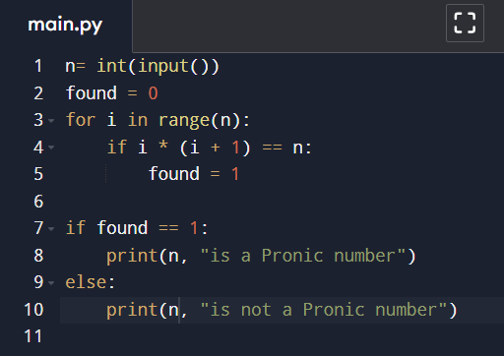

2.to check the given number is perfect or not.

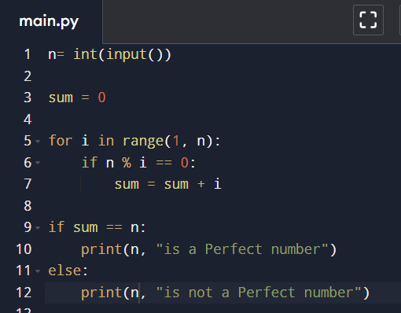

3.write a program for Fibonacci series .

