1.write a program to print sum of two numbers.

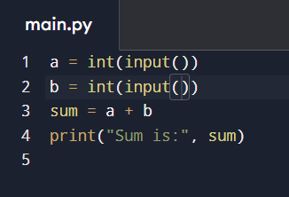

2.write a program to Find Largest of Two Numbers.

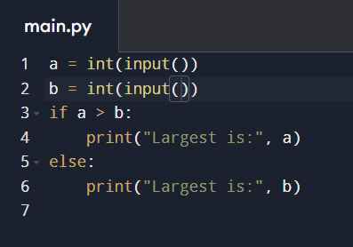

3. write a program to Find Sum of First N Natural Numbers.

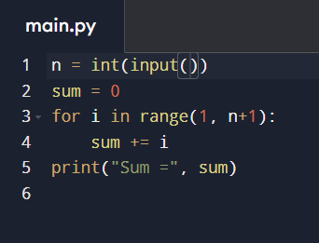

4. Program to Swap Two Numbers Without Temp Variable.

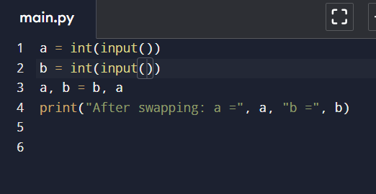

5. program to print Table of a Number .

