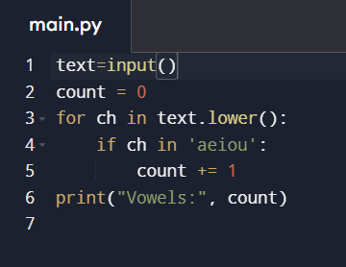1.write a program to Count Vowels in a String.

2. Write a program to Find Minimum and Maximum in a List.

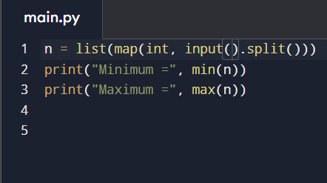

3.Write a program to perform arithmetic operations.

