11th august 2025

1.To check the given number is Even or Odd program.

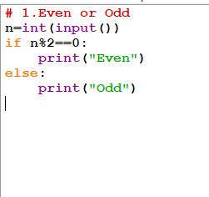

2.To check the given number is positive or negative or zero program.

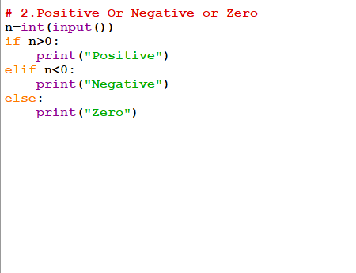

3.To check the given number is prime or not.

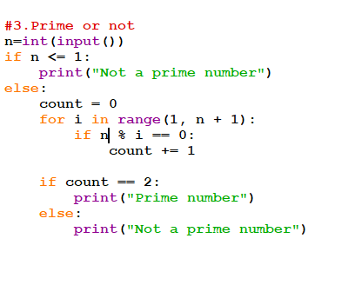

4.To check the given number is factorial or not.

