**CHAPTER1**

**INTRODUCTION**

1. **INTRODUCTION**

The "Online Food Ordering System" has been developed to override the problems prevailing in the practicing manual system. This software is supported to eliminate and,in some cases, reduce the hardships faced by this existing system. Moreover, this system is designed for the particular need of the company to carry out operations in a smooth and effective manner.The application is reduced as much as possible to avoid errors while entering the data.It also provides error message while entering invalid data. No formal knowledge is needed for the user to use this system. Thus, by this all it proves it is user-friendly.Online Food Ordering System, as described above, can lead to error free, secure,reliable and fast management system. It can assist the user to concentrate on their other activities rather to concentrate on the record keeping. Thus, it will help organization in better utilization of resources.Every organization, whether big or small, has challenges to overcome and managing the information of Category, Food Item, Order, Payment, Confirm Order. Every Online Food Ordering System has different Food Item needs; therefore, we design exclusive employee management systems that are adapted to your managerial requirements.This is designed to assist in strategic planning and will help you ensure that your organization is equipped with the right level of information and details for your future goals. Also, for those busy executives who are always on the go, our systems come with remote access features, which will allow you to manage your workforce anytime, at all times. These systems will ultimately allow you to better manage resources.

**1.1** **OBJECTIVE:**

The People have to be present condition in taken food from Hotel that means People had to compulsion of goes to Hotel.Now the moment the Online food ordering could be called the response of the Internet to the desire for delivery food.It is a growing trend especially in urban areas and on college campuses that allows people to order from restaurants featuring interactive menus, by use of their Internet connection.

This study lays out a framework for a new system to be developed and brought to the market for maximum use and to create an avenue through the web where users can log on to our server and make a selection of whatever goods or food they like and subsequently pay via the internet. The following are the objectives this would bring:

1. The home page of this web interfile provides an avenue where customers

will be able to gather more and reliable information about what the fast food

industry really does.

2. The products and services offered would provide the customers with all the

different categories of available products that they can choose and select

from.

3. This will provide a user friendly environment between the customer and

employee thus increasing the efficiency of the food ordering system.

4. There will also be an online purchase form with which valued customers

will be using to get in touch with any of their request whenever the need

arises.

It will also help for easy retrieval of orders made by the customers.

**1.2 PROJECT DESCRIPTION**

As industries are fast expanding, people are seeking for more ways to purchase products with much ease and still maintain cost effectiveness. The vendors need to purchase the products in order to sell to end users. The manual method of going to their local food sales outlets to purchase food is becoming obsolete and more tasking. Food can be ordered through the internet and payment made without going to the restaurant or the food vendor. So there is need for a wide range of publicity and enabling direct order, processing and delivering of food through online system.For this system, there will be a system administrator who will have the rights to enter the menu with current prevailing prices.

**1.3 SIGNIFICANCE OF STUDY**

In view of the rapid development of computer technology in almost all the fields of operation and its use in relation to information management, it has become important to look into the development of online ordering system for firms to meet up with demands of the customers. Therefore, the food ordering and delivery system will help customers and management to:

1. Advertise available foods in their company

2. Reduce the workload in the present system

3. Reduce time wasted in data processing

4. Create a platform for online purchase and delivery of fast food

5. Keep accurate record on purchased order and delivery.

**1.4 SCOPE**

In this project, a fast food company is designed,the food is taken as a case study to enable customers order for food and get it delivered accordingly and also to reduce the long queues of customers at the counter ordering for food and to reduce the work lord on the employees.

The following things are among other things that are discussed and what the software would handle:

*  About the company
*  The food and the services offered there
*  Online purchase
*  Type of food provided.

**1.4 LITERATURE SURVEY**

**[1]“A Proposed System for Touchpad Based Food Ordering System Using Android Application”, International Journal of Advanced Research in Computer Science Technology (IJARCST 2015).**

The author of the paper describes about an automated food ordering system is proposed which will keep track of user orders smartly. Basically, they implemented a food ordering system for different type of restaurants in which user will make order or make custom food by one click only. By means of android application for Tablet PCs this system was implemented. The front end was developed using JAVA, Android and at the backend MySQL database was used.

**[2]”Implementing Customizable Online Food Ordering System Using Web Based Application”, International Journal of Innovative Science, Engineering Technology(IJISET) 2015.**

The author in this paper describes the Customer using a Smartphone is considered as a basic assumption for the system. When the customer approach to the restaurant, the saved order can be confirmed by touching the Smartphone. The list of selected preordered items shall be shown on the kitchen screen, and when confirmed, order slip shall be printed for further order processing. The solution provides easy and convenient way to select pre-order transaction form customers.

**[3]” Implementation of Smart Restaurant with e-menu Card,” International Journal of Computer Applications 2015 of Smart Restaurant with emenu Card, ”International Journal of Computer Applications 2015.**

The author decribes the research works on efforts taken by owners of restaurants to adopt information and communication technologies such as PDA, wireless LAN, costly multi-touch screens, etc. to enhance dining experience. This paper highlights some of the limitations of the conventional paper based and PDA-based food ordering system and proposed the low-cost touch screen-based Restaurant Management System using an android Smartphone or tablet as a solution. **CHAPTER 2**

**SYSTEM ANALYSIS**

**2.1 SYSTEM ANALYSIS**

System analysis is a process of gathering and interpreting facts, diagnosing problems and the information to recommend improvements on the system. It is a problem solving activity that requires intensive communication between the system users and system developers. System analysis or study is an important phase of any system development process. The system is studied to the minutest detail and analyzed. The system analyst plays the role of the interrogator and dwells deep into the working of the present system. The system is viewed as a whole and the input to the system are identified. The outputs from the organizations are traced to the various processes. System analysis is concerned with becoming aware of the problem, identifying the relevant and decisional variables, analyzing and synthesizing the various factors and determining an optimal or at least a satisfactory solution or program of action and the software should run with multiple threads.

A detailed study of the process must be made by various techniques like interviews, questionnaires etc. The data collected by these sources must be scrutinized to arrive to a conclusion. The conclusion is an understanding of how the system functions. This system is called the existing system. Now the existing system is subjected to close study and problem areas are identified. The designer now functions as a problem solver and tries to sort out the difficulties that the enterprise faces. The solutions are given as proposals. The proposal is then weighed with the existing system analytically and the best one is selected. The proposal is presented to the user for an endorsement by the user. The proposal is reviewed on user request and suitable changes are made. This is loop that ends as soon as the user is satisfied with proposal and it should be free of relating with the multiple threads. .  
  
Preliminary study is the process of gathering and interpreting facts, using the information for further studies on the system. Preliminary study is problem solving activity that requires intensive communication between the system users and system developers. It does various feasibility studies. In these studies a rough figure of the system activities can be obtained, from which the decision about the strategies to be followed for effective system study and analysis can be taken.

**Existing System**

The existing system happens to be a non computerized operating system were all

operations are done manually by the waiter carrying paper and to take down the

order of the customer or making an order over the counter. This leads to mistakes

because the waiter might not understand what the customer had ordered therefore

serving him/her a different menu. This could be so embarrassing because the

customer might not take it lightly with the waiter which may lead to

misunderstanding.

Due to manual means being employed by the fast food restaurants, it is very

difficult to satisfy the wants and needs of the customers. Most of the problems

include:

1. Mistakes are made when taking the orders of the customers

2. The process of collecting customers’ purchases order is very tedious.

This makes it impossible to deliver goods on time.

3. It leads to lack of understanding between the customers and the

Employees.

**ProposedSystem**  
  
The aim of proposed system is to develop a system of improved facilities. The proposed system can overcome all the limitations of the existing system. The system provides proper security and reduces the manual work.

* Security of data.
* Ensure data accuracy's.
* Proper control of the higher officials.
* Minimize manual data entry.
* Minimum time needed for the various processing.
* Greater efficiency.
* Better service.
* User friendliness and interactive.
* Minimum time required.

**2**.**2 SYSTEM ARCHITECTURE**  
 **Introduction**

Design is the first step into the development phase for any engineered product or system. Design is a creative process. A good design is the key to effective system. The term "design" is defined as "the process of applying various techniques and principles for the purpose of defining a process or a system in sufficient detail to permit its physical realization". It may be defined as a process of applying various techniques and principles for the purpose of defining a device, a process or a system in sufficient detail to permit its physical realization. Software design sits at the technical kernel of the software engineering process and is applied regardless of the development paradigm that is used. The system design develops the architectural detail required to build a system or product. As in the case of any systematic approach, this software too has undergone the best possible design phase fine tuning all efficiency, performance and accuracy levels. The design phase is a transition from a user oriented document to a document to the programmers or database personnel.System design goes through two phases of development: Logical and Physical Design.

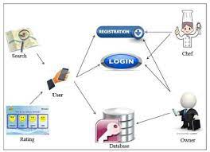

2.1 System architecture

**DESIGN STANDARD**

The system is designed with several interaction cues on each web page that

makes up the web application (Bristo). These cues are well-defined such as to

make several functionality that the application exposes to collect, process and

output data. Access to these functionalities is made possible by the well designed

user interface which embodies several technologies such as JavaScript and php) to process data. The application is built in a modular form

where these functionalities are built into modules. Some of the modules are as

follows:

1. login.php

2. adminlogin.php

3. orders.php

4. tickets.php

5. register.php

**2.3 UML DIAGRAMS**

**2.3.1 USE CASE DIAGRAM**

A use case diagram at its simplest is a representation of a user's interaction with the system and depicting the specifications of a [use case](http://en.wikipedia.org/wiki/Use_Case). A use case diagram can portray the different types of users of a system and the various ways that they interact with the system.Admin maintains all the details and update the information so thet it will be useful to police officers to save the time instead of searching in manual records.User can only view the data. Admin can change the data from the database.

 The purposes of use case diagrams can be as follows:

* Used to gather requirements of a system.
* Used to get an outside view of a system.
* Identify external and internal factors influencing the system.
* Show the interacting among the requirements are actors.

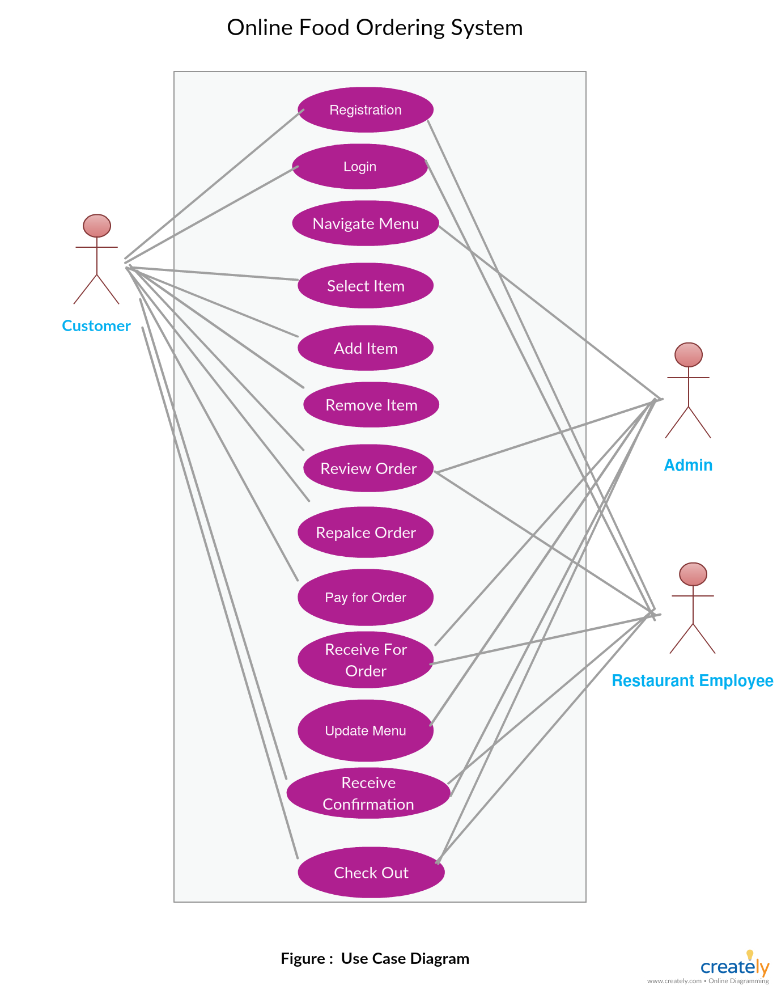

**Fig 2.3.1.1.Use Case Diagram**

**2.3.2 CLASS DIAGRAM**

The class diagram is a static diagram. It represents the static view of an application. Class diagram is not only used for visualizing, describing and documenting different aspects of a system but also for constructing executable code of the software application.

The class diagram describes the attributes and operations of a class and also the constraints imposed on the system.

The above class diagram explains about the different operations done by the admin and the user.

Class diagrams are used for:

* Describing the static view of the system.
* Showing the collaboration among the elements of the static view.
* Describing the functionalities performed by the system.
* Construction of software applications using object orientedlanguages

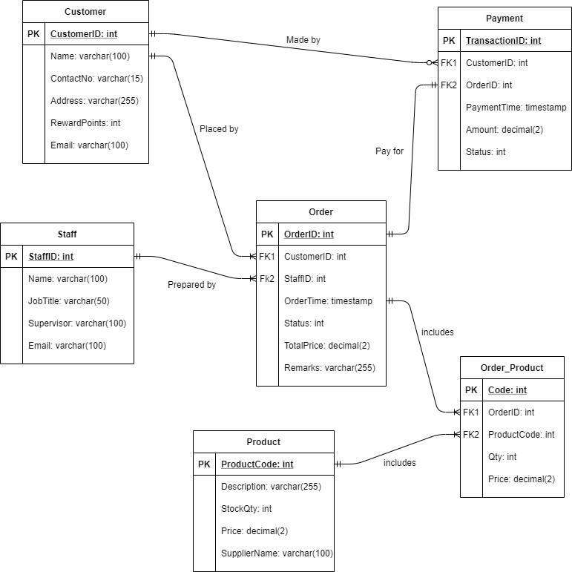 **Fig 2.3.2.1 Class Diagram**

**2.3.3.SEQUENCE DIAGRAM**

A sequence diagram is an [interaction diagram](http://en.wikipedia.org/wiki/Interaction_diagram) that shows how processes operate with one another and in what order. It is a construct of a [Message Sequence Chart](http://en.wikipedia.org/wiki/Message_Sequence_Chart). A sequence diagram shows object interactions arranged in time sequence. It depicts the objects and classes involved in the scenario and the sequence of messages exchanged between the objects needed to carry out the functionality of the scenario

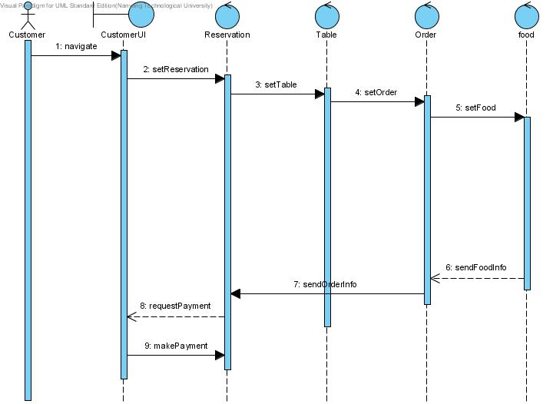

**2.3.3.1 Sequence Diagram**

**2.3.4.COLLABORATION DIAGRAM**

A collaboration diagram, also called a communication diagram or interaction diagram, is an illustration of the relationships and interactions among [software](http://searchsoa.techtarget.com/definition/software) [object](http://searchsoa.techtarget.com/definition/object)s in the Unified Modeling Language (UML). The concept is more than a decade old although it has been refined as modeling paradigms have evolved.

A collaboration diagram resembles a [flowchart](http://whatis.techtarget.com/definition/flowchart) that portrays the roles, functionality and behavior of individual objects as well as the overall operation of the system in [real time](http://searchcio-midmarket.techtarget.com/definition/real-time). Objects are shown as rectangles with naming labels inside. These labels are preceded by colons and may be underlined. The relationships between the objects are shown as lines connecting the rectangles. The [message](http://whatis.techtarget.com/definition/message)s between objects are shown as arrows connecting the relevant rectangles along with labels that define the message sequencing.

Collaboration diagrams are best suited to the portrayal of simple interactions among relatively small numbers of objects.

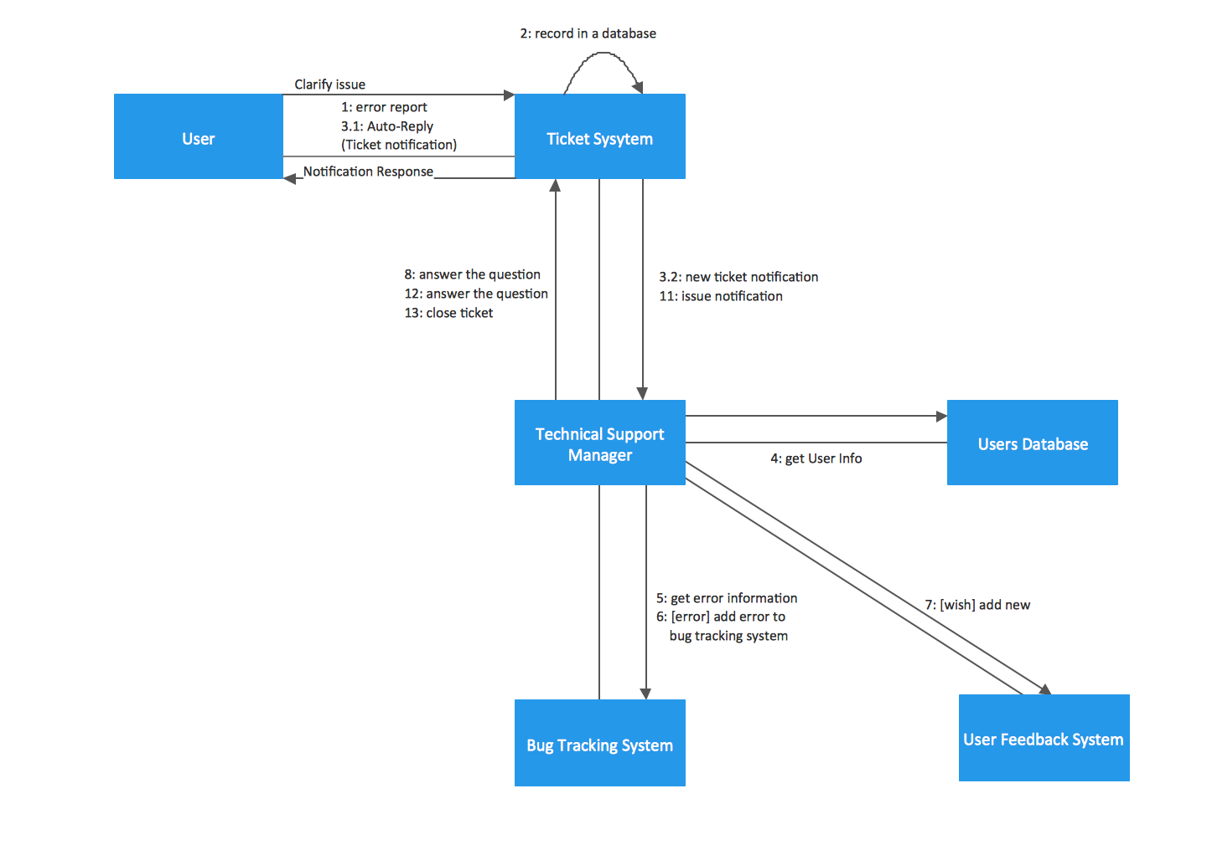

**Fig 2.3.4.1 Colloboration Diagram**

**2.3.5.ACTIVITY DIAGRAM**

Activity diagrams are graphical representations of [workflows](http://en.wikipedia.org/wiki/Workflow) of stepwise activities and actions[[1]](http://en.wikipedia.org/wiki/Activity_diagram#cite_note-1) with support for choice, iteration and concurrency. In the [Unified Modeling Language](http://en.wikipedia.org/wiki/Unified_Modeling_Language), activity diagrams are intended to model both computational and organisational processes (i.e. workflows).[[2]](http://en.wikipedia.org/wiki/Activity_diagram#cite_note-2)[[3]](http://en.wikipedia.org/wiki/Activity_diagram#cite_note-3) Activity diagrams show the overall flow of control.

Activity diagrams are constructed from a limited number of shapes, connected with arrows.

The most important shape types:

* rounded rectangles represent actions;
* diamonds represent decisions;
* bars represent the start (split) or end (join) of concurrent activities;
* a black circle represents the start (initial state) of the workflow;
* an encircled black circle represents the end (final state).

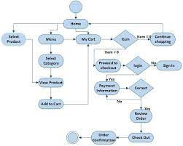

**Fig 2.3.5.1 Activity Diagram**

**2.3.6.COMPONENT DIAGRAM**

Component diagram is a special kind of diagram in UML. The purpose is also different from all other diagrams discussed so far. It does not describe the functionality of the system but it describes the components used to make those functionalities.

 Purpose of the component diagram can be summarized as:

* Visualize the components of a system.
* Construct executables by using forward and reverse engineering.

Describe the organization and relationships of the components

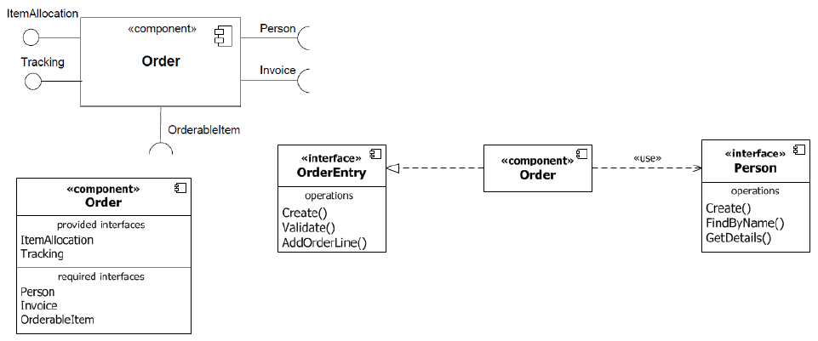

**Fig 2.3.6.1 Component Diagram**

**2.3.7.DEPLOYMENT DIAGRAM**

A deployment diagram in the [Unified Modeling Language](http://en.wikipedia.org/wiki/Unified_Modeling_Language) models the physical deployment of [artifacts](http://en.wikipedia.org/wiki/Artifact_(UML)) on [nodes](http://en.wikipedia.org/wiki/Node_(UML)).[[1]](http://en.wikipedia.org/wiki/Deployment_diagram#cite_note-1) To describe a web site, for example, a deployment diagram would show what hardware components ("nodes") exist (e.g., a web server, an application server, and a database server), what software components ("artifacts") run on each node (e.g., web application, database), and how the different pieces are connected (e.g. JDBC, REST, RMI).

The nodes appear as boxes, and the artifacts allocated to each node appear as rectangles within the boxes. Nodes may have subnodes, which appear as nested boxes. A single node in a deployment diagram may conceptually represent multiple physical nodes, such as a cluster of database servers.

Deployment diagrams are used to visualize the topology of the physical components of a system where the software components are deployed.So deployment diagrams are used to describe the static deployment view of a system. Deployment diagrams consist of nodes and their relationships

The purpose of deployment diagrams can be described as:

* Visualize hardware topology of a system.
* Describe the hardware components used to deploy software components.
* Describe runtime processing nodes.

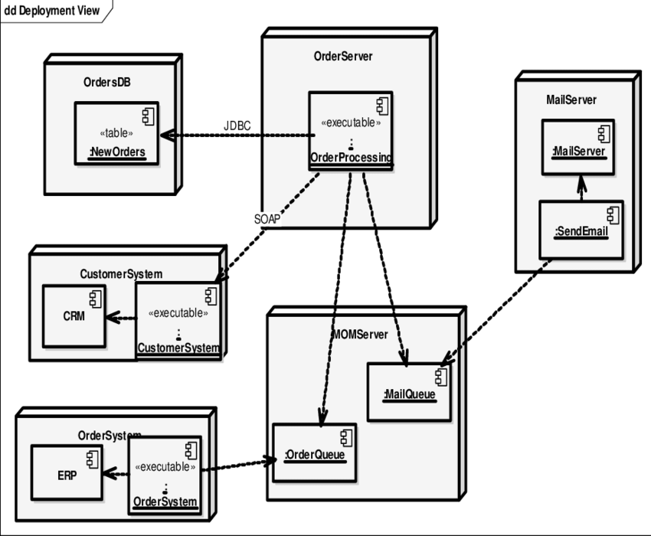

**Fig 2.3.7.1 Deployment Diagram**

**2.3.8 ER Diagram**

An entity–relationship model (ER model) is a [data model](http://en.wikipedia.org/wiki/Data_modeling) for describing the data or information aspects of a business domain or its process requirements, in an abstract way that lends itself to ultimately being implemented in a [database](http://en.wikipedia.org/wiki/Database) such as a [relational database](http://en.wikipedia.org/wiki/Relational_database). The main components of ER models are [entities](http://en.wikipedia.org/wiki/Entities) (things) and the relationships that can exist among them.An entity-relationship model is a systematic way of describing and defining a business process. The process is modeled as components (entities) that are linked with each other byrelationships that express the dependencies and requirements between them, such as: one building may be divided into zero or more apartments, but one apartment can only be located in one building. Entities may have various properties (attributes) that characterize them. Diagrams created to represent these entities, attributes, and relationships graphically are called entity–relationship diagrams.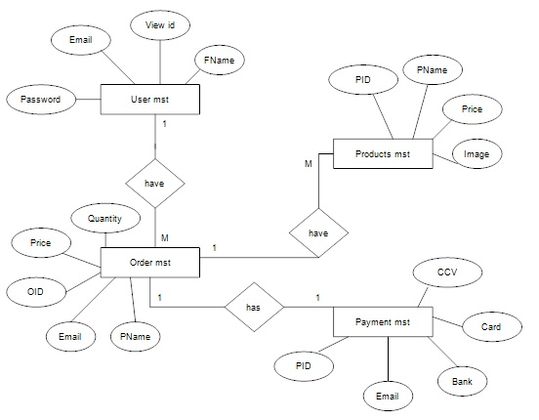

**Fig 2.3.8.1 Entity Diagram**

**CHAPTER 3**

**MODULES**

**3.MODULES**

* Admin
* User
  1. **MODULES DESCRIPTION:**

**31.1 Main Page**

Main Page contains all the information about the restaurant and the list of foods available,and the order page and so on.

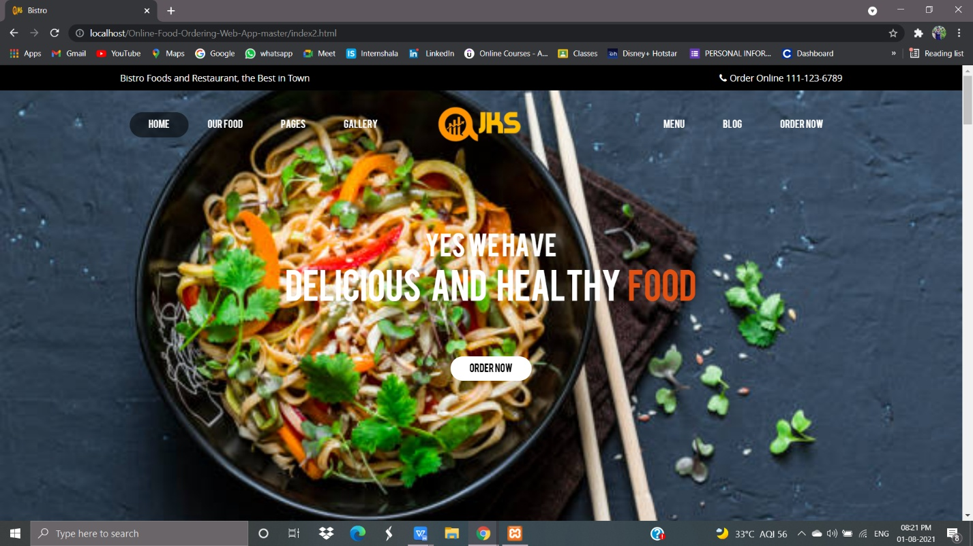

**3.1.1 Login Page**

Admin logins with username and password. Admin authenticates all the information .User can also login and can view the information. User can’t update the information. Admin can delete the users and can add the users. So that the users can view only the information after completing their login with their username and password. Everything is stored in db and it can be viewed only by the admin.

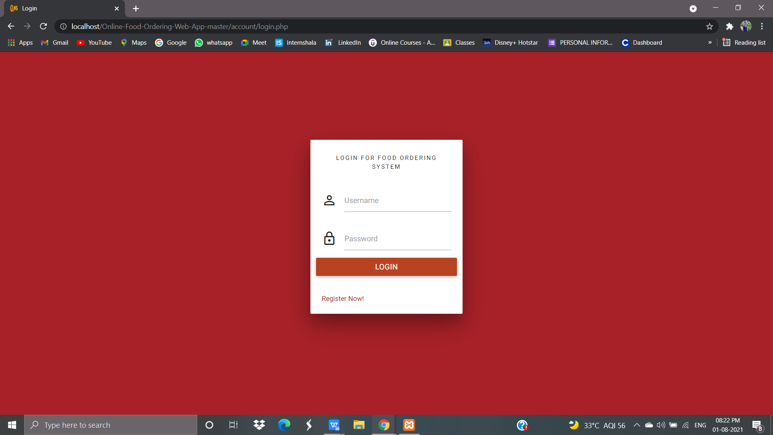

**3.1.2 Account Registration**

This module helps to register the details about the User Account Information. This is done by entering some personal details, like name,user name,password and confirm password.

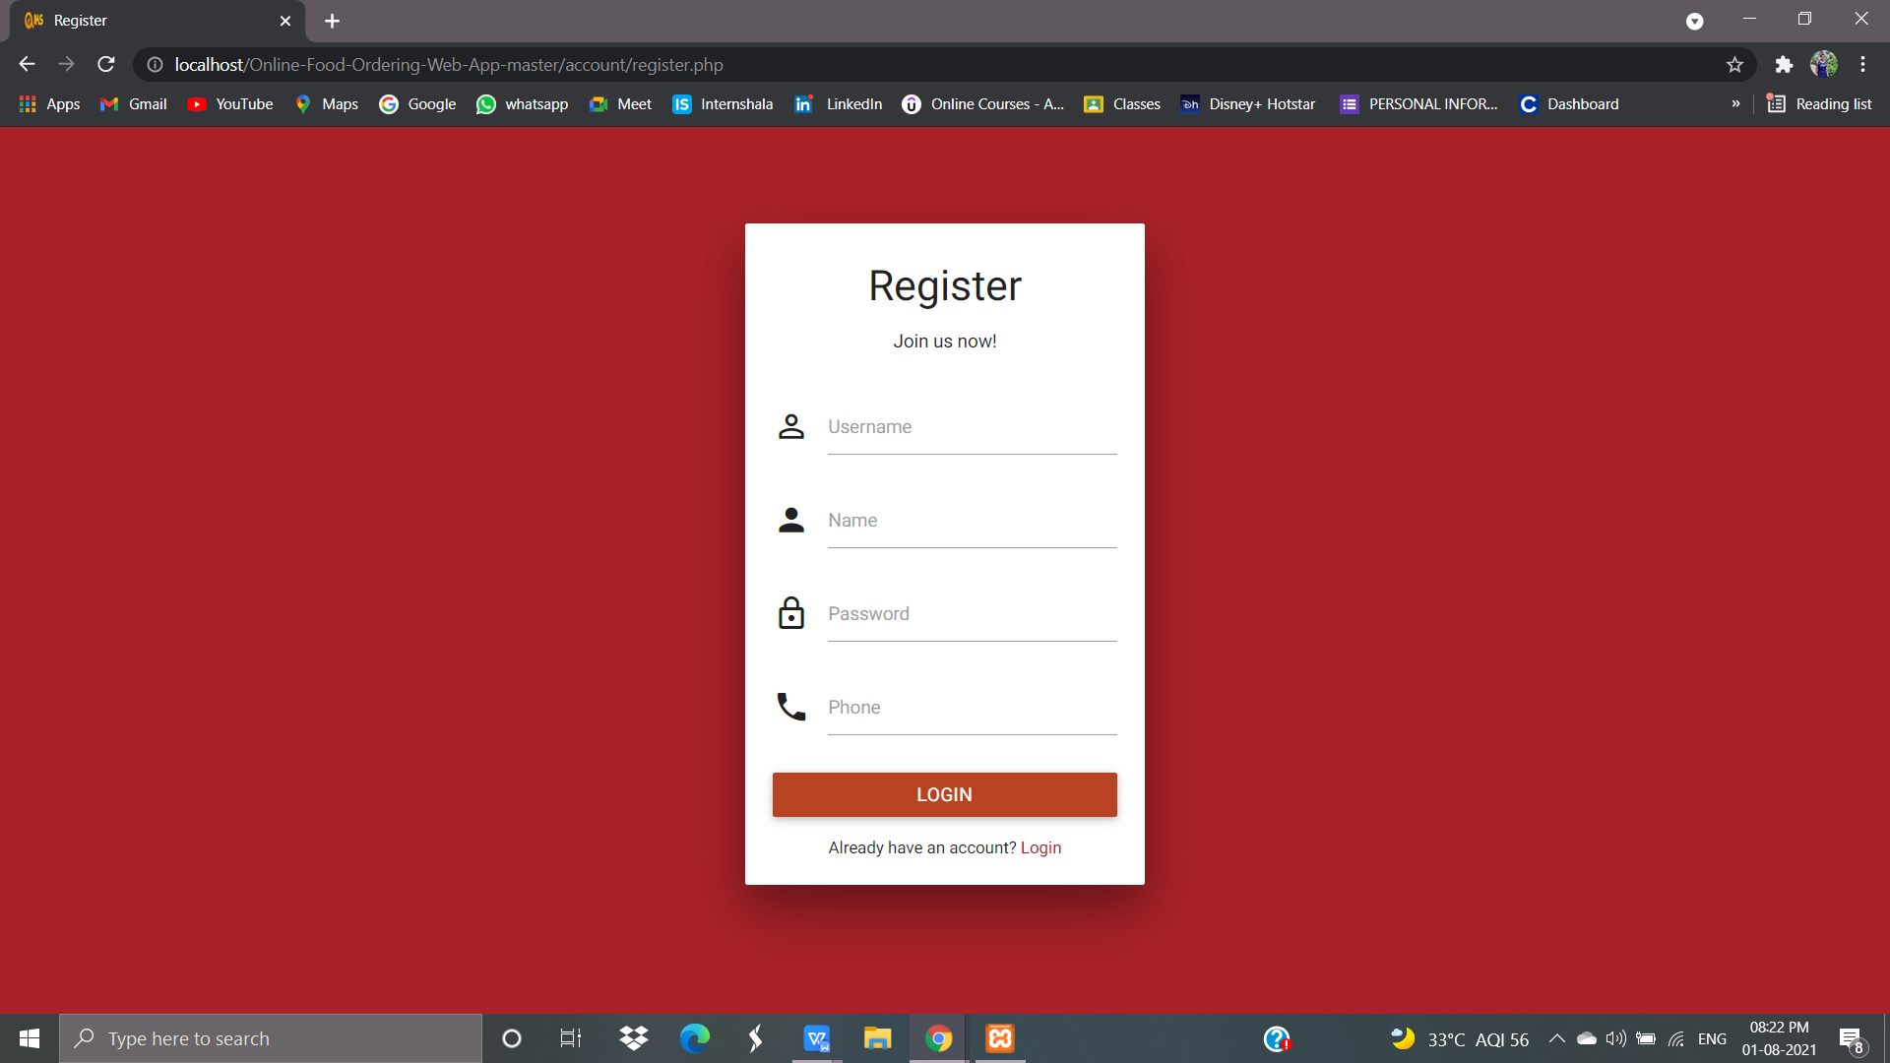

**3.1.3 Admin Page**

User can perform his operations as soon as the user authenticates himself as a customer, The customer can perform the following operations orders,users,tickets,add items,delete items.

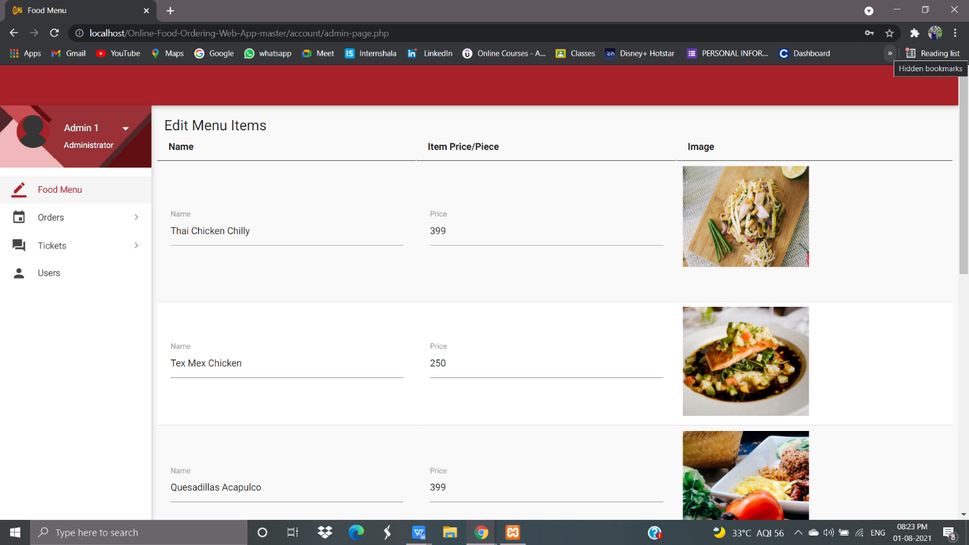

**3.1.4 User Page**

This module allows viewing the User to check their orders after logging into their personal account.

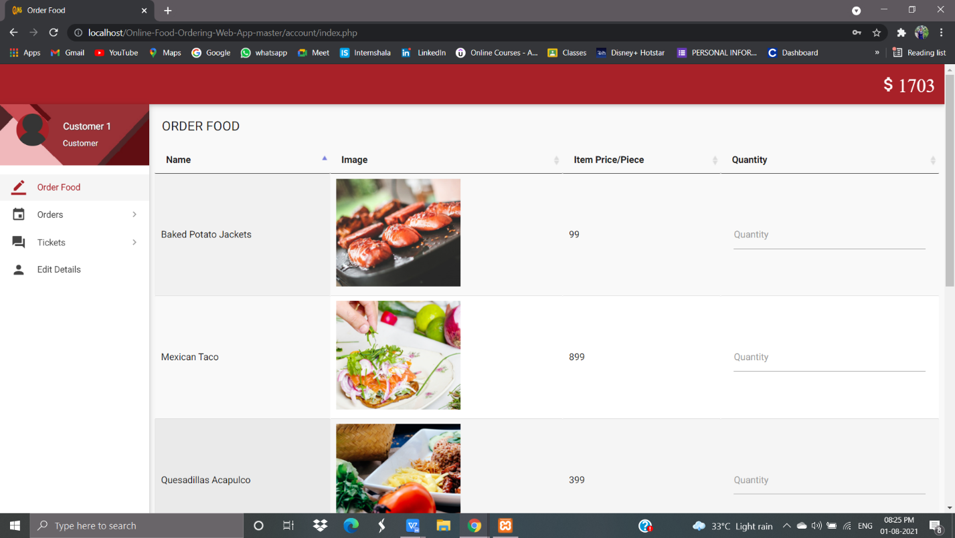

**3.1.5 User ordering Page -Ordering foods**

Here the User can order food after the user has logged in to their personal account.

And customer can click on the order now option. The order was confirmed.And the user can also delete the order.

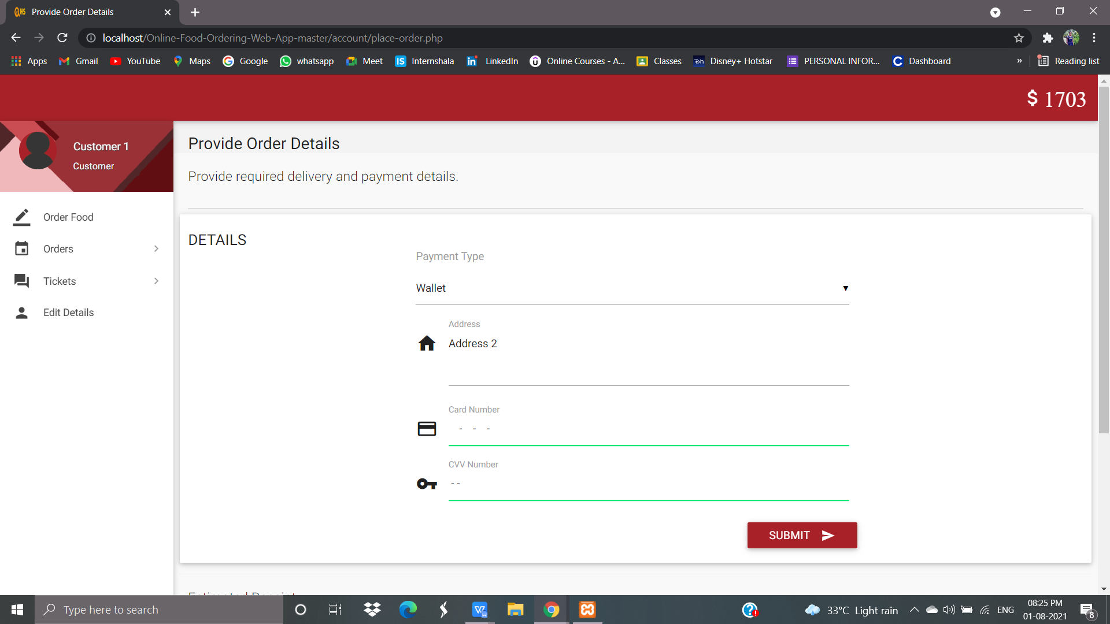

**3.1.6 User Page – Ticket raising**

The user can write the queries if necessary, After logging in using their credentials

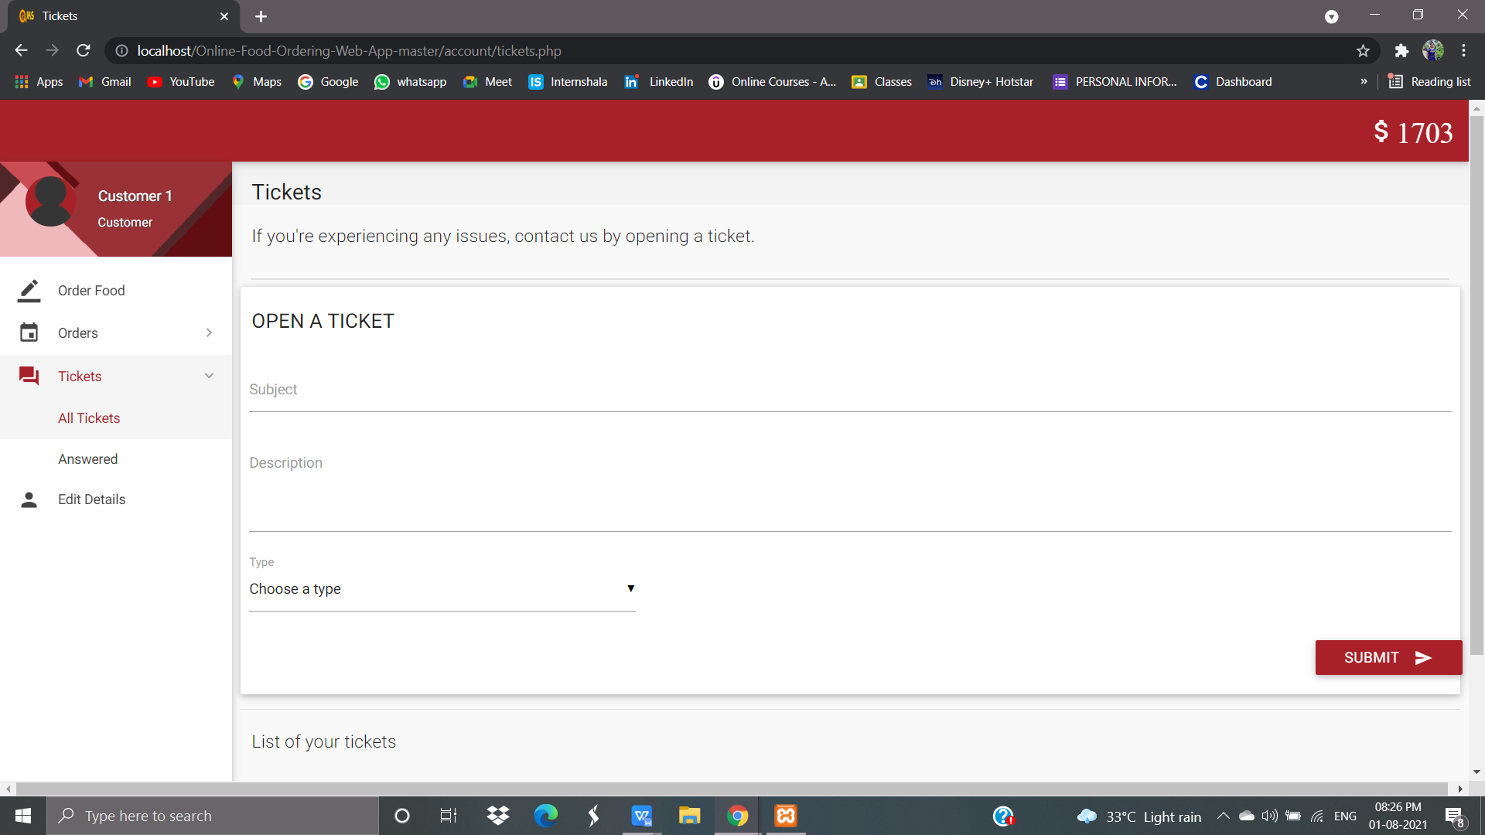

**3.1.7 Admin Page-Users List**

As soon as the user authenticates himself as the Admin , The customer can perform the following OperationsMonitor The User Account Details,name,id,email,phone number,their account number.

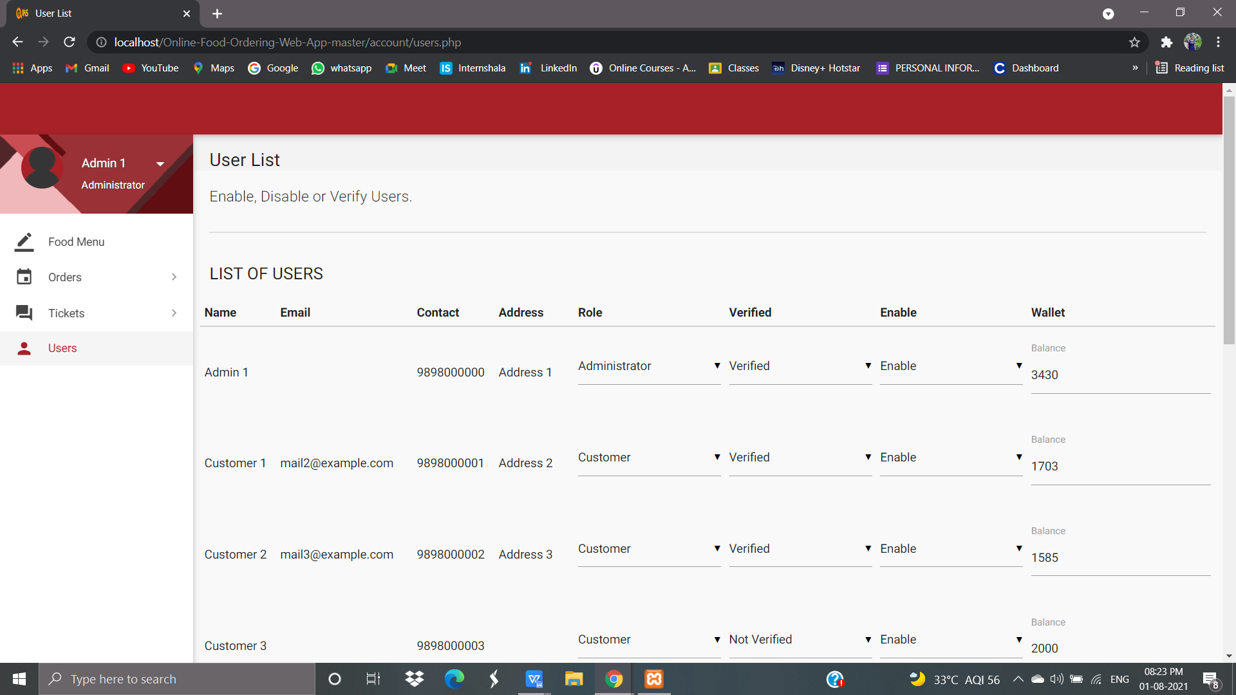

**3.1.8 Admin Page – View Orders**

This module allows us to view the status of the User’s order that have been registered earlier.

The database shows all the customer orders .It shows the order date,status,any note.

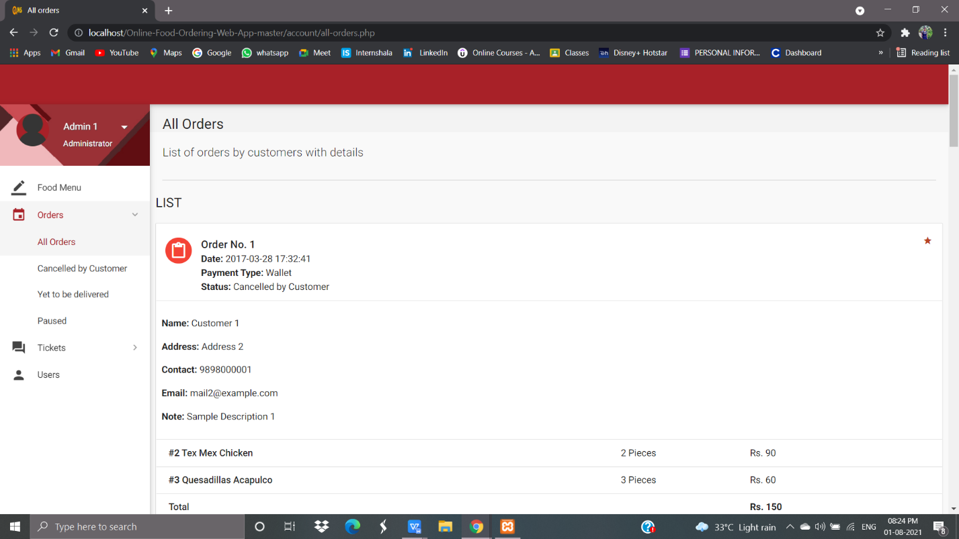

**3.1.9 Admin Page – View User Tickets**

The database shows all the detail of the customer’s tickets. Full history and details can be viewed in the database.

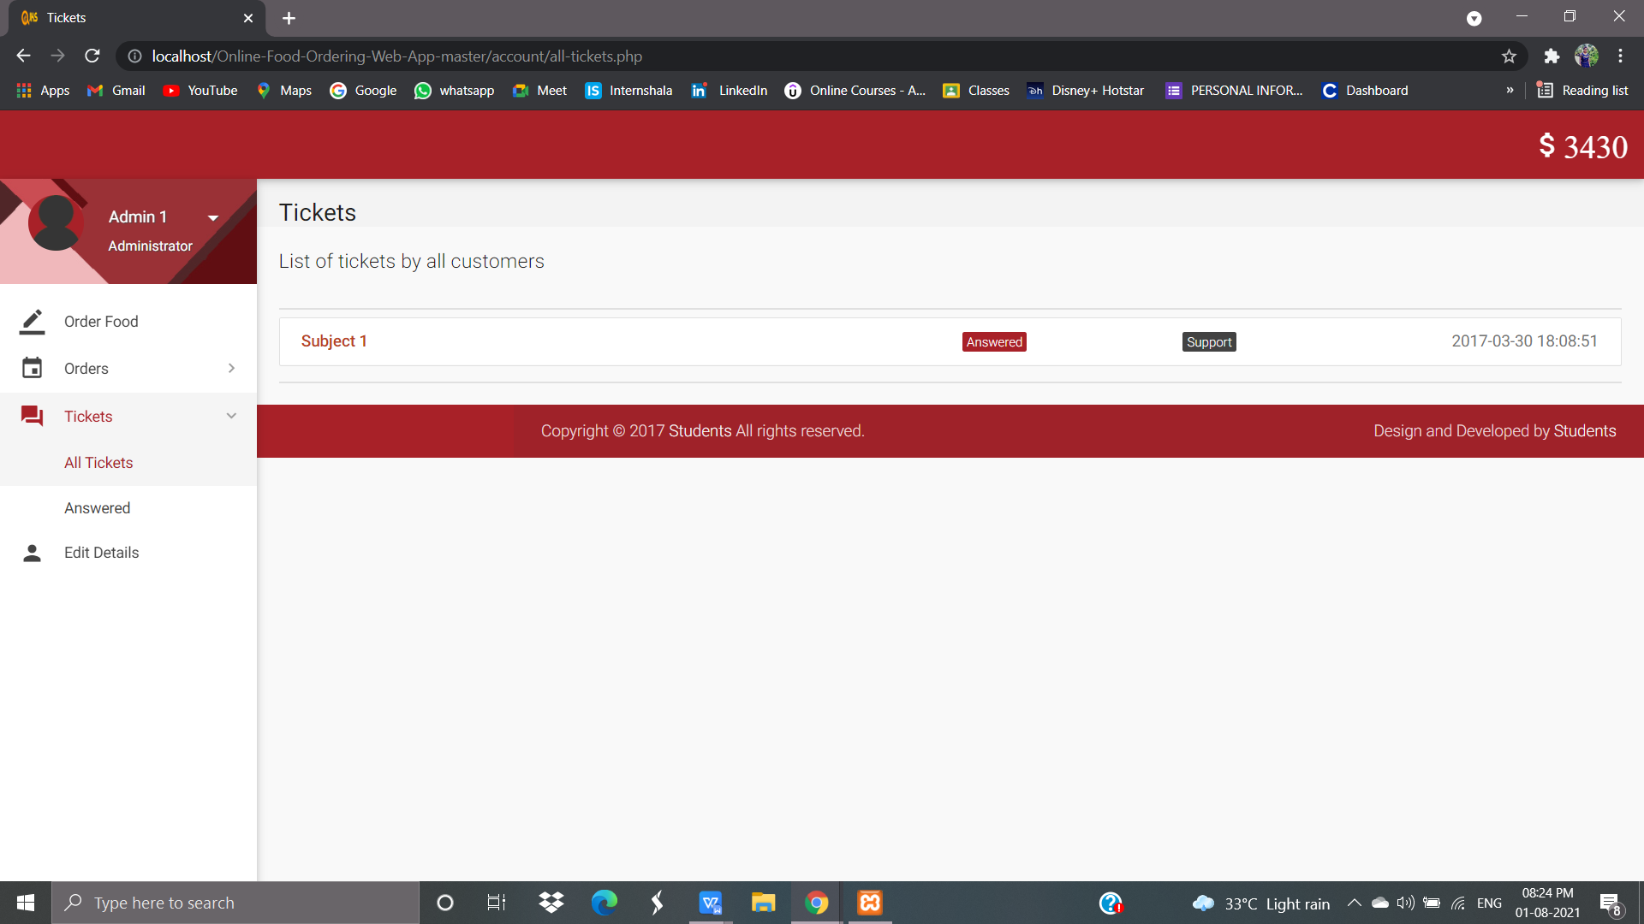

**CHAPTER 4**

**CONCLUSION AND FUTURE ENHANCEMENTS**

**4. CONCLUSION**

The approach used is a top-down one concentrating on *what* first, then *how* and

moving to successive levels of details.

The first phase started with a detailed study of the problems and prospects of

ordering in Bristo In the course of this study, many problems

were discovered to have hindered the effectiveness of the existing manual

system. These problems, information needs and activities were documented and

later used as the basis for system design, which immediately followed the first

phase. The design phase was concerned primarily with the specification of the

system elements in manner that best met the organization’s business needs.

During this phase, strict adherence was made on proven software engineering

principles and practices. To implement this design, a computer program was

then written and tested in phpMyadmin environment.

It is hoped that effective implementation of this software product would

eliminate many problems discovered during systems investigation.

* 1. **FUTURE ENHANCEMENT:**
* We can give more advance software for Online Food Ordering System including
* more facilities
* We will host the platform on online servers to make it accessible worldwide
* Integrate multiple load balancers to distribute the loads of the system
* Create the master and slave database structure to reduce the overload of the
* database queries
* Implement the backup mechanism for taking backup of codebase and database
* on regular basis on different servers

The above-mentioned points are the enhancements which can be done to increase

the applicability and usage of this project. Here we can maintain the records of Food

Item and Category. Also, as it can be seen that now-a-days the players are versatile,

i.e. so there is a scope for introducing a method to maintain the Online Food Ordering

System. Enhancements can be done to maintain all the Food Item, Category,

Customer, Order, Confirm Order.

We have left all the options open so that if there is any other future requirement

in the system by the user for the enhancement of the system then it is possible to

implement them. In the last we would like to thanks all the persons involved in the

development of the system directly or indirectly. We hope that the project will serve its

purpose for which it is develop there by underlining success of process.

* 1. **REFERENCES**

**[1]**Anderson, R.G. (1978), “Data processing and Management Information

Systems” McDonald and Evans Ltd.32.

**[2]**Bhatnagar, P. (2006, march 28). Dinning Trends: self service=Quick-service.

**[3]**Brickers, J. (2006, July 24). Is Fast Casual Self-Service at the Tripping

Ponit?

**[4]**De Leon, E. (2008, August 23). Best Online Food Ordering System.

Restaurant Checklist.

**[5]**Gan, C.C. (2002). Online Fast Food Restaurant Ordering Systems.

**[6]**Hobbs, N. (2004, march 26). Restaurant Customer Ordering.

**[7]**Kroc, Ray(1977). Grinding it out: The Making of McDonald’s. Chicago:

Contemporary Books.

**[8]**Purname, J., & Wibowo, A.Y. (2007). Wireless Application for Ordering

Management System in a Restaurant.

**[9]**Sharma, I.(2007,June 22). How Online Food Ordering System helps you

run more efficiently.

**[10]**Kirti Bhandge, Tejas Shinde, Dheeraj Ingale, Neeraj Solanki, Reshma Totare,”A Proposed System for Touchpad Based Food Ordering System Using Android Application”, International Journal of Advanced Research in Computer Science Technology (IJARCST 2015).

**[11]**Varsha Chavan, Priya Jadhav,Snehal Korade,Priyanka Teli, ”Implementing Customizable Online Food Ordering System Using Web Based Application”, International Journal of Innovative Science, Engineering Technology(IJISET) 2015.

**APPENDICES**

**SAMPLE CODING**

**5.1LogIn.php**

<?php

session_start();

if(isset($_SESSION['admin_sid']) || isset($_SESSION['customer_sid']))

{

header("location:index.php");

}

else{

?>

<!DOCTYPE html>

<html lang="en">

<head>

<meta http-equiv="Content-Type" content="text/html; charset=UTF-8">

<meta name="viewport" content="width=device-width, initial-scale=1, maximum-scale=1.0, user-scalable=no">

<meta http-equiv="X-UA-Compatible" content="IE=edge">

<meta name="msapplication-tap-highlight" content="no">

<title>Login</title>

<!-- Favicons-->

<link rel="icon" href="images/favicon/favicon-32x32.png" sizes="32x32">

<!-- Favicons-->

<link rel="apple-touch-icon-precomposed" href="images/favicon/apple-touch-icon-152x152.png">

<!-- For iPhone -->

<meta name="msapplication-TileColor" content="#00bcd4">

<meta name="msapplication-TileImage" content="images/favicon/mstile-144x144.png">

<!-- For Windows Phone -->

<!-- CORE CSS-->

<link href="css/materialize.min.css" type="text/css" rel="stylesheet" media="screen,projection">

<link href="css/style.min.css" type="text/css" rel="stylesheet" media="screen,projection">

<!-- Custome CSS-->

<link href="css/custom/custom.min.css" type="text/css" rel="stylesheet" media="screen,projection">

<link href="css/layouts/page-center.css" type="text/css" rel="stylesheet" media="screen,projection">

<!-- INCLUDED PLUGIN CSS ON THIS PAGE -->

<link href="js/plugins/perfect-scrollbar/perfect-scrollbar.css" type="text/css" rel="stylesheet" media="screen,projection">

</head>

<body class="cyan">

<!-- Start Page Loading -->

<div id="loader-wrapper">

<div id="loader"></div>

<div class="loader-section section-left"></div>

<div class="loader-section section-right"></div>

</div>

<!-- End Page Loading -->

<div id="login-page" class="row">

<div class="col s12 z-depth-4 card-panel">

<form method="post" action="routers/router.php" class="login-form" id="form">

<div class="row">

<div class="input-field col s12 center">

<p class="center login-form-text">Login for Food Ordering System</p>

</div>

</div>

<div class="row margin">

<div class="input-field col s12">

<i class="mdi-social-person-outline prefix"></i>

<input name="username" id="username" type="text">

<label for="username" class="center-align">Username</label>

</div>

</div>

<div class="row margin">

<div class="input-field col s12">

<i class="mdi-action-lock-outline prefix"></i>

<input name="password" id="password" type="password">

<label for="password">Password</label>

</div>

</div>

<div class="row">

<a href="javascript:void(0);" onclick="document.getElementById('form').submit();" class="btn waves-effect waves-light col s12">Login</a>

</div>

<div class="row">

<div class="input-field col s6 m6 l6">

<p class="margin medium-small"><a href="register.php">Register Now!</a></p>

</div>

</div>

</div>

</form>

</div>

</div>

<!-- ================================================

Scripts

================================================ -->

<!-- jQuery Library -->

<script type="text/javascript" src="js/plugins/jquery-1.11.2.min.js"></script>

<!--materialize js-->

<script type="text/javascript" src="js/materialize.min.js"></script>

<!--scrollbar-->

<script type="text/javascript" src="js/plugins/perfect-scrollbar/perfect-scrollbar.min.js"></script>

<!--plugins.js - Some Specific JS codes for Plugin Settings-->

<script type="text/javascript" src="js/plugins.min.js"></script>

<!--custom-script.js - Add your own theme custom JS-->

<script type="text/javascript" src="js/custom-script.js"></script>

</body>

</html>

<?php

}

?>

<?php

session_start();

if(isset($_SESSION['admin_sid']) || isset($_SESSION['customer_sid']))

{

header("location:index.php");

}

else{

?>

<!DOCTYPE html>

<html lang="en">

<head>

<meta http-equiv="Content-Type" content="text/html; charset=UTF-8">

<meta name="viewport" content="width=device-width, initial-scale=1, maximum-scale=1.0, user-scalable=no">

<meta http-equiv="X-UA-Compatible" content="IE=edge">

<meta name="msapplication-tap-highlight" content="no">

<title>Login</title>

<!-- Favicons-->

<link rel="icon" href="images/favicon/favicon-32x32.png" sizes="32x32">

<!-- Favicons-->

<link rel="apple-touch-icon-precomposed" href="images/favicon/apple-touch-icon-152x152.png">

<!-- For iPhone -->

<meta name="msapplication-TileColor" content="#00bcd4">

<meta name="msapplication-TileImage" content="images/favicon/mstile-144x144.png">

<!-- For Windows Phone -->

<!-- CORE CSS-->

<link href="css/materialize.min.css" type="text/css" rel="stylesheet" media="screen,projection">

<link href="css/style.min.css" type="text/css" rel="stylesheet" media="screen,projection">

<!-- Custome CSS-->

<link href="css/custom/custom.min.css" type="text/css" rel="stylesheet" media="screen,projection">

<link href="css/layouts/page-center.css" type="text/css" rel="stylesheet" media="screen,projection">

<!-- INCLUDED PLUGIN CSS ON THIS PAGE -->

<link href="js/plugins/perfect-scrollbar/perfect-scrollbar.css" type="text/css" rel="stylesheet" media="screen,projection">

</head>

<body class="cyan">

<!-- Start Page Loading -->

<div id="loader-wrapper">

<div id="loader"></div>

<div class="loader-section section-left"></div>

<div class="loader-section section-right"></div>

</div>

<!-- End Page Loading -->

<div id="login-page" class="row">

<div class="col s12 z-depth-4 card-panel">

<form method="post" action="routers/router.php" class="login-form" id="form">

<div class="row">

<div class="input-field col s12 center">

<p class="center login-form-text">Login for Food Ordering System</p>

</div>

</div>

<div class="row margin">

<div class="input-field col s12">

<i class="mdi-social-person-outline prefix"></i>

<input name="username" id="username" type="text">

<label for="username" class="center-align">Username</label>

</div>

</div>

<div class="row margin">

<div class="input-field col s12">

<i class="mdi-action-lock-outline prefix"></i>

<input name="password" id="password" type="password">

<label for="password">Password</label>

</div>

</div>

<div class="row">

<a href="javascript:void(0);" onclick="document.getElementById('form').submit();" class="btn waves-effect waves-light col s12">Login</a>

</div>

<div class="row">

<div class="input-field col s6 m6 l6">

<p class="margin medium-small"><a href="register.php">Register Now!</a></p>

</div>

</div>

</div>

</form>

</div>

</div>

<!-- ================================================

Scripts

================================================ -->

<!-- jQuery Library -->

<script type="text/javascript" src="js/plugins/jquery-1.11.2.min.js"></script>

<!--materialize js-->

<script type="text/javascript" src="js/materialize.min.js"></script>

<!--scrollbar-->

<script type="text/javascript" src="js/plugins/perfect-scrollbar/perfect-scrollbar.min.js"></script>

<!--plugins.js - Some Specific JS codes for Plugin Settings-->

<script type="text/javascript" src="js/plugins.min.js"></script>

<!--custom-script.js - Add your own theme custom JS-->

<script type="text/javascript" src="js/custom-script.js"></script>

</body>

</html>

<?php

}

?>

**5.2 Register.php**

<?php

session_start();

if(isset($_SESSION['admin_sid']) || isset($_SESSION['customer_sid']))

{

header("location:index.php");

}

else{

?>

<!DOCTYPE html>

<html lang="en">

<head>

<meta http-equiv="Content-Type" content="text/html; charset=UTF-8">

<meta name="viewport" content="width=device-width, initial-scale=1, maximum-scale=1.0, user-scalable=no">

<meta http-equiv="X-UA-Compatible" content="IE=edge">

<meta name="msapplication-tap-highlight" content="no">

<title>Register</title>

<!-- Favicons-->

<link rel="icon" href="images/favicon/favicon-32x32.png" sizes="32x32">

<!-- Favicons-->

<link rel="apple-touch-icon-precomposed" href="images/favicon/apple-touch-icon-152x152.png">

<!-- For iPhone -->

<meta name="msapplication-TileColor" content="#00bcd4">

<meta name="msapplication-TileImage" content="images/favicon/mstile-144x144.png">

<!-- For Windows Phone -->

<!-- CORE CSS-->

<link href="css/materialize.min.css" type="text/css" rel="stylesheet" media="screen,projection">

<link href="css/style.min.css" type="text/css" rel="stylesheet" media="screen,projection">

<!-- Custome CSS-->

<link href="css/custom/custom.min.css" type="text/css" rel="stylesheet" media="screen,projection">

<link href="css/layouts/page-center.css" type="text/css" rel="stylesheet" media="screen,projection">

<link href="js/plugins/perfect-scrollbar/perfect-scrollbar.css" type="text/css" rel="stylesheet" media="screen,projection">

<style type="text/css">

.input-field div.error{

position: relative;

top: -1rem;

left: 0rem;

font-size: 0.8rem;

color:#FF4081;

-webkit-transform: translateY(0%);

-ms-transform: translateY(0%);

-o-transform: translateY(0%);

transform: translateY(0%);

}

.input-field label.active{

width:100%;

}

.left-alert input[type=text] + label:after,

.left-alert input[type=password] + label:after,

.left-alert input[type=email] + label:after,

.left-alert input[type=url] + label:after,

.left-alert input[type=time] + label:after,

.left-alert input[type=date] + label:after,

.left-alert input[type=datetime-local] + label:after,

.left-alert input[type=tel] + label:after,

.left-alert input[type=number] + label:after,

.left-alert input[type=search] + label:after,

.left-alert textarea.materialize-textarea + label:after{

left:0px;

}

.right-alert input[type=text] + label:after,

.right-alert input[type=password] + label:after,

.right-alert input[type=email] + label:after,

.right-alert input[type=url] + label:after,

.right-alert input[type=time] + label:after,

.right-alert input[type=date] + label:after,

.right-alert input[type=datetime-local] + label:after,

.right-alert input[type=tel] + label:after,

.right-alert input[type=number] + label:after,

.right-alert input[type=search] + label:after,

.right-alert textarea.materialize-textarea + label:after{

right:70px;

}

</style>

</head>

<body class="cyan">

<!-- Start Page Loading -->

<div id="loader-wrapper">

<div id="loader"></div>

<div class="loader-section section-left"></div>

<div class="loader-section section-right"></div>

</div>

<!-- End Page Loading -->

<div id="login-page" class="row">

<div class="col s12 z-depth-4 card-panel">

<form class="formValidate" id="formValidate" method="post" action="routers/register-router.php" novalidate="novalidate" class="col s12">

<div class="row">

<div class="input-field col s12 center">

<h4>Register</h4>

<p class="center">Join us now!</p>

</div>

</div>

<div class="row margin">

<div class="input-field col s12">

<i class="mdi-social-person-outline prefix"></i>

<input name="username" id="username" type="text" data-error=".errorTxt1">

<label for="username" class="center-align">Username</label>

<div class="errorTxt1"></div>

</div>

</div>

<div class="row margin">

<div class="input-field col s12">

<i class="mdi-social-person prefix"></i>

<input name="name" id="name" type="text" data-error=".errorTxt2">

<label for="name" class="center-align">Name</label>

<div class="errorTxt2"></div>

</div>

</div>

<div class="row margin">

<div class="input-field col s12">

<i class="mdi-action-lock-outline prefix"></i>

<input name="password" id="password" type="password" data-error=".errorTxt3">

<label for="password">Password</label>

<div class="errorTxt3"></div>

</div>

</div>

<div class="row margin">

<div class="input-field col s12">

<i class="mdi-communication-phone prefix"></i>

<input name="phone" id="phone" type="number" data-error=".errorTxt4">

<label for="phone">Phone</label>

<div class="errorTxt4"></div>

</div>

</div>

<div class="row">

<div class="input-field col s12">

<a href="javascript:void(0);" onclick="document.getElementById('formValidate').submit();" class="btn waves-effect waves-light col s12">Login</a>

</div>

<div class="input-field col s12">

<p class="margin center medium-small sign-up">Already have an account? <a href="login.php">Login</a></p>

</div>

</div>

</form>

</div>

</div>

<!-- ================================================

Scripts

================================================ -->

<!-- jQuery Library -->

<script type="text/javascript" src="js/plugins/jquery-1.11.2.min.js"></script>

<!--materialize js-->

<script type="text/javascript" src="js/materialize.min.js"></script>

<!--scrollbar-->

<script type="text/javascript" src="js/plugins/perfect-scrollbar/perfect-scrollbar.min.js"></script>

<script type="text/javascript" src="js/plugins/jquery-validation/jquery.validate.min.js"></script>

<script type="text/javascript" src="js/plugins/jquery-validation/additional-methods.min.js"></script>

<!--plugins.js - Some Specific JS codes for Plugin Settings-->

<script type="text/javascript" src="js/plugins.min.js"></script>

<!--custom-script.js - Add your own theme custom JS-->

<script type="text/javascript" src="js/custom-script.js"></script>

<script type="text/javascript">

$("#formValidate").validate({

rules: {

username: {

required: true,

minlength: 5

},

name: {

required: true,

minlength: 5

},

password: {

required: true,

minlength: 5

},

phone: {

required: true,

minlength: 4

},

},

messages: {

username: {

required: "Enter username",

minlength: "Minimum 5 characters are required."

},

name: {

required: "Enter name",

minlength: "Minimum 5 characters are required."

},

password: {

required: "Enter password",

minlength: "Minimum 5 characters are required."

},

phone:{

required: "Specify contact number.",

minlength: "Minimum 4 characters are required."

},

},

errorElement : 'div',

errorPlacement: function(error, element) {

var placement = $(element).data('error');

if (placement) {

$(placement).append(error)

} else {

error.insertAfter(element);

}

}

});

</script>

</body>

</html><?php}?>