**Experiment -1.1**

Install Git and creating repository.

**Student Name: Sandhya kumari UID:22bdo10074**

**Branch: CSE devops Section/Group:22bcd-1**

**Semester: 4 Date of Performance:15|1|24**

**Subject Name : git and hub Subject Code:22csh-293**

## 1.Aim/Overview of the practical: Install Git and creating repository

## 2. Apparatus : windows for git and Github websites.

**3.steps:**

* Browse to the official Git website: <https://git-scm.com/downloads>
* download link for Windows and allow the download to complete.

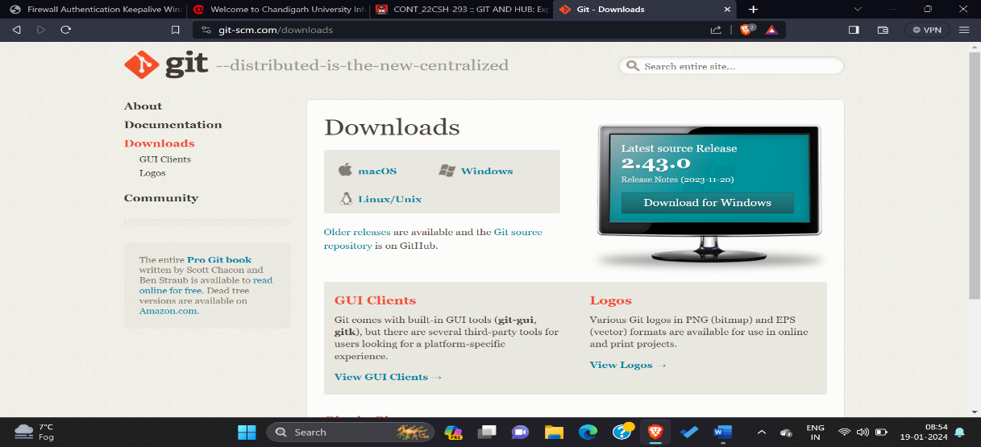

3. Browse to the download location

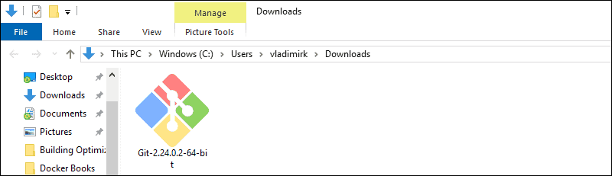

4. Allow the app to make changes to your device by clicking **Yes** on the User Account Control dialog that opens.

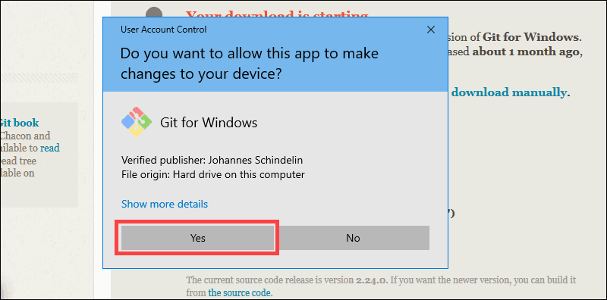

5. Review the GNU general public liscence and when you’re ready to install, click **Next**.

6. The installer will ask you for an installation location. Leave the default, unless you have reason to change it, and click **Next**.

7. A component selection screen will appear. Leave the defaults unless you have a specific need to change them and click **Next**.

8. The installer will offer to create a start menu folder. Simply click **Next**.

9. Select a text editor you’d like to use with Git. Use the drop-down menu to select Notepad++ (or whichever text editor you prefer) and click **Next**.

10. The next step allows you to choose a different name for your initial branch.

11. This installation step allows you to change the **PATH environment**. The **PATH**is the default set of directories included when you run a command from the command line. Leave this on the middle (recommended) selection and click **Next**.

12. The installer now asks which SSH client you want Git to use. Git already comes with its own SSH client, so if you don't need a specific one, leave the default option and click **Next**

13. The next option relates to server certificates. Most users should use the default. If you’re working in an Active Directory environment, you may need to switch to Windows Store certificates. Click **Next**.

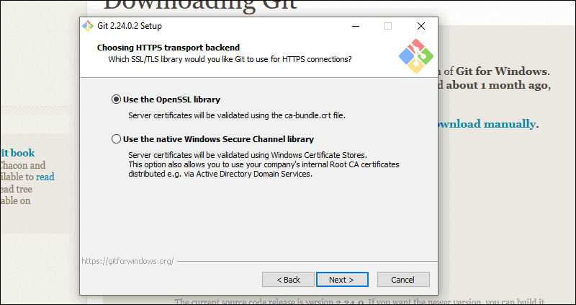

14. The next selection converts line endings. It is recommended that you leave the default selection. This relates to the way data is formatted and changing this option may cause problems. Click **Next**.

15. Choose the terminator emulator you want to use. The default MiniTTY is recommended, for its features. Click **Next**.

16. The installer now asks what the **git pull** command should do. The default option is recommended unless you specifically need to change its behaviour. Click **Next**to continue with the installation

17. Next you should choose which credential helper to use. Git uses credential helpers to fetch or save credentials. Leave the default option as it is the most stable one, and click **Next**.

18. The default options are recommended however this step allows you to decide which extra option you would like to enable. If you use symbolic links, which are like shortcuts for the command line, tick the box. Click **Next**.

19. Depending on the version of Git you’re installing it may offer to install experimental features. At the time this article was written, the options to include support for pseudo controls and a built-in file system monitor were offered. Unless you are feeling adventurous, leave them unchecked and click **Install**.

20. Once the installation is complete, tick the boxes to view the Release Notes or Launch Git Bash, then click **Finish**.

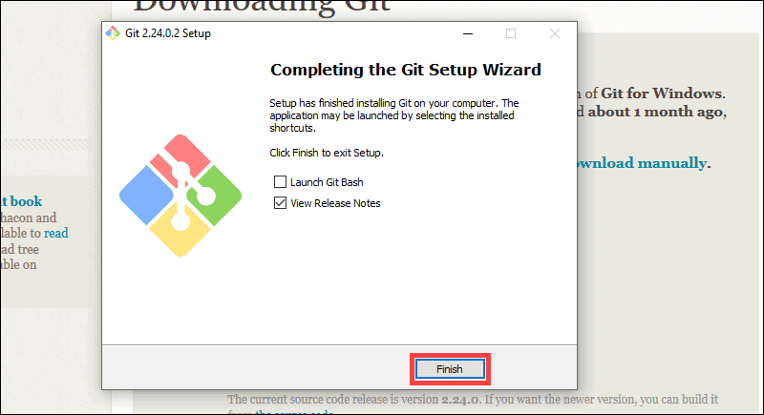

4.HOW TO LAUNCH GIT WINDOWS?

Git has two modes of use – a **bash scripting shell** (or command line) and a **graphical user interface** (GUI).

### Launch Git Bash Shell

To launch **Git Bash** open the **Windows Start** menu, type **git bash** and press **Enter** (or click the application icon).

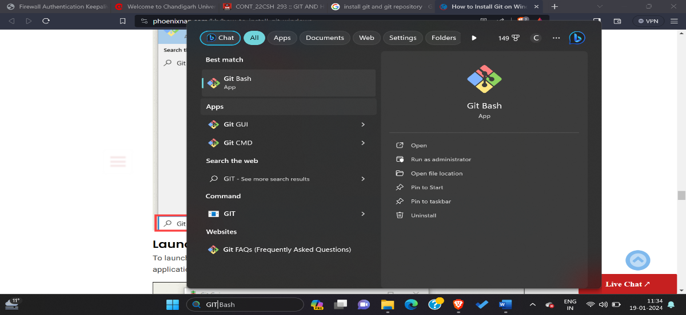

### Launch Git GUI

To launch **Git GUI** open the **Windows Start** menu, type ***git gui*** and press **Enter** (or click the application icon)

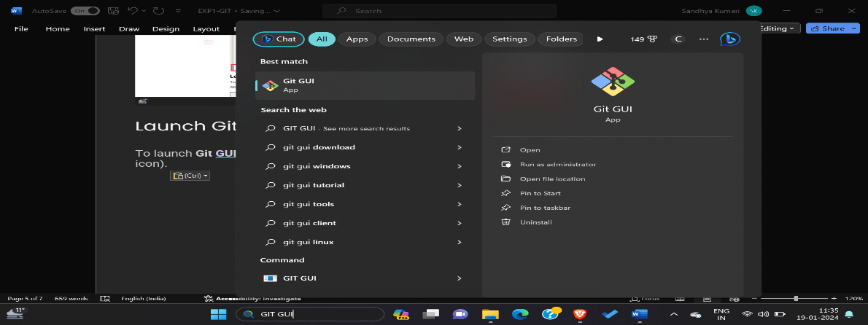

### Creating directory:

Git commands:

$ git - -version

$ git config - -help

$ git config - - global user.username Sandhya-Noni

$ git config - - global user.email [connect2sandhyaa@gmail.com](mailto:connect2sandhyaa@gmail.com)

$ git config - -list

Using git bash and executing commands of git

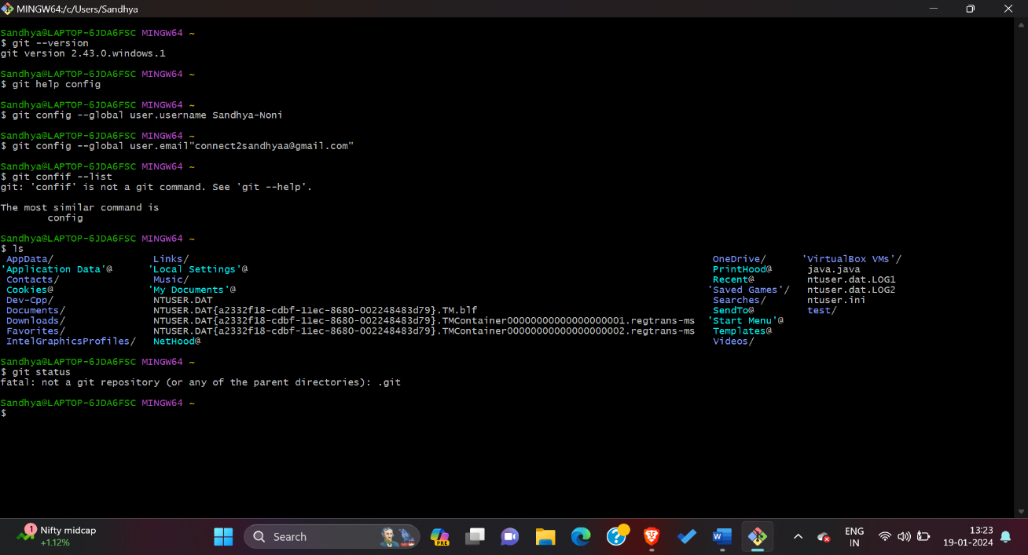

GitHub repository images:

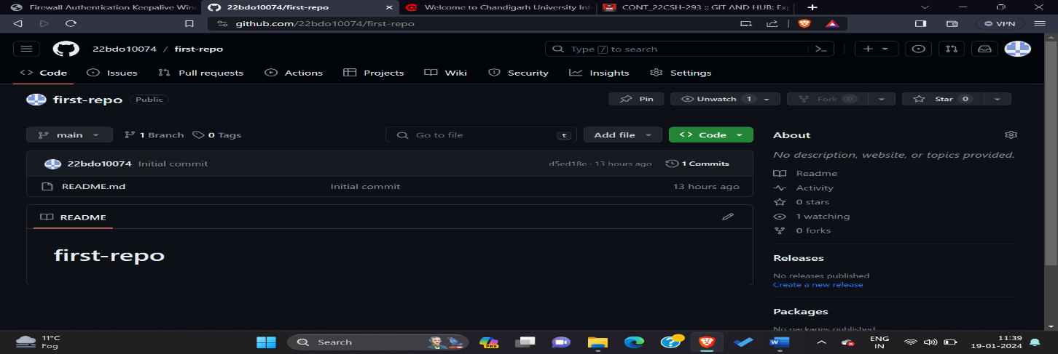

Result of this experiment:

* We have learnt about the version control system that is git and it is a tools that helps to track changes in code.
* It is very popular
* It is open source and free
* It is fast and scalable

**7. learning outcomes (What I have learnt):**

**1. learnt about how to install windows for git**

**2. learnt about concept of git and how to use it**

**3. learnt about how to make account on github**

**4. learnt about how to use github**

**5. learnt about how to make repository on github**

**Evaluation Grid (To be created as per the SOP and Assessment guidelines by the faculty):**

|  |  |  |  |
| --- | --- | --- | --- |
| Sr. No. | Parameters | Marks Obtained | Maximum Marks |
| 1. |  |  |  |
| 2. |  |  |  |
| 3. |  |  |  |
|  |  |  |  |