Checklist Verification System (CVS)
Technical Report: Audio Processing Pipeline
Noise Reduction | Speech/Non-Speech Separation | Word Segmentation
__________________________________________________________________________________________
1. What CVS Does and Why We Built Custom Processing
CVS listens to military radio communication during missile pre-launch checklist verification and automatically tracks which checklist items have been confirmed or failed. The entire system runs offline on edge hardware -- no internet connection is available or allowed during live operations.
We deal with background noise from launch-pad environments, domain-specific terminology that standard models consistently get wrong (words like "telemetry", "umbilical", "INS alignment"), and strict real-time requirements -- the system must process and display results within 5 seconds of a person speaking.
These constraints meant we could not simply plug in an off-the-shelf speech recognizer and expect useful results.
We built a multi-stage processing pipeline with custom noise reduction, intelligent speech segmentation, and extensive domain-specific post-processing. The diagram below shows the four main stages.
Pre-launch checklist verification system (PLCVS)
Figure 1: End-to-End Pipeline Overview
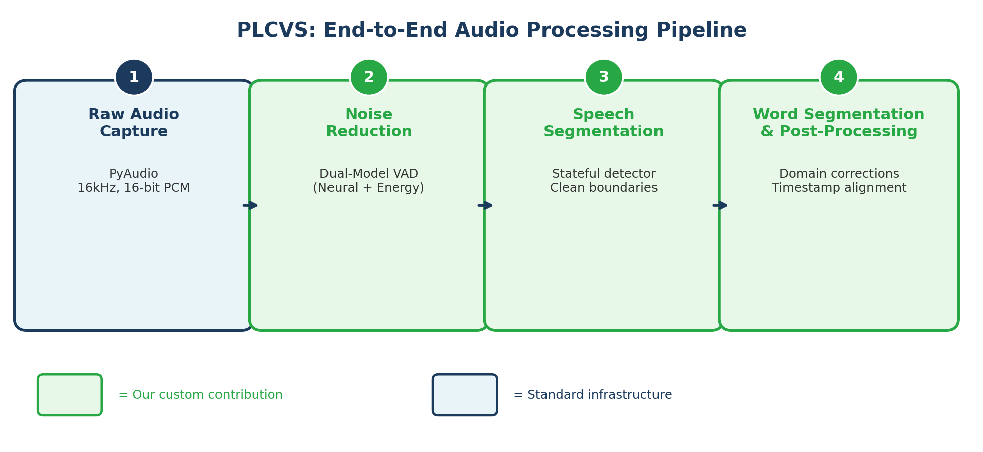

2. Noise Reduction: How We Filter Out Unwanted Sound
Before any speech recognition happens, we need to separate human speech from everything else -- engine noise, wind, radio static, mechanical clicks from push-to-talk buttons, and periods of silence. Our approach uses Voice Activity Detection (VAD) to analyze audio frame-by-frame and decide: "Is someone speaking right now, or is this just noise?"
What we built:
- Primary detector: We use the Silero neural network VAD model, which processes audio in 32-millisecond frames and outputs a probability score for each frame. We tuned the decision threshold to 0.5, specifically calibrated for the signal-to-noise ratio typical of military radio channels.
- Custom energy-based fallback: If the neural model is unavailable or encounters unusual audio it was not trained on (radio codec artifacts, for example), the system automatically falls back to our custom energy-based VAD. This computes the RMS energy of each frame against an adaptive noise floor. The key point: the system never silently fails -- it always has a working detection path.
- Pre-speech ring buffer: We maintain a rolling 200ms audio buffer at all times. When VAD detects speech onset, we prepend this buffer to the speech segment. Without this, the first syllable of each utterance would be clipped -- a common problem in naive VAD implementations.
- Duration constraints: Minimum speech duration of 250ms filters out transient noise (a click or cough), while maximum duration of 30s prevents buffer overflow from continuous radio keying. The silence gap threshold of 600ms determines when an utterance has ended.
Figure 2: Noise Reduction -- Dual-Model VAD Architecture
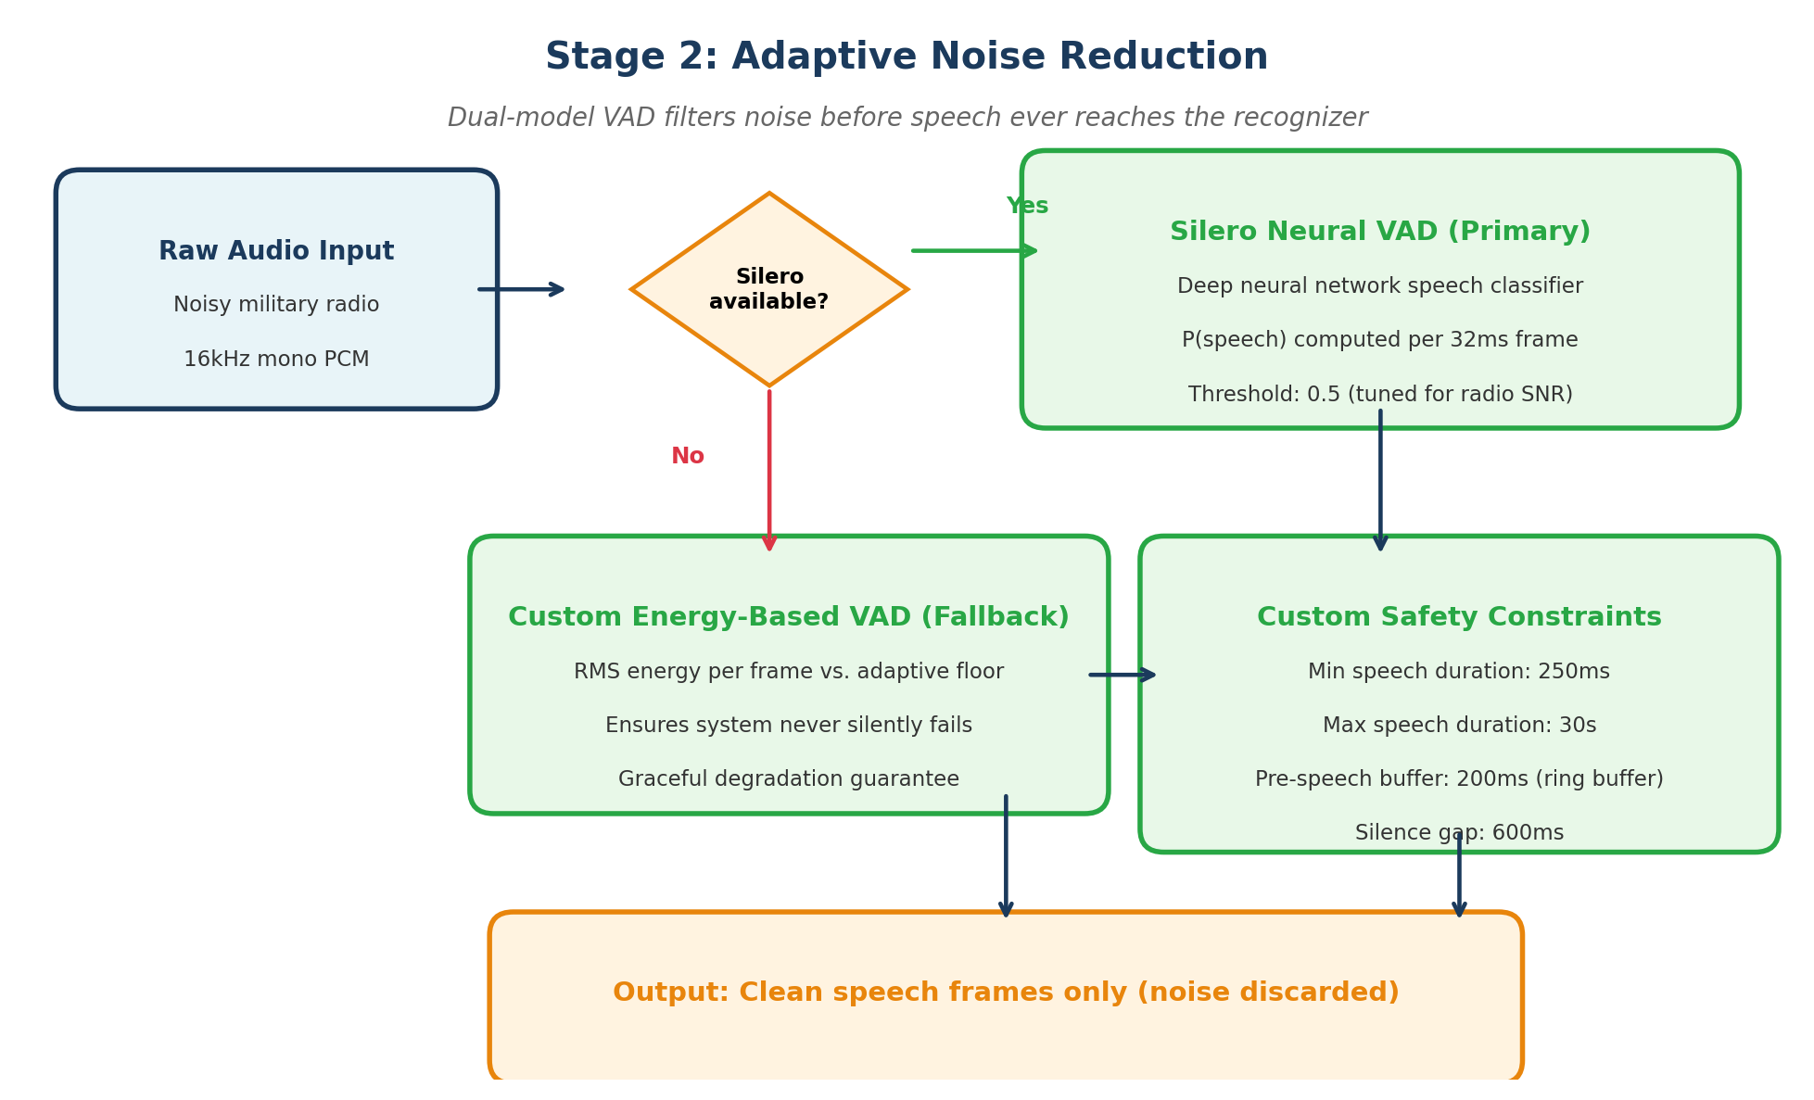

3. Speech / Non-Speech Separation: Producing Clean Segments
Once we know which frames contain speech, the next challenge is grouping those frames into complete, meaningful utterance segments. A person might say "fuel pressure nominal" as a single phrase, but the VAD sees it as a sequence of individual 32ms frames. Our stateful segment detector assembles these frames into coherent speech regions with precise start and end timestamps.
What we built:
- Finite state machine: The detector maintains two states -- NOT_SPEAKING and SPEAKING. It transitions to SPEAKING when the VAD probability exceeds 0.5, and back to NOT_SPEAKING only after sustained silence of at least 600ms. This hysteresis prevents brief pauses within a sentence (like between words) from prematurely splitting the segment.
- Speech region accumulation: During the SPEAKING state, audio frames are continuously accumulated into a buffer. When the state transitions back to NOT_SPEAKING, the accumulated audio is packaged into a SpeechRegion object with its start time, end time, duration, audio data, and a confidence score derived from the average VAD probability.
- Segment quality validation: Before emitting a segment, we validate that it meets our minimum duration requirement (250ms). Segments that are too short are discarded as noise. Segments that exceed the maximum duration (30s) are force-emitted to prevent unbounded memory growth.
- Audit trail: Each segment is automatically saved as an individual WAV file with a timestamped filename. This provides a complete, reviewable record of every speech segment the system processed during a verification session.
Figure 3: Speech Segmentation State Machine
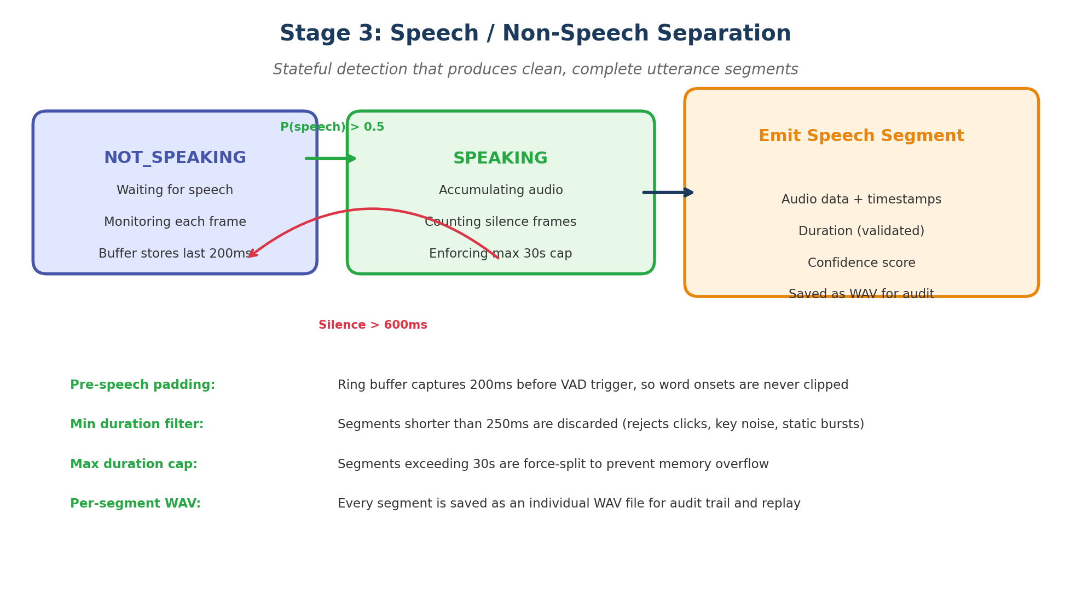

4. Word Segmentation & Domain-Specific Post-Processing
The speech segments are transcribed using Faster-Whisper (large-v3-turbo model), which provides word-level timestamps through forced alignment. However, raw Whisper output on military radio audio contains significant errors -- domain terms are misrecognized, filler words clutter the text, and numbers are spelled out rather than digitized.
We built a custom 6-stage post-processing pipeline to address each of these problems.
What we built:
- Domain vocabulary injection: We feed a curated prompt of 46 military terms (fuel pressure, telemetry, INS alignment, flight termination system, etc.) into Whisper's decoder as an initial prompt. This biases the language model toward domain-specific vocabulary and significantly reduces misrecognition of critical terminology. The vocabulary is stored in an external YAML file, making it configurable per mission type.
- Domain correction dictionary: We maintain a dictionary of 50+ common Whisper misrecognitions specific to our domain. For example, Whisper often transcribes "telemetry" as "tell a metric" or "tell em a tree", "umbilical" as "umber lick", and "INS" as "eye and s". Our correction rules are applied in length-sorted order (longest match first) to handle overlapping patterns correctly.
- Military abbreviation expansion: 20 defence acronyms (INS, FTS, LOX, UDMH, IMU, OBC, GCS, RSO, MET, MECO, etc.) are recognized and can be expanded to their full forms, enabling downstream NLP processing to handle both spoken and abbreviated forms.
- Spoken number normalization: Converts verbal number expressions to digits -- "twenty three" becomes "23", "one hundred" becomes "100". This is essential for pressure readings, voltage levels, and countdown values that appear throughout checklist verification.
- Artifact removal: Consecutive duplicate words (a common Whisper failure where it outputs "confirmed confirmed") are deduplicated. Vocal fillers ("uh", "um", "hmm", "you know") are stripped. The result is clean, publication-ready transcription text.

Figure 4: Word Segmentation & Post-Processing Pipeline
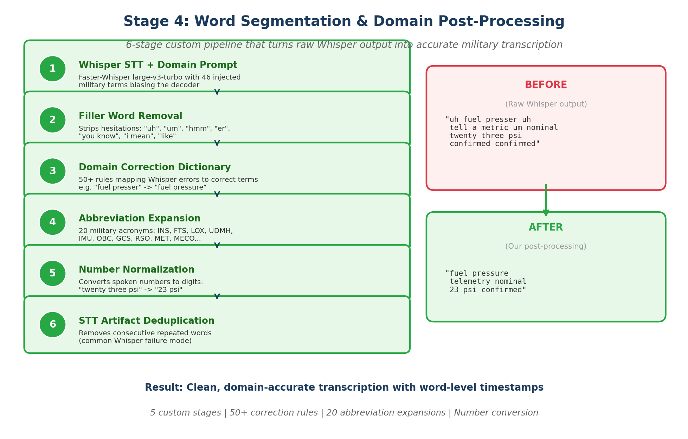

5. Summary of Original Contributions
The table below summarizes what we built versus what comes from existing libraries. The core insight is that while we leverage established models (Whisper for STT, Silero for VAD), the integration logic, domain adaptation, fault tolerance, and post-processing are entirely our own design and implementation.
Component | What We Built | Impact
Dual-Model VAD Architecture | Neural VAD with custom energy-based fallback; adaptive threshold tuning for military radio SNR | Zero silent failures; works on any hardware
Pre-Speech Ring Buffer | 200ms rolling buffer that preserves word onsets before VAD trigger fires | No syllable clipping at segment start
Stateful Speech Detector | FSM with hysteresis, min/max duration enforcement, silence gap detection | Clean, complete utterance segments
Domain Vocabulary Injection | 46-term military prompt fed into Whisper decoder; externalized YAML config | Significant accuracy gain on domain terms
Correction Dictionary | 50+ rules mapping Whisper misrecognitions to correct military terms | Handles terms no retraining could fix
Post-Processing Pipeline | 6-stage pipeline: filler removal, corrections, abbreviation expansion, number normalization, deduplication | Clean text from noisy radio audio

__________________________________________________________________________________________
Checklist Verification System | Technical Report | April 2026

