WEB TECHNOLOGY

LAB5

ASSIGNMENT

SAHIL

22CS3052

CSE

T1. Make a simple web page that contains an h2 with the word “Hello” a text input box, and

a button. When the user types a word or phrase into the input box and presses the button,

replace the old h2 with the word entered. Using animation, make the word spin.

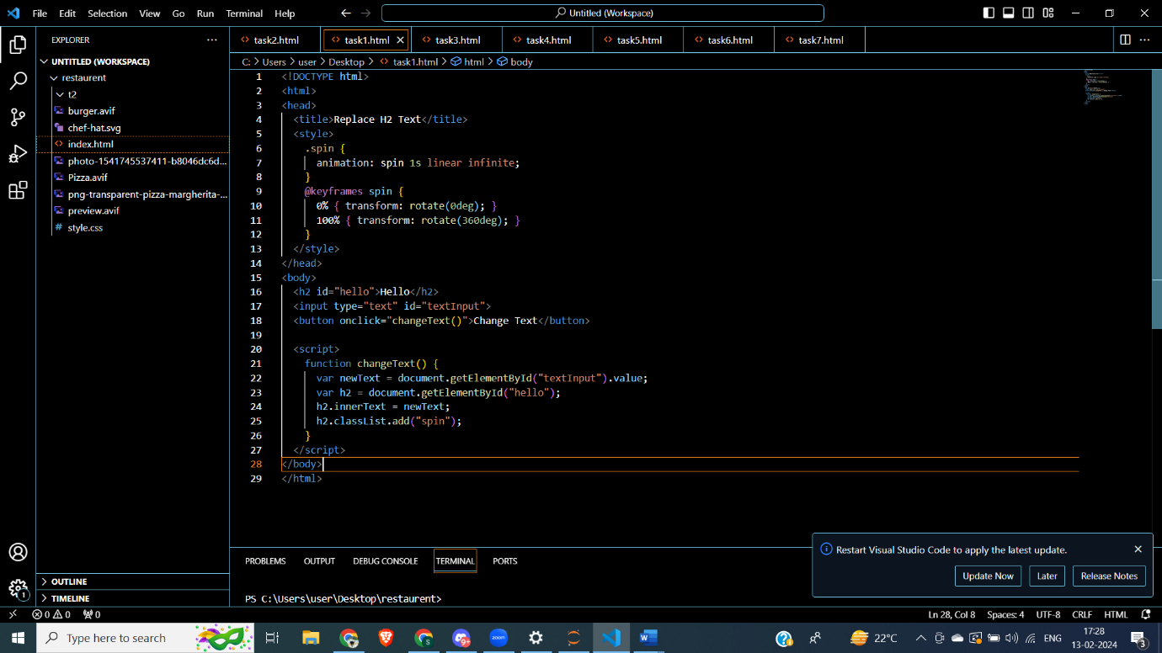

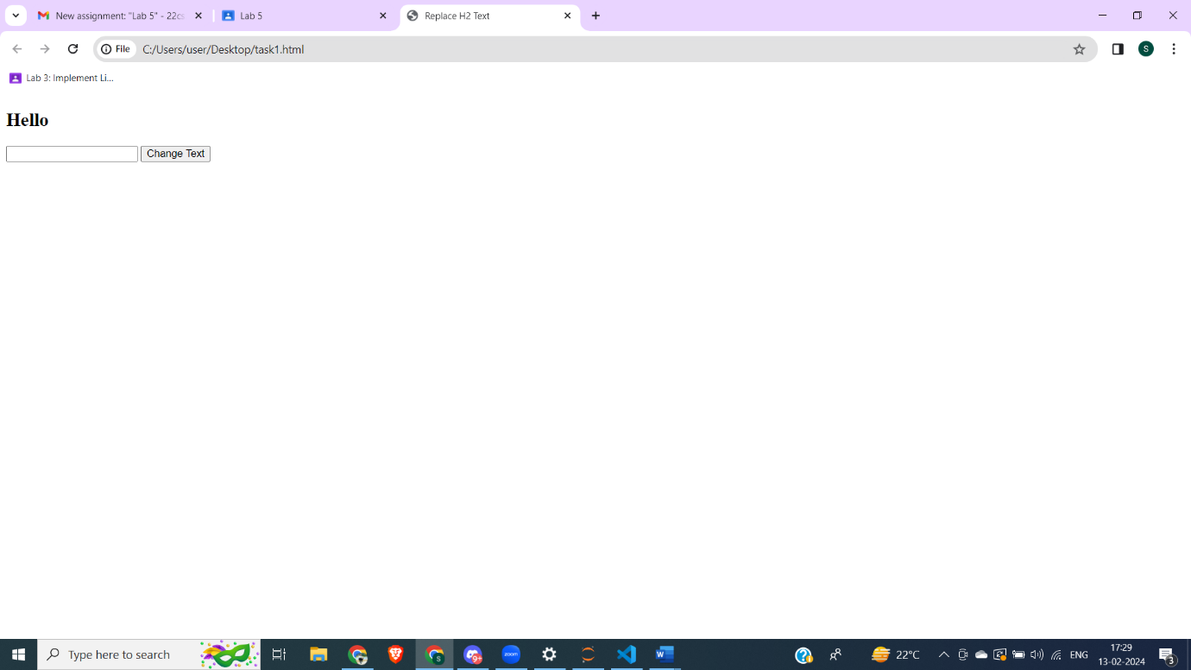

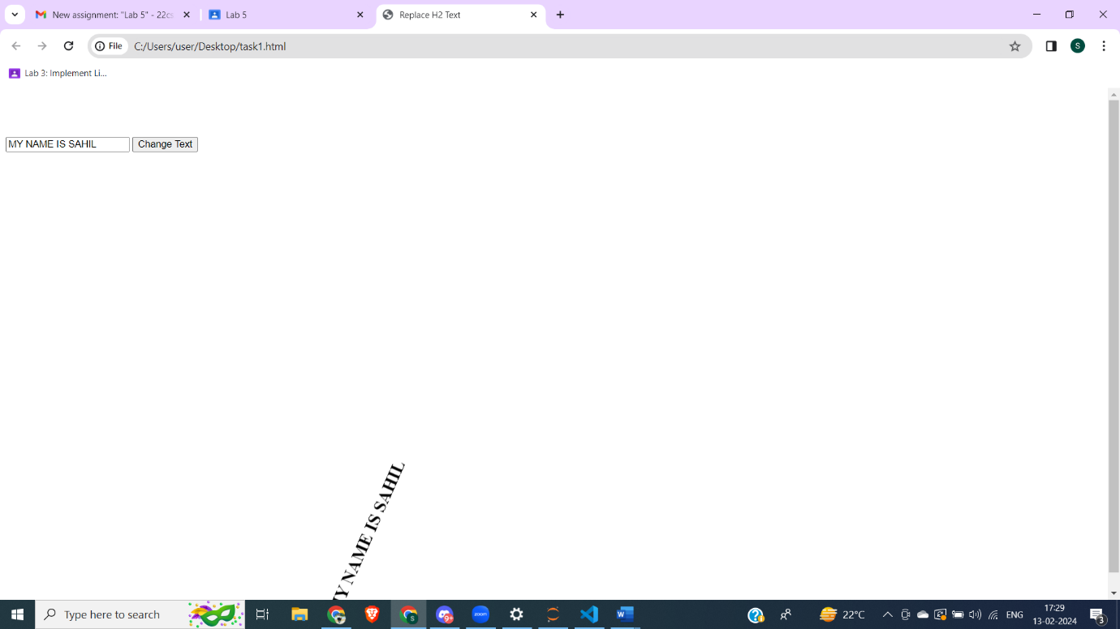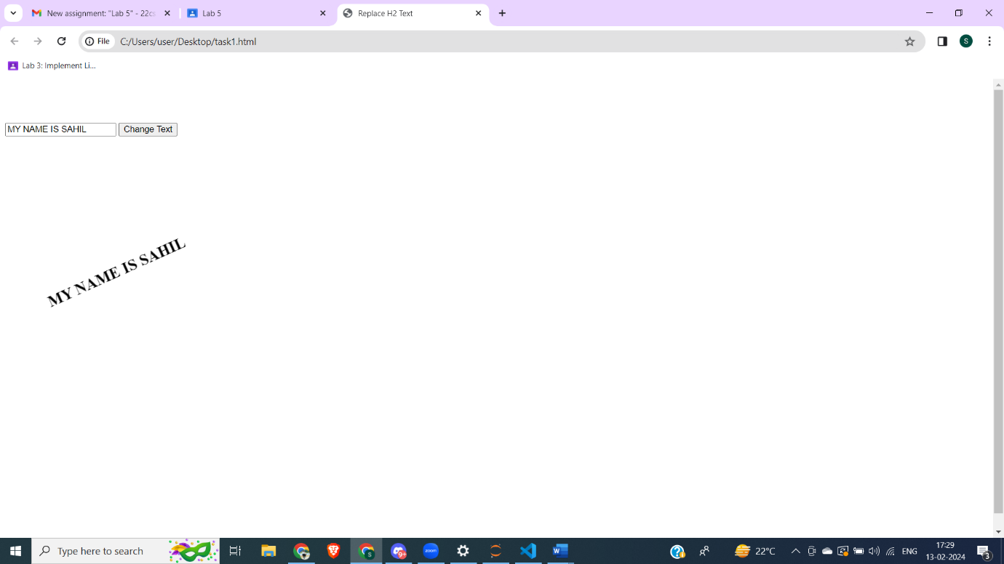

T2. Make a simple web page that contains a button and a paragraph with the id of count

Whenever this button is pressed increment the count by 1 and update the paragraph text.

Also update the font size so that as the number gets larger, so does the font.

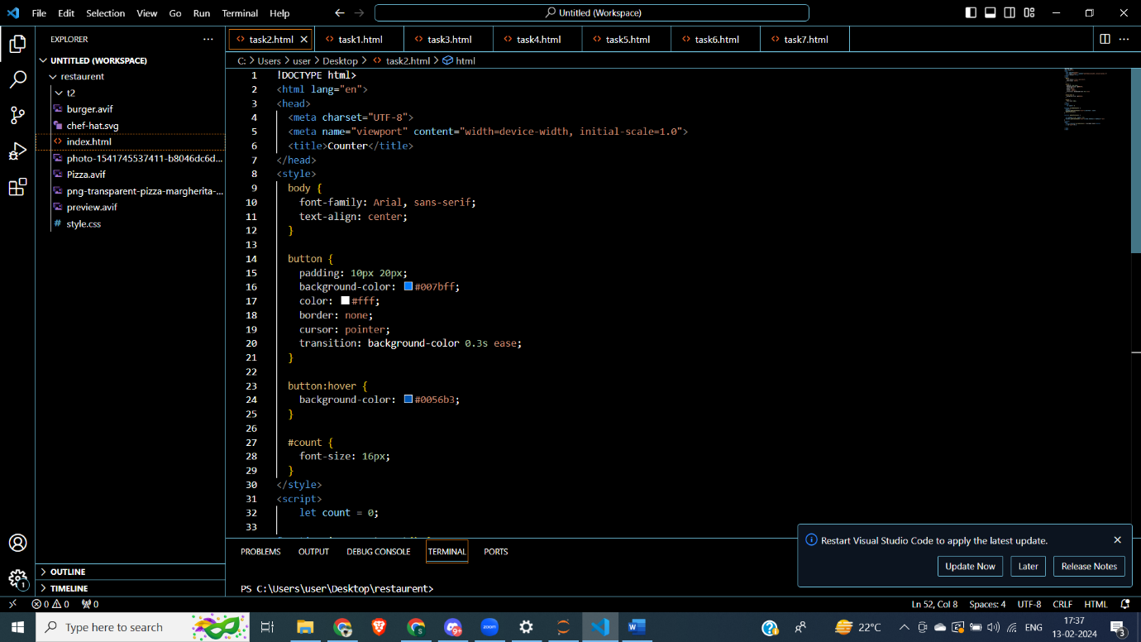

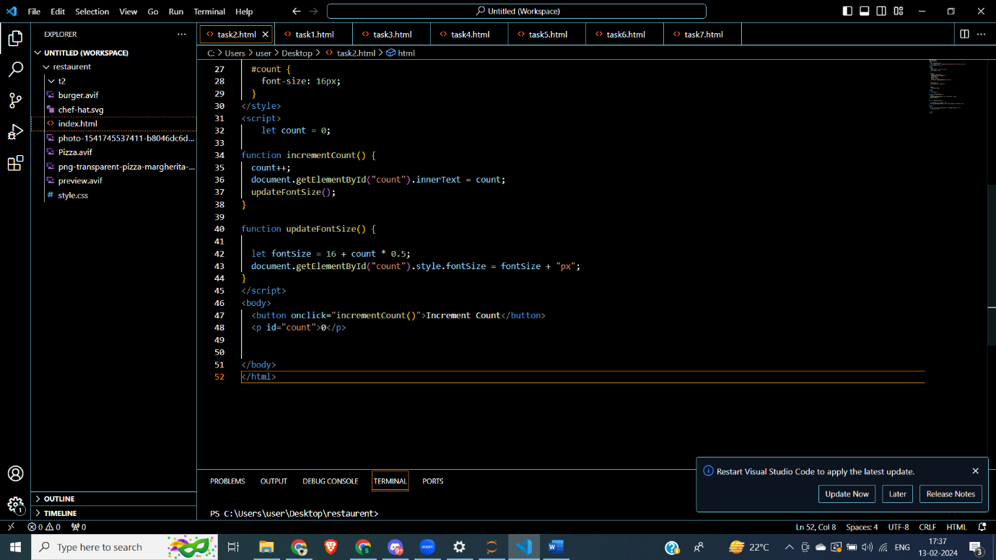

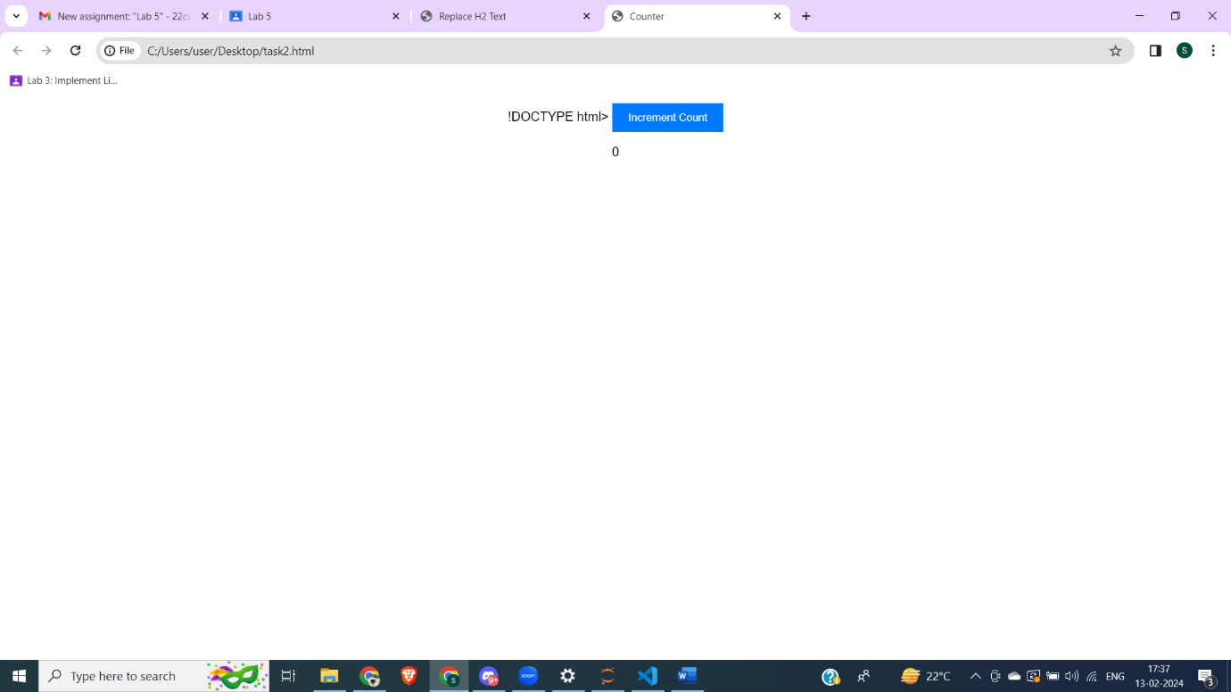

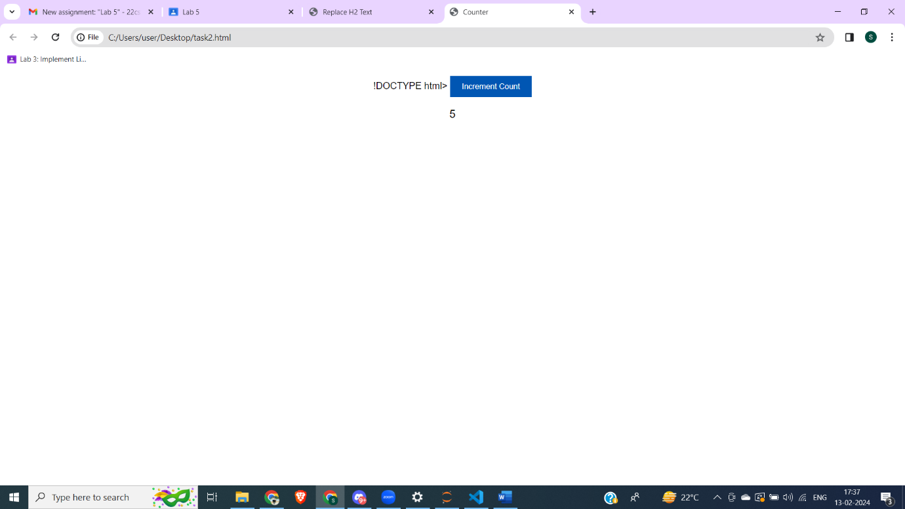

T3. Repeat the previous exercise but make a list of numbers. In this case you will not be able

to simply update the innerHTML of the paragraph, you will need to use the

document.createElement() and document.appendChild() functions to add a new list item.

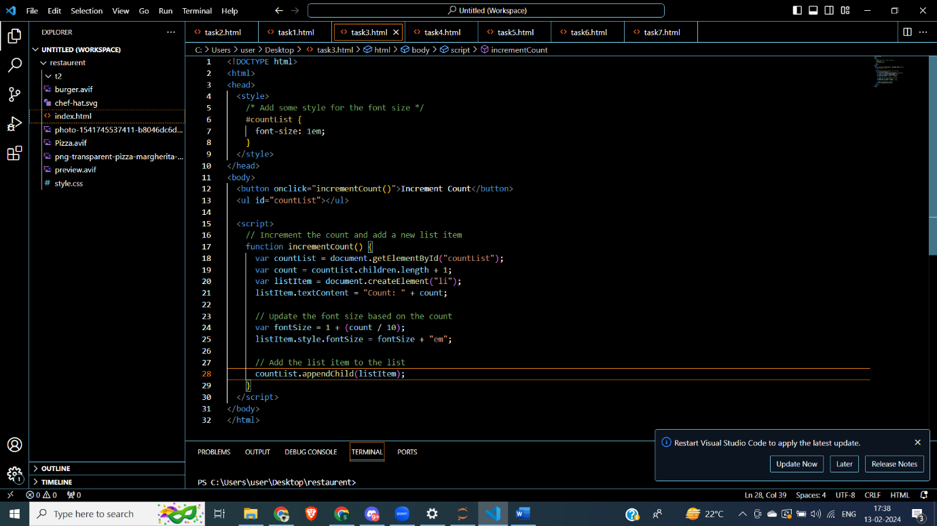

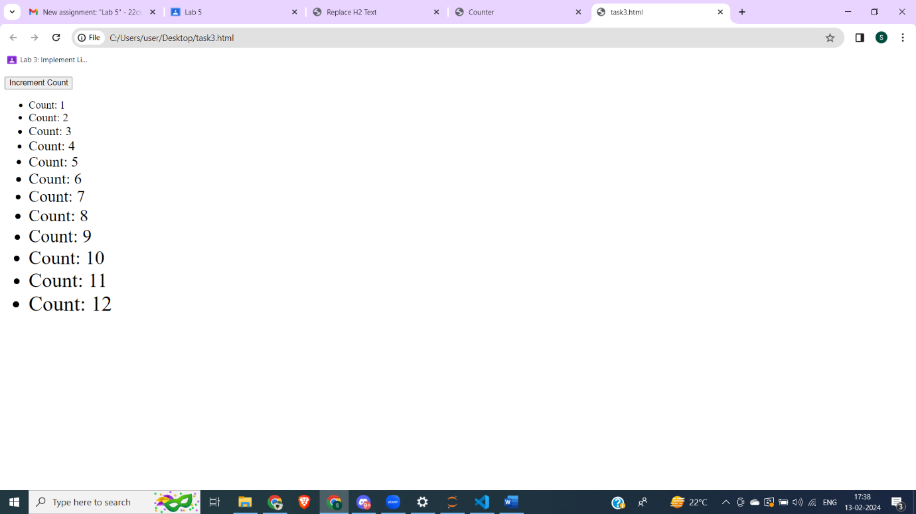

T4. Given the following html. Every time the button is pressed you should add a row to the

table, where the new row of the table contains the sum of the previous two rows. You should make use of the lastChild, previousSibling, and innerText attributes in this exercise.

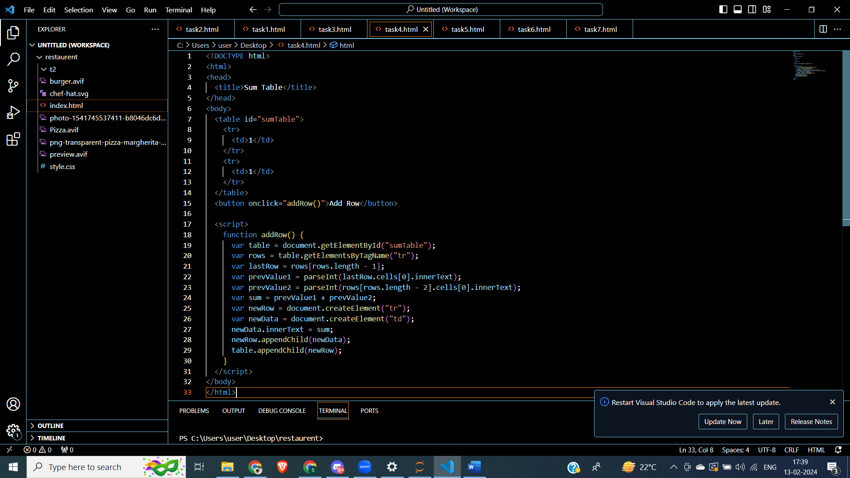

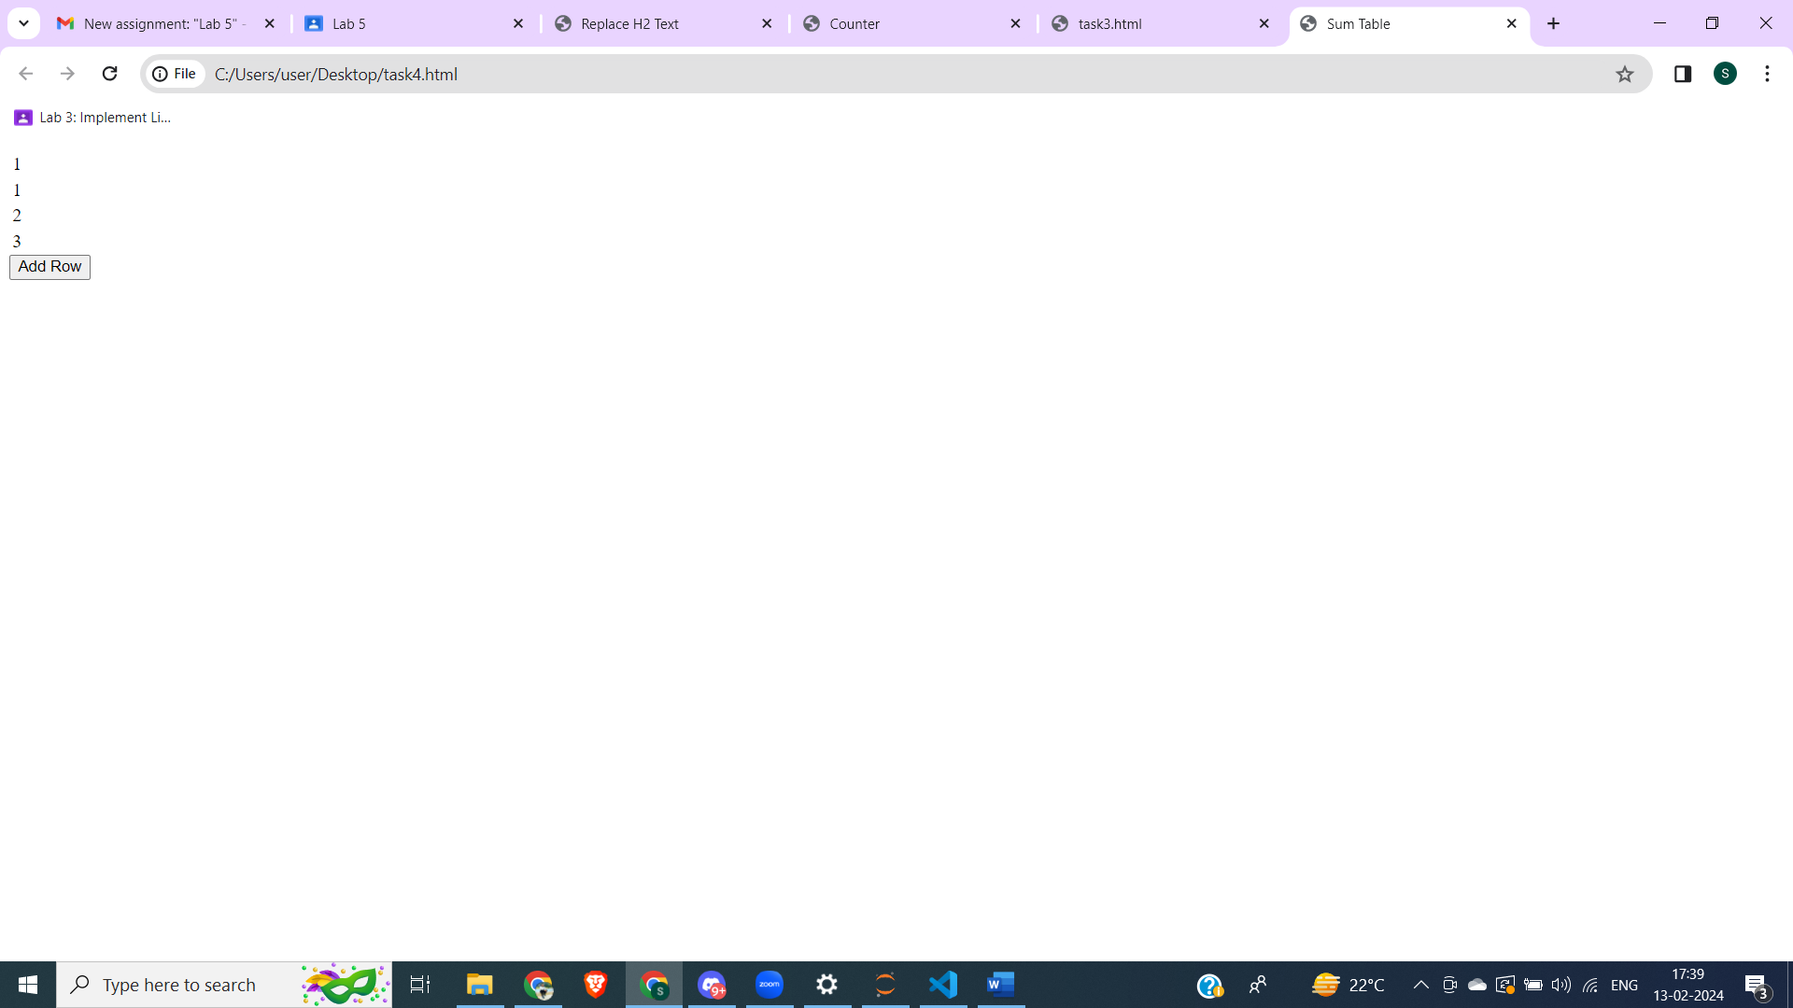

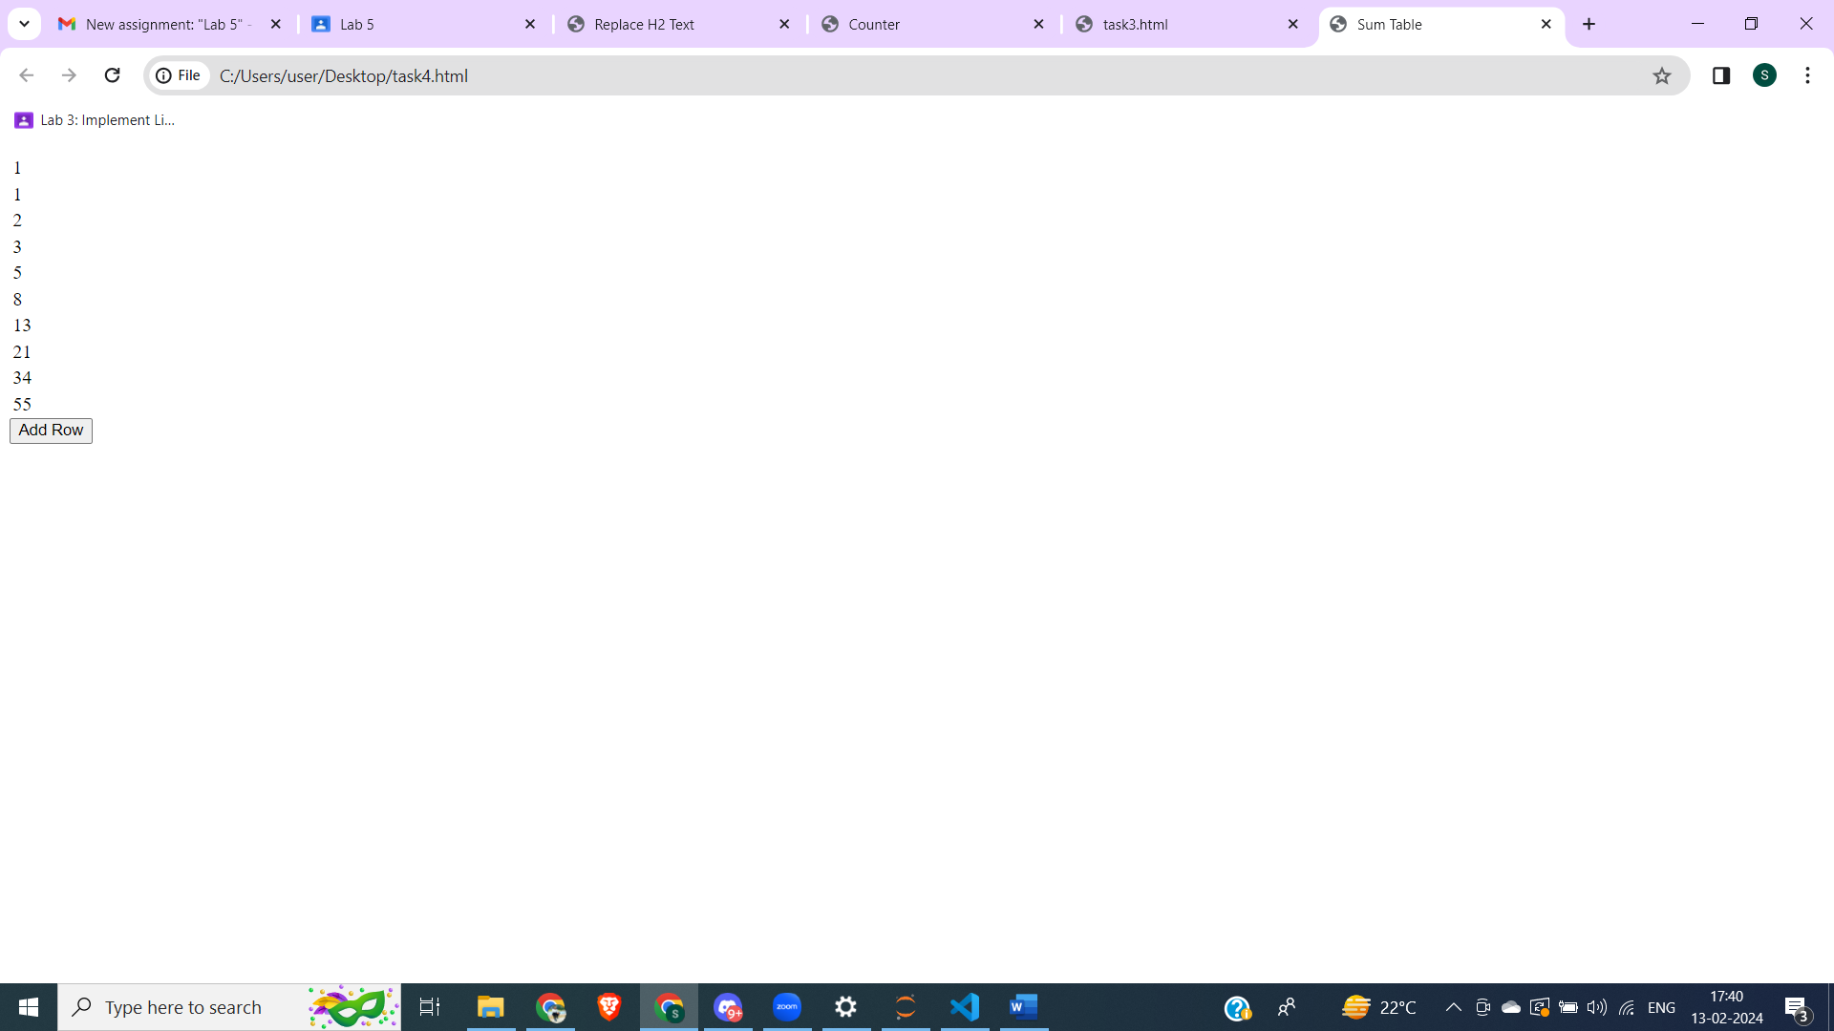

T5. Create an html page with two text input boxes and four buttons. The buttons should be

labeled +, -, \*, and /. When one of these buttons is pressed you should get the value from

both text input boxes and add, subtract, multiply, or divide the numbers entered in the text

input boxes. The result should be displayed below the buttons. Note In order to do math on

the values you read from the text input boxes you will need to use Number.parseInt on the

value. for example suppose you get a reference to input box 1 using myIn1 =

document.querySelector("#in1id"); then the statement value1 =

Number.parseInt(myIn1.value) converts the string from the text input box to an integer. In

fact most of the time Javascript will do the conversion for you automatically except for

addition.

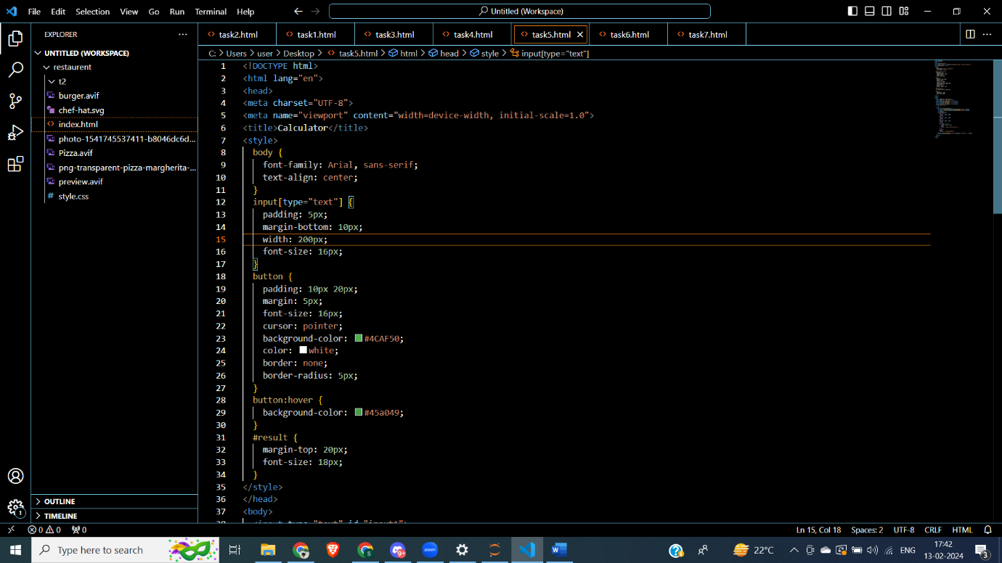

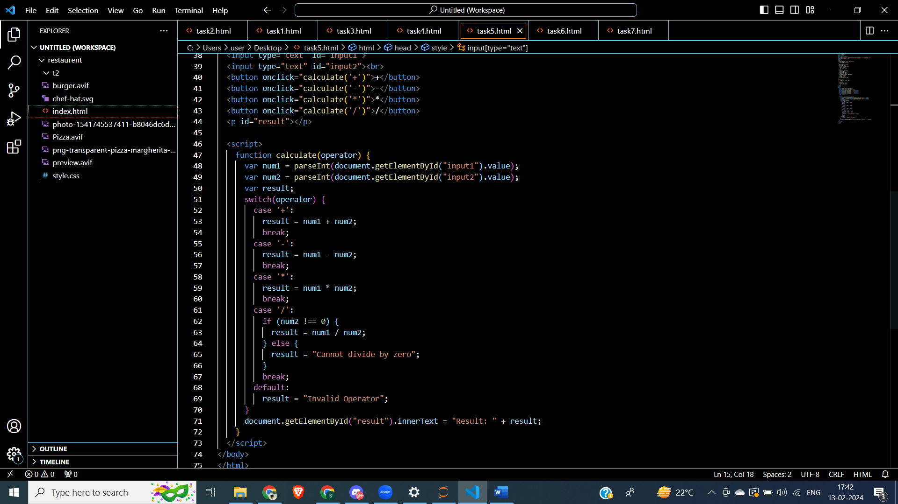

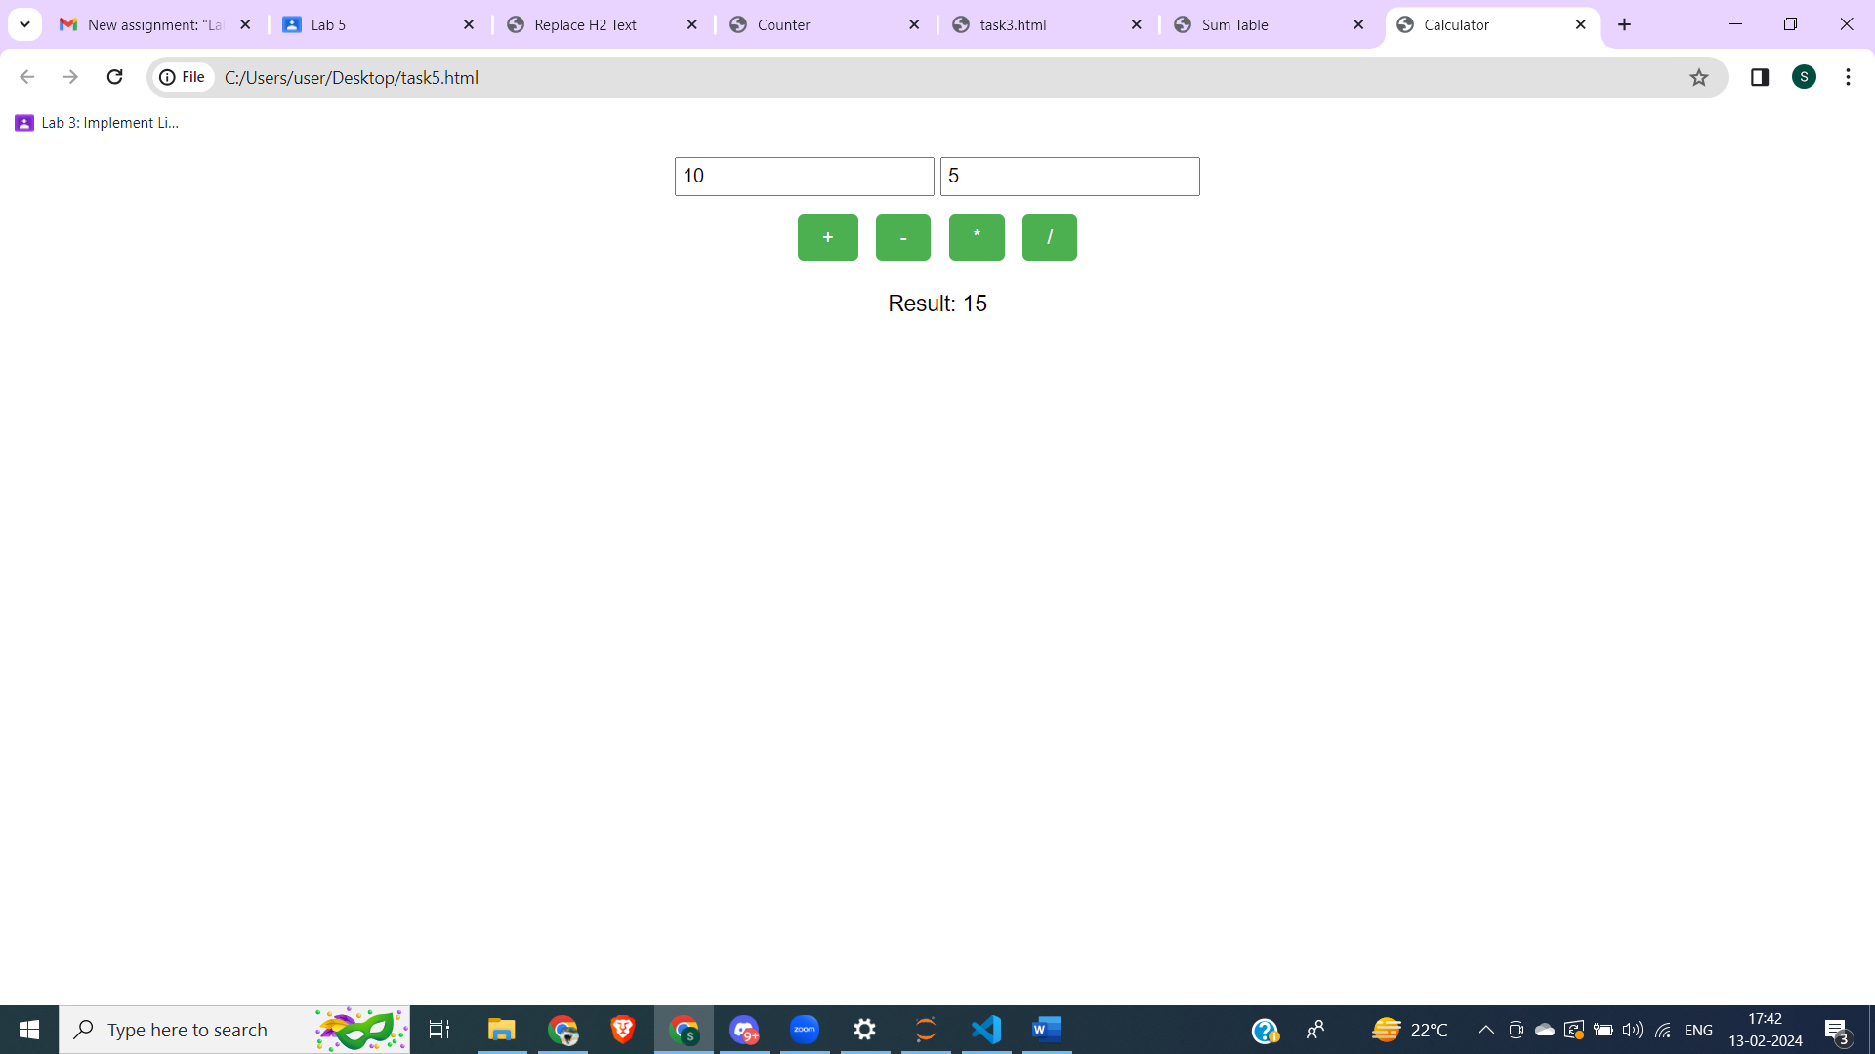

T6. Starting with the code given, create a page that looks like the following image: The rest

of the page must be created using javascript. You must use document.createElement and

the appendChild functions.

<html>

<body>

<button onclick="makePage();">Click Here</button>

</body>

</html>

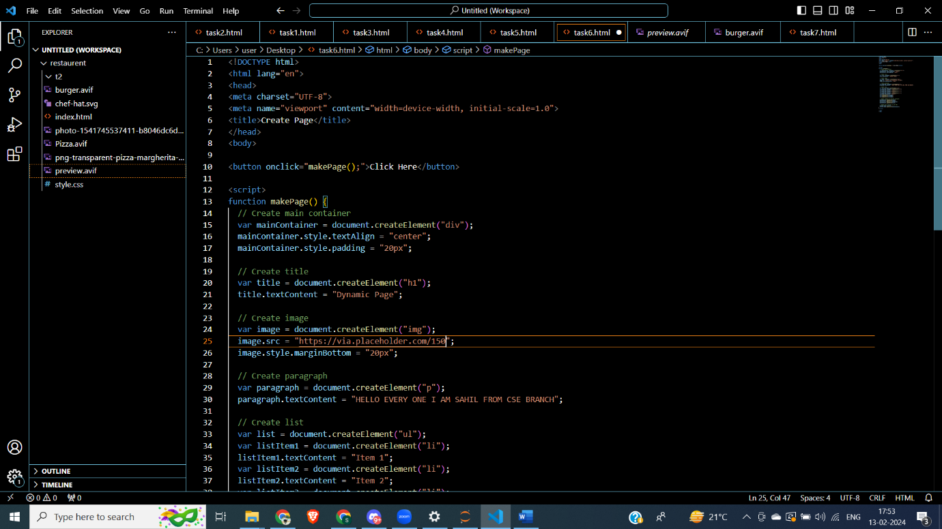

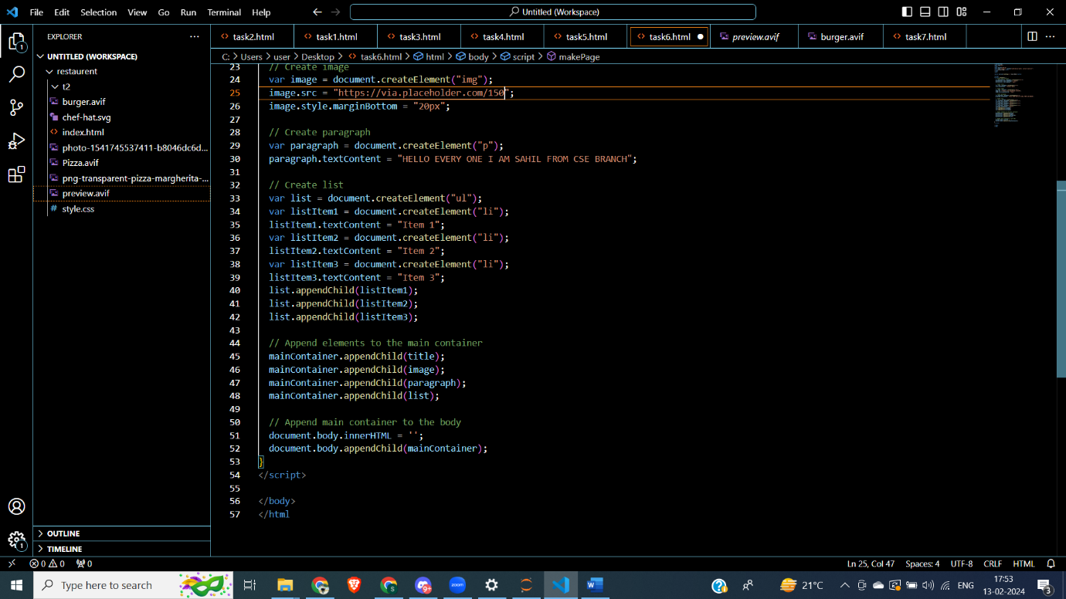

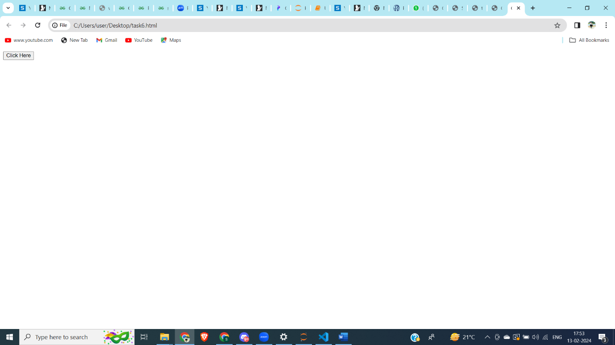

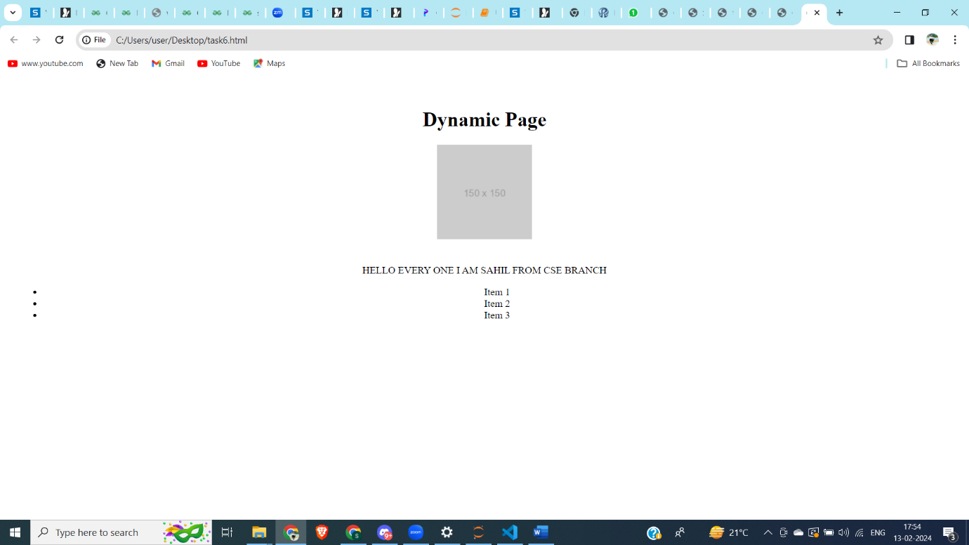

T7. Create a Tip Calculator as a single page web application (SPA). Design an interface that

allows you to enter the amount of the tip. The percentage you would like to tip, and the

number of people to split the tip with. Do not use 3 text input elements! Calculate and

dynamically display the tip.

