WEB TECHNOLGY

LAB_2

NAME – SAHIL

ROLL NO. – 22CS3052

BRANCH – CSE

T1. Make a little webpage to tell a little about yourself. Use at least three levels of headings

and some paragraphs.

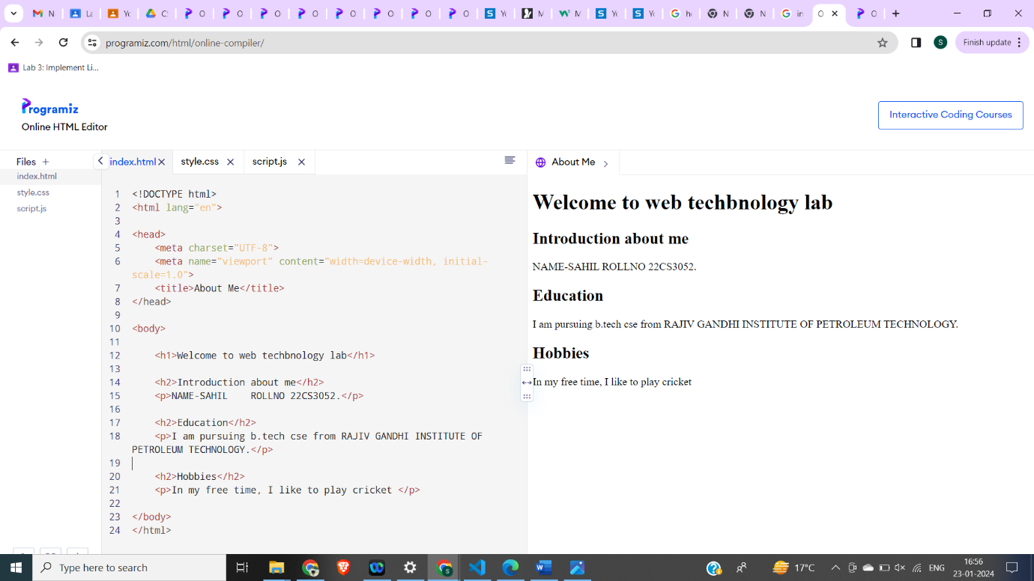

T2. Write an html page that includes a header element giving a title to some image then

include the image in the page, sized appropriately, and a paragraph that describes the

image.

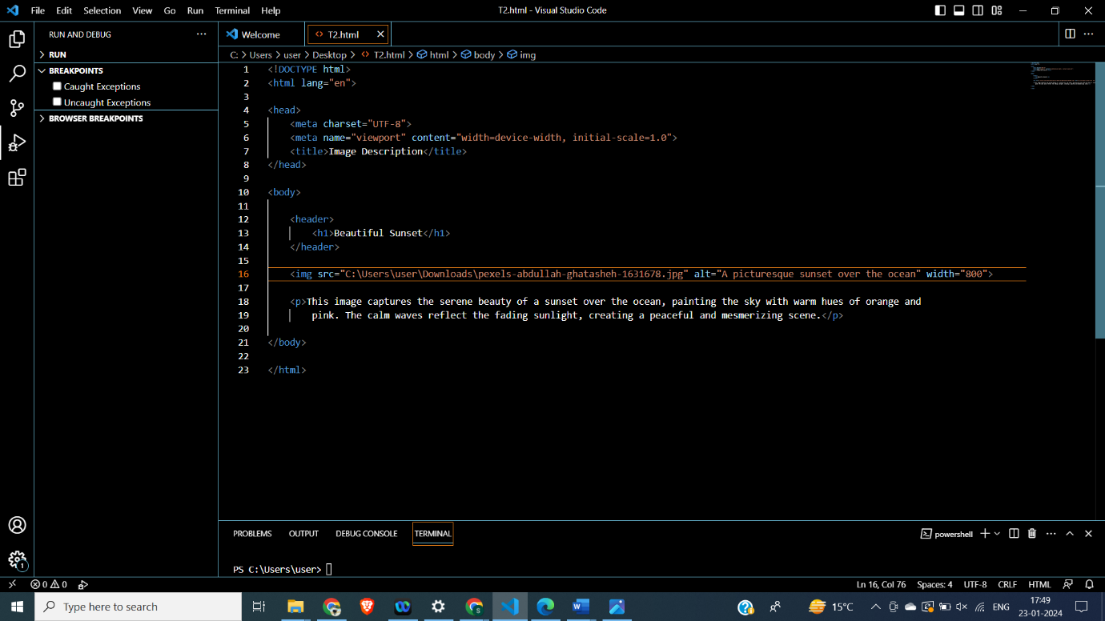

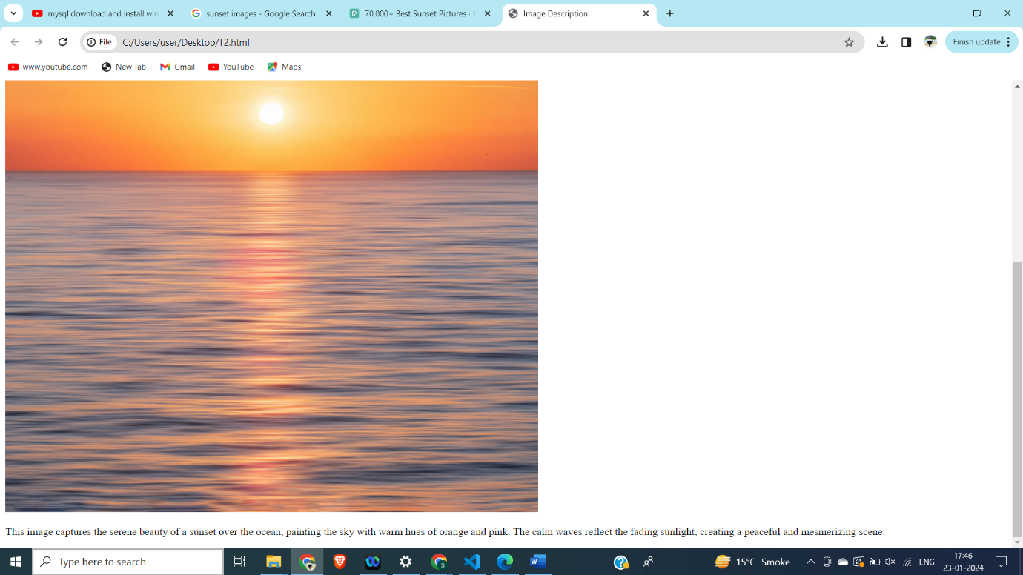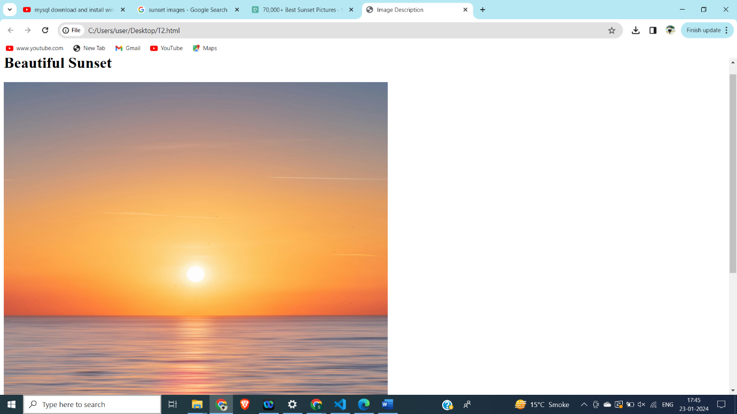

T3. Make an ordered list that has capital roman numerals at the highest level and lower

case roman numerals for the second level items. List three countries at the first level, and

for each of those list two spoken languages in that country.

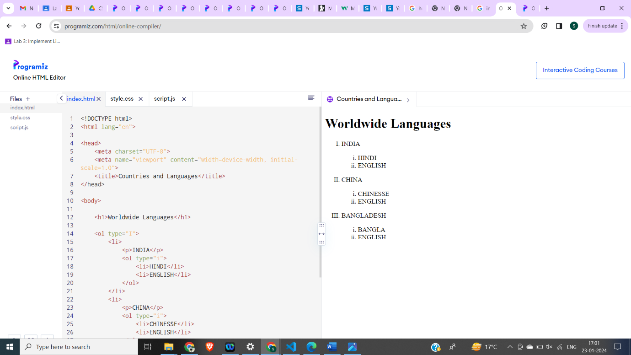

T4. Make a webpage that uses a table to create two columns. In the left column should be

a bulleted list of 5 countries. In the right column should be a numbered list of capitals of

those countries.

<table>

<head> <tr>

<th>Column 1</th>

<th>Column 2</th>

...

</tr>

</thead>

<tbody> <tr>

<td>Data 1</td>

<td>Data 2</td>

...

</tr>

<tr>

...

</tr>

</tbody>

<tfoot> </tfoot>

</table>

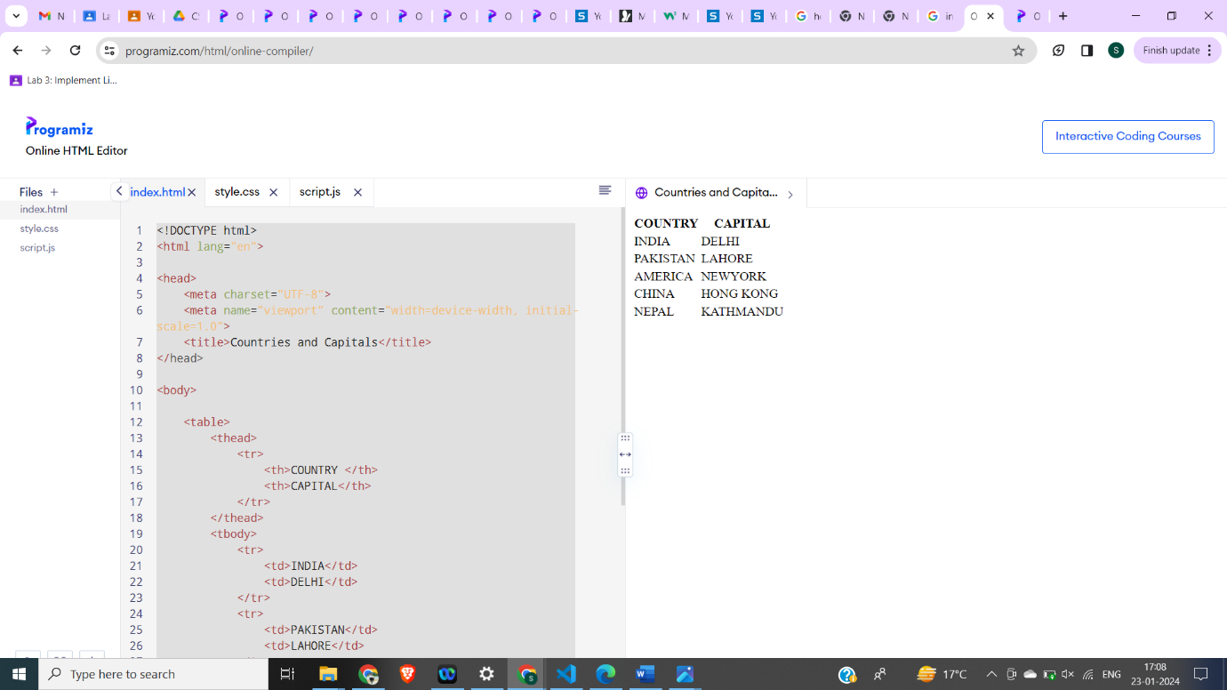

T5. Make a table that looks like this:

Country Politicians

Turkmenistan President Gurbanguly

Berdimuhamedow

Vice-President Raşit Meredow

Eritrea

President Isaias Afwerki

Vice-President None

*Hint, this is going to require both rowspan and columnspan. Also, Do not try to do this all at once.

Start with the header, then move on to the rest of the table, working in small parts.

<table>

<thead>

<tr>

<th>Product</th>

<th colspan="2">Sales</th>

<th rowspan="2">Total</th>

</tr>

<tr>

<th></th>

<th>Q1</th>

<th>Q2</th>

</tr>

</thead>

<tbody>

<tr>

<td>Widget A</td>

<td>100</td>

<td>150</td>

<td>250</td>

</tr>

<tr>

<td>Widget B</td>

<td>200</td>

<td>180</td>

<td>380</td>

</tr>

</tbody>

</table>

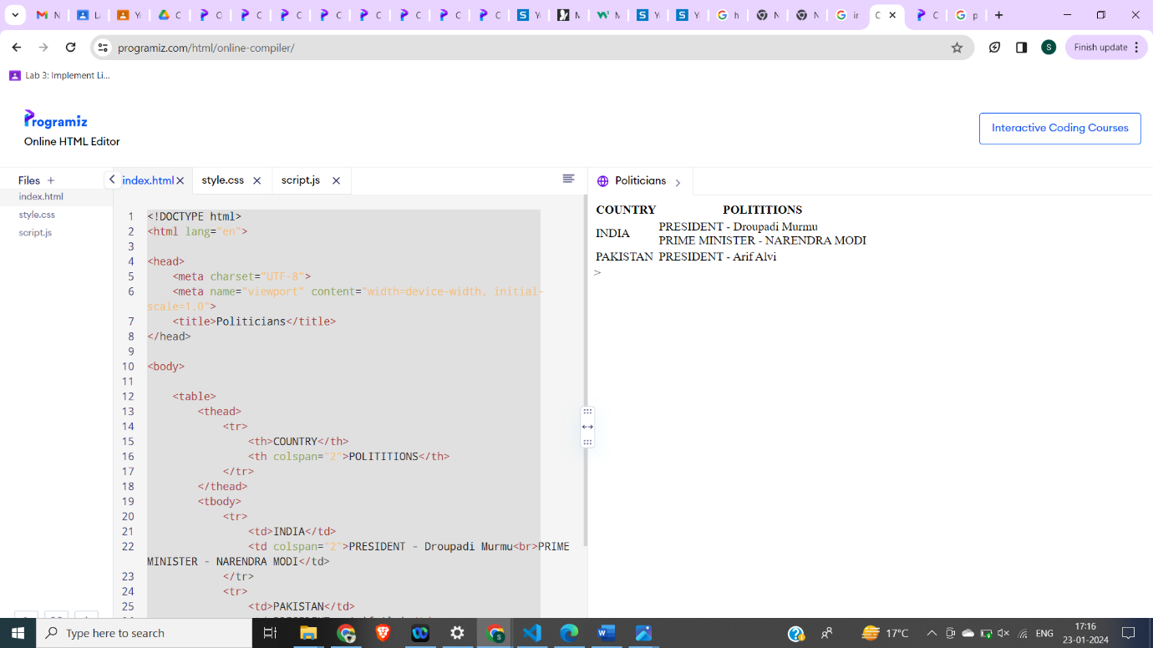

T6. Make a webpage that links to four of your favorite websites.

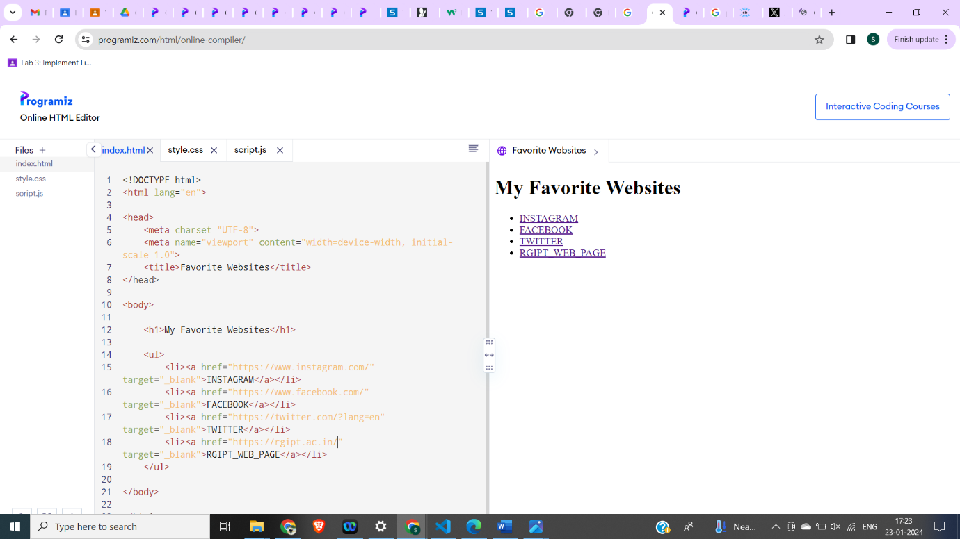

T7. Make a webpage with a link at the bottom that when clicked will jump you all the way

to the top of the page.

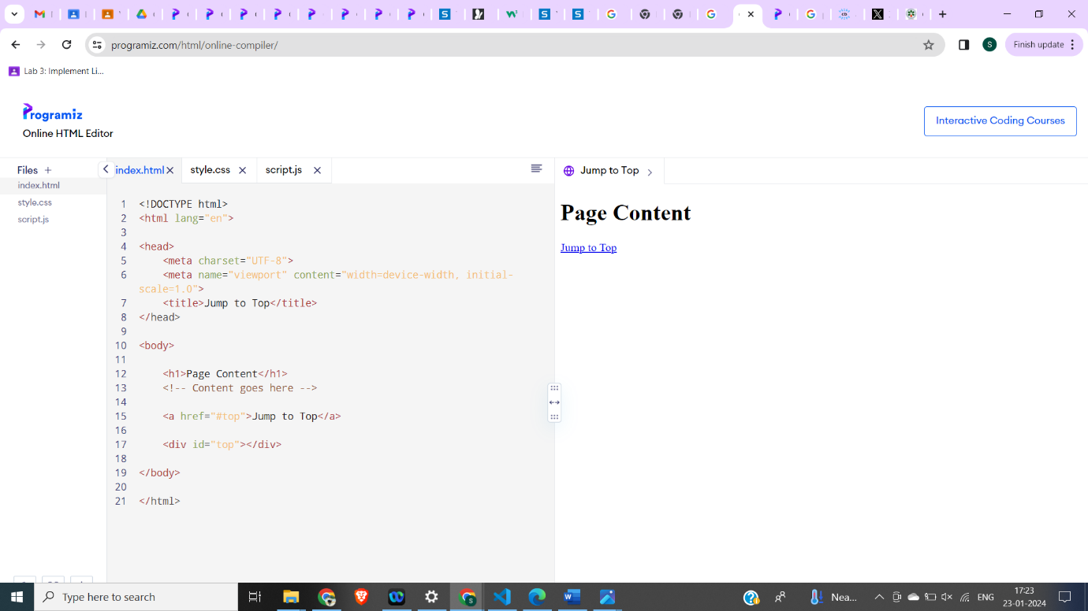

T8. Make a webpage with a link at the top of it that when clicked will jump all the way to

the bottom of the page. At the bottom of the page there should be a link to jump back to the

top of the page.

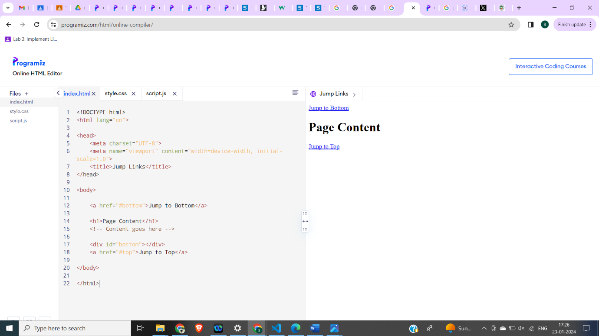

T9. Make a webpage with an image that has a border of size 2, a width of 200, and a height

of 200. 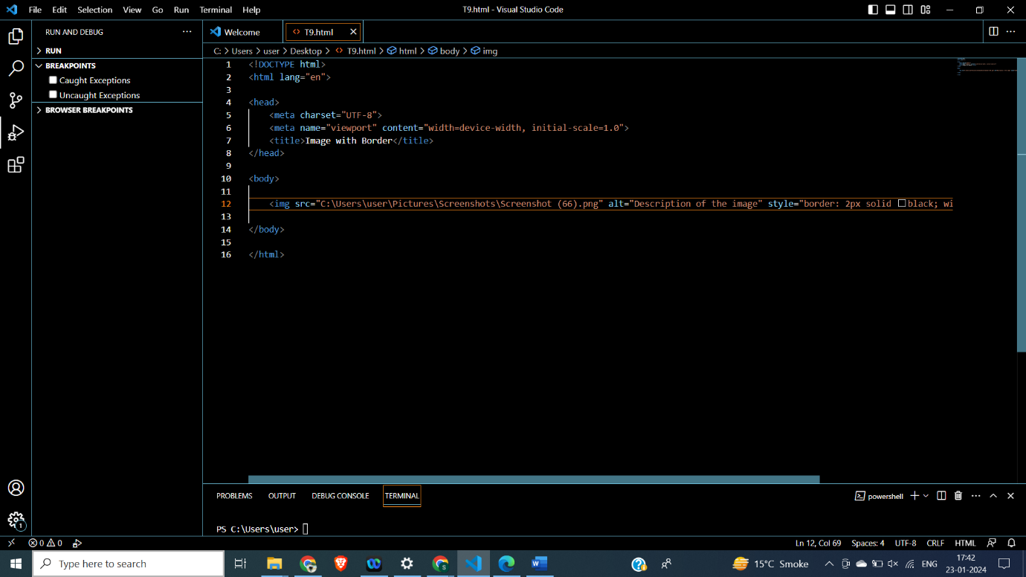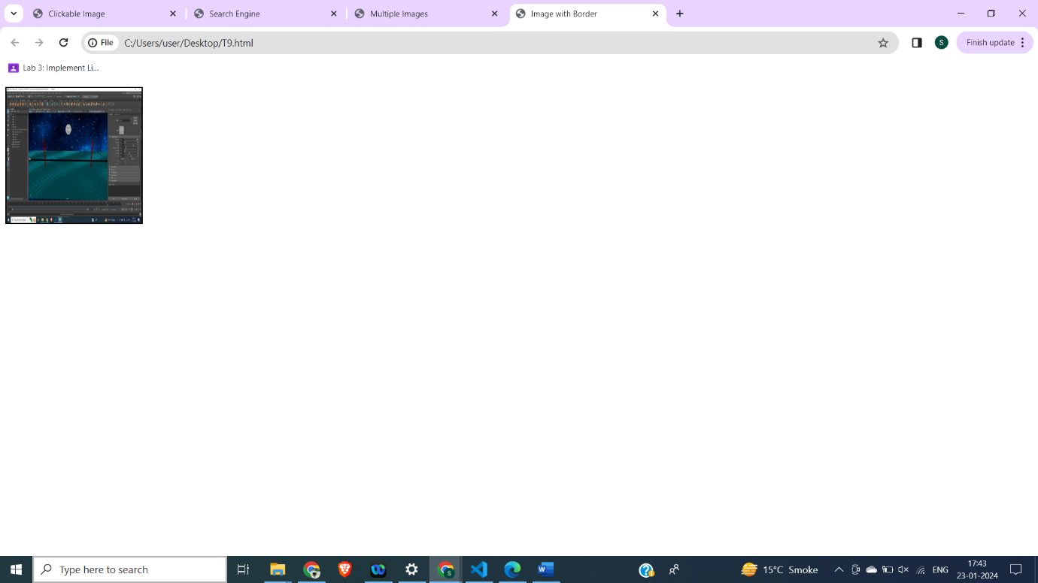

T10. Make a webpage with five different images. Skip two lines between each image (Use

<br> tag). Each image should have a caption.

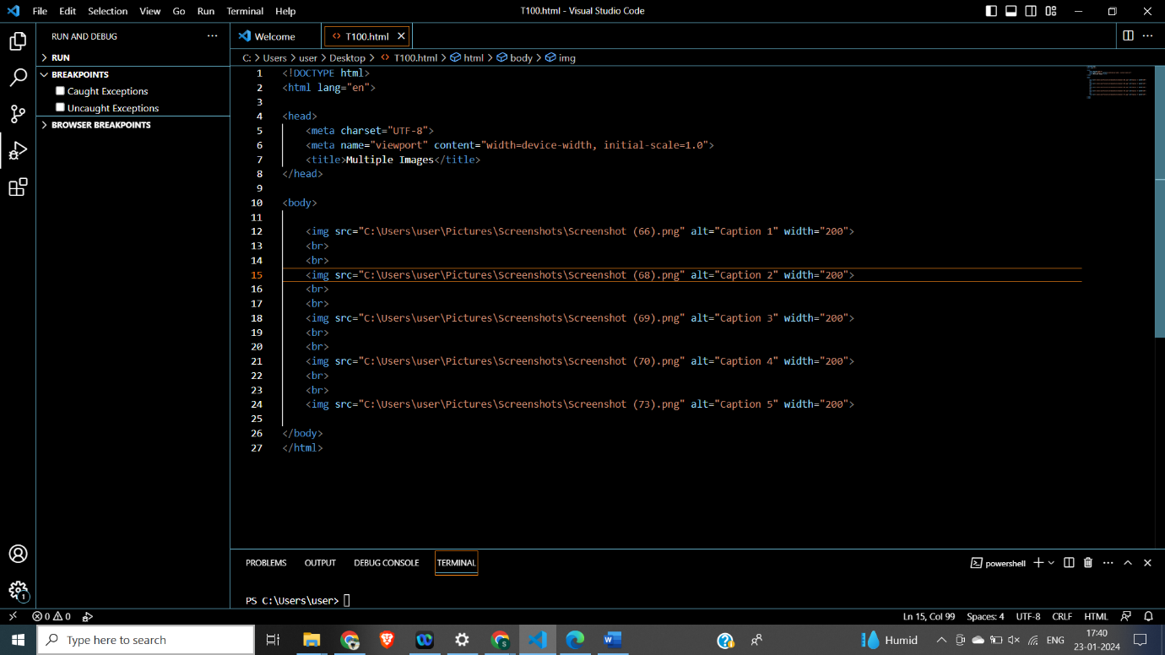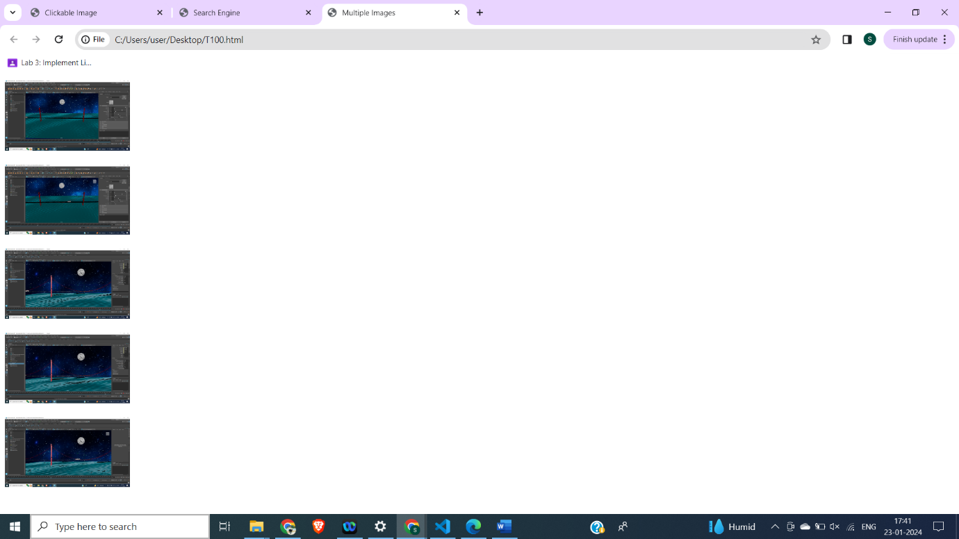

T11. Make a webpage with an image that when clicked will link to a search engine of your

choice. 