WEB TECHNOLOGY

LAB4

ASSIGNMENT

NAME – SAHIL

ROLLNO – 22CS3052

BRANCH – CSE

T1. Create a webpage that has a heading and a button. Write a script to change thebackground color and text when the button is clicked.

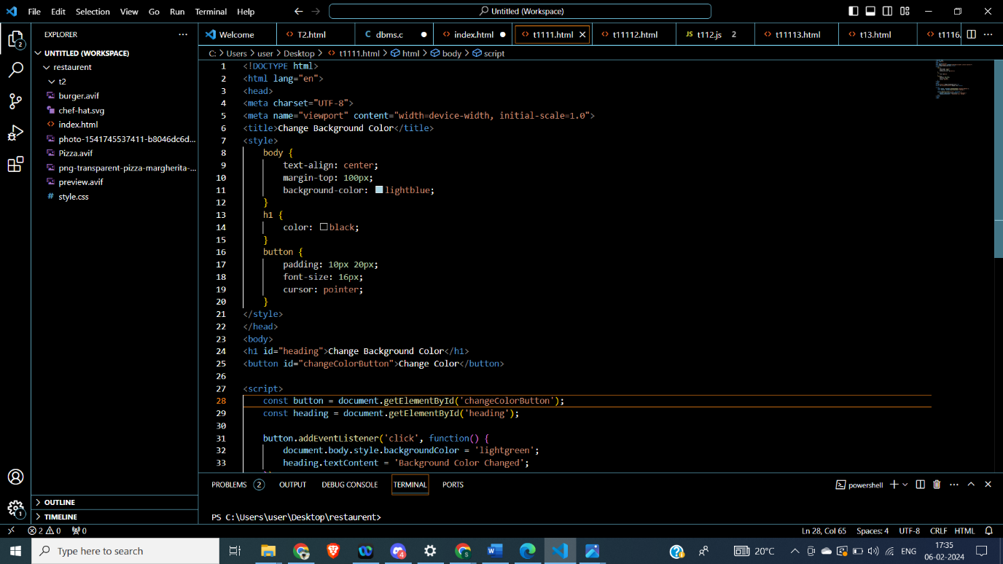

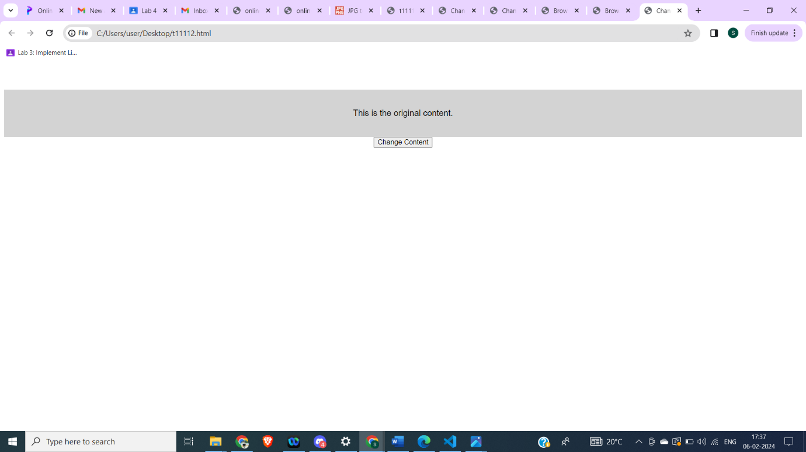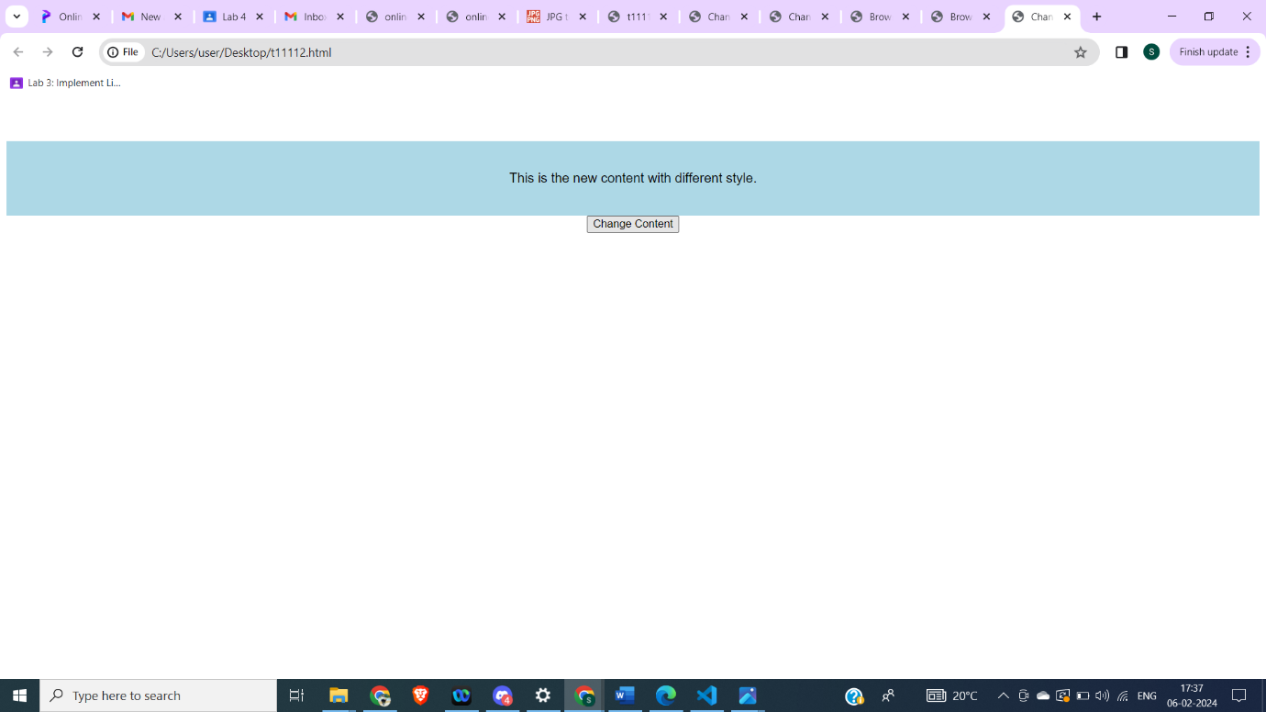

T2. For T1, experiment with the Javascript code by trying the following things:

a. Make the background light green.

b. Add a line that makes the text red.

c. Change the fontSize to 48pt.

d. Change the wording inside the <h1> tag in the Javascript.

e. Add <button>Click Me</button> after the closing </h1>.

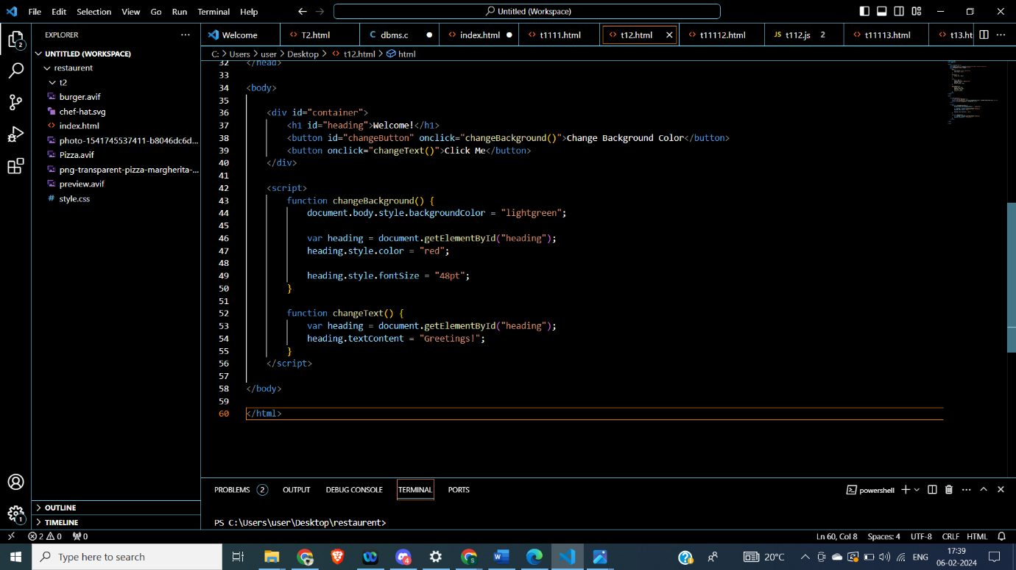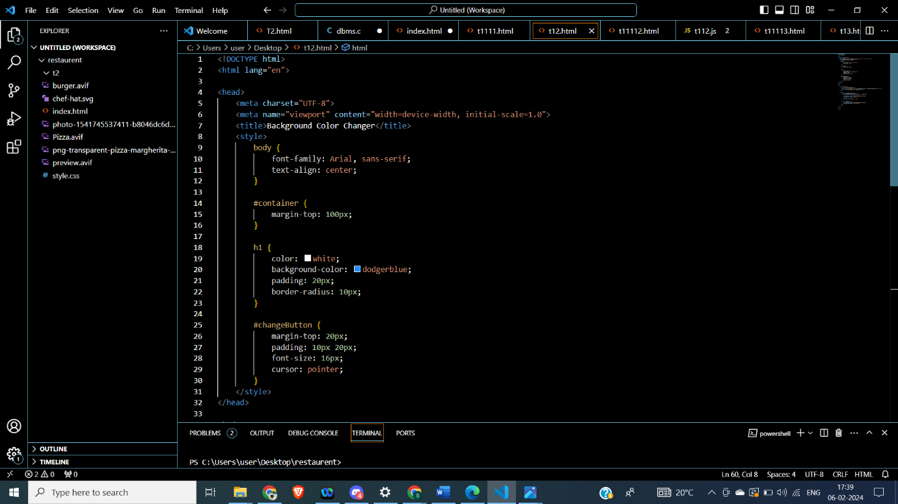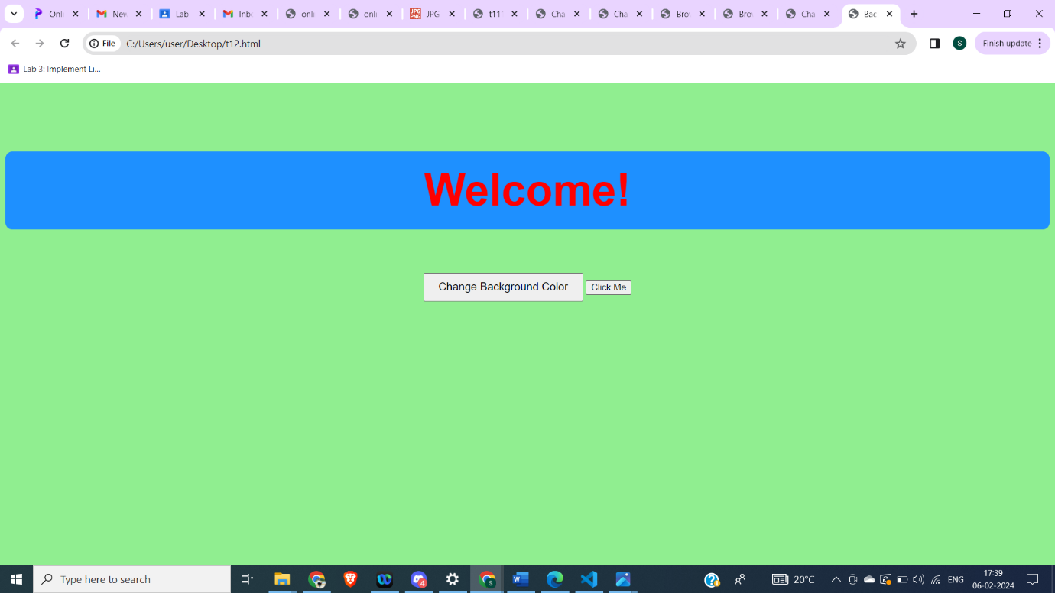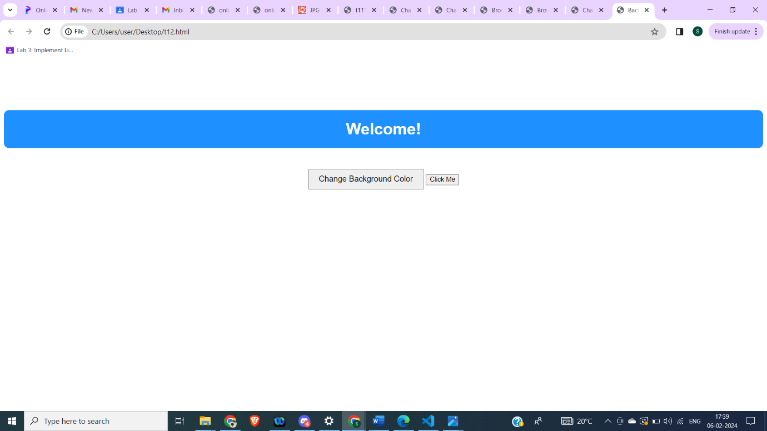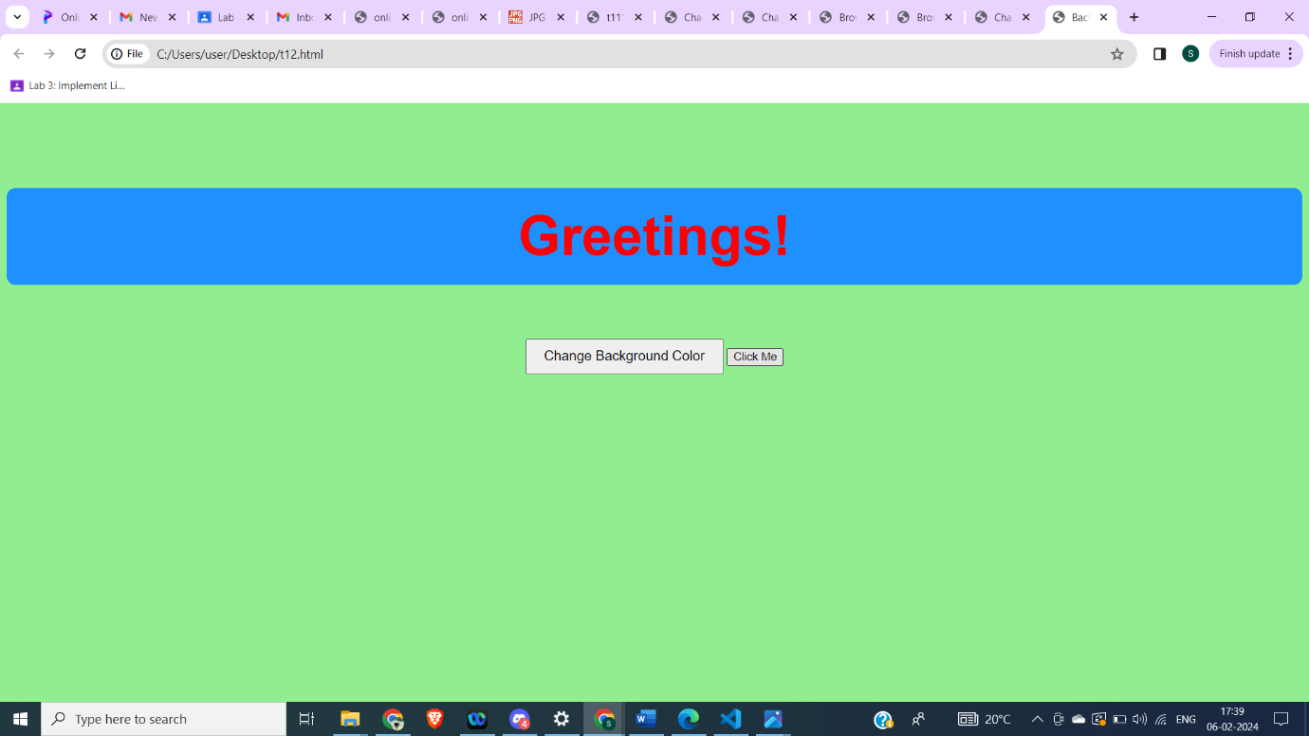T3. For T1, set the color of the background directly with the class attribute. Generate alertsbefore and after assigning the class attribute to document object. 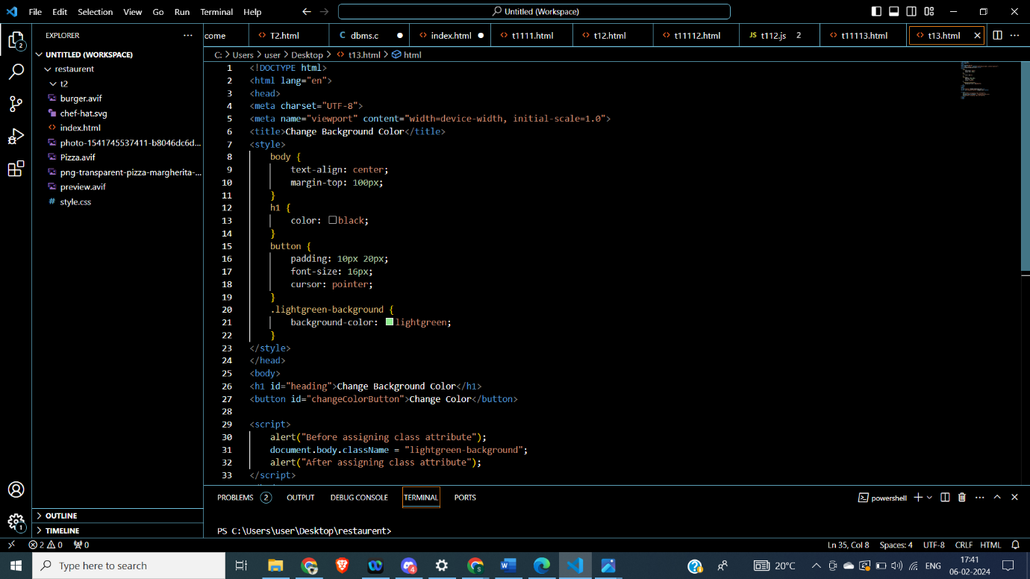

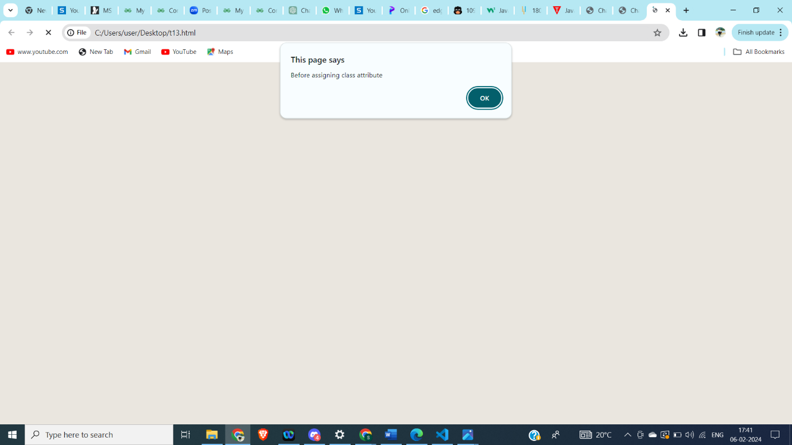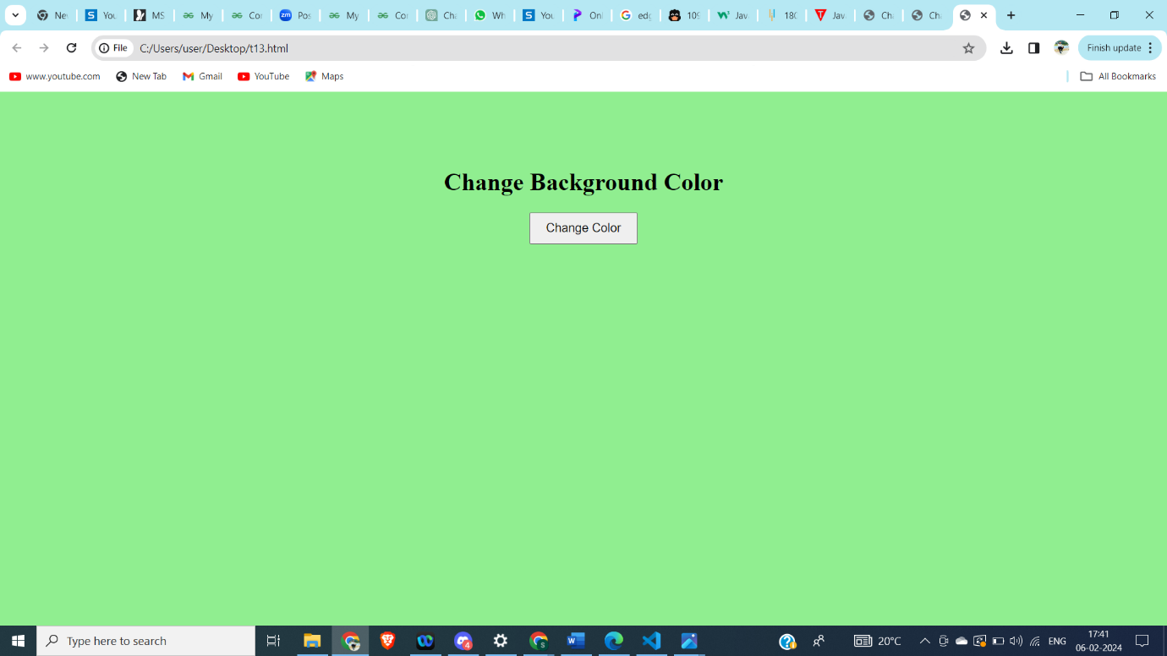

T4. Design a page having contents within and outside the main section. The page mustcontain a button that when clicked replaces the content of the main section with anothercontent having different style. 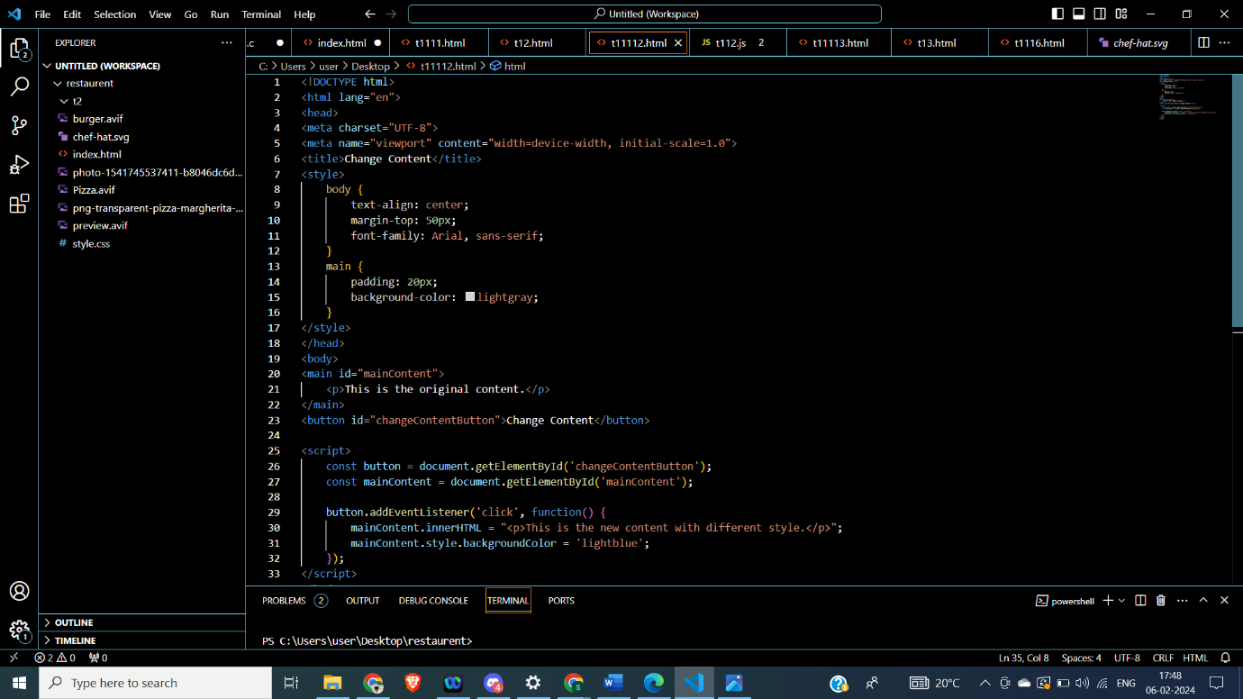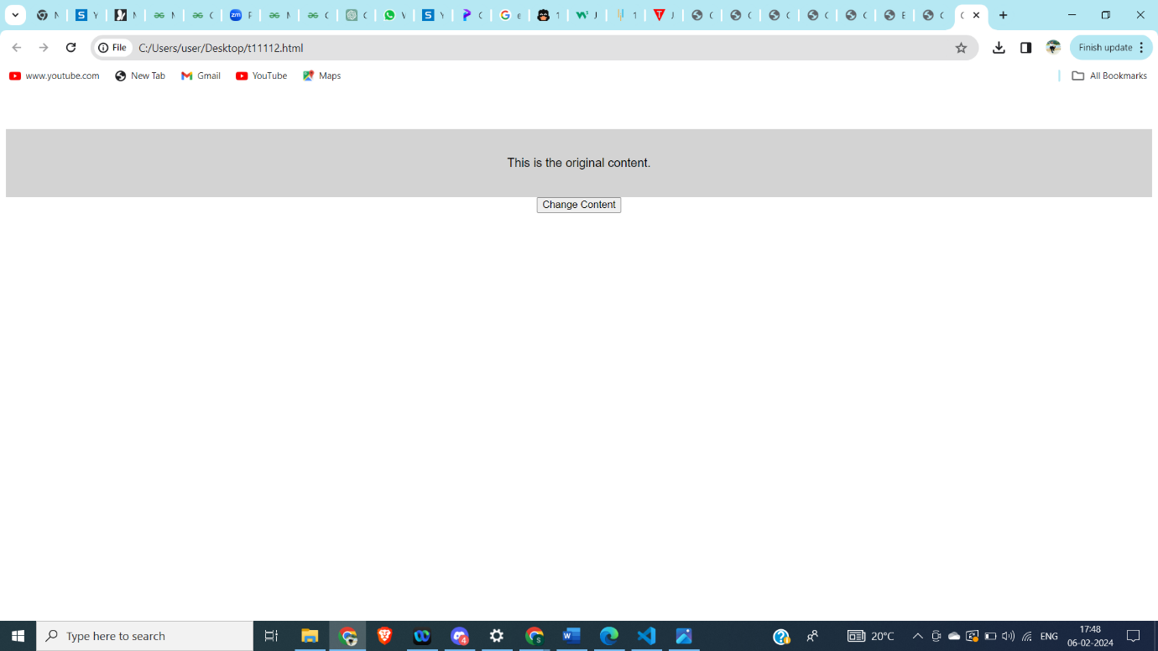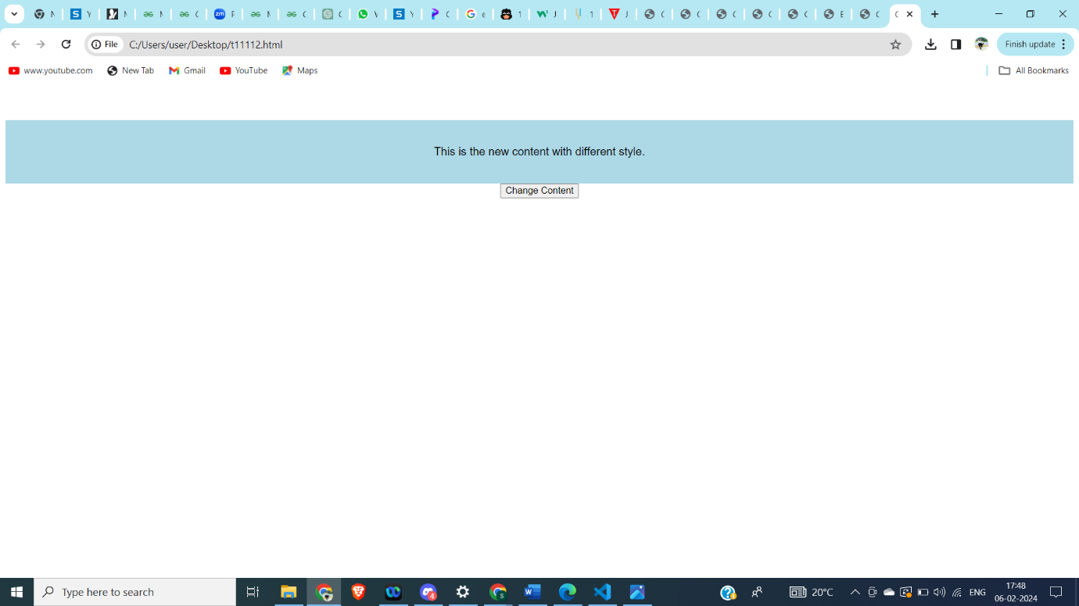

T5. Consider a h1 heading lying outside the main section in the page. Try changing the color

of h1 in at least 3 different ways. 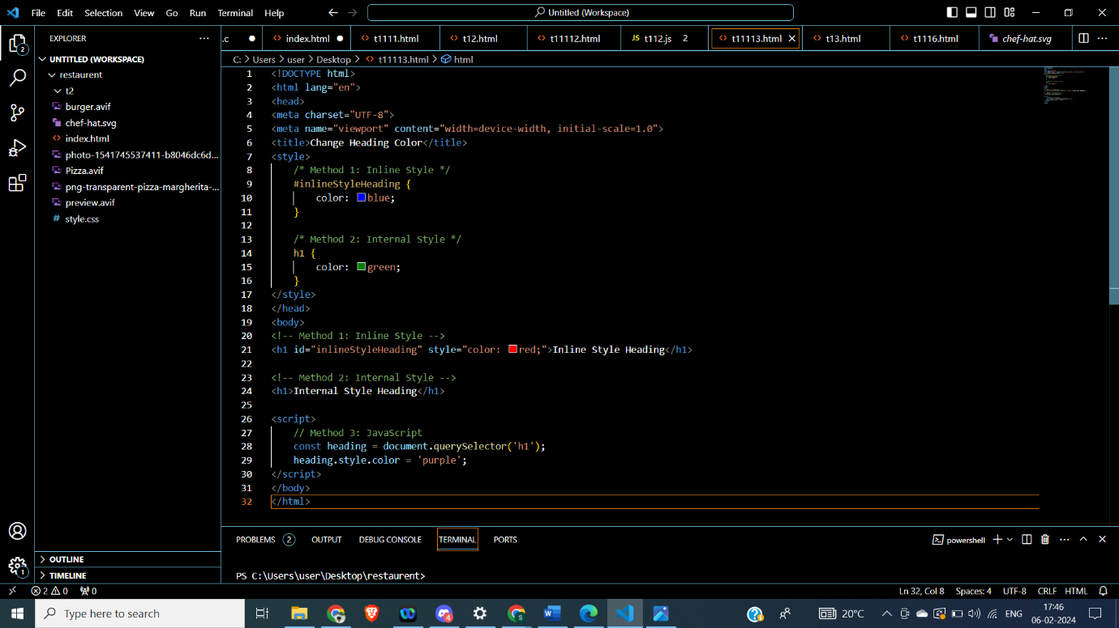

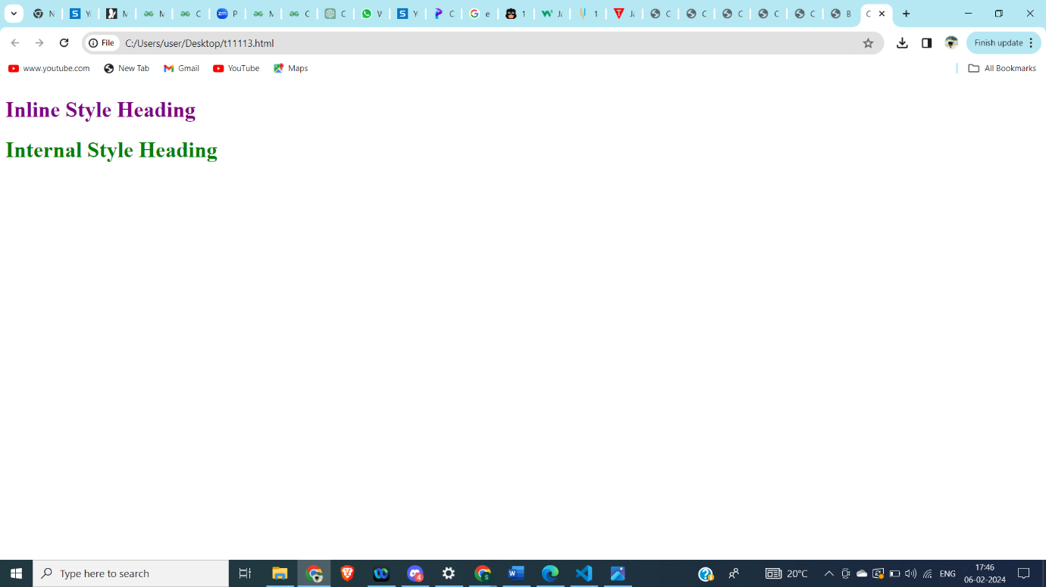

T6. Design a webpage using grid layout that displays the following:The first row shows icons of various web browsers and the second row shows the latest

version number. 