Optimizing Retail Sales and Stock Management for Sahu Cloth House

A Final Report for the BDM Capstone Project

Submitted by:

Name: Deepanshi
Roll number: 22f1000455



IITM Online BS Degree Program,
Indian Institute of Technology, Madras,
Chennai, Tamil Nadu, India, 600036

CONTENTS

Executive Summary 2

Detailed Explanation of Analysis Process and Methodology 2-4

Results and Findings 4-15

Interpretation of Results and Recommendation 15-19

1. Executive Summary
This study looks at improving sales and stock management for Sahu Cloth House, a retail store in Ranila that often struggles with stock shortages and unpredictable sales. I collected 12 weeks of sales and inventory data directly from the store’s records and carefully cleaned it—fixing missing entries, removing duplicates, and standardizing product lists to keep everything accurate. Using tools like ABC categorization, Pareto analysis, and visual dashboards, I dug into the data to uncover key business patterns.
The analysis showed that just 28% of the inventory brings in 78% of the total revenue, with premium ladies’ suits standing out as the top driver. At the same time, revenues jumped up and down from week to week, mainly because of demand swings and stockouts.
Based on these insights, I suggest a few practical steps:
- Keep higher safety stock for the top-selling, high-revenue items.
- Track weekly sales closely to catch unusual changes early.
- Run focused marketing campaigns for mid-range (“B” category) products.
Following these steps can help reduce shortages, steady sales, and set the store up for more consistent growth.

2. Detailed Explanation of Analysis Process and Methodology
2.1 Data Collection & Cleaning:
- Data were collected from physical registers and electronic records for 12 consecutive weeks.
- Merging and standardization of product and sales logs was performed.
- Duplicates and missing entries were removed or corrected using cross-checks with inventory and direct owner input.

Full details about the chosen methods (descriptive stats, ABC, Pareto) are provided in the mid-term report (see Mid-term Report, Section 3)—referenced here for completeness.
Mid-term Submission (BDM Project) 22f1000455
Summary of Method Appropriateness
The methods I used are robust enough methodologically, but also practical for a small retail business like Sahu Cloth House. By combining ABC Analysis, Pareto Analysis, and some basic stats, I get:
- Data Accessibility: It's great because these methods just use the sales and revenue data we already have on hand.
- Interpretability: The results are easy for business owners to understand.
- Scalability: Framework can be maintained and updated with ongoing business data
- Cost-Effectiveness: Cheap because no specialized software or extensive training is required.
- Problem Alignment: These methods directly address the identified challenges of our inventory optimization and revenue concentration.

This methodological approach prioritizes practical business value over analytical sophistication, making it most appropriate for the specific context of operational challenges and data availability constraints.

2.2 Price Structure Analysis:
Price structure was analyzed using descriptive statistics (mean, median, SD, CV) on the full product list to highlight high-variance categories.
The product prices differ a lot. The average item costs about ₹371.33, but prices spread out largely with a standard deviation of ₹469.50. This means we have a very high coefficient of variation (126.4%), indicating a broad pricing strategy. Their offerings range from low-cost items like Atta Noodles and Coconut Biscuits at ₹40 a unit to high-end products such as Ladies' Suits at ₹1,800 and Nutricharge Bioage at ₹1,500. This wide range of prices helps us serve many different customers and meet their varied needs.

2.3 Sales Volume Characteristics:
The total sales quantities also show significant differences. A product sells an average of 4.74 units each week, but differs a lot, with a standard deviation of 3.60 units and a coefficient of variation of 75.8%. Over a 12-week period, individual product sales ranged from just 1 unit for Gamma Oryzanol to a remarkable 181 units for Atta Noodles has wide range in sales volume highlights highly inconsistent demand, making targeted inventory management really crucial.

3. Results and Findings

3.1. Sales and Revenue Concentration

3.1.1 ABC Category Analysis
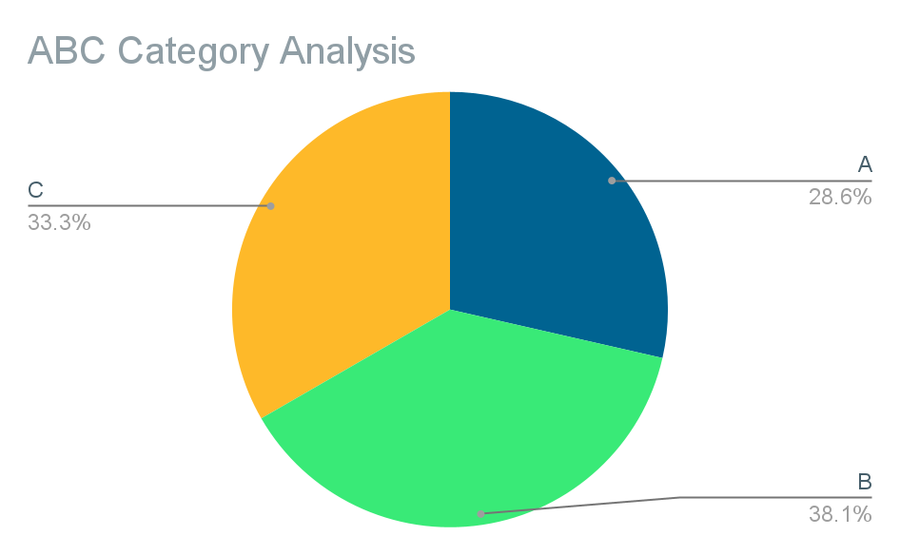

Figure-1

Name of the Item | Total Sale | Revenue Generated | Cummulative Value | Cumulative % | ABC Category
Ladies' Suit (Pcs.) | 77 | 138600 | 138600 | 0.456766973 | A
Ladies Slippers (Pairs) | 93 | 46407 | 185007 | 0.6097048152 | A
Bizz Detergent Powder (Pkt.) | 44 | 20240 | 205247 | 0.6764072938 | A
Amla Candy (200gm) (Pkt.) | 79 | 12640 | 217887 | 0.7180633871 | A
Aaloo Bhujia (Pkt.) | 95 | 10450 | 228337 | 0.7525021668 | A
Men's Shirt (Pcs.) | 10 | 7990 | 236327 | 0.7788338271 | A
Nutricharge Woman (Pkt.) | 15 | 7350 | 243677 | 0.8030563181 | B
Atta Noodles (Pkt.) | 181 | 7240 | 250917 | 0.8269162956 | B
Coconut Oil (175ml) (Pcs.) | 71 | 7100 | 258017 | 0.8503148924 | B
Liquid Handwash (200ml) (Pcs.) | 76 | 6080 | 264097 | 0.8703520006 | B
Nutricharge Bioage (Pcs.) | 4 | 6000 | 270097 | 0.8901254626 | B
Green Tea (20 bags) (Pkt.) | 22 | 5720 | 275817 | 0.9089761631 | B
Coconut Biscuits (Pkt.) | 121 | 4840 | 280657 | 0.9249267558 | B
Rice Bran Oil (Lts.) | 40 | 4800 | 285457 | 0.9407455254 | B
Pasta (Pkt.) | 66 | 3960 | 289417 | 0.9537960104 | C
Jasmine Soap (Pcs.) | 46 | 3680 | 293097 | 0.9659237338 | C
Red Chilli Powder (100gm) (Pkt.) | 67 | 3350 | 296447 | 0.9769639167 | C
Dish Soap Bar (Pcs.) | 52 | 3120 | 299567 | 0.987246117 | C
Chaat Masala (100gm) (Pkt.) | 32 | 1920 | 301487 | 0.9935736248 | C
Nutricharge Veg Omega (Pcs.) | 3 | 1380 | 302867 | 0.9981215211 | C
Gamma Oryzanol (Pcs.) | 1 | 570 | 303437 | 1 | C
Table-1

The comprehensive ABC analysis (Figure-1) reveals stark revenue concentration patterns that validate strategic focus requirements.
- Category A (top revenue generators) comprises only 28.6% of products but delivers nearly 78% of total revenue.
- Category B and C products, while numerous, contribute much less to overall business results.

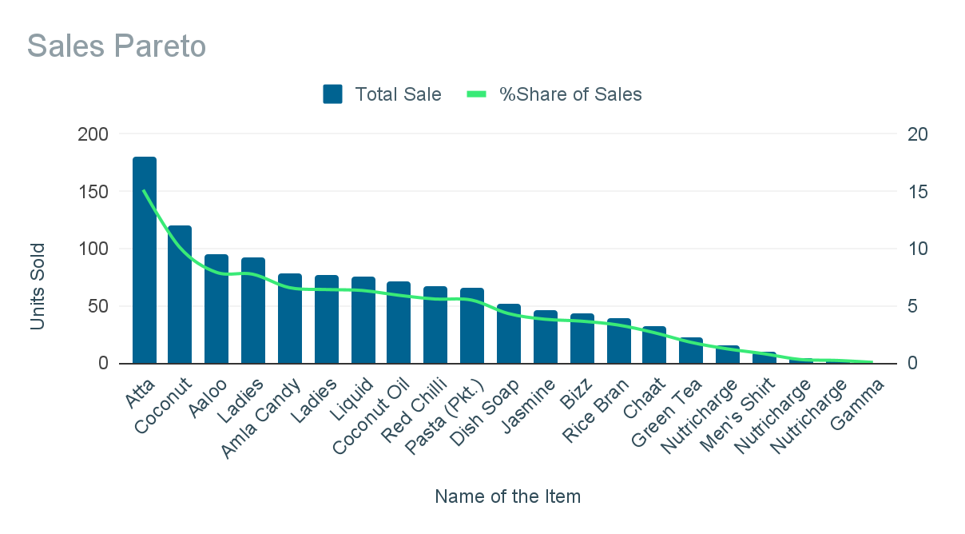
3.1.2 Sales Pareto Analysis:
Figure-2

The sales distribution across products is highly skewed, as shown in the Sales Pareto chart (Figure-2). Aata Noodles, Coconut Biscuits, Aaloo Bhujia, and Ladies Slippers are among the top contributors in terms of total units sold. Still, their share of overall sales varies, highlighting the difference between volume leaders and value leaders.

3.1.3 Revenue Pareto Analysis:
The Revenue Pareto chart (Figure-3) demonstrates that revenue is even more concentrated than sales volume. Ladies Suit dominates revenue generation, followed by Ladies Slippers and Bizz Detergent Powder. This validates the 80/20 rule, with a small number of products generating the majority of revenue.

Name of the Item | Total Sale | Revenue Generated
Ladies' Suit (Pcs.) | 77 | 138600
Ladies Slippers (Pairs) | 93 | 46407
Bizz Detergent Powder (Pkt.) | 44 | 20240
Amla Candy (200gm) (Pkt.) | 79 | 12640
Aaloo Bhujia (Pkt.) | 95 | 10450
Men's Shirt (Pcs.) | 10 | 7990
Nutricharge Woman (Pkt.) | 15 | 7350
Atta Noodles (Pkt.) | 181 | 7240
Coconut Oil (175ml) (Pcs.) | 71 | 7100
Liquid Handwash (200ml) (Pcs.) | 76 | 6080
Nutricharge Bioage (Pcs.) | 4 | 6000
Green Tea (20 bags) (Pkt.) | 22 | 5720
Coconut Biscuits (Pkt.) | 121 | 4840
Rice Bran Oil (Lts.) | 40 | 4800
Pasta (Pkt.) | 66 | 3960
Jasmine Soap (Pcs.) | 46 | 3680
Red Chilli Powder (100gm) (Pkt.) | 67 | 3350
Dish Soap Bar (Pcs.) | 52 | 3120
Chaat Masala (100gm) (Pkt.) | 32 | 1920
Nutricharge Veg Omega (Pcs.) | 3 | 1380
Gamma Oryzanol (Pcs.) | 1 | 570

Table-2
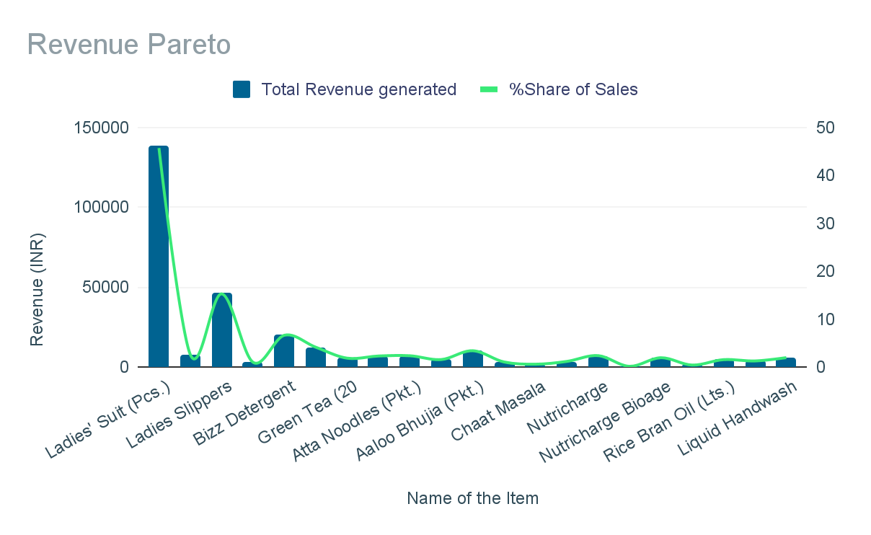

Figure-3

3.2 Product Mix and Sales Distribution
3.2.1 Total Sales Share:
A pie chart visualization of total sales share (Figure-4) shows that Atta Noodles alone accounts for over 15% of all units sold, with Coconut Biscuits and Aaloo Bhujia also making significant contributions. The "Others" category, comprising many low-volume products, underscores the long-tail nature of the inventory.
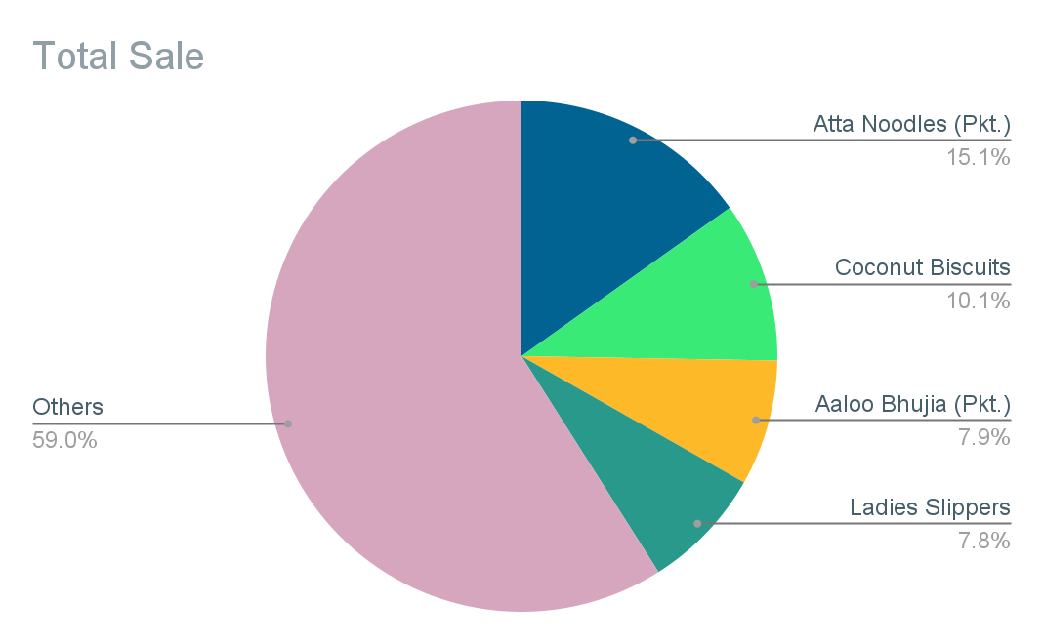
“Others” group includes Coconut Oil, Jasmine Soap, Red Chilli Powder, Chaat Masala, Gamma Oryzanol, and other long-tail products each individually contributing less than 5% to total sales, collectively 59% of volume.

Figure-4
3.2.2 Max and Min Sales per Product
The Max Sale and Min Sale chart (Figure-5) highlights the variability in weekly sales for each product. Some products, such as Ladies Suit and Atta Noodles, show high maximum sales in certain weeks, while others have weeks with zero sales, indicating inconsistent demand and potential overstocking risk.
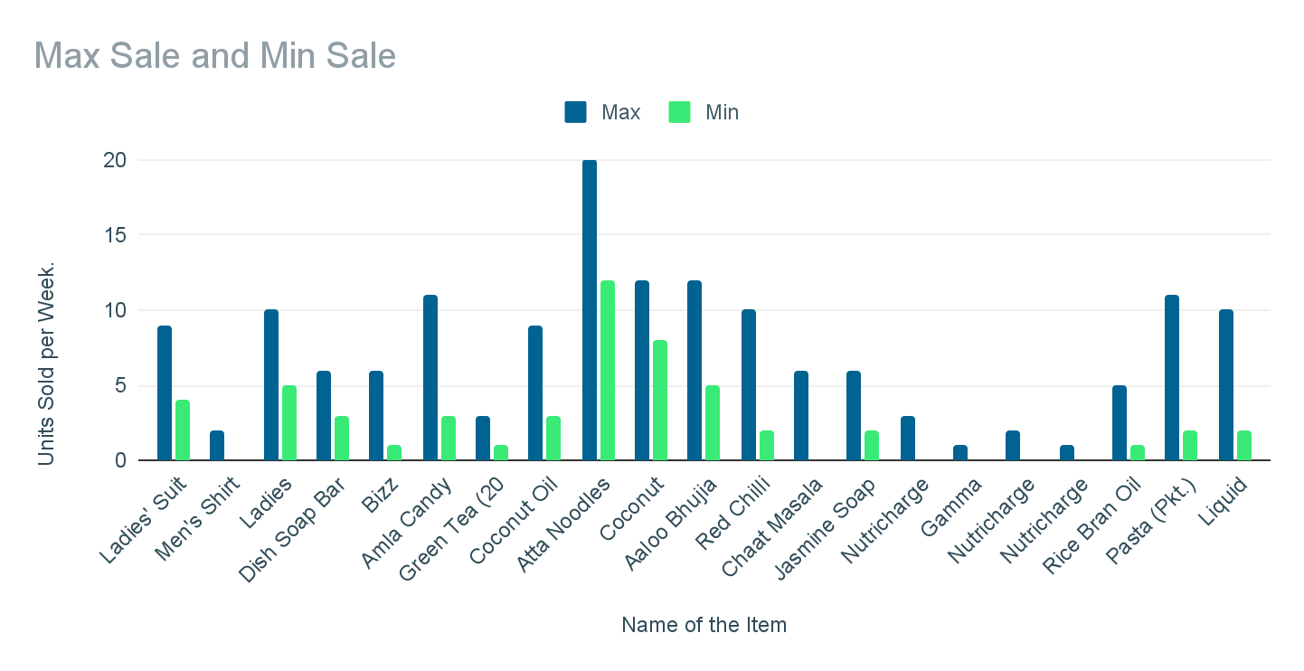
Figure-5

Name of the Item | Total Sale | Max Sale | Min Sale
Ladies' Suit (Pcs.) | 77 | 9 | 4
Men's Shirt (Pcs.) | 10 | 2 | 0
Ladies Slippers (Pairs) | 93 | 10 | 5
Dish Soap Bar (Pcs.) | 52 | 6 | 3
Bizz Detergent Powder (Pkt.) | 44 | 6 | 1
Amla Candy (200gm) (Pkt.) | 79 | 11 | 3
Green Tea (20 bags) (Pkt.) | 22 | 3 | 1
Coconut Oil (175ml) (Pcs.) | 71 | 9 | 3
Atta Noodles (Pkt.) | 181 | 20 | 12
Coconut Biscuits (Pkt.) | 121 | 12 | 8
Aaloo Bhujia (Pkt.) | 95 | 12 | 5
Red Chilli Powder (100gm) (Pkt.) | 67 | 10 | 2
Chaat Masala (100gm) (Pkt.) | 32 | 6 | 0
Jasmine Soap (Pcs.) | 46 | 6 | 2
Nutricharge Woman (Pkt.) | 15 | 3 | 0
Gamma Oryzanol (Pcs.) | 1 | 1 | 0
Nutricharge Bioage (Pcs.) | 4 | 2 | 0
Nutricharge Veg Omega (Pcs.) | 3 | 1 | 0
Rice Bran Oil (Lts.) | 40 | 5 | 1
Pasta (Pkt.) | 66 | 11 | 2
Liquid Handwash (200ml) (Pcs.) | 76 | 10 | 2
Table-3

3. Weekly Sales and Revenue Patterns
3.2.3 Weekly Sales Amount:
The Weekly Sale Amount bar chart (Figure 6) illustrates significant fluctuations in weekly revenue. Notably, Week 10 experienced a sharp decline, while Weeks 7 and 12 saw peak sales, confirming the business’s challenge with cash flow volatility. Week 10 saw a sharp drop due to delayed inventory restocking and sudden lower footfall because of local events.
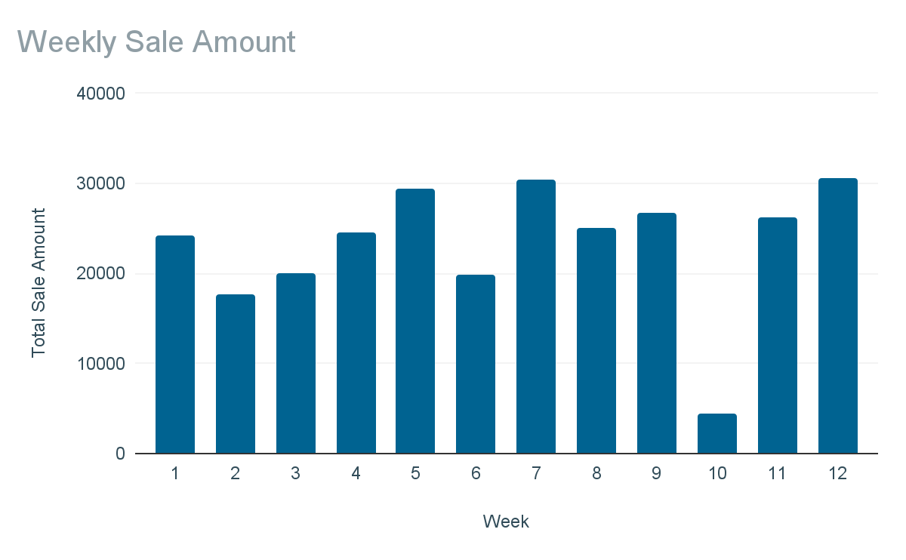

Figure-6

3.3 Sales Trend Analysis by Product:

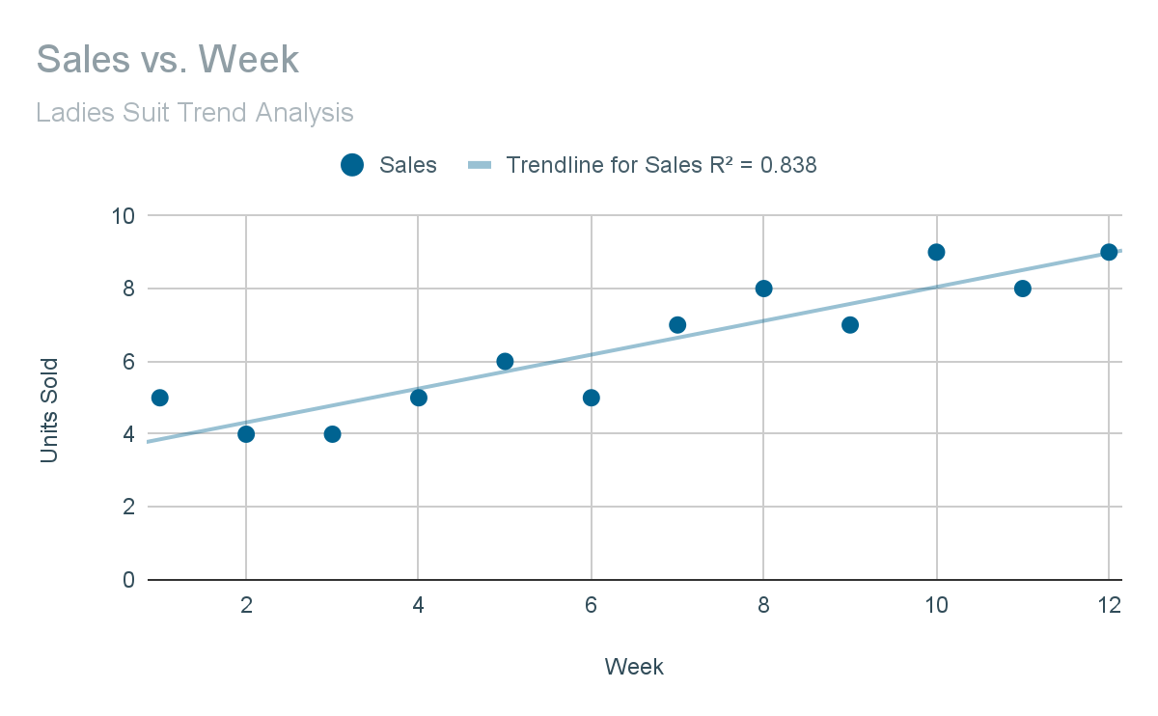
Ladies Suit (Figure 7): The sales trend for Ladies Suit exhibits a clear upward trajectory over the 12 weeks, with an R² value of 0.838, indicating a strong and consistent growth trend.

Figure-7

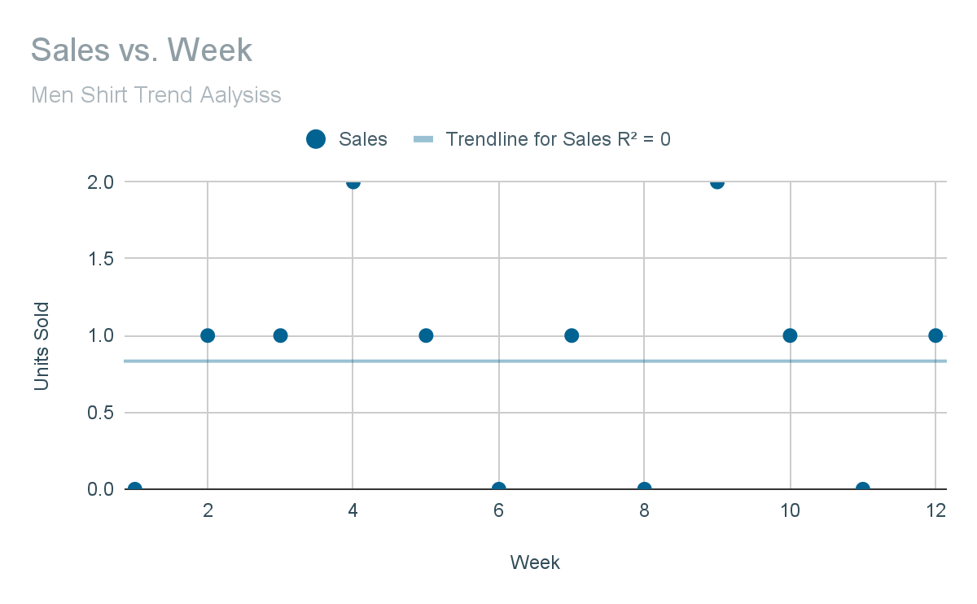
Men’s Shirt (Figure 8): In contrast, Men’s Shirt sales are sporadic and low, with frequent weeks of zero sales, reflecting poor demand stability.

Figure-8

Aata Noodles (Figure 9): The trend for Aata Noodles is relatively flat (R² ≈ 0), indicating consistent but unspectacular weekly sales.

Figure-9

3.4 Correlation and Statistical Insights

3.4.1 Revenue and Sales Correlation :
The scatter plot of Revenue and Sales by week (Figure 10) shows only a weak positive correlation, confirming that higher sales volume does not always translate to higher revenue, due to the impact of product pricing and mix.
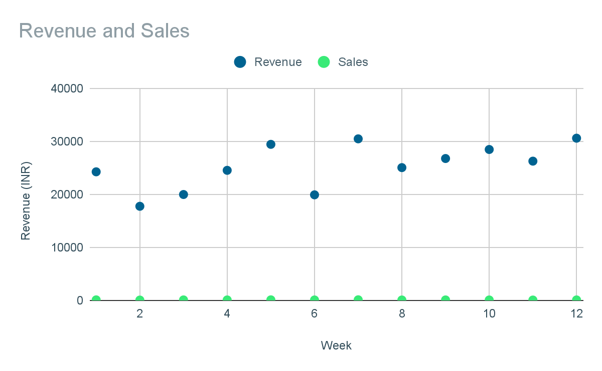

Figure-10

3.4.2 Weekly Performance Dynamics and Trend Analysis
Weekly performance data reveals significant operational challenges with revenue fluctuations ranging from ₹4,470 to ₹30,590, representing a 584% maximum weekly variation. Week 10 emerges as a critical performance anomaly, marked by a dramatic revenue drop that directly correlates with operational challenges identified through discussions with business owners.

Metric | Value
Min Weekly Revenue | 4470
Max Weekly Revenue | 30590
Max Weekly Variation (%) | 584.3400447
February Revenue | 86509
March Revenue | 104855
April Revenue | 88081
March Growth over Feb (%) | 17.49654284
April Decline over Mar (%) | -15.99732965
Min Weekly Units Sold | 76
Max Weekly Units Sold | 128
Avg Weekly Units Sold | 99.58333333

Table 4

Seasonal performance patterns demonstrate apparent monthly variations, with February generating ₹86,509, March achieving ₹104,855 (21.2% growth), and April declining to ₹88,081 (16% decrease). This pattern suggests seasonal demand fluctuations that require strategic inventory planning and cash flow management.
Weekly sales volume analysis shows total unit movements ranging from 76 to 128 units per week, with an average of 99.6 units. The highest sales volume was recorded in Week 7 (128 units), while the lowest was in Week 2 (76 units), indicating moderate demand stability despite revenue volatility.
3.4.3 Revenue Generation Patterns
Revenue across products is very uneven. On average, the store earns about ₹23,287 per week, but sales swing widely—sometimes dropping as low as ₹4,470 and peaking at ₹30,590. The standard deviation of ₹6,929 (CV of 29.76%) highlights just how unstable weekly revenue can be, with fluctuations reaching as high as 584%.
Another striking finding is that zero sales were recorded 37 times across products, and 4 items went for at least 3 weeks without selling at all.
Most importantly, the data shows that only 6 products generate nearly 80% of total revenue (77.88%), proving that a handful of best-sellers are driving the business while many other products barely make a dent.

Metric | Value
Mean Weekly Revenue | 23287.08333
Std Dev Weekly Revenue | 6929.435456
CV Weekly Revenue (%) | 29.75656228
Max Weekly Revenue | 30590
Min Weekly Revenue | 4470
Max Weekly Fluctuation (%) | 584.3400447
Total Zero Sales Instances | 37
Products with ≥3 Zero Sales Weeks | 4
Number of Products for 80% Revenue | 6
% Revenue by Top Products | 77.88338271
Table-5

3.5 Product Performance Insights and Strategic Classifications
3.5.1 Premium Product Dominance: Ladies Suits emerges as the dominant revenue driver, contributing ₹138,600 (45.7% of total revenue) from 77 units sold at ₹1,800 per unit. This premium positioning demonstrates successful high-value market penetration and represents the business's most critical success factor.

Name of the Item | Revenue Generated
Ladies' Suit | 138600
Ladies Slippers (Pairs) | 46407
Bizz Detergent Powder (Pkt.) | 20240
Amla Candy (200gm) (Pkt.) | 12640
Table-6

3.5.2 Volume-Value Disconnect: Atta Noodles presents an interesting paradox, achieving the highest sales volume (181 units) but generating only ₹7,240 in revenue due to its unit price of ₹ 40. This product exemplifies high-volume, low-margin items that drive customer traffic but require careful analysis of profitability.

Name of the Item | Total Sale
Atta Noodles (Pkt.) | 181
Coconut Biscuits (Pkt.) | 121
Aaloo Bhujia (Pkt.) | 95
Ladies Slippers (Pairs) | 93
Others | 705
Table-7

3.5.3 Performance Inconsistency: Four products exhibit sporadic demand patterns, characterized by three or more consecutive weeks of zero sales, including Men's Shirt, Gamma Oryzanol, Nutricharge Bioage, and Nutricharge Veg Omega. These products represent inventory management challenges and potential candidates for strategic review.

Name of the Item | Total Sale
Gamma Oryzanol (Pcs.) | 1
Nutricharge Veg Omega (Pcs.) | 3
Nutricharge Bioage (Pcs.) | 4
Men's Shirt (Pcs.) | 10
Table-8

4. Interpretation of Results and Recommendations

4.1 Critical Business Challenge ValidationRevenue Fluctuations:

Weekly revenue shows high variation (31.1% coefficient of variation) with some weeks seeing over 500% swings, making cash flow hard to manage.
- Inventory Issues: There were 37 weeks with zero sales for some items, and 4 products showed very unpredictable demand throughout the period.
- Revenue Dependence Risk: Just 6 products bring in nearly 80% of total revenue, making the business vulnerable if demand for these drops or competitors step in.

4.2 Strategic Priority Framework
4.2.1 Immediate Priority Actions: Focus intensive inventory management and marketing efforts on Category A products, particularly Ladies' Suits, which single-handedly drive 45.7% of total revenue. Implement demand forecasting systems for these critical products to prevent stockouts while optimizing investment allocation and ensuring optimal resource utilization. Establish emergency protocols for Week 10-type revenue drops to maintain cash flow stability and ensure financial stability.
4.2.2 Medium-term Strategic Initiatives: Develop Category B products through targeted marketing and pricing optimization to reduce dependency on Category A items. Implement systematic review processes for sporadic-demand products to determine continuation, modification, or discontinuation strategies. Establish seasonal inventory planning protocols to capitalize on identified monthly performance patterns.
4.2.3 Long-term Growth Strategies: Explore expansion of premium product offerings similar to Ladies Suits to capture high-margin market segments. Develop customer loyalty programs to stabilize demand patterns and reduce revenue volatility. Consider strategic partnerships or supplier relationships to improve inventory management efficiency and reduce working capital requirements.

4.3 Inventory Optimization Recommendations
4.3.1 Category A Product Management: Increase safety stock levels for Ladies Suit, Ladies Slippers, and Bizz Detergent Powder to prevent stockouts of revenue-critical items. Implement weekly monitoring systems for these products with automated reorder triggers based on sales velocity patterns. Negotiate favorable supplier terms for these high-volume, high-value products to improve margins and availability.
4.3.2 Category B Product Development: Focus marketing efforts on Nutricharge Woman and other health supplement products that show growth potential. Optimize pricing strategies for Atta Noodles and similar high-volume products to improve profitability without sacrificing market share. Develop promotional strategies to move Category B products toward Category A performance levels.
4.3.3 Category C Product Review: Conduct a systematic evaluation of products like Gamma Oryzanol and Nutricharge Veg Omega that show minimal sales activity. Consider discontinuing consistently poor performers to free capital for higher-performing alternatives. Maintain only those Category C products that serve strategic purposes such as customer retention or competitive positioning.

4.4 Revenue Stabilization Strategies
4.4.1 Demand Forecasting Implementation: Develop predictive models based on 12 weeks of historical data to anticipate seasonal fluctuations and prevent revenue drops similar to those in Week 10. Implement weekly sales monitoring with variance analysis to identify and respond to performance deviations quickly.
4.4.2 Customer Base Diversification: Expand marketing efforts to reduce dependency on current customer patterns that create revenue volatility. Develop customer segmentation strategies to identify and target stable, high-value customer groups that can provide consistent demand.
4.4.3 Product Mix Optimization: Balance the portfolio between high-margin premium products and volume-driving basic products to achieve both profitability and cash flow stability. Consider introducing additional premium products in successful categories to diversify revenue sources while maintaining a high-margin focus.

4.5 Financial Management Recommendations
4.5.1 Cash Flow Management: It's a good idea to create cash flow forecasting systems built on the weekly patterns we've noticed. It's also useful to keep enough cash on hand so we can handle any drops in performance, like what we saw in Week 10, without disrupting our operations.
4.5.2 Working Capital Optimization: We should optimize our inventory levels using the ABC classification. This will help us cut down on stock for slow-moving items while still keeping plenty of those products that bring in the most revenue. It's also wise to link our supplier payment terms to our sales cycles; this way, our cash flow will be better timed.
4.5.3 Performance Monitoring Systems: We should set up weekly performance dashboards to keep an eye on revenue, how fast inventory sells, and cash flow. We also need to use exception reporting systems. These will help us quickly spot and fix any unusual performance issues before they start to affect how the business is doing overall.

The recommendations are based on solid data analysis and directly tackle the key challenges the business is facing. To put them into action, the store should take a phased approach—first focusing on stabilizing revenue in the short term, and then gradually building systems that support long-term, sustainable growth. Regularly tracking performance and fine-tuning strategies along the way will help Sahu Cloth House keep improving efficiency and profitability over time.

