# Project Report: Quiz Master V2

## 1. Student Details

* **Name**: Ali Jawad
* **Roll No**: 22f3001825
* **Email**: [22f3001825@ds.study.iitm.ac.in](mailto:22f3001825@ds.study.iitm.ac.in)
* **Current Academic Status**: Final term of diploma in Data Science and Programming at IIT Madras

## 2. Project Overview

* **Project Name:** Quiz Master
* **Objective:** This project aims to build a multi-user quiz application designed as an exam preparation platform. The application supports two types of users:
  1. **Administrator (Quiz Master):** Manages subjects, chapters, quizzes, and users.
  2. **Users:** Can register, log in, and attempt quizzes of their choice.

## 3. Frameworks and Libraries Used

* **Backend**: Flask, Flask-RESTful, SQLAlchemy
* **Frontend**: Vue.js, Bootstrap
* **Database**: SQLite
* **Caching**: Redis
* **Asynchronous Tasks**: Celery with Redis
* **Data Visualization**: Chart.js
* **Authentication**: Flask Security
* **Email Service**: MailHog

## 4. ER Diagram

### ****Database Schema****

* **User_Info Table**: Stores user details (email, password, role)
* **Subject Table**: Contains subject-related data
* **Chapter Table**: Represents subdivisions of subjects
* **Quiz Table**: Stores quiz metadata (date, duration)
* **Question Table**: Stores multiple-choice questions
* **Score Table**: Tracks user quiz performance
* **Feedback Table**: Stores user feedback
* **Notification Table**: Handles system notifications

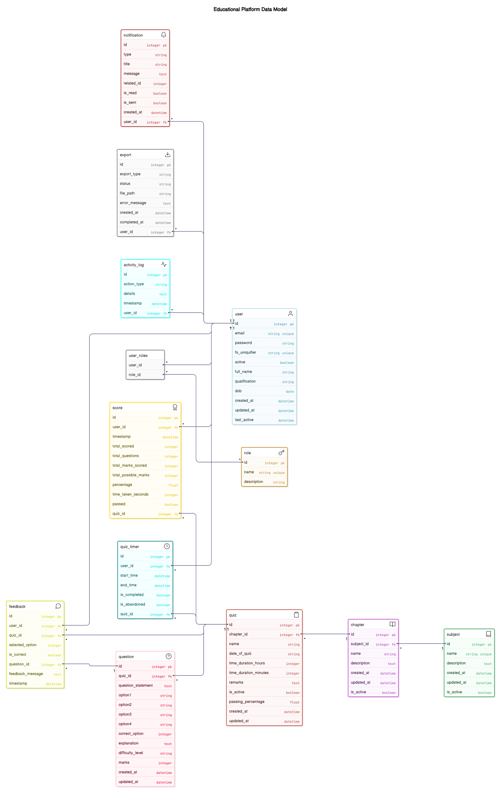

## 5. Core Features

### ****Admin Role:****

* Manage subjects, chapters, quizzes, and questions
* User management and quiz analytics

### ****User Role:****

* Register/Login
* Attempt quizzes
* View quiz scores and history
* Timer-enabled quizzes

### ****Automated Jobs:****

* **Scheduled Daily Reminder**: Notifies users about pending quizzes
* **Monthly Activity Report**: Summarizes user engagement
* **User-Triggered Async Task**: Export quiz results as CSV

## 6. API Endpoints

| **Endpoint** | **Description** |
| --- | --- |
| /users/<int:user_id> | Retrieve, update, or delete a user by ID |
| /users | Get all users or create a new user |
| /subjects/<int:subject_id> | Retrieve, update, or delete a subject |
| /subjects | Get all subjects or create a new one |
| /chapters/<int:chapter_id> | Retrieve, update, or delete a chapter |
| /chapters | Get all chapters or create a new one |
| /quizzes/<int:quiz_id> | Retrieve, update, or delete a quiz |
| /quizzes | Get all quizzes or create a new one |
| /questions/<int:question_id> | Retrieve, update, or delete a question |
| /questions | Get all questions or create a new one |
| /scores/<int:score_id> | Retrieve user quiz scores |
| /scores | Get all scores |
| /feedbacks/<int:feedback_id> | Retrieve feedback by ID |
| /feedbacks | Get all feedback entries |

## 7. Application Workflow

### ****Admin Workflow:****

1. Logs into the admin dashboard
2. Creates subjects and chapters
3. Adds quizzes under chapters
4. Adds questions to quizzes
5. Manages users and quiz analytics

### ****User Workflow:****

1. Registers and logs in
2. Selects a quiz by subject and chapter
3. Attempts the quiz within the time limit
4. Views quiz results and attempt history
5. Reviews performance summary

## 8. Presentation Video

https://drive.google.com/file/d/1NOxUMmp6SUlaMgyzdqfu3VKRl0DQeXMA/view?usp=sharing