Project Report - Vehicle Parking App (SpotKart)

Author:
Name: Vedant Konde
Roll Number: 22f3002244
Email: 22f3002244@ds.study.iitm.ac.in

About Me:
Myself Vedant Konde, Computer Science Engineering Student with expertise in Cybersecurity, Blockchain, IoT, Data Science, and AI/ML. Passionate about building secure, data-driven solutions and exploring emerging technologies.

Description:
To build a Flask-based Parking Management Web Application that enables users to seamlessly find, book, and manage parking spots while providing administrators with comprehensive tools to oversee facilities, track usage, and analyze performance through interactive dashboards.

Technologies Used:
- Backend: Flask, SQLAlchemy, Werkzeug, Blueprint Architecture
- Frontend: HTML, CSS, Bootstrap, JavaScript, Font-Awesome, Plotly.js
- Database: SQLite

DB Schema Design :
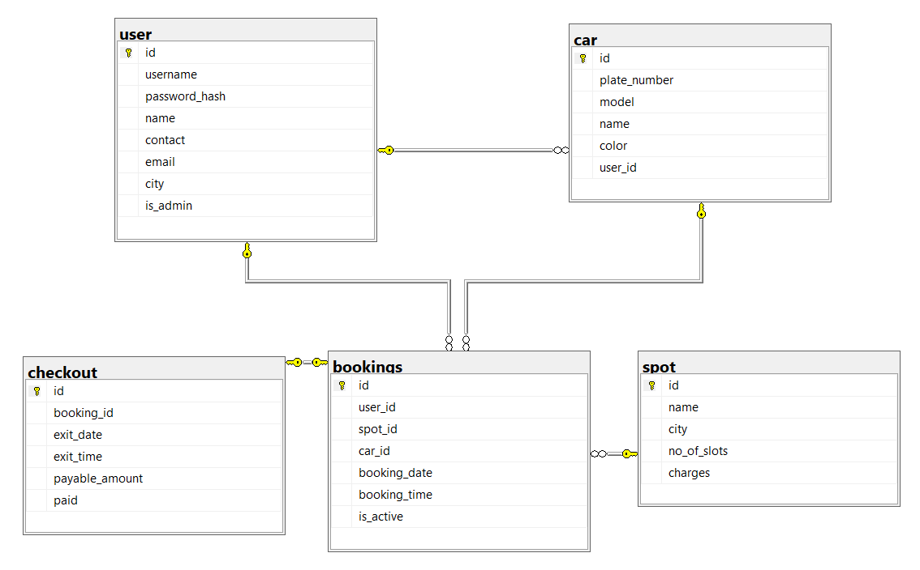

Folder Structure:
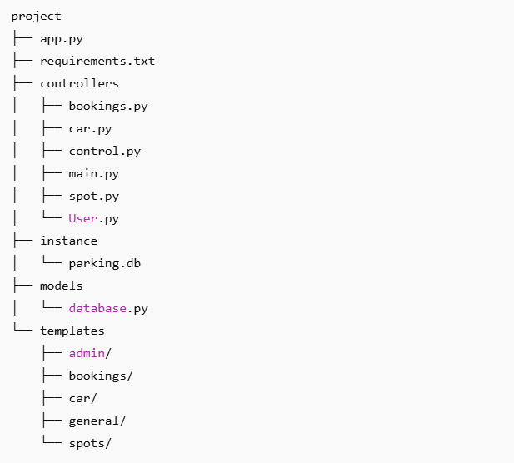

Architecture and Features:

Authentication & Security:
- Session-based auth with Flask sessions
- Password hashing via Werkzeug
- Role-based access (admin/user decorators)
- Form validation and CSRF protection

Real-time Booking System:
- Live slot availability tracking
- Instant booking confirmation
- Automated slot count management
- Duration-based billing calculation

Admin Dashboard:
- Plotly.js charts for analytics visualization
- User/vehicle management interface
- Spot management with CRUD operations
- Revenue and usage analytics

Key Functionality

User Dashboard:
- Multi-Vehicle Support: Users can register multiple cars
- Smart Booking: Real-time slot selection with availability check
- Auto-Billing: Time-based charges calculated on checkout
- History Tracking: Complete booking and payment history
- Profile Management: Update personal details securely

Admin Panel:
- Spot Management: Add/edit/delete parking locations across cities
- User Analytics: View all registered users and their vehicles
- Interactive Charts:
  - Bookings distribution by city
  - User activity patterns
  - Vehicle registration stats
  - Slot utilization by location
- Advanced Search: Filter users by name, city, or vehicle details
- Revenue Monitoring: Track payments and usage patterns

Core Workflows:

Booking Flow:
- User selects available spot → system validates vehicle registration
- Slot count decrements → booking record created with timestamp
- User gets confirmation → can proceed to checkout when done

Checkout Flow:
- System calculates parking duration → applies hourly charges
- Payment record generated → slot released back to pool
- Booking marked inactive → history updated

Video:
Link: MAD1_Project_SpotKart

