## Civilization 112

#### A multiplayer turn-based game in which players compete in a 2D square-grid world to create cities, expand, and win in different ways; inspired by the Civilization games

### Structural Plan

* Each player will be its own Player object. Each Player object will have a list of buildings and units that the player owns, and will also keep track of what instructions/menus to show on screen based on the player’s selected tile, unit or building.
* Each unit type will be its own subclass under a Unit superclass, with the superclass storing the unit’s location and owner. Each unit subclass will specify the unit’s move and vision range and any abilities it has.
* Like units, each building type will be its own subclass under a Building superclass which stores the building’s location and owner. As of now, the only building is a City, which will give options to the player to create units or city improvements in a side menu.

### Algorithmic Plan

* One of the complex parts of the project will be the map generation at the beginning of each game. This map generation will not be entirely random, but ideally will create clusters of similar tiles in order to create biomes such as deserts, forests, plains, or oceans.

### Version Control Plan

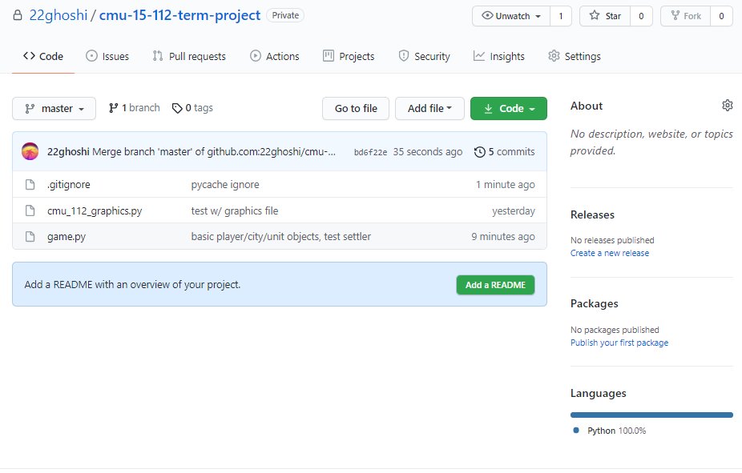

* I am using github to back up my code. Whenever I make a major change and it works in my tests, I push it to github so that I record the changes I made and I can reset back to that working version if I need to.