**Calculating Family Expenses Using ServiceNow**

**NAANMUDHALVAN PROJECT REPORT**

**Submitted by**

**TEAM ID: NM2025TMID00117**

**KARTHICK RAJA K (912922205008) SANMITHA S (912922205016)**

**ARCHANAPRIYA V (912922205002) RACHANA M (912922205014)**

***Degree of***

**BACHELOR OF ENGINEERING**

***in***

**INFORMATION TECHNOLOGY**

**ULTRA COLLEGE OF ENGINEERING AND TECHNOLOGY,**

**MADURAI-625106 ANNAUNIVERSITY:CHENNAI-600025**

**NOV2025**

**ANNAUNIVERSTY:CHENNAI-600025**

**BONAFIDECERTIFICATE**

Certified that this project report **“CALCULATING FAMILY EXPENSES USING SERVICE NOW”** is the Bonafide work of **KARTHICK RAJA K (912922205008),SANMITHA S (912922205016),ARCHANAPRIYA V (912922205002), RACHANA M (912922205014)**

### Who carried out the project work under my supervision.

Submitted for the Project Viva-Voice held on…………………….

## InternalExaminer ExternalExaminer

**CalculatingFamilyExpensesUsingServiceNow**

## ProblemStatement

In a project of managing family expenses is often challenging due to the lack of a centralization systemfor tracking income, expenses, and savings. Families typicallyrelyon manual methods such as spreadsheet, paper records, or multiple apps, which can lead to errors, duplication, and difficulty in analysing financial patterns.

## Objective

**SimplifyExpenseTracking**-provideacentralizationsystemforrecordingandcategorizingall family expenses

**Improve FinancialAwareness -**offerreal-time dashboards and reports to give clearinsights into spending patterns

**Enhance Budget Planning-**support better financial planning by identify high-spending categories and opportunities to save

Skills:ServicenowDevelopment,Workflow&Automation,ScriptinginServicenow,Reporting& Dashboards, Integration Skills

TASKINITIATION

# Update

### Activity1:

1. OpenServicenow
2. 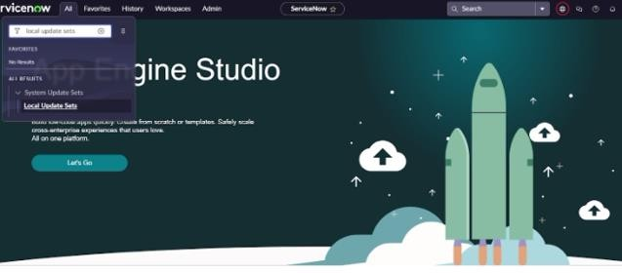GotoAll>>searchfor LocalUpdateSet>Clickon New
3. EntertheDetailsas:

Name:FamilyExpenses

1. AndthenclickonSubmitandmake current

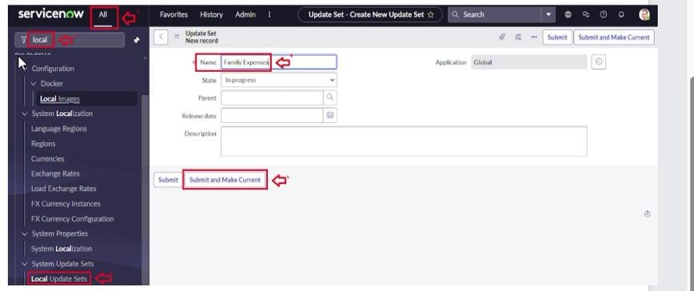

# Table

### Activity2:

1. OpenServicenow
2. Gotoall>searchforTables>ClickonNew
3. EntertheDetails:

Label:FamilyExpenses Name: Auto-Populated

Newmenuname:FamilyExpenditure

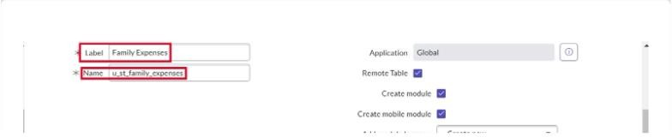

1. Clickonsave

### Activity2:

1. OpenServicenow
2. NearColumnsDoubleClicknear insertanewrow Give the details as:

Columnlabel:Number Type: String

1. Doubleclickoninsertanewrowagain Give the details as:

Columnlabel:Date Type: Date

1. Doubleclickoninsertanewrowagain Give the details as:

Columnlabel:Amount Type: Integer

1. Doubleclickoninsertanewrowagain Give the details as:

Columnlabel:ExpenseDetails Type: String

Maxlength:800

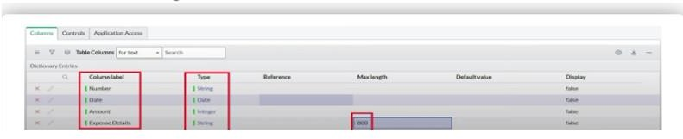

1. Clickonsave

### Activity2:

1. OpenServicenow
2. DoubleclickontheNumberfield/Column
3. Godownanddoubleclick onAdvanced view
4. InDefaultValue:

Usedynamicdefault:checkthebox

Dynamicdefaultvalue: GetNextPaddedNumber

1. clickonupdate

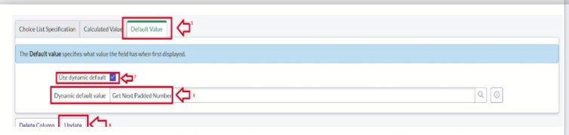

1. Gotoall>>searchforNumberMaintenance>>select numbermaintenance
2. clickonnew
3. Enterthedetails:

Table:FamilyExpenses Prefix: MFE

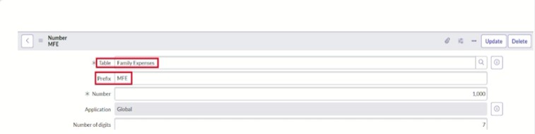

8.Click onSubmit

### Activity2:

1. OpenServicenow
2. Gotoall>>searchforFamilyExpenses>>OpenfamilyExpenses
3. Clickon new
4. Gotoheaderandclickthere>>clickonconfigure>>SelectFormDesign
5. DragDroptheformasrequirement

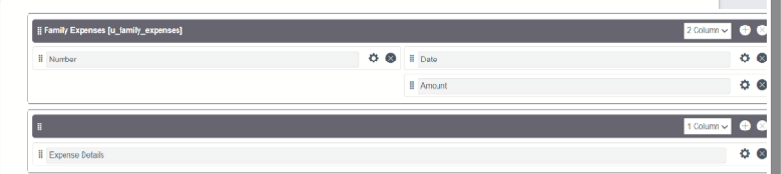

1. MakeNumberRead-OnlyFieldbyClicking
2. MakeDate,AmountMandatoryfieldbyClicking
3. Clickonsave

# Table(DailyExpenses)

### Activity3

1. OpenServicenow
2. Gotoall>searchforTables>ClickonNew
3. EntertheDetails:

Label: DailyExpenses Name:Auto-Populated

AddModuletomenu:FamilyExpenditure

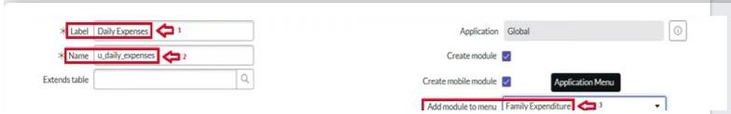

1. clickon save

### Activity3:

1. OpenServicenow
2. NearColumnsDoubleClicknear insertanewrow Give the details as:

Columnlabel:Number Type: String

1. Doubleclickoninsertanewrowagain

Givethedetails as:

Columnlabel:Date Type: Date

1. Doubleclickoninsertanewrowagain Column label: Amount

Type:Integer

1. Doubleclickoninsertanewrowagain Column label: Expense Details

Type: String Maxlength:800

1. Doubleclickoninsertanewrowagain Give the details as:

Columnlabel:Comments Type: String

Maxlength:800

6.Click on save

### Activity3:

1. OpenServicenow
2. DoubleclickontheNumberfield/Column
3. GodownanddoubleclickonAdvanced view
4. InDefaultValue:

Usedynamicdefault:checkthebox

Dynamicdefaultvalue: GetNextPaddedNumber

1. clickonupdate

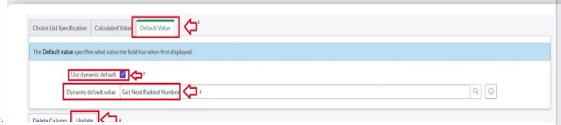

1. Gotoall>>searchforNumberMaintenance>>select numbermaintenance
2. clickonnew
3. Enterthedetails:

Table:DailyExpenses Prefix: MFE

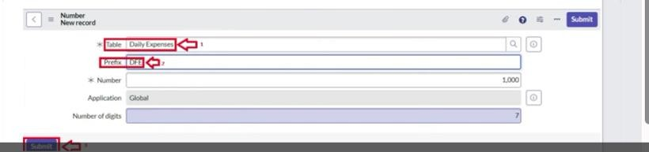

1. clickonsubmit

### Activity3:

1. OpenServicenow
2. Goto all>>searchfor DailyExpenses>>OpenDailyExpenses
3. Clickon new
4. Gotoheaderandclickthere>>clickonconfigure>>SelectFormDesign
5. DragDroptheformasrequirement

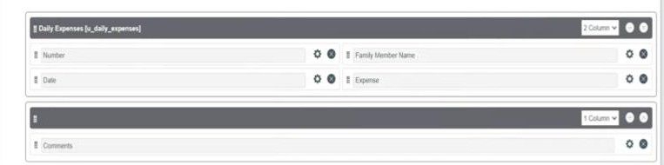

1. MakeNumberRead-OnlyFieldbyClicking
2. MakeDate,FamilyMemberNameMandatoryfieldbyClicking
3. Clickonsave

# Relationship

### Activity4:

1. OpenServicenow
2. Gotoall>>searchforrelationships>>openrelationships
3. clickonnew
4. Enterthedetails:

Name: DailyExpenses

Appliestotable:selectFamilyExpenses Daily Expenses: select Daily Expenses

1. clicksave

# ConfiguringRelatedList

### Activity5:

1. openServicenow
2. Gotoall>>searchfor FamilyExpenses>>OpenFamilyExpenses
3. Clickon new
4. Gotoheaderandclickthere>>clickonconfigure>>selectRelated Lists
5. AddDailyExpensestoselectedarea
6. clickon save

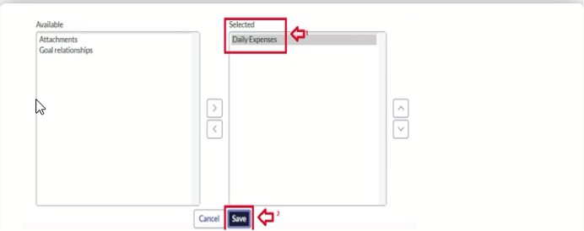

# Businessrule

### Activity6:

1. OpenServiceNow
2. Gotoall>>searchforBusiness Rules
3. Undersystemdefinitionselectbusinessrulesthenclicknew
4. EntertheDetails:

Name: Family Expenses BR Table:SelectDailyExpenses

CheckAdvanced

1. Inwhentheruncheckinsertsand update

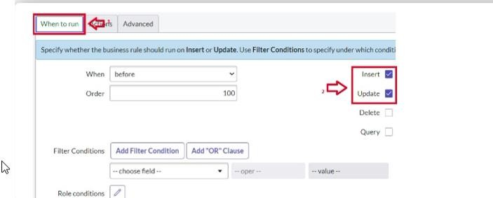

1. Inadvance(wewritethe code)

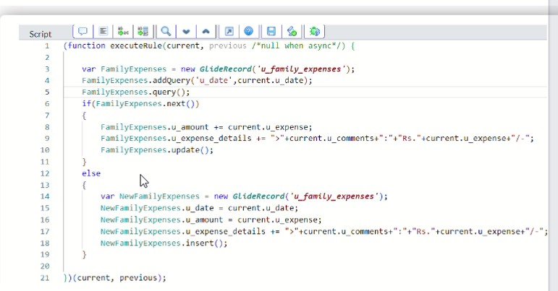

1. clickon save

# ConfigureTheRelationship

### Activity7:

1. OpenServicenow
2. Gotoall>>searchforrelationships>>openrelationships
3. InopenDailyExpenses relationship

ForAppliestotable:selectFamilyExpenses In Query with write the below Query

1. clickonupdate

