# Sequance

**Explorer**

**Date: 6th june 2024**

**Submited by: Gonugunta Deepika (22kq1a0276)**

**Details of project: I'm implementing this project by using python progrming language**

# Code:

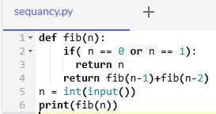

Int of input:

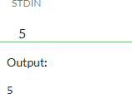

Exaplanation: In this program i have implemented "SEQANCE EXPLORER", is nothing but to print nth series fubinacci using recursion. sequace explorer i defined the fabinacci function.with a single parameter n after that i used if condition to check if n is equal to 0 or 1 if it is equal to 0 or 1 it retururns to if it is not eqal to 0 or 1 it retunsto call n-1 and n-2 and adding the sum of n-1 and n-2 after that takes intiger input. the nth number of fibinacci series

# Conclusion:

Finally i have got desired output nth fabinacci series 0 1 1 2 3 5