SEQUENCE EXPLORER
DATE:6th June 2024
Submitted By:p.v.Tejaswini,22kq1a0282
Details of Project:I'm implementing this project by using python programming lanaguage
CODE:
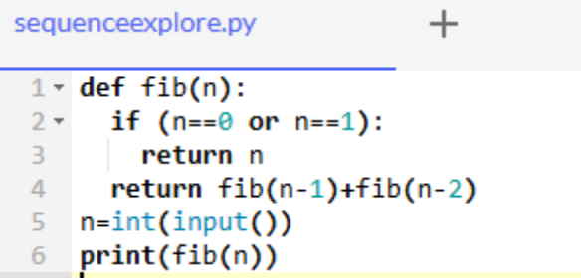
Input and Output:
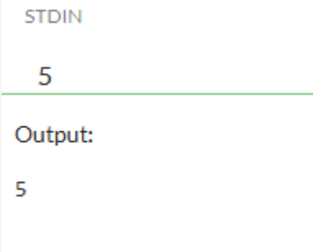
Explanation:
In this program i have implemented sequence explorer is nothing but number sequence generator or nth fibinocci number. where ecah number is the sum of the sum of the two preceding ones, usually starting with 0 and 1.And to generate the sequence explorer upto a give number of terms. we have to use recursion, which means the function calls itself repeatedly.
Here 'fib' is function definition which takes as 'n' as input.
if 'n' is (0 or 1) its prints "n". otherwise its prints sequence number by using recursion.
The 'fib' function call form input from the user. which prints nth fibinocci series upto a given number of terms using recurion.
conclusion:
Finally i have got the desired output of sequence explorer output as(0 1 1 2 3 5).
Her i will get the nth fibonacci number based on the input provided by me as 5. Then the program prints output as 5.

