Text Analyzer
Date:6th June 2024
Submitted by:Yadla Swathi Priya(22kq1a0292)
Details of project:
I'm implementing this Project by using Python Programming Language.
Code:
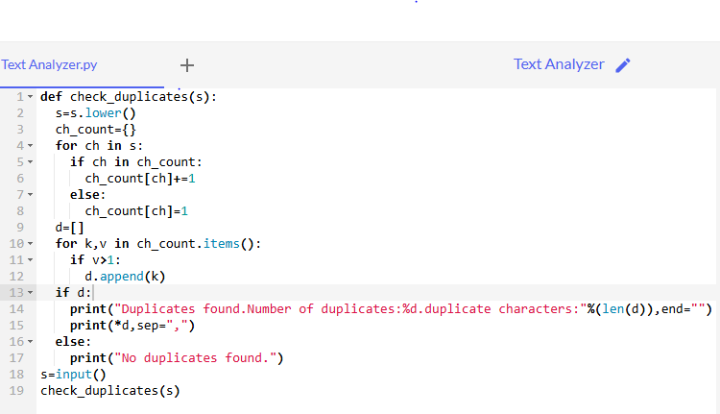
Input and output:
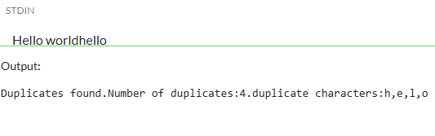
Explanation:
In this program I've implemented the project Text Analyzer which is nothing but to print the duplicate elements in the given string.For that initially i've defined the function as check_duplicates.And we have to print the output in lower case letters only so,I've convert given string into lower case letters by using lower() built in method.And I've taken an empty dictionary and by using for loop I am accessing each character one by one and I am checking whether the character in my dictionary if it is in the dictionary it increases that character value by one,else it is not in the dictionary it gives that character value as one only.
After I've taken an empty list and I'am checking how many times it is repeating.If the character repeated more than once it is added to the empty list and then prints "duplicates found" and also it prints the how many characters repeated and what are the characters were repeated that are in the list.If there are no elements in the list it prints "No duplicates found".
conclusion:
Finally I got the desired output of Text Analyzer which prints the duplicates in the given string.

