(1)PROGRAM : RIGHT-ANGLED TRIANGLE

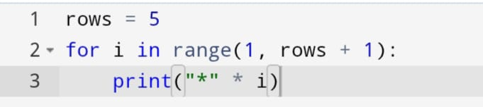

OUTPUT :

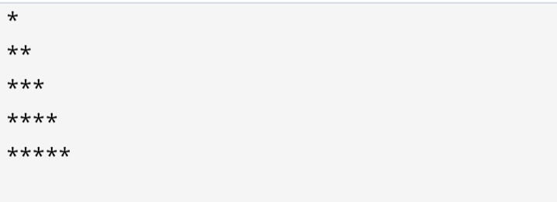

(2)PROGRAM : INVERTED TRIANGLE

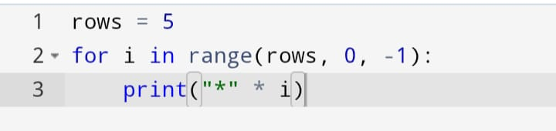

OUTPUT :

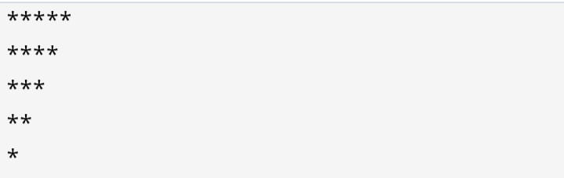

(3)PROGRAM : PYRAMID PATTERN

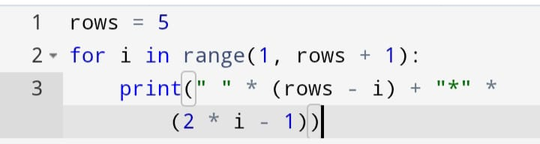

OUTPUT :

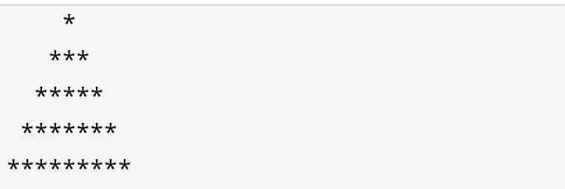

(4)PROGRAM : DIAMOND PATTERN

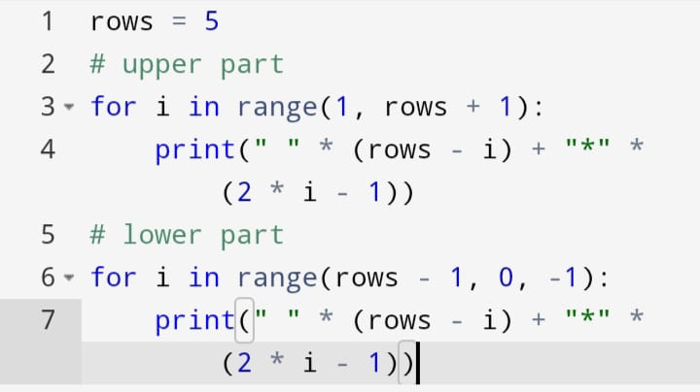

OUTPUT :



(5)PROGRAM : NUMBER TRIANGLE

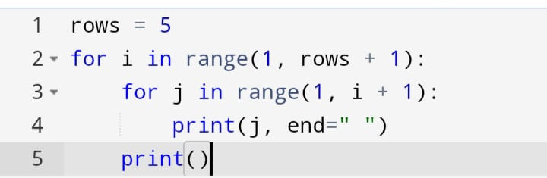

OUTPUT :

