(1)PROGRAM : SUM OF N NATURAL NUMBERS

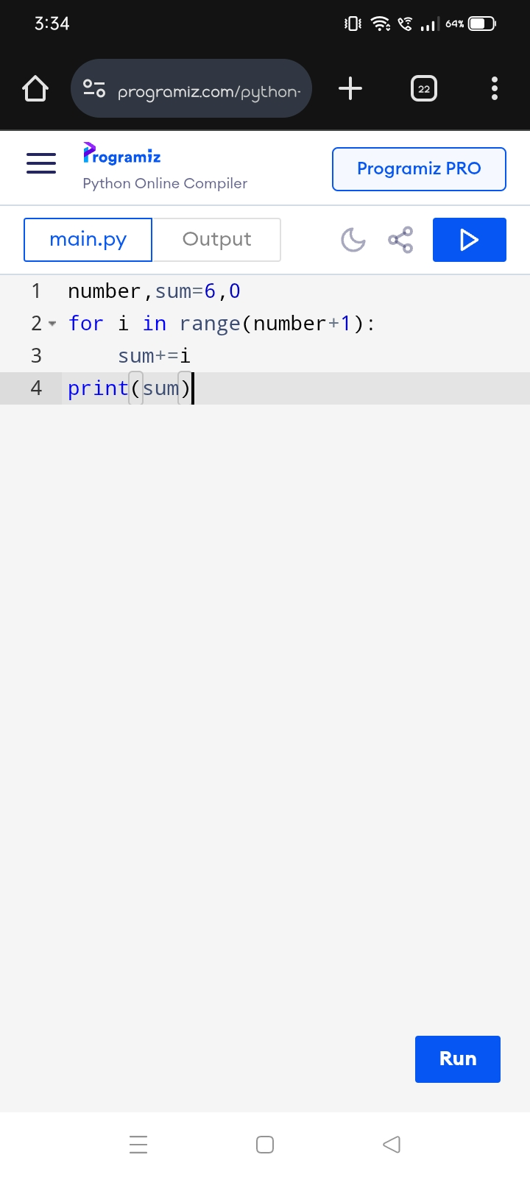

OUTPUT :



(2)PROGRAM :SUM OF NUMBERS IN A GIVEN RANGE

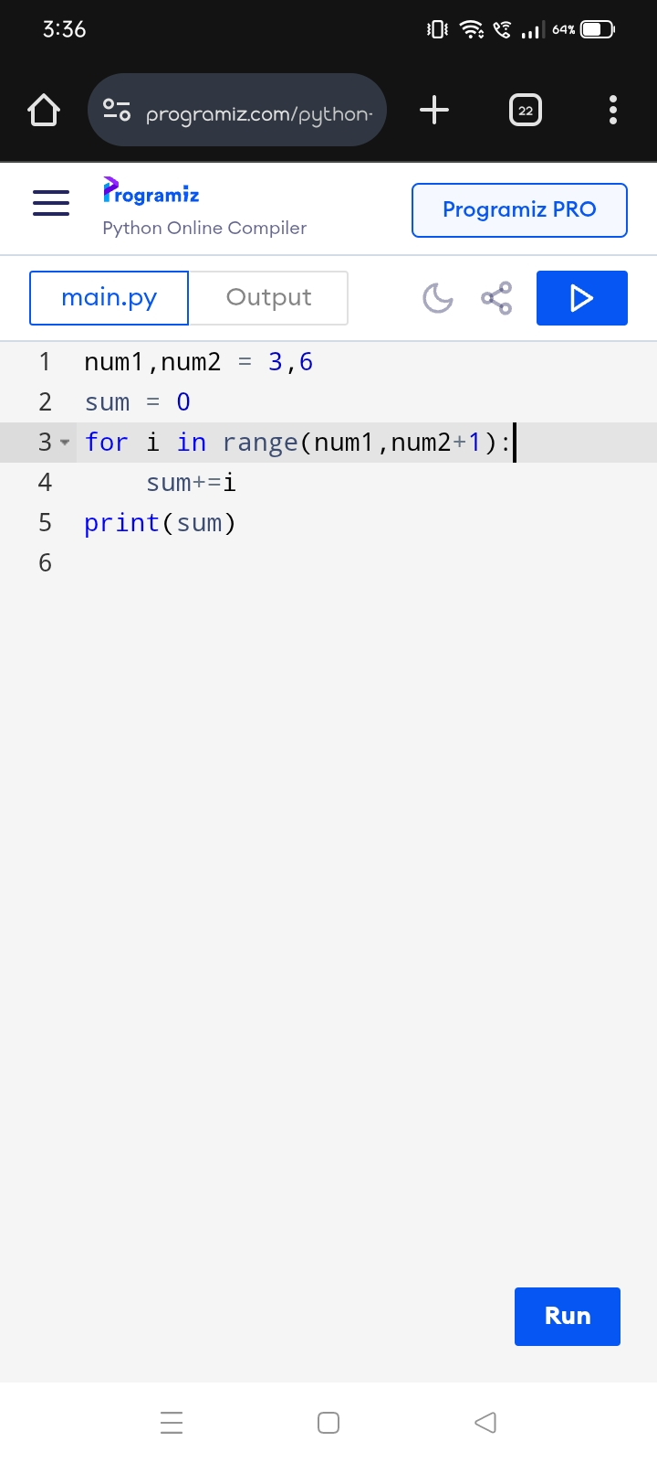

OUTPUT :



(3)PROGRAM :GREATEST OF TWO NUMBERS

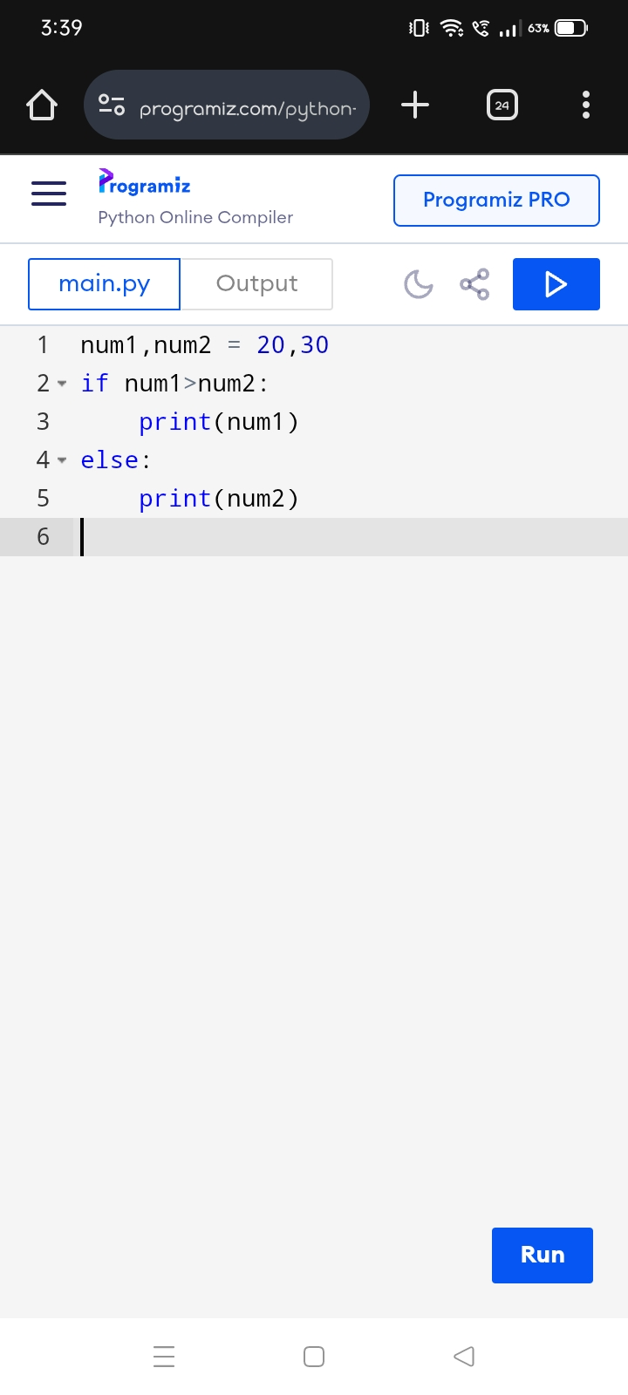

OUTPUT :

