(1)PROGRAM : POSITIVE OR NEGATIVE NUMBER

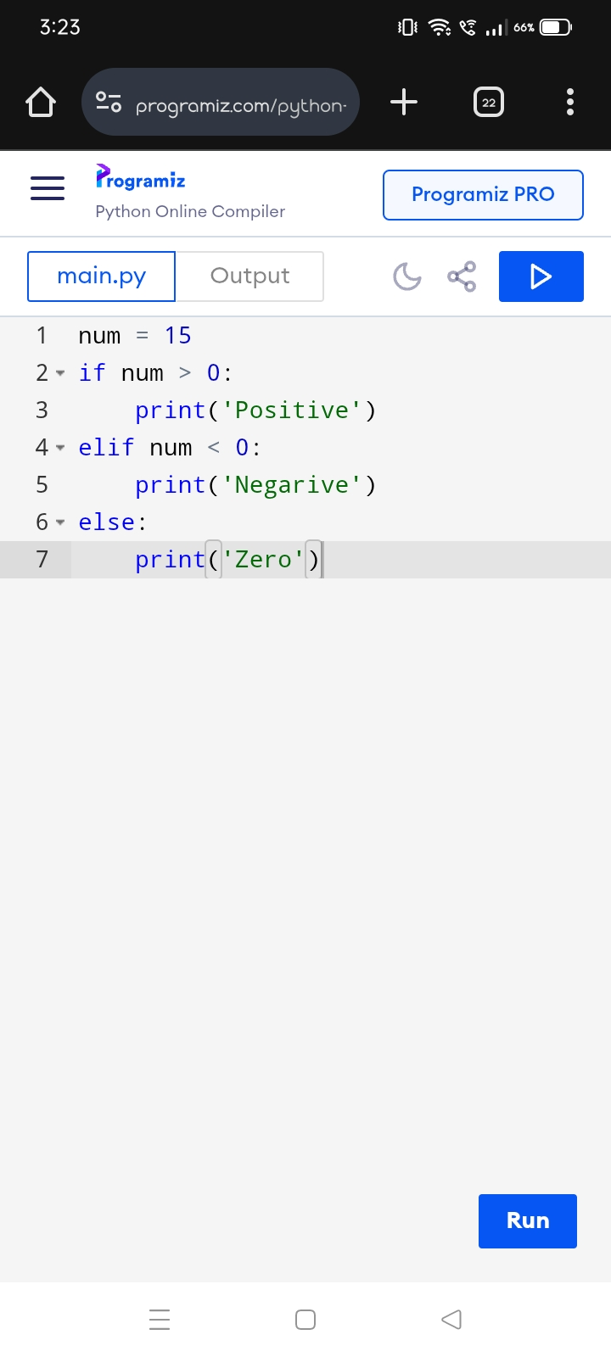

OUTPUT :

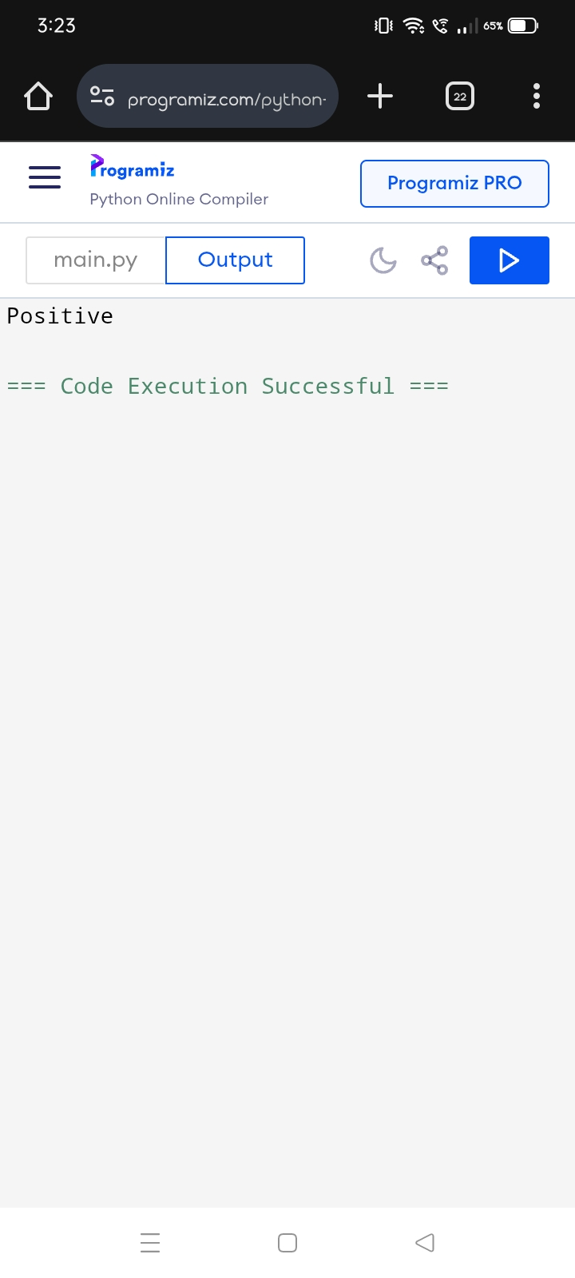

(2)PROGRAM : EVEN OR ODD NUMBER

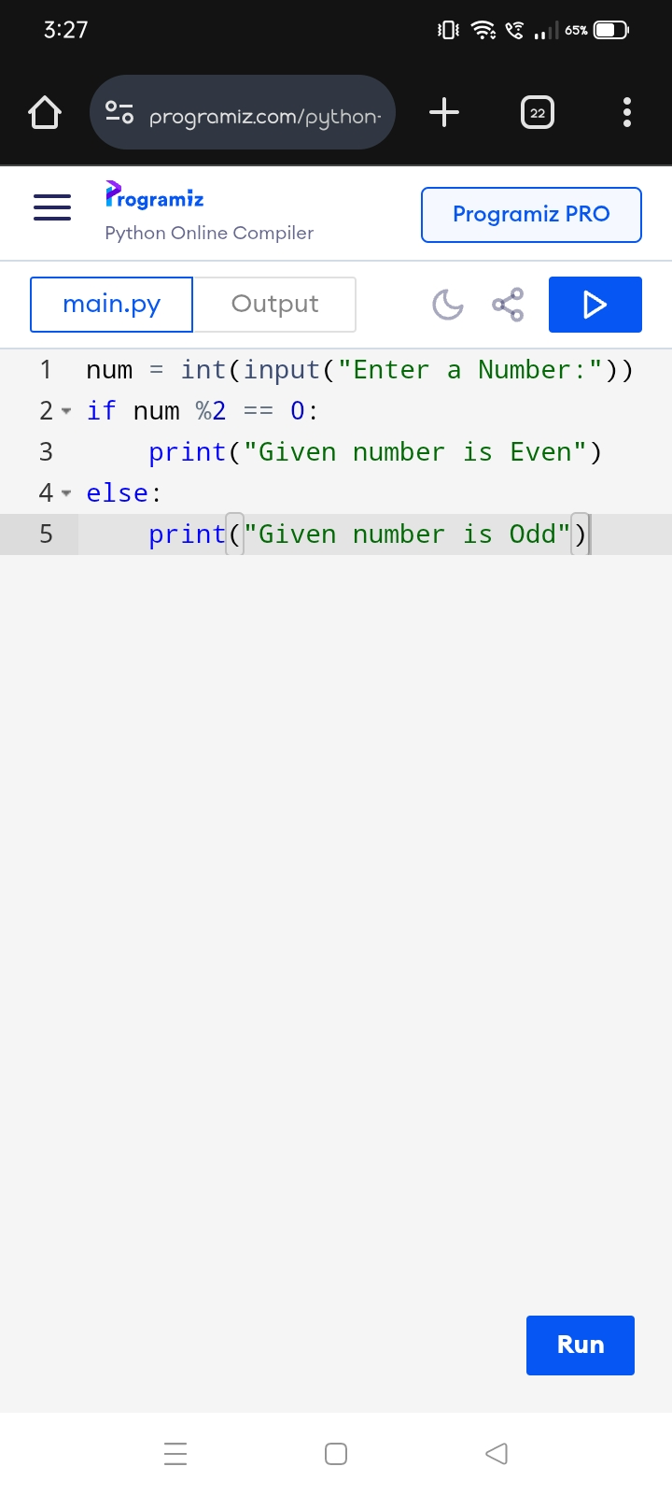

OUTPUT :

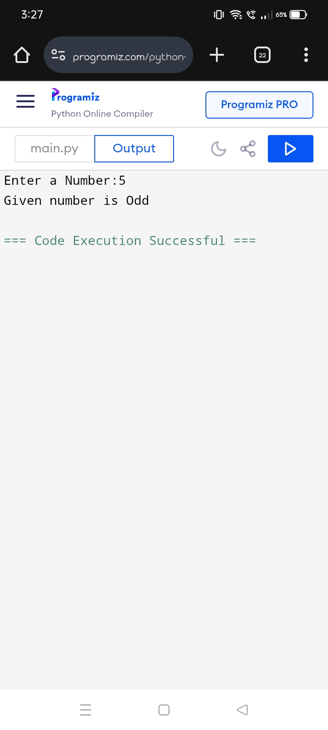

(3)PROGRAM : SUM OF FIRST N NATURAL NUMBERS

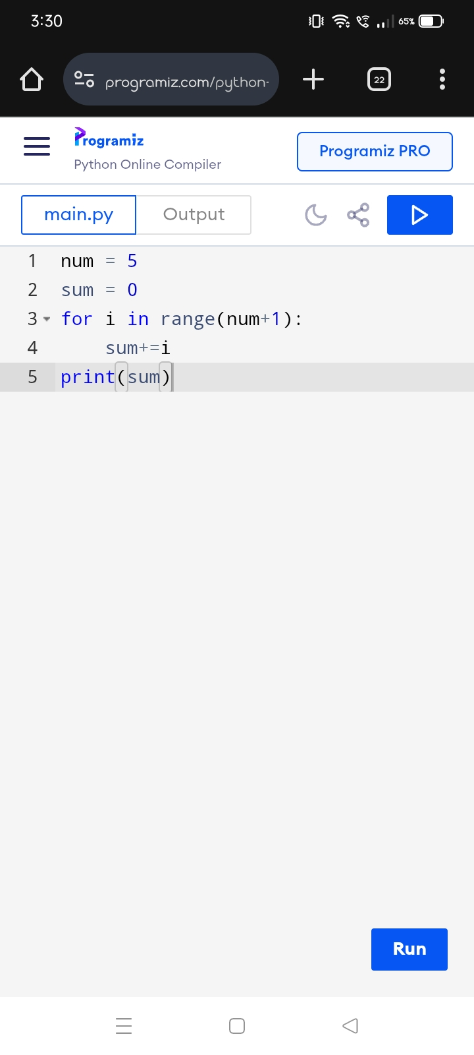

OUTPUT :

