(1)PROGRAM : GREATEST OF THE THREE NUMBERS

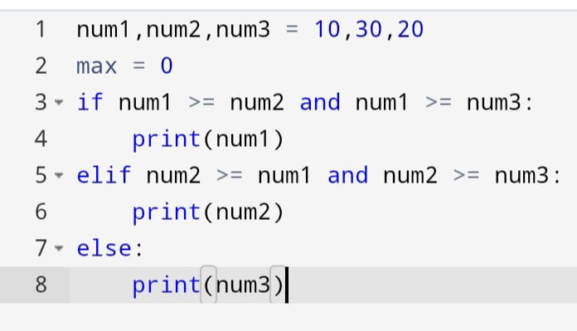

OUTPUT :

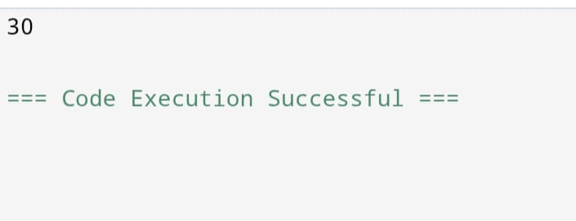

(2)PROGRAM : LEAP YEAR OR NOT

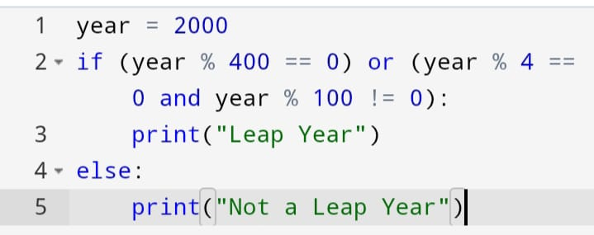

OUTPUT :

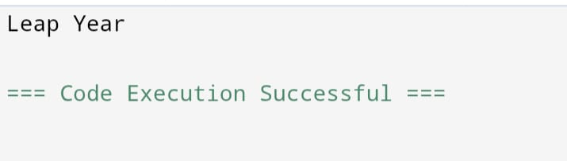

(3)PROGRAM : PRIME NUMBER

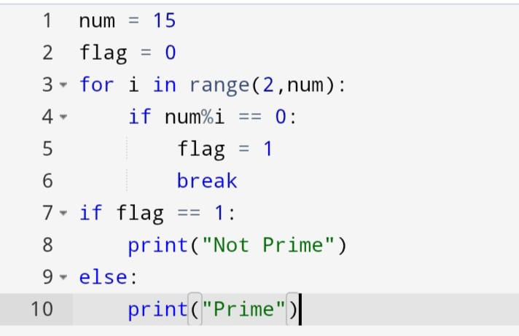

OUTPUT :

