Count Vowels in a String

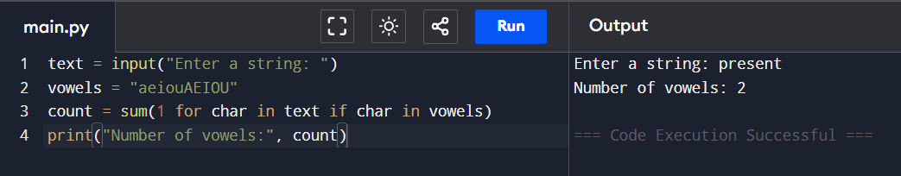

Simple Calculator

