**Find the Armstrong Numbers in a given Range in Python**

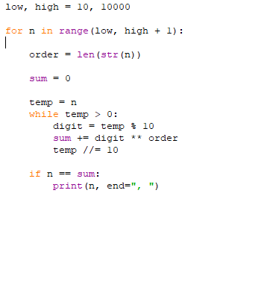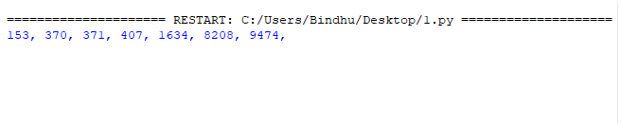

**Find the Fibonacci Series up to Nth Term in Python**

