**Find the Prime Numbers in a Given Range in Python**

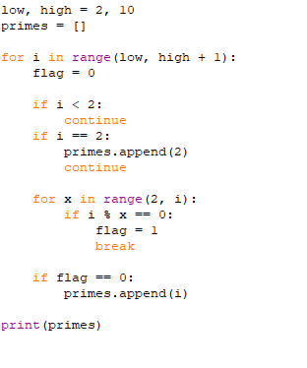

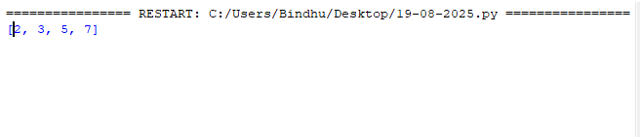

**Find the sum of the Digits of a Number in Python**

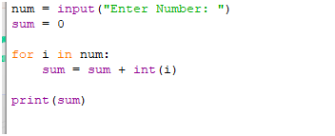



**Find the Reverse of a Number in Python**

