Repository Link
https://github.com/22mis0246/Manifest--Agentic_Customer_Segmentation.git
Platform Architecture
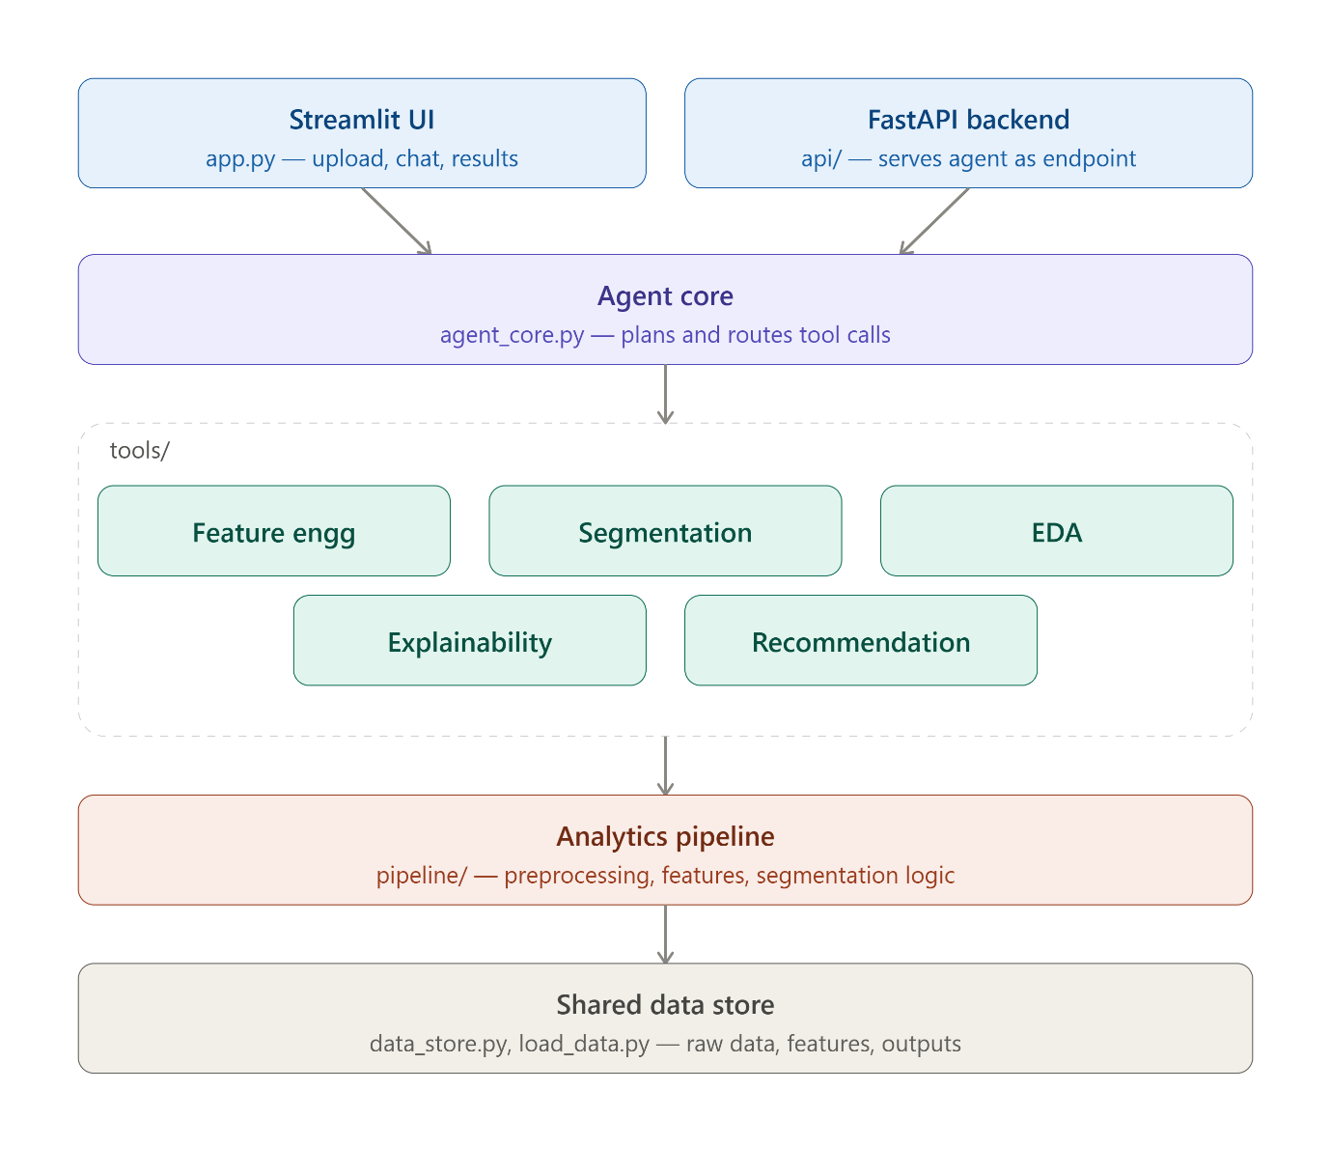
- UI Layer — app.py (Streamlit): dataset upload, chat interface, segment visualization, downloads.
- Agent Orchestration Layer — agent_core.py: parses the user's NL query, decides which tool(s) to invoke, sequences the workflow. This is what makes it "agentic" rather than a single prompt-response call.
- Tool Execution Layer — tools/: discrete callables (feature engineering, segmentation, EDA, explainability, recommendation) that agent_core dispatches to.
- Analytics Pipeline Layer — pipeline/: the actual transformation logic — preprocessing, column mapping, feature computation, clustering/rule logic, evaluation, persona generation.
- Data Layer — data_store.py + load_data.py + data/: shared in-session state (raw data, engineered features, segmentation output, metadata) plus CSV ingestion.

AI Agent Workflow
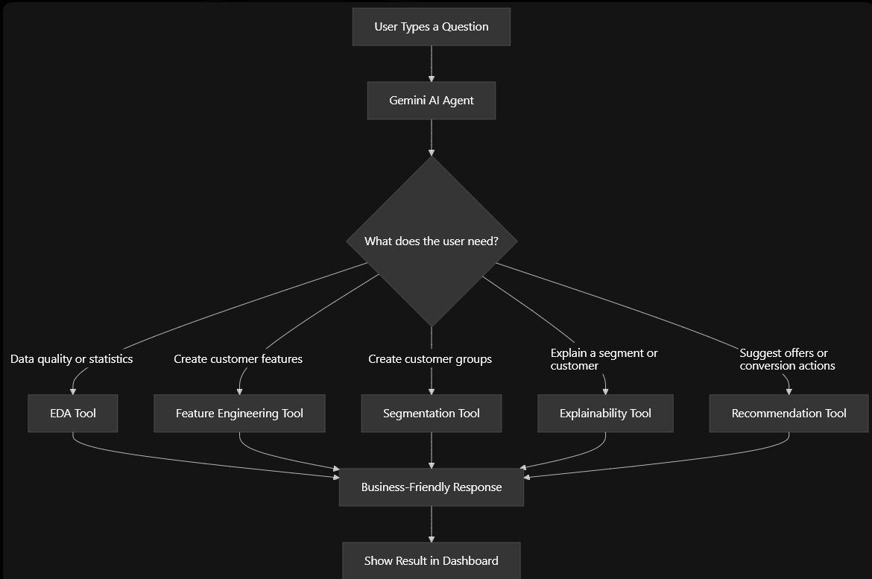
Analysis Algorithms
- Preprocessing & column mapping — normalizes inconsistent field names/formats into standard schema (customer ID, amount, balance, frequency, recency).
- Feature engineering — aggregates transaction-level rows into customer-level features: avg/max monthly balance, transaction frequency, avg transaction amount, recency, total count/amount.
- Segmentation — two modes:
  - Rule-based: threshold logic → priority / regular / dormant.
  - K-Means: standardized features, unsupervised clustering for pattern discovery beyond fixed rules.
- Evaluation & persona generation — measures segment separation quality, converts numeric clusters into readable business personas.
- Explainability — surfaces why a customer landed in a segment (feature contribution, not just the label).
- Recommendation — maps segment/persona to action (retention, upsell, re-engagement).
UI Design
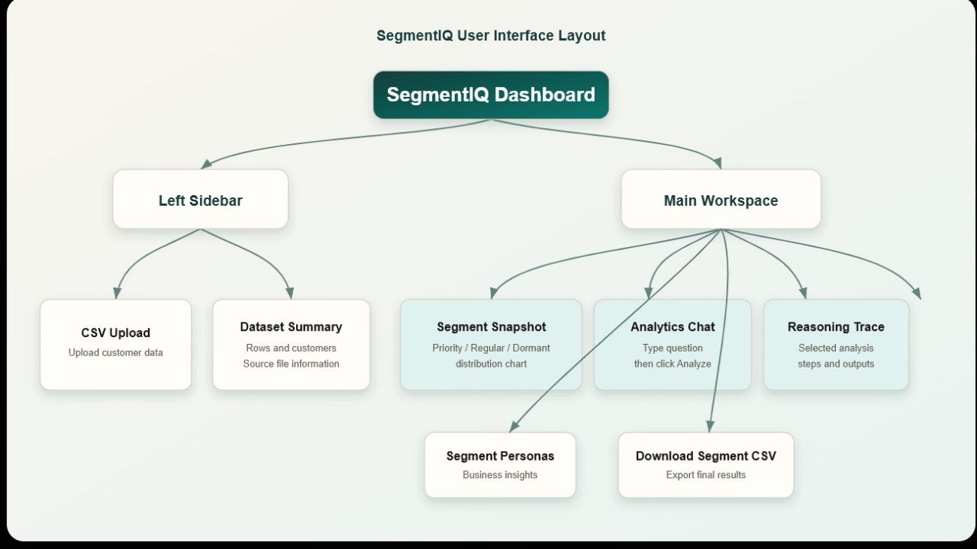

1. Dataset Source
- Source: Kaggle https://www.kaggle.com/datasets/kundanbedmutha/india-customer-financial-profiles-and-transactions?resource=download
- Domain: Retail Banking Customer Transactions
- Purpose: Customer segmentation and personalized financial recommendations.
- Dataset name: India Customer Financial Profiles & Transactions

2. Synthetic Data Generation
- Expanded the original dataset to simulate a larger banking environment.
- Generated realistic customer transaction patterns, account balances, transaction frequencies, and activity dates.
- Preserved statistical characteristics while increasing data diversity for testing and demonstration.

3. Technologies Used
Python • Streamlit • Gemini 2.5 Flash • Pandas • NumPy • Scikit-learn • GitHub

Video explanation link
https://drive.google.com/file/d/1-KGThSpVBAIfWMLPv60rMZDblobM--k0/view?usp=drivesdk

Reference
We referred to the paper titled Hyper-Personalisation in Retail Banking: Engagement, Retention and Commercial Growth (2026) which helped us understand and develop certain concepts and methodologies used in this work. Additionally, we consulted various credible resources and official documentation during the implementation

REGARDS,
NAVEEN RAJ M
BRINTO JENITH B

