2. Firewall Simulation

**Name** : Pulidindi Prasanth Babu

**Regd** : 22PA1A05D6

**Branch** : CSE

**Section** : C

**Sem** : 3-2

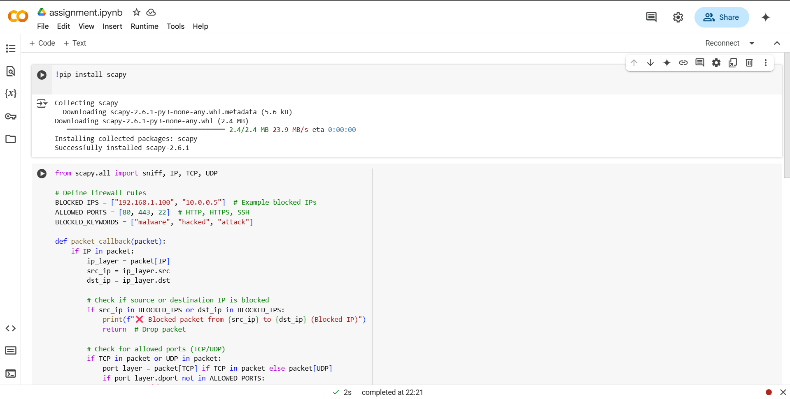

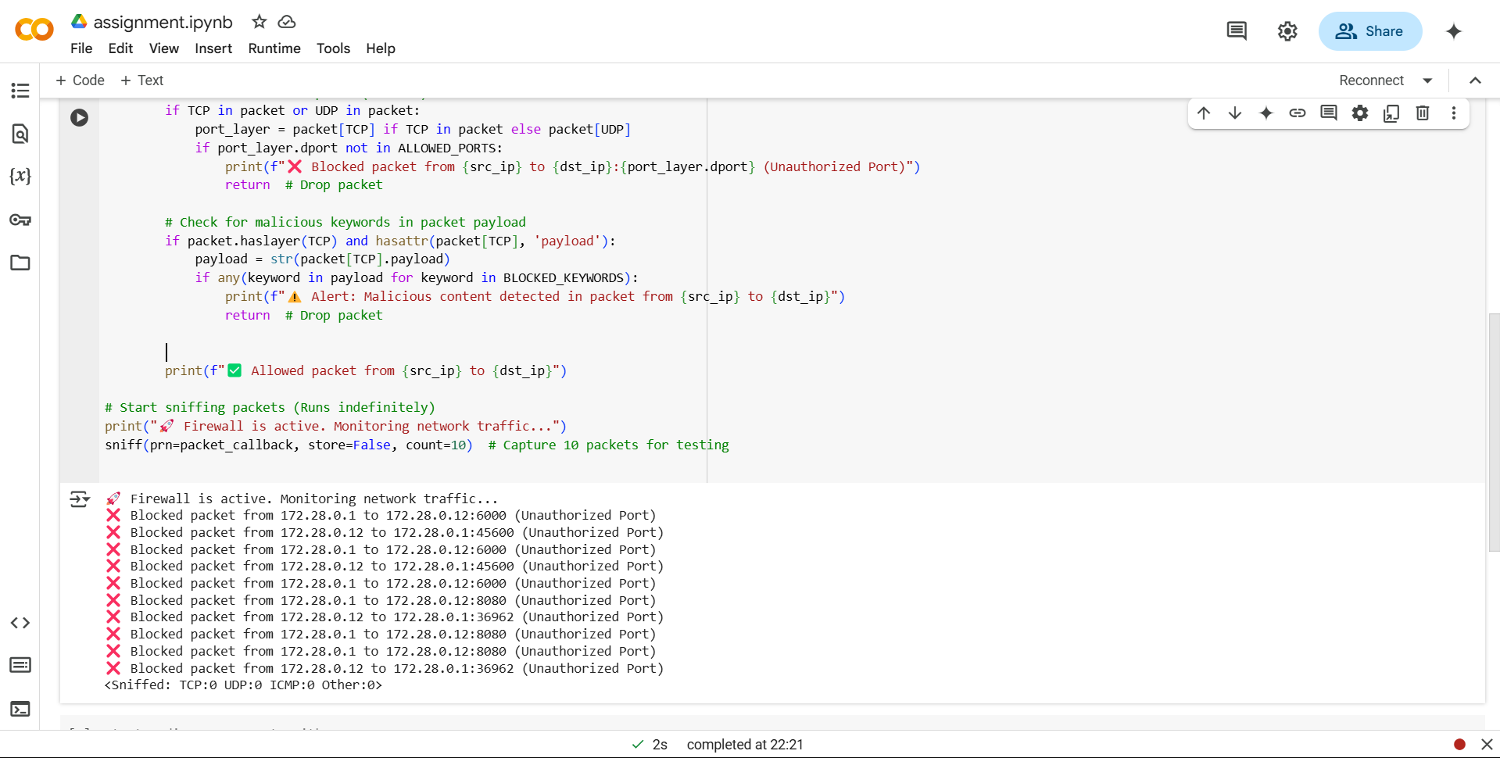

GitHub Link : https://github.com/Prasanthd6/firewall-Simulation-cns