Problem Statement
  - Considering all the requirements, softwares/libraries/models, hardware which should we choose?
  - Problem Statements for 1st Half
  - 1. Apply n-gram model on mammogram dataset (reports), Dataset: SPR2026 Mammography classification:Dataset

  - Set-1 - Next word prediction & text generation
    - a) Visualize it using word clouds (other visualization try if req ) for top 20 different n-grams and identify the keyword/grams
    - b) Construct n-gram models
    - c) Given a first word for each class, and a label, it generates a report as output. evaluate it using different RNN models.
    - Apply explanation

  - Set-2- Multi Classification
    - d) Apply n-gram model for classification and compare it with different ML & RNN & LSTM algorithms.
    - Apply explanations

  - Set-3
    - e) Apply LLMs and compare it with different n-gram & DL models
    - f) Apply explanations

  - Paper publish: stats model/ngram, Neural language model, Large language model
    - Tutorial Marks -Paper, Quiz: Non assessment
    - Each paper 4 people, Experiments+then write Paper ( deadline: 2 weeks )
    - Hyper parameter tuning on us, rest AI
    - Understand every problem statement
    - Paper Format:
      - Page 1:
        - Heading: All aspects of tech used in Title
        - Authors: All details
      - Abstract:
        - Motivation, Propose Novelty of our paper, How experiment conducted, Dataset used and any details, Exp measures&values like results if any, How outperform others, what all are compared
      - Introduction
      - Preliminaries/Background
      - Related works
      - Problem Statement
        - What given, Objective:eg: Construct model using n gram
      - Proposed Work (Step wise)
        - Data Collection
        - Preprocessing
        - Model Construction
        - Experiments
          - Setup(data split, hyperparam, fine tuning how and what, Measures used and technique)
          - Results
          - Findings/Discussions [Inference]
          - Conclusion [block diagram]
        - Conclusion [Overall conc Summary, Pros, Limitations]
        - Future Scope

Data translation code
import os
import glob
import time
from concurrent.futures import ThreadPoolExecutor, as_completed
import kagglehub
import pandas as pd
from deep_translator import GoogleTranslator
from tqdm import tqdm

# --- CONFIGURATION ---
MAX_WORKERS = 10 # Number of parallel threads (adjust between 5-15 based on rate limits)
SAVE_INTERVAL = 50 # Save progress to disk every N rows
OUTPUT_DIR = "./output" # Your custom path to save the final and checkpoint files
OUTPUT_FILE = os.path.join(OUTPUT_DIR, "fully_translated_mammography_train.csv")

os.makedirs(OUTPUT_DIR, exist_ok=True)

# 1. Download and load the entire dataset
path = kagglehub.competition_download('spr-2026-mammography-report-classification')
train_path = os.path.join(path, "train.csv")
if not os.path.exists(train_path):
csv_files = glob.glob(os.path.join(path, "**", "train.csv"), recursive=True)
if csv_files:
train_path = csv_files[0]

df = pd.read_csv(train_path)
print(f"Loaded full dataset. Rows to process: {len(df)}")

text_column_name = 'report'

# 2. Check for existing progress (Resume functionality)
if os.path.exists(OUTPUT_FILE):
df_translated = pd.read_csv(OUTPUT_FILE)
# Identify which indices are already completely processed
processed_indices = set(df_translated['original_index'].dropna().astype(int).tolist())
print(f"Found existing progress file. Already processed {len(processed_indices)} rows.")
else:
df_translated = pd.DataFrame()
processed_indices = set()

# Filter out rows that are already completed
df['original_index'] = df.index
rows_to_process = df[~df['original_index'].isin(processed_indices)].to_dict(orient='records')
print(f"Remaining rows to process: {len(rows_to_process)}")

# 3. Translation worker function
def translate_row(row_dict):
"""Worker function executed by threads in parallel"""
# Create an independent translator instance per thread to avoid race conditions
translator = GoogleTranslator(source='pt', target='en')
text = row_dict[text_column_name]

try:
if pd.isna(text) or not str(text).strip():
row_dict['report_english'] = text
else:
row_dict['report_english'] = translator.translate(str(text)[:4999])
except Exception as e:
row_dict['report_english'] = f"[Translation Error: {e}]"
time.sleep(2) # Short pause if hit by a soft block

return row_dict

# 4. Parallel Execution Engine
print(f"\nStarting parallel translation using {MAX_WORKERS} workers...")
newly_translated_rows = []

with ThreadPoolExecutor(max_workers=MAX_WORKERS) as executor:
# Submit all remaining translation tasks to the thread pool
future_to_row = {executor.submit(translate_row, row): row for row in rows_to_process}

# Track progress as tasks complete dynamically
pbar = tqdm(total=len(rows_to_process), desc="Translating Parallelly")

for count, future in enumerate(as_completed(future_to_row), start=1):
try:
result_row = future.result()
newly_translated_rows.append(result_row)
except Exception as exc:
print(f"\nA row generated an unhandled exception: {exc}")

pbar.update(1)

# Periodic checkpoint saving
if count % SAVE_INTERVAL == 0 or count == len(rows_to_process):
if newly_translated_rows:
df_new = pd.DataFrame(newly_translated_rows)
df_translated = pd.concat([df_translated, df_new], ignore_index=True)
# Sort by original index to keep dataset integrity
df_translated = df_translated.sort_values(by='original_index').reset_index(drop=True)
df_translated.to_csv(OUTPUT_FILE, index=False)
newly_translated_rows = [] # Clear the buffer after saving

pbar.close()

# 5. Final Save and View Results
# Flush any remaining items in the buffer
if newly_translated_rows:
df_new = pd.DataFrame(newly_translated_rows)
df_translated = pd.concat([df_translated, df_new], ignore_index=True)
df_translated = df_translated.sort_values(by='original_index').reset_index(drop=True)

# Drop the helper index before final export if desired
if 'original_index' in df_translated.columns:
df_translated = df_translated.drop(columns=['original_index'])

df_translated.to_csv(OUTPUT_FILE, index=False)
print(f"\n🎉 Success! The entire dataset is translated and saved at: '{OUTPUT_FILE}'")

☑️ Checklist
Jul 29, Wed:
- Workflow Discussion
- Present the idea and steps
- NLP_Research_Project

Aug 5, Wed:
- Translated Data data
- Translation Validation and EDA 01_data_preprocessing.ipynb (B)
  - ML/DL models and results 02_classical_ml_pipeline.ipynb

Aug 27, Thu:
- Pre-processing, SMoothing, Model specific processing - n gram(M)
- N grams classification model creation (A)
- N grams model evaluation and consolidated all model evaluation, comparison and Explainable visualization (V)

Pipeline
.## Detailed pipeline — text version for slide content
Stage 1 — Data acquisition
- Source: SPR2026 Mammography Report Classification dataset (Portuguese)
- Fields: free-text findings, impression, target BI-RADS (0–6)
- Initial audit: class distribution, report length distribution, missing/duplicate records
Stage 2 — Preprocessing
- Data quality audit → missing data, duplicates, label consistency checks
- Target leakage detection → strip explicit BI-RADS mentions, target-bearing fields, label proxies from free text
- Portuguese → English translation with terminology, negation, laterality, and measurement validation (or keep native-language pipeline if translation isn't required — state your choice)
- Text normalization → Unicode cleanup, whitespace, case normalization
- Domain-aware processing → preserve clinical terms, negation scope, laterality (left/right), measurements, abbreviation expansion
- Post-processing QC → text integrity, vocabulary/length stats, semantic spot-check
- Output: model-ready clinical text corpus
Stage 3 — Train/test split
- Stratified 80/20 split on BI-RADS class to preserve imbalance ratio in both sets
- Optionally reserve a validation fold for hyperparameter tuning (5-fold CV within train set)
Stage 4 — Three parallel modeling branches
Branch A — Probabilistic N-gram classifier
- Generate unigrams, bigrams, trigrams, and combined n-grams per report
- Partition training data by BI-RADS class (7 parallel branches)
- Count per-class n-gram frequencies
- Estimate P(n-gram | class) using Kneser-Ney smoothing (discounted counts + lower-order interpolation)
- Store one class-specific probabilistic language model per BI-RADS category in a shared repository
- Inference: generate n-grams for new report → compute document likelihood P(report | class) against each class model → Bayesian posterior P(class | report) → MAP decision rule
Branch B — Classical machine learning
- TF-IDF vectorization, n-gram range 1–3
- Hyperparameter tuning via GridSearchCV, 5-fold CV
- Train: Naive Bayes, Logistic Regression, SVM, Random Forest, XGBoost, LightGBM
- Output predicted class + probability per model
Branch C — Deep learning
- Tokenization + padding, max sequence length 100 tokens
- Embedding layer, 100-dim Word2Vec/GloVe vectors
- Sequential architectures: RNN → LSTM → BiLSTM → GRU → LSTM+attention
- Dense + softmax output layer for class probabilities
Stage 5 — Combined predictions
- Aggregate outputs from all 11 models (1 n-gram + 6 ML + 4 DL) into one comparison table
Stage 6 — Unified evaluation
- Primary: Macro F1 (handles class imbalance)
- Secondary: Accuracy, Precision, Recall
- Confusion matrix per model
- Per-class performance breakdown (especially minority BI-RADS classes: 0, 1, 3, 4, 5, 6)
Stage 7 — Explainability & error analysis
- SHAP and LIME for feature attribution on ML models
- Important n-grams driving each BI-RADS prediction
- Systematic misclassification review — which classes get confused with which, and why (e.g., BI-RADS 3 vs 4 boundary cases)
Stage 8 — Efficiency benchmarking
- Training time per model
- Inference latency
- Model size / memory footprint
- Feeds into a performance-vs-efficiency tradeoff chart
Stage 9 — Comparative analysis & conclusions
- Cross-branch comparison (n-gram vs ML vs DL) on Macro F1
- Ablation results on n-gram range
- Practical deployment recommendation (which model best balances accuracy, interpretability, and compute cost for clinical use)
You can turn any of these stage blocks into its own slide, or use the diagram above as a single "detailed pipeline" overview slide — just screenshot it or export it as an image.

🔗 Ref Links

- NLP_Research_Project
- Github: https://github.com/22pt16/BI-RADS-Classification

- Grok (Vismaya) : https://grok.com/share/c2hhcmQtNQ_7ace6be8-b002-4c14-91fa-b54dab47d393

🌱 PROJECT PLAN

SPR 2026 Mammography Classification — Project Blueprint

N-gram vs. Classical ML vs. RNN/LSTM/BiLSTM, with Explainability (Set 2d + 2f)
Team size: 4 | Duration: ~14 days | Hardware: Local (Ryzen 5, no dGPU) + Colab/Kaggle GPU

0. Mentor's Critical Take (read this first)
Before the plan: three corrections to the brief as given, because a comparative paper lives or dies on these.
- Translation is not a side-note — treat it as an experimental variable, not a fixed preprocessing step. Google-Translate-based pipelines routinely invert or drop negations ("não há evidência de malignidade" → risk of losing "não"/"no evidence"), which is catastrophic for a diagnostic-label task. You should not assume translate-then-model is even the best approach. Build in a cheap alternative comparison: also run at least one classical model directly on the original Portuguese text (Portuguese stopword list + PT-BR tokenizer, e.g. spaCy pt_core_news_sm). This turns "translation quality" from an afterthought into a real research contribution ("does translation help or hurt classification vs. native-language modeling?") — reviewers will ask this anyway, so pre-empting it is higher value than another DL variant.
- Do not include all of {RNN, LSTM, BiLSTM} as three fully separate hyperparameter-tuned pipelines. On a small, likely-imbalanced medical-report dataset with a two-week clock, RNN (vanilla) will almost certainly underperform and add engineering time for a foregone conclusion. Recommended correction: implement RNN as a lightweight baseline (fixed, minimal tuning) to demonstrate the vanishing-gradient/context-limitation point empirically, then invest real tuning budget in LSTM and BiLSTM. This is scientifically honest (you still "compare" all three) and protects your timeline.
- Do not include five classical models. Random Forest and XGBoost rarely add insight on sparse high-dimensional TF-IDF text vectors beyond what Logistic Regression/SVM already show, and tuning two tree ensembles well eats days you don't have. Recommended final classical set: Multinomial Naive Bayes (fast, standard n-gram baseline), Logistic Regression (strong linear baseline + interpretable coefficients), Linear SVM (typically the strongest classical text classifier). Keep Random Forest only as a single non-linear reference point without heavy tuning — cut XGBoost entirely unless the dataset audit reveals something (e.g., strong tabular metadata alongside text) that specifically justifies it. This is a "should-have," not "must-have."
Everything below reflects these corrections. Where the original brief listed something broader, I've marked what was trimmed and why.

1. Final Research Scope & Research Questions
Scope statement: An experimental comparative study of n-gram-based, classical ML, and recurrent deep-learning approaches for BI-RADS/category classification of Portuguese mammography reports translated to English, with explainability and statistical validation of the model comparison.
Research Questions (RQs):
- RQ1: How does classification performance vary across n-gram orders (unigram/bigram/trigram/combined) and vectorization schemes (Count vs. TF-IDF) for mammography report classification?
- RQ2: How do classical ML models (Naive Bayes, Logistic Regression, SVM) compare against RNN/LSTM/BiLSTM architectures on this task, under matched, fair evaluation protocol?
- RQ3: Does English translation (via Google-Translate-based pipeline) preserve enough clinical/negation signal to match or beat native-Portuguese modeling, and does translation quality correlate with downstream classification errors?
- RQ4: Are performance differences between top models statistically significant, and where (which classes/error types) do models systematically fail?
- RQ5: What do explainability methods (n-gram/feature importance, LIME/SHAP, attention where applicable) reveal about which clinical terms drive predictions, and are these clinically plausible?

2. Dataset Audit (must happen before any modeling — Day 1 deliverable)
Do not assume any of the following; verify and report as a table in the paper:
Item to verify | Why it matters
Total samples, per-class counts (class imbalance ratio) | Determines resampling/weighting strategy, metric choice
Label scheme — true BI-RADS 0–6, or a collapsed category set? | Determines whether this is binary, multi-class, or ordinal
One report per patient, or multiple reports per patient? | Leakage risk if same patient appears in train and test
Text length distribution (tokens/report) | Determines truncation/padding for DL models
Missing/empty reports, duplicate reports | Cleaning step count, reported in paper
Language consistency (is it 100% Portuguese, or mixed?) | Determines translation necessity
Any existing train/test split provided, or must you create one? | Determines your split protocol
Presence of structured/tabular fields alongside free text | Determines if multimodal features are in-scope (likely: out-of-scope, note as future work)
Encoding issues (accents, OCR artifacts if scanned) | Determines preprocessing/regex cleaning needs
Action: Person A produces a one-page EDA report (counts, class distribution bar chart, text-length histogram, sample reports) by end of Day 1. This gates every downstream decision (splitting strategy, metric choice, imbalance method).

3. End-to-End Methodology (Pipeline)
Raw PT reports
│
├──► [Branch A: Portuguese-native pipeline] ── PT cleaning ── PT stopwords ── TF-IDF ── 1 classical model (comparison anchor)
│
└──► [Branch B: Translation pipeline]
│
▼
Google-Translate (batched, cached, rate-limited)
│
▼
Translation Quality Evaluation (Section 4)
│
▼
Medical-text preprocessing (English)
(lowercasing, negation-scope tagging, medical
abbreviation expansion, tokenization,
stopword removal EXCEPT negation words)
│
├──► N-gram extraction & visualization (Section 5)
│ │
│ ▼
│ N-gram-based classification (NB / LogReg / SVM / RF-lite)
│
└──► Sequence encoding (padded token IDs)
│
▼
Embeddings (pretrained GloVe or trainable embedding layer — decide after audit)
│
▼
RNN (lite) / LSTM (tuned) / BiLSTM (tuned)
│
▼
Unified Evaluation (same test split, same metrics, both branches)
│
▼
Explainability (LIME/SHAP for classical+n-gram; attention/gradient-based for DL)
│
▼
Statistical significance testing + Error analysis
│
▼
Results, Discussion, Limitations

Data split protocol (fixed once, used everywhere): Stratified train/val/test (e.g., 70/15/15), split at the patient level if multiple reports per patient exist (this is a leakage risk item flagged above), fixed random seed, saved split indices to a file so every model/team member uses identical splits.

4. Translation Approach & Evaluation
Approach: Batch-translate via a Google-Translate-based Python library (e.g., googletrans, deep-translator), with:
- Local caching (translate once, store to disk — avoids re-hitting the API and guarantees reproducibility)
- Rate-limiting/retry logic
- A logged failure list (empty/error translations flagged and handled)
Evaluation of translation quality (this is a real experimental component, not a footnote):
- Manual spot-check + rubric: One team member (with Portuguese ability, or using back-translation as an aid) manually reviews a stratified random sample (e.g., 50–100 reports) and rates each on a 3-point scale: (a) clinical meaning preserved, (b) negation preserved, (c) meaningless/garbled. Report inter-item agreement if 2 people rate a subset.
- Back-translation consistency: Translate EN→PT again and compute a similarity metric (e.g., BLEU or simple cosine similarity of sentence embeddings) between original and back-translated PT text as a proxy quality signal — cheap, automatable, defensible.
- Negation-term audit: Regex-based count of Portuguese negation markers ("não", "sem", "ausência de") in source vs. corresponding English negation markers ("no", "without", "absence of") in translated text — a simple, novel, low-cost check directly relevant to diagnostic text.
- Downstream correlation: After modeling, check whether misclassified samples disproportionately came from low-quality-translation samples (ties Section 4 into Section 11 error analysis).
This produces one of your more original contributions — most n-gram/DL comparison papers don't rigorously evaluate translation; doing so with even lightweight methods differentiates the paper.

5. N-gram Experimental Design & Visualization
- N-gram orders: unigram, bigram, trigram, and combined (1,2) and (1,3) ranges — 5 configurations.
- Representations: Raw Count vs. TF-IDF (2 configurations) → 10 n-gram/representation combinations total, used as a controlled ablation, not all pushed through every downstream model (see experiment matrix, Section 14, for what's actually run in full vs. what's an ablation-only check).
- Vocabulary control: min_df/max_df thresholds, top-k feature cap (e.g., top 5,000–10,000 features) to keep classical models tractable and comparable.
- Visualizations:
  - Top-N most frequent/most-informative n-grams per class (bar charts)
  - Word clouds per class (optional, secondary — bar charts are more rigorous for a paper)
  - TF-IDF score heatmap for top discriminative n-grams across classes
  - N-gram order vs. validation-accuracy/F1 line plot (this is the ablation study result)

6. Final Classical ML Models — and Why
Model | Include? | Justification
Multinomial Naive Bayes | Yes | Canonical, fast n-gram/text baseline; expected paper reviewers
Logistic Regression | Yes | Strong linear baseline; coefficients directly support explainability (Section 11)
Linear SVM | Yes | Typically top classical performer on sparse TF-IDF text
Random Forest | Yes (lite) | Single non-linear reference point; minimal tuning only
XGBoost | No (cut) | Marginal gain over RF/SVM on sparse text features; tuning cost not justified in 2 weeks — note as future work
kNN / Decision Tree alone | No | Weak baselines, low information value for the comparison

7. RNN / LSTM / BiLSTM Design
- Tokenization: Keras Tokenizer or a simple vocabulary builder; cap vocab size (e.g., 10k–20k) based on the audit's text-length/vocabulary findings.
- Sequence length: Set from the Day-1 text-length histogram (e.g., 95th percentile), pad/truncate.
- Embeddings: Start with a trainable embedding layer (feasible, no download dependency); optionally compare against pretrained GloVe embeddings only if time permits (Should-Have, not Must-Have).
- Architectures:
  - RNN (lite baseline): 1 layer, fixed hidden size (e.g., 64), light/no tuning — purpose is to show the expected weakness, not chase performance.
  - LSTM (tuned): 1–2 layers, dropout, tuned hidden size/learning rate.
  - BiLSTM (tuned): mirrors LSTM config bidirectionally; typically the strongest DL candidate here.
- Regularization: Dropout + early stopping (on validation macro-F1, not accuracy) given expected imbalance.
- Training location: All DL training on Colab/Kaggle GPU (free tier is sufficient at this data scale); classical ML and n-gram work run locally on the Ryzen 5 laptop (CPU-only, fast enough for TF-IDF-scale data).

8. Class-Imbalance Strategy
Decide after the Day-1 audit reveals actual imbalance ratio, but pre-plan the toolkit:
- Metric-level (always applied): report macro-F1 and per-class precision/recall/F1 as primary metrics — never rank models by accuracy alone.
- Model-level: class_weight='balanced' for Logistic Regression/SVM/RF; weighted loss for DL models.
- Data-level (only if severe imbalance, e.g., minority class <5–10% and dataset is not huge): light oversampling (e.g., random oversampling or SMOTE on TF-IDF space only, never on raw text, and only applied to the training fold, never to validation/test — a leakage risk to explicitly guard against and mention in the paper).
- Avoid combining multiple imbalance techniques simultaneously across all models — keep the imbalance-handling choice the same across all compared models for a fair comparison, unless imbalance-handling itself is being explicitly ablated as a side experiment.

9. Hyperparameter-Tuning Strategy (time-boxed)
- Classical models: Small grid/random search over 2–3 key hyperparameters each (e.g., SVM: C, kernel-linear only; LogReg: C, penalty; NB: alpha) using stratified k-fold (k=3–5) on the training set only.
- DL models: Random search (not full grid) over hidden size, learning rate, dropout — 3–5 configurations max per architecture, tracked in a simple results table/spreadsheet, not a heavy AutoML tool (out of scope/time).
- Budget rule: total DL tuning must fit inside a single-day Colab session per architecture (Section 16 timeline reflects this).

10. Evaluation Metrics & Fair Comparison Protocol
- Primary: Macro-F1 (handles imbalance, treats classes equally)
- Secondary: Accuracy, weighted-F1, per-class precision/recall, confusion matrix
- Statistical rigor: report mean ± std over multiple runs (different seeds) for DL models (DL is stochastic; classical models are largely deterministic given fixed splits — note this asymmetry explicitly in the paper, it's a legitimate methodological point).
- Fairness rules (write these into your methodology section verbatim):
  - Identical train/val/test split across all models.
  - Identical preprocessing branch (translated-English) for the head-to-head comparison; Portuguese-native run is a clearly labeled separate comparison, not mixed into the main leaderboard.
  - Hyperparameters tuned only on validation fold; test set touched exactly once per model, at the end.
  - Same imbalance-handling strategy applied uniformly (Section 8).

11. Explainability, Statistical Testing & Error Analysis
Explainability:
- Classical + n-gram models: top TF-IDF/coefficient weights per class (Logistic Regression coefficients are directly interpretable); LIME for local explanation of specific predictions (works model-agnostically, feasible in the time given).
- DL models: attention weights (if you add a simple attention layer on top of BiLSTM — cheap addition, strong payoff for explainability section) or gradient-based saliency (e.g., integrated gradients) over the embedding layer as a fallback if attention isn't implemented.
- Present 3–5 worked examples per class: report text → predicted label → top contributing terms, with a clinician-plausibility comment.
Statistical testing:
- Pairwise model comparison via McNemar's test (appropriate for comparing two classifiers' predictions on the same test set) between the top classical model and the top DL model.
- If comparing 3+ models' scores across CV folds, a Friedman test with post-hoc Nemenyi is the correct rigorous choice — feasible in time if you only run it on the tuned final models, not every ablation configuration.
Error analysis:
- Confusion matrix per top model, with qualitative review of the most-confused class pair.
- Cross-reference misclassifications with translation-quality flags (Section 4) and with report length (short reports likely harder).

12. Computational-Efficiency Comparison
Report a simple table: training time, inference time per sample, model size (parameters or disk size), for each final model — this is cheap to collect (just log timestamps) and strengthens the "comparative" framing reviewers expect, and directly supports a practical takeaway (e.g., "SVM offers 95% of BiLSTM's macro-F1 at 1% of the training cost").

13. Software, Libraries, Hardware Plan
Task | Library | Where run
EDA, cleaning | pandas, matplotlib/seaborn | Local
Translation | deep-translator or googletrans | Local (cache to disk)
PT NLP | spaCy pt_core_news_sm | Local
N-grams/TF-IDF | scikit-learn (CountVectorizer, TfidfVectorizer) | Local
Classical ML | scikit-learn | Local
Imbalance handling | imbalanced-learn (SMOTE) | Local
DL models | TensorFlow/Keras or PyTorch (pick one, team-wide consistency) | Colab/Kaggle GPU
Explainability | lime, shap | Local (classical) / Colab (DL)
Stats testing | statsmodels, scipy.stats, scikit-posthocs (Nemenyi) | Local
Experiment tracking | a shared spreadsheet or lightweight mlflow/CSV log | Shared repo

14. Final Experiment Matrix (non-redundant)
# | Branch | Feature/Input | Model | Tuned? | Purpose
1 | EN (translated) | Unigram TF-IDF | Naive Bayes | Light | Baseline
2 | EN | Unigram TF-IDF | Logistic Regression | Yes | Core comparison + interpretability
3 | EN | Unigram TF-IDF | Linear SVM | Yes | Core comparison
4 | EN | Unigram TF-IDF | Random Forest | Light | Non-linear reference
5 | EN | Bigram TF-IDF | Best classical model from 1–4 | Yes | N-gram order ablation
6 | EN | Trigram TF-IDF | Best classical model | Yes | N-gram order ablation
7 | EN | (1,2) combined TF-IDF | Best classical model | Yes | N-gram order ablation
8 | EN | (1,2) Count vs TF-IDF | Best classical model | Light | Representation ablation
9 | EN (translated) | Padded sequence | RNN (lite) | No/light | Baseline DL, expected-weak reference
10 | EN | Padded sequence | LSTM | Yes | Core DL comparison
11 | EN | Padded sequence | BiLSTM | Yes | Core DL comparison, top candidate
12 | PT (native) | Unigram/bigram TF-IDF (PT) | Best single classical model | Light | Translation-necessity check (RQ3)
13 | EN | — | Imbalance-handling on/off | — | Ablation only if imbalance is confirmed severe
Runs 5–8 are ablations reported as a single results table/plot, not repeated full tuning cycles — this is what keeps the matrix from exploding past the 2-week budget.

15. Division of Work Among 4 People (parallelizable)
Person | Primary Ownership | Also supports
A — Data & Preprocessing Lead | Dataset audit, cleaning, PT text preprocessing, Portuguese-native branch (Exp. 12), translation pipeline + caching | Translation quality evaluation (with C)
B — Classical ML & N-gram Lead | N-gram extraction/visualization, all classical models (Exp. 1–8), classical-model explainability (LIME/coefficients) | Statistical testing (with D)
C — Deep Learning Lead | RNN/LSTM/BiLSTM implementation, tuning, Colab/Kaggle management (Exp. 9–11), DL explainability (attention/saliency) | Translation quality evaluation (with A)
D — Evaluation, Stats & Writing Lead | Unified evaluation harness, metrics dashboard, statistical significance testing, error analysis, coordinates paper assembly & presentation | Computational-efficiency logging (with C)
Everyone contributes to their own methods/results section drafting as they finish; D consolidates into the full paper. This avoids the common failure mode of writing starting only after all experiments finish.

16. Day-by-Day 14-Day Timeline
Day | Focus | A | B | C | D
1 | Dataset audit, EDA, splits fixed | Leads audit report | Reviews audit, plans n-gram configs | Sets up Colab/Kaggle env | Sets up shared repo, results log template
2 | Translation pipeline built + cached | Runs translation, logs failures | Starts PT-native preprocessing branch | Prototypes tokenizer/sequence pipeline | Drafts Intro/Related Work outline
3 | Translation quality evaluation | Runs manual+back-translation eval | Begins n-gram extraction/visualization | Finalizes embedding/sequence config | Literature search (12–20 papers) begins
4 | English medical-text preprocessing finalized | Negation-preserving cleaning | N-gram visualizations done | Baseline RNN implemented & run | Continue lit review; draft Background
5 | Classical models: initial runs | Support B/C | NB, LogReg, SVM, RF — Exp 1–4 run | LSTM implementation started | Related Work draft
6 | Classical tuning + n-gram ablations | PT-native model (Exp 12) run | Tuning Exp 1–4, runs Exp 5–8 ablations | LSTM tuning (3–5 configs) | Methodology section draft
7 | Mid-point checkpoint — review all results so far, cut scope if behind | All | All | All | All — team sync meeting
8 | DL core models | Support translation-error tagging | Classical explainability (LIME) starts | BiLSTM implementation | Draft Dataset & Preprocessing sections
9 | DL tuning continues | — | Finalizes classical results table | BiLSTM tuning (3–5 configs) | Draft Model Construction section
10 | Unified evaluation | Cross-checks PT vs EN result | Feeds classical results into evaluation harness | Feeds DL results into evaluation harness | Builds unified evaluation harness, runs McNemar/Friedman
11 | Explainability + error analysis | Ties translation-quality flags to errors | Completes classical explainability writeup | Attention/saliency visualizations for DL | Error analysis, confusion matrices, drafts Explainability section
12 | Results & Discussion drafting | Reviews Dataset/Preprocessing text | Writes Results (classical) | Writes Results (DL) | Assembles full Results, drafts Discussion/Limitations
13 | Paper assembly + presentation build | Proofs Methods/Dataset sections | Proofs Results/tables | Proofs DL sections, builds demo/plots for slides | Compiles full paper draft, builds slide deck
14 | Final polish, rehearsal | Final proofread pass | Final proofread pass | Final proofread pass + rehearsal | Final formatting, references check, rehearsal lead
Day 7 checkpoint is the built-in contingency gate — if experiments are behind, this is where you cut to the Must-Have list (Section 22) rather than discovering the shortfall on Day 12.

17. Repository & Reproducibility Strategy
Single shared Git repo (GitHub), structure:
/data (raw — gitignored, or pointer/download script only)/notebooks (EDA, per-model notebooks, one per person's ownership area)/src (shared preprocessing, evaluation harness functions — imported, not copy-pasted across notebooks)/results (CSV logs of every run: config, seed, metrics)/paper (LaTeX/Word draft + figures)/slidesREADME.md (setup + how to reproduce each experiment)

- Fixed random seeds logged per run; split indices saved once and reused (not regenerated per notebook).
- Every result in the paper must be traceable to a specific logged run in /results — no numbers typed from memory into the paper.
- requirements.txt / environment.yml pinned so Colab and local environments match on library versions.

18. Literature-Review Strategy
- Target 12–20 papers, prioritize (in order): (1) recent — last 3–5 years — medical/clinical NLP classification papers, (2) mammography/radiology report NLP specifically, (3) n-gram vs. deep learning comparative studies in text classification generally, (4) foundational LSTM/BiLSTM/attention papers (can be older — cite as foundational, not "recent work"), (5) explainability-in-NLP papers (LIME/SHAP/attention-based interpretability).
- Divide: each person sources/reads ~4–5 papers in their ownership area (A: medical text/translation-in-NLP; B: n-gram/classical text classification; C: RNN/LSTM/BiLSTM text classification; D: explainability + comparative-methodology papers), D compiles the Related Work section from all four contributions.
- Do not fabricate citations — every reference must be one the team actually located and read (at least abstract-level); keep a shared spreadsheet of title/authors/year/venue/one-line relevance as you go, so the Related Work section and bibliography stay consistent.

19. Final Paper Structure & Expected Tables/Figures
Structure (as specified in the brief — confirmed appropriate, no changes needed): Title → Abstract → Introduction → Background/Preliminaries → Related Work → Problem Statement → Methodology/Proposed Work → Dataset → Translation & Preprocessing → Model Construction → Experimental Setup → Hyperparameter Tuning → Evaluation → Results → Explainability/Statistical & Error Analysis → Discussion → Limitations → Conclusion → Future Scope
Expected tables:
- Dataset statistics / class distribution
- Translation quality evaluation summary
- N-gram ablation results (order × representation)
- Classical model results (per-class + macro-F1)
- DL model results (per-class + macro-F1, mean±std over seeds)
- Computational efficiency comparison
- Statistical significance test results (McNemar/Friedman)
Expected figures:
- Class distribution bar chart
- Text-length histogram
- Top n-grams per class (bar charts)
- N-gram order vs. performance line plot
- Confusion matrices (top classical + top DL model)
- LIME/attention explainability examples (2–3 worked cases)
- Training time / model size comparison chart

20. Presentation Flow & Simple Verbal Explanation
Presentation flow (10–12 slides):
- Title/Team
- Problem & motivation (why mammography report classification matters, why comparative NLP study)
- Dataset & audit findings
- Translation pipeline + quality evaluation
- Methodology pipeline diagram (the flowchart in Section 3)
- N-gram experiments + visualization highlight
- Classical ML results
- DL (RNN/LSTM/BiLSTM) results
- Unified comparison table + statistical significance
- Explainability examples (make this visually strong — it's memorable)
- Key findings, limitations, future work
- Q&A backup slide (extra metric tables)
Simple verbal explanation (elevator pitch): "Mammography reports are written in Portuguese, so we first translate them to English and check how much clinical meaning — especially negation words like 'no evidence of' — survives translation. We then try to predict each report's BI-RADS category using two different modeling philosophies: simple statistical models that count word patterns (n-grams) versus deep learning models that read the text sequentially (RNN, LSTM, BiLSTM). We compare all of them fairly — same data splits, same metrics, accounting for class imbalance — and use explainability tools to show which words drove each prediction, so the results aren't just a leaderboard but tell a clinically interpretable story about how well text classification can support mammography reporting."

21. Major Risks & Contingency Plans
Risk | Likelihood | Contingency
Google Translate API rate-limits/blocks mid-project | Medium | Cache translations immediately on Day 2; have a backup library (e.g., switch googletrans↔deep-translator) ready
Dataset smaller/more imbalanced than expected | Medium | Day-1 audit catches this early; fall back to fewer classes (binary/collapsed categories) if needed — decide by Day 1 checkpoint, not Day 10
DL models underperform classical models | Medium-High (common in small medical text datasets) | This is a valid and publishable finding, not a failure — frame it explicitly as a result ("classical models remain competitive/superior on small, high-precision-vocabulary medical text")
Colab session limits interrupt DL tuning | Medium | Checkpoint model weights every epoch; keep tuning configs to 3–5 max (Section 9) so reruns are cheap
Team falls behind schedule | Medium | Day 7 checkpoint gate — cut to Must-Have list (Section 22)
Fabricated/low-quality citations under time pressure | Medium | Literature search starts Day 3, not Day 12; shared spreadsheet enforces traceability
Data leakage (patient overlap, tuning on test set) | Low-Medium if unaware | Fixed split file + explicit "test touched once" rule (Section 10)
Translation manual review is too slow/subjective | Medium | Cap manual review sample at 50–100 reports; rely on automatable back-translation + negation-regex checks as the primary quantitative signal

22. Scope Classification — Must Have / Should Have / Optional / Future Work
Must Have (paper is incomplete/indefensible without these):
- Dataset audit + documented class distribution, split protocol
- Translation pipeline with at least automated quality checks (back-translation similarity + negation-term audit)
- N-gram extraction across unigram/bigram/trigram/combined + visualization
- Classical models: Naive Bayes, Logistic Regression, Linear SVM (tuned)
- DL models: LSTM and BiLSTM (tuned); RNN as a light baseline
- Unified fair-comparison evaluation (macro-F1 + per-class metrics, same split)
- At least one explainability method per branch (LIME for classical, saliency or attention for DL)
- At least one statistical significance test (McNemar between top classical vs. top DL)
- Error analysis with confusion matrix
- Full paper draft in the specified structure + presentation
Should Have (strong additions if on schedule):
- Random Forest as classical non-linear reference
- Portuguese-native modeling branch as a translation-necessity comparison
- Manual translation-quality rubric review (beyond automated checks)
- Attention-layer-based explainability (rather than gradient/saliency only)
- Friedman + Nemenyi test across full model set (not just pairwise McNemar)
- Computational-efficiency table
Optional (only if significantly ahead of schedule):
- Pretrained GloVe embeddings comparison vs. trainable embeddings
- SMOTE-based oversampling ablation (on top of class-weighting)
- Word-cloud visualizations (bar charts already cover this rigorously)
Future Work (explicitly write these into the paper's Future Scope, do not attempt now):
- Transformer-based models (BERT/ClinicalBERT/PT-BR BERT variants)
- Multimodal fusion with structured/tabular clinical fields, if present
- Larger-scale human expert translation-quality annotation study
- XGBoost/ensemble methods with full tuning budget
- Active-learning or semi-supervised extension for label-scarce settings

There are 5 things I would correct/freeze before coding:
- Do the Day-1 dataset audit first. This is correctly identified as the gate for everything else: actual labels, imbalance, patient duplication, report lengths, existing splits, etc. Do not finalize sequence length, class weighting, or even the exact split before this.
- Translation evaluation is slightly overcomplicated. Back-translation + BLEU/cosine similarity is only a proxy and should not be presented as proof that translation is clinically correct. The strongest feasible check is a stratified manual sample focusing on meaning, medical terminology, and negation preservation. The proposed negation audit is particularly useful. The Portuguese-vs-English classifier is interesting, but I'd keep it Should Have, exactly as the plan eventually does.
- Don't add an attention layer just to get explainability. The response suggests adding attention to BiLSTM as a "cheap addition." That changes the model architecture from the BiLSTM you're supposed to compare and adds another variable. Keep your primary models RNN, LSTM, BiLSTM. Use LIME/SHAP or an appropriate gradient-based attribution method separately if needed.
- Do not collapse BI-RADS classes just because imbalance is bad. The contingency table suggests falling back to fewer/collapsed classes if the dataset is very imbalanced. Don't do this unless the assignment/dataset definition or a clinically justified experimental design permits it. Otherwise you'd be changing the actual problem statement because the model struggles.
- Framework must be frozen now. The plan says "TensorFlow/Keras or PyTorch (pick one)." I recommend PyTorch for the whole DL branch. Don't let different members independently choose frameworks.

The scope I'd freeze
Must implement: Dataset audit → translation + basic translation validation → preprocessing → unigram/bigram/trigram/(1,2)/(1,3) analysis → TF-IDF/Count → NB + LR + Linear SVM → RNN + LSTM + BiLSTM → imbalance handling → common evaluation → explainability → error analysis → McNemar test → paper.
Add if on schedule: Random Forest, Portuguese-vs-English comparison, computational-efficiency analysis, stronger manual translation evaluation.
Skip for now: XGBoost, LightGBM, transformers/LLMs, ensembles, GloVe comparison, SMOTE experiments, attention architecture, Friedman/Nemenyi unless you have plenty of time.

This blueprint is designed to be defensible to faculty/reviewers: every experiment has a stated purpose, every model choice has a stated justification for inclusion or exclusion, and the Day-7 checkpoint plus the Must/Should/Optional split give the team an explicit, pre-agreed way to protect paper quality if the 14-day clock runs short.

ML AND DL PART

1. Machine Learning (Classical ML) Part
Goal: Use n-gram features + traditional ML algorithms and compare them.

Steps You Must Do:
A. Feature Engineering (N-grams)
- Use CountVectorizer or TfidfVectorizer from scikit-learn.
- Try different n-gram ranges:
  - Unigram (1 word)
  - Bigram (2 words)
  - Trigram (3 words)
  - Combined (1+2+3 grams)
- Apply Portuguese stopwords removal.
- Optional: Use medical domain-specific terms.
B. Models to Implement (Aim for 5–6 models)
- Logistic Regression (strong baseline)
- Naive Bayes (MultinomialNB — very good with text)
- Support Vector Machine (SVM)
- Random Forest
- XGBoost or LightGBM (usually best performers)
- (Optional) K-Nearest Neighbors or Decision Tree
C. What to Do for Each Model
- Train on TF-IDF n-gram features
- Use class weights or SMOTE to handle imbalance
- Hyperparameter tuning (use GridSearchCV or Optuna)
- Save best model
D. Evaluation
- Macro F1 Score (most important)
- Accuracy, Precision, Recall, F1 per class
- Confusion Matrix
- Training time

2. Deep Learning (RNN & LSTM) Part
Goal: Compare sequence models (that understand word order) with n-gram + ML approaches.

Steps You Must Do:
A. Text Preparation for DL
- Tokenization (use Keras Tokenizer or Hugging Face)
- Convert text to sequences
- Padding to fixed length
- Create embedding matrix (use pre-trained Portuguese embeddings if possible)
B. Models to Implement
- Simple RNN (baseline DL)
- LSTM
- Bidirectional LSTM (BiLSTM) ← Recommended strongest
- (Optional) GRU or Stacked LSTM
C. Model Architecture (Typical)
- Embedding Layer
- LSTM / BiLSTM Layer(s)
- Dropout for regularization
- Dense Layer + Softmax output (7 classes for BI-RADS 0-6)
- Use Class Weights
D. Training
- Optimizer: Adam
- Loss: Categorical Crossentropy
- Early Stopping + Model Checkpoint
- Batch size: 32 or 64
- Epochs: 20–50 with early stopping
E. Evaluation
- Same metrics as ML part
- Compare training time and model size
- Plot learning curves (accuracy/loss)

Title: Comparative Study of N-gram based Machine Learning and Deep Learning Models (RNN & LSTM) for BI-RADS Classification from Mammography Reports
1. Literature Review & Problem Understanding
↓
2. Dataset Preparation & Preprocessing
↓
3. Feature Engineering (N-grams + TF-IDF)
↓
4. Traditional Machine Learning Models
(Logistic Regression, Random Forest, SVM, XGBoost)
↓
5. Deep Learning Models
(Simple RNN → LSTM → Bidirectional LSTM)
↓
6. Model Evaluation & Comparison
↓
7. Analysis, Discussion & Conclusion

1. Data Preparation
├── Load preprocessed mammography reports
├── Stratified Train-Validation-Test Split
└── Handle class imbalance strategy (Class Weights + Optional SMOTE)

2. Traditional Machine Learning Pipeline
├── Feature Engineering
│ └── TF-IDF with N-grams (1,2,3)
├── Model Training
│ ├── Logistic Regression (Baseline)
│ ├── Random Forest
│ ├── SVM
│ └── XGBoost
├── Hyperparameter Tuning
└── Evaluation (Macro F1, Per-class metrics)

3. Deep Learning Pipeline (RNN Family)
├── Text Sequence Preparation
│ ├── Tokenization
│ ├── Padding
│ └── Embedding Layer
├── Model Architectures
│ ├── Simple RNN
│ ├── LSTM
│ └── Bidirectional LSTM (BiLSTM)
├── Training Strategy
│ ├── Class Weights
│ ├── Early Stopping
│ └── Dropout for regularization
└── Evaluation (Same metrics as ML)

4. Comparative Analysis (Research Component)
├── Performance Comparison Table
├── Statistical Significance Testing (optional but good)
├── Error Analysis by BI-RADS class
├── Computational Efficiency Comparison
│ (Training time, Inference time, Model size)
└── Ablation Study
├── Effect of different n-gram ranges
└── Effect of BiLSTM vs LSTM vs RNN

5. Innovation / Research Contribution
├── Propose a Hybrid Insight:
│ “When and why n-gram models are competitive with sequential models
│ in short clinical reports”
├── Clinical Interpretation of misclassified cases
└── Recommendation for practical deployment
(Accuracy vs Speed vs Interpretability trade-off)

┌─────────────────────────────────────────────┐
│ 1. DATA COLLECTION │
│ SPR 2026 Mammography Report Dataset │
│ (Portuguese radiology reports + BI-RADS) │
└────────────────────┬────────────────────────┘
│
▼
┌─────────────────────────────────────────────┐
│ 2. DATA PREPROCESSING │
│ • Lowercasing │
│ • Removing punctuation & special characters│
│ • Removing Portuguese stopwords │
│ • Tokenization │
└────────────────────┬────────────────────────┘
│
▼
┌─────────────────────────────────────────────┐
│ 3. FEATURE ENGINEERING │
│ • N-gram Extraction (Unigram + Bigram + │
│ Trigram) │
│ • TF-IDF Vectorization │
│ (Used only for Traditional ML models) │
└────────────────────┬────────────────────────┘
│
┌──────────┴──────────┐
▼ ▼
┌──────────────────┐ ┌──────────────────────┐
│ 4A. TRADITIONAL │ │ 4B. DEEP LEARNING │
│ MACHINE LEARNING │ │ │
│ │ │ • Simple RNN │
│ • Logistic Reg. │ │ • LSTM │
│ • Random Forest │ │ • Bidirectional LSTM │
│ • SVM │ │ │
│ • XGBoost │ │ (Uses Embedding + │
│ │ │ Sequence modeling) │
└────────┬─────────┘ └──────────┬───────────┘
│ │
└────────────┬───────────┘
▼
┌─────────────────────────────────────────────┐
│ 5. MODEL EVALUATION │
│ • Macro F1 Score (Primary Metric) │
│ • Accuracy, Precision, Recall │
│ • Confusion Matrix │
│ • Per-class Performance │
└────────────────────┬────────────────────────┘
│
▼
┌─────────────────────────────────────────────┐
│ 6. COMPARISON & ANALYSIS │
│ • Compare all models │
│ • Identify best performing model │
│ • Error Analysis │
│ • Computational Efficiency │
└────────────────────┬────────────────────────┘
│
▼
┌─────────────────────────────────────────────┐
│ 7. CONCLUSION & FUTURE WORK │
└─────────────────────────────────────────────┘

tech stack

Each person owns one main notebook/workstream:
Person | Main notebook | Work
P1 | 01_data_preprocessing.ipynb | Audit, EDA, translation, preprocessing, final dataset
P2 | 02_ngram_ml.ipynb | N-grams, visualization, NB/LR/SVM/RF
P3 | 03_deep_learning.ipynb | RNN, LSTM, BiLSTM
P4 | 04_evaluation_analysis.ipynb | Combined results, statistical tests, explainability, error analysis

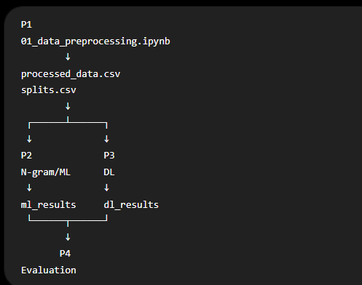
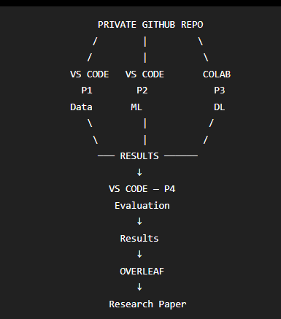
—----------------------------------------------------------------------------------------------------------------------------------------------------

1. Freeze the tech stack
I'd use this stack for the project:
Area | Final choice
Language | Python 3.11
IDE | VS Code
Experiment notebooks | Jupyter Notebook
Version control | Git + GitHub
Data manipulation | Pandas + NumPy
NLP/basic preprocessing | NLTK + regex
Translation | deep-translator initially; translated output cached
N-grams / TF-IDF | scikit-learn
Classical ML | scikit-learn
RF | scikit-learn
DL | PyTorch
Tuning ML | RandomizedSearchCV / small GridSearchCV
Tuning DL | small controlled search; Optuna only if useful
Explainability | LIME + SHAP where appropriate
Statistics | SciPy + statsmodels
Visualization | Matplotlib + WordCloud
Local compute | CPU laptops
DL compute | Google Colab / Kaggle GPU
Paper | Overleaf / LaTeX
References | Zotero + shared BibTeX
Team coordination | GitHub + shared experiment sheet/document
Your earlier blueprint left TensorFlow/Keras vs PyTorch open. I'd close that decision now: PyTorch only.

2. One GitHub repository for everyone
Create something like:
mammography-nlp-comparison/
│
├── README.md
├── requirements.txt
├── .gitignore
├── config.yaml
│
├── data/
│ ├── raw/
│ ├── translated/
│ ├── processed/
│ └── splits/
Train_ids.csv
Val_ids.csv
test_ids.csv

│
├── notebooks/
│ ├── 01_eda/
│ ├── 02_translation/
│ ├── 03_ngram/
│ ├── 04_classical_ml/
│ ├── 05_deep_learning/
│ └── 06_analysis/
│
├── src/
│ ├── data/
│ │ ├── load_data.py
│ │ ├── translate.py
│ │ └── preprocess.py
│ │
│ ├── features/
│ │ └── ngrams.py
│ │
│ ├── models/
│ │ ├── classical.py
│ │ ├── rnn.py
│ │ ├── lstm.py
│ │ └── bilstm.py
│ │
│ ├── evaluation/
│ │ ├── metrics.py
│ │ ├── statistical_tests.py
│ │ └── explainability.py
│ │
│ └── utils/
│ ├── seed.py
│ └── logging.py
│
├── models/
│ ├── classical/
│ └── deep_learning/
│
├── results/
│ ├── experiments/
│ ├── predictions/
│ ├── metrics/
│ ├── figures/
│ ├── confusion_matrices/
│ └── explanations/
│
├── paper/
│ ├── figures/
│ ├── tables/
│ └── references.bib
│
└── presentation/
└── figures/
Your .gitignore should include:
data/raw/*
data/translated/*
data/processed/*
models/*
.venv/
__pycache__/
.ipynb_checkpoints/
.env

requirements.txt
numpy
pandas
scipy

scikit-learn
nltk

matplotlib
wordcloud

torch

deep-translator

lime
shap

statsmodels

tqdm
joblib
pyyaml

jupyter
ipykernel

CHANGES TO DO
- For smoothing use Kneser-Ney smoothing

WORK PLAN-OLD
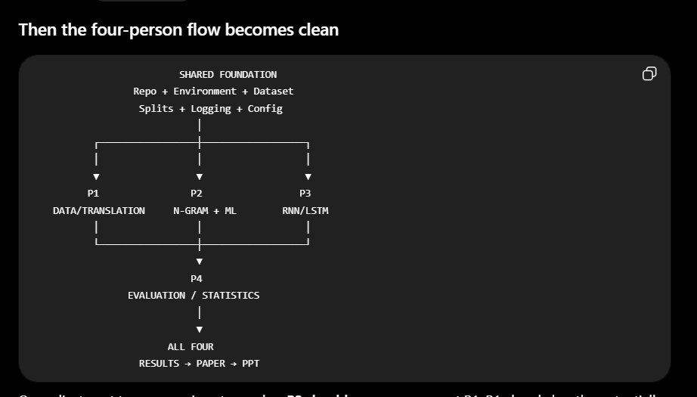

Person | Codes? | Trains/Runs? | Tunes? | Evaluates own models? | Gives final outputs
P1 Data | ✅ | Translation/preprocessing runs | — | EDA + translation evaluation | Processed dataset
P2 N-gram + ML | ✅ | ✅ Trains all ML models | ✅ | ✅ | ML metrics + predictions + figures
P3 DL | ✅ | ✅ Trains RNN/LSTM/BiLSTM | ✅ | ✅ | DL metrics + predictions + figures
P4 Analysis | ✅ | Not responsible for training others' models | — | ✅ Cross-model analysis | Combined comparison/statistics/XAI

P1 — Data person
P1 actually executes:
Raw Portuguese dataset
↓
EDA
↓
Translation
↓
Translation evaluation
↓
Preprocessing
↓
Final processed dataset
↓
Train / Val / Test IDs
P1 doesn't have a classification model to train because their responsibility is the data pipeline.
Their output is real data, not placeholder code:
processed_data.csv
splits.csv
EDA figures
translation evaluation results

P2 — N-gram + Classical ML person
P2 does the entire classical experiment:
Processed dataset from P1
↓
CountVectorizer / TF-IDF
↓
Unigram / Bigram / Trigram
↓
TRAIN
┌────┼────┐
↓ ↓ ↓
NB LR SVM (+ RF)
↓ ↓ ↓
Hyperparameter tuning
↓
Validation
↓
Select configurations
↓
FINAL TEST INFERENCE
↓
Metrics + predictions
So P2's notebook contains actual calls conceptually like:
vectorizer.fit(X_train)
model.fit(X_train_tfidf, y_train) # TRAINING

pred = model.predict(X_test_tfidf) # INFERENCE
P2 owns the resulting numbers.

P3 — Deep Learning person
Same thing.
P3 doesn't merely write:
model = LSTM(...)
# TODO: train later
😄
P3 uses Colab GPU and actually trains everything:
Processed dataset
↓
Tokenization
↓
Embedding
↓
┌─────┼─────┐
↓ ↓ ↓
RNN LSTM BiLSTM
↓ ↓ ↓
TRAIN for epochs
↓
Validation
↓
Hyperparameter tuning
↓
Early stopping
↓
Best checkpoint
↓
Test inference
↓
Metrics + predictions
For example:
Epoch 1 → val macro-F1 ...
Epoch 2 → val macro-F1 ...
...
Best LSTM saved
P3 returns actual:
rnn_predictions.csv
lstm_predictions.csv
bilstm_predictions.csv

dl_metrics.csv

training curves
best model checkpoints
The blueprint explicitly assigns P3/C implementation and tuning of RNN/LSTM/BiLSTM.

Then what does P4 actually do?
P4 doesn't retrain P2/P3's models.
P2 gives:
SVM predictions
LR predictions
NB predictions
ML metrics
P3 gives:
RNN predictions
LSTM predictions
BiLSTM predictions
DL metrics
P4 combines them:
P2
NB LR SVM RF results
↓
↓
P4
Overall Comparison
Statistical Tests
Error Analysis
Confusion Matrices
Explainability integration
Efficiency comparison
↑
↑
P3
RNN LSTM BiLSTM results
For example, McNemar requires the actual predictions from the best ML and DL models. That's why P2/P3 save prediction files rather than merely telling P4 their F1 scores.

Better definition of ownership
The principle should be:
If a person owns an experimental component, they code it, run it, debug it, tune it, generate its results, understand those results, and write the first draft of that methodology/results subsection.
So:
P1: owns Data → runs everything Data
P2: owns N-gram + ML → trains/runs everything ML
P3: owns DL → trains/runs everything DL
P4: owns Comparative Analysis → runs statistics/explainability/error analysis
—--
[DAY 0]
While A is doing that:
B
Can prepare:
TF-IDF pipeline
CountVectorizer
NB
Logistic Regression
SVM
metric functions
using a tiny dummy/sample dataset.
You — C
Open Colab and prepare:
PyTorch
Dataset/DataLoader
tokenizer/vocabulary
RNN class
LSTM class
BiLSTM class
training loop
evaluation function
Again using dummy text.
Don't train final models yet.
D
Prepares:
evaluation notebook
common metrics
confusion matrix
McNemar test
experiment results format
literature/paper skeleton
So Day 1 is still parallel.

Work Plan-Aug_5-NEW

Comparative Analysis of N-gram based, Machine Learning and Deep Learning Models for BI-RADS Classification from Mammography Reports

Master Project Workflow (Freeze This)
Raw Portuguese Mammography Dataset
│
▼
Data Quality Audit
• Missing values
• Duplicate reports
• Class distribution
• Report statistics
│
▼
Portuguese → English Translation
│
▼
Translation Validation
• Clinical terminology
• Negation
• Measurements
• Laterality
• Random manual verification
│
▼
Dataset Quality Check
│
▼
Train / Validation / Test Split
│
▼
translated_dataset.csv
│
▼
──────────────────────────────────────────────
│
Text Preprocessing Pipeline
• Unicode normalization
• Whitespace cleanup
• Remove target leakage
• Preserve medical terms
• Preserve negations
• Clinical abbreviation handling
│
▼
processed_dataset.csv
│
▼
──────────────────────────────────────────────
│
Three Parallel Model Pipelines
│
┌──────────────┼──────────────┐
│ │ │
▼ ▼ ▼
Probabilistic Classical ML Deep Learning
N-gram TF-IDF Embeddings
CountVectorizer
│ │ │
▼ ▼ ▼
Prediction Prediction Prediction
└──────────────┼──────────────┘
│
▼
Unified Evaluation
• Accuracy
• Precision
• Recall
• Macro F1
• Confusion Matrix
• Runtime
• Statistical Tests
• SHAP / LIME
• Error Analysis
│
▼
Comparative Analysis
│
▼
Research Paper

Phase 1 — Dataset Preparation

Objective
Produce one clean, validated, reproducible dataset that every model uses.

Step 1
Raw Portuguese Dataset
↓
Perform Data Audit

Check
- Missing reports
- Missing labels
- Duplicate reports
- Empty reports
- BI-RADS class distribution
- Report length statistics

Generate
- Class distribution plot
- Word cloud
- Report length histogram
- Report length boxplot
- Dataset summary table

Step 2
Portuguese → English Translation
Output
translated_dataset.csv

Step 3
Translation Validation
Randomly sample reports.
Check
- Medical terminology preserved
- Negation preserved
- Measurements preserved
- Laterality preserved
- Overall semantic meaning preserved
Generate
translation_validation.xlsx

translation_validation_summary.pdf

Step 4
Dataset Quality Verification
Check
- Encoding
- Unicode
- Empty rows
- Translation failures
- Duplicate reports
- Average report length

Step 5
Dataset Split
Generate
train_ids.csv

validation_ids.csv

test_ids.csv

using
Stratified Split.

Phase 2 — Text Preprocessing
Input
translated_dataset.csv

Perform
- Unicode normalization
- Whitespace normalization
- Remove BI-RADS mentions (target leakage)
- Preserve negations
- Preserve measurements
- Preserve abbreviations
- Clinical text normalization
Output
processed_dataset.csv

This dataset becomes the single input for every model.

Phase 3 — Model Development
All models use exactly the same processed dataset.

Pipeline A

Probabilistic N-gram Language Model
Generate
- Unigram
- Bigram
- Trigram
- Combined N-gram
Apply
- Laplace / Kneser-Ney smoothing
Train
Bayesian Language Model
Predict
BI-RADS category

Pipeline B

Classical Machine Learning
Feature Extraction
- CountVectorizer
- TF-IDF
Models
- Naive Bayes
- Logistic Regression
- Linear SVM
- Random Forest
- XGBoost (optional)
Generate predictions.

Pipeline C

Deep Learning
Text Tokenization
↓
Embedding Layer
↓
Models
- RNN
- LSTM
- BiLSTM
Generate predictions.

Phase 4 — Evaluation
Collect predictions from all models.
Compute
- Accuracy
- Precision
- Recall
- Macro F1
- Weighted F1
- Confusion Matrix
- Per-class performance
- Runtime
- Training time
Generate
- Confusion matrices
- Performance comparison tables
- Performance plots
Perform
- SHAP
- LIME
- Error analysis

Phase 5 — Comparative Analysis
Compare
- N-gram vs ML
- N-gram vs DL
- ML vs DL
Compare
- Accuracy
- Interpretability
- Computational Cost
- Training Time
- Clinical Reliability
Write conclusions.

Final Repository
mammography-nlp/

README.md
requirements.txt
config.yaml

data/
│
├── raw/
├── translated/
├── processed/
└── splits/

src/
│
├── data/
├── preprocessing/
├── features/
├── models/
├── evaluation/
└── utils/

notebooks/
│
├── 01_dataset_pipeline.ipynb
├── 02_text_preprocessing.ipynb
├── 03_ngram_model.ipynb
├── 04_ml_dl_models.ipynb
└── 05_final_analysis.ipynb

results/
│
├── metrics/
├── predictions/
├── figures/
├── confusion_matrices/
└── explanations/

paper/

presentation/

Team Work Split

P1 — Dataset Pipeline

Notebook
01_dataset_pipeline.ipynb

Responsibilities
- Import dataset
- Data audit
- EDA
- Translation
- Translation validation
- Dataset quality verification
- Train/Validation/Test split

Deliverables
translated_dataset.csv

splits.csv

eda_report.pdf

translation_validation.xlsx

P2 — Text Preprocessing

Notebook
02_text_preprocessing.ipynb

Responsibilities
- Unicode normalization
- Remove target leakage
- Clinical text normalization
- Preserve negation
- Preserve abbreviations
- Final preprocessing
- Generate model-ready dataset

Deliverables
processed_dataset.csv

preprocessing_report.pdf

P3 — Probabilistic N-gram Model

Notebook
03_ngram_model.ipynb

Responsibilities
- Generate Unigrams
- Generate Bigrams
- Generate Trigrams
- Combined N-grams
- Apply smoothing
- Bayesian classifier
- N-gram visualization
- Save predictions

Deliverables
ngram_predictions.csv

ngram_metrics.json

trained_ngram_model.pkl

P4 — Classical ML + Deep Learning + Evaluation

Notebook
04_ml_dl_models.ipynb

Responsibilities
Classical ML
- TF-IDF
- CountVectorizer
- Naive Bayes
- Logistic Regression
- Linear SVM
- Random Forest
- XGBoost (optional)
Deep Learning
- RNN
- LSTM
- BiLSTM
Evaluation
- Accuracy
- Precision
- Recall
- Macro F1
- Confusion Matrix
- SHAP/LIME (where applicable)
- Runtime comparison
- Final comparison tables and plots

Deliverables
ml_predictions.csv

dl_predictions.csv

metrics_summary.csv

comparison_tables.xlsx

paper_figures/

Final Integration
Once all four workstreams are complete:
- Merge all prediction files.
- Run the unified evaluation and comparison.
- Generate the final figures and tables for the paper.
- Write the Results, Discussion, and Conclusion sections.
This structure matches your workflow diagram: one shared data pipeline feeding three parallel modeling pipelines, followed by a unified evaluation and comparative analysis, while ensuring each team member has a clearly owned, largely independent workstream.

prompts-diagram
Create a publication-quality methodology professional block diagram in landscape for an IEEE/Springer research paper.
Figure Title:
"Proposed Probabilistic N-Gram Language Model Classifier"
Purpose
This figure illustrates only the proposed probabilistic n-gram classifier. Assume that all mammography reports have already been preprocessed. Do not include dataset acquisition, preprocessing, evaluation, or explainability. Focus exclusively on the classification methodology.
Style Requirements
Workflow
Start with
Preprocessed Mammography Reports
↓
N-Gram Generation
Generate
• Unigrams (n=1)
• Bigrams (n=2)
• Trigrams (n=3)
• Combined N-Grams (1–3)
↓
Class-wise Data Partitioning
Separate reports according to BI-RADS labels
BI-RADS 0
BI-RADS 1
BI-RADS 2
BI-RADS 3
BI-RADS 4
BI-RADS 5
BI-RADS 6
Show these as parallel branches.
↓
For Each BI-RADS Class
Count occurrences of every unigram, bigram and trigram.
↓
Frequency Tables
Generate class-specific frequency tables.
↓
Probability Estimation
Estimate conditional probabilities
P(N-Gram | BI-RADS Class)
↓
Laplace Smoothing
Apply Add-One Laplace Smoothing to avoid zero probabilities for unseen n-grams.
↓
Construct Class-Specific Probabilistic Language Models
Create one probabilistic language model for each BI-RADS class.
Merge all branches into a central repository labelled
"Probabilistic N-Gram Language Model Repository"
↓
Classification Stage
Input New Mammography Report
↓
Generate Unigrams, Bigrams and Trigrams
↓
For each BI-RADS language model
Compute Document Likelihood
P(Report | Class)
↓
Bayesian Inference
Compute Posterior Probability
P(Class | Report)
↓
Maximum A Posteriori (MAP) Decision
Select the BI-RADS class with the highest posterior probability.
↓
Output
Predicted BI-RADS Category
Add a small note beneath the MAP block:
"Decision Rule: Choose class with maximum posterior probability."
• Ensure the figure is publication-ready for IEEE, Springer, Elsevier, or Journal of Biomedical Informatics.
(keep it minimal not with too many granular details)

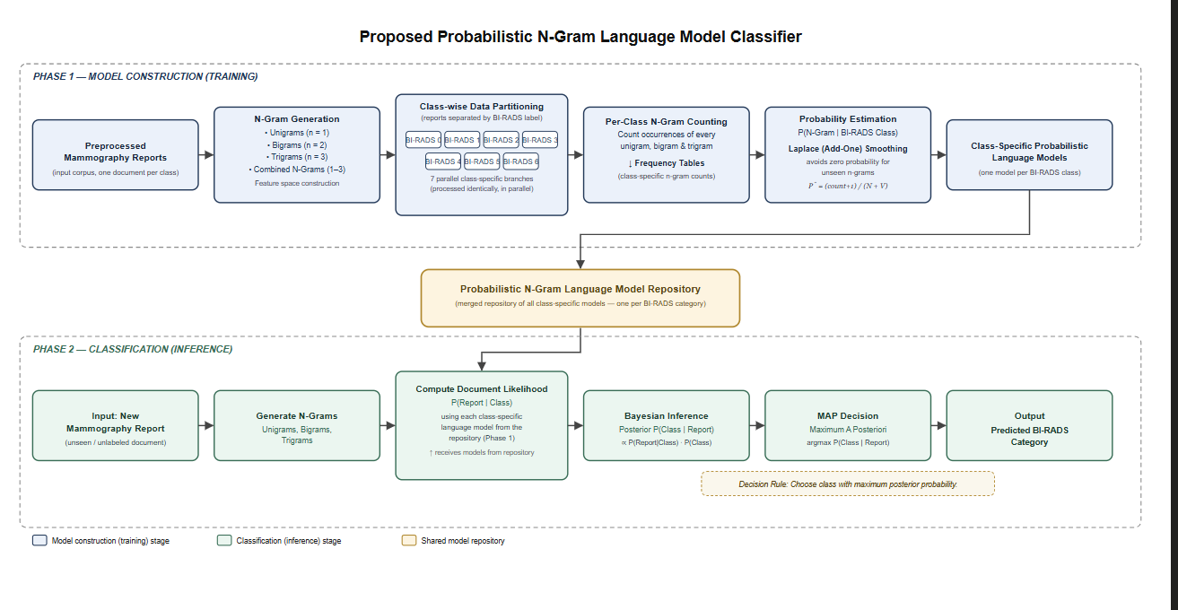

For smoothing use Kneser-Ney smoothing

Stage 1 — Data Acquisition
SPR2026 mammography reports + labels (BI-RADS / benign-malignant-normal)
Stage 2 — Preprocessing (shared)
Text cleaning → stopword removal → handling medical abbreviations → train/test split (stratified) → class imbalance handling (if needed)
Stage 3 — Three parallel tracks
- Track A (Classical ML): TF-IDF feature extraction → Naive Bayes, Logistic Regression, SVM, Random Forest, XGBoost
- Track B (RNN): Tokenize + pad → Word2Vec/GloVe embedding layer → Simple RNN → Dense output
- Track C (LSTM family): Same embedding → LSTM, BiLSTM, GRU, LSTM+Attention → Dense output
Stage 4 — Training Setup
Adam optimizer, loss function, batch size, epochs, dropout, early stopping
Stage 5 — Evaluation
Accuracy, Precision, Recall, F1, Confusion Matrix, ROC-AUC → compared against n-gram results
Stage 6 — Explainability
LIME/SHAP for ML models; Attention-weight visualization + SHAP/LIME for RNN/LSTM/GRU
Stage 7 — Comparative Analysis
Consolidated performance table across n-gram, ML, RNN, LSTM family → best model discussion

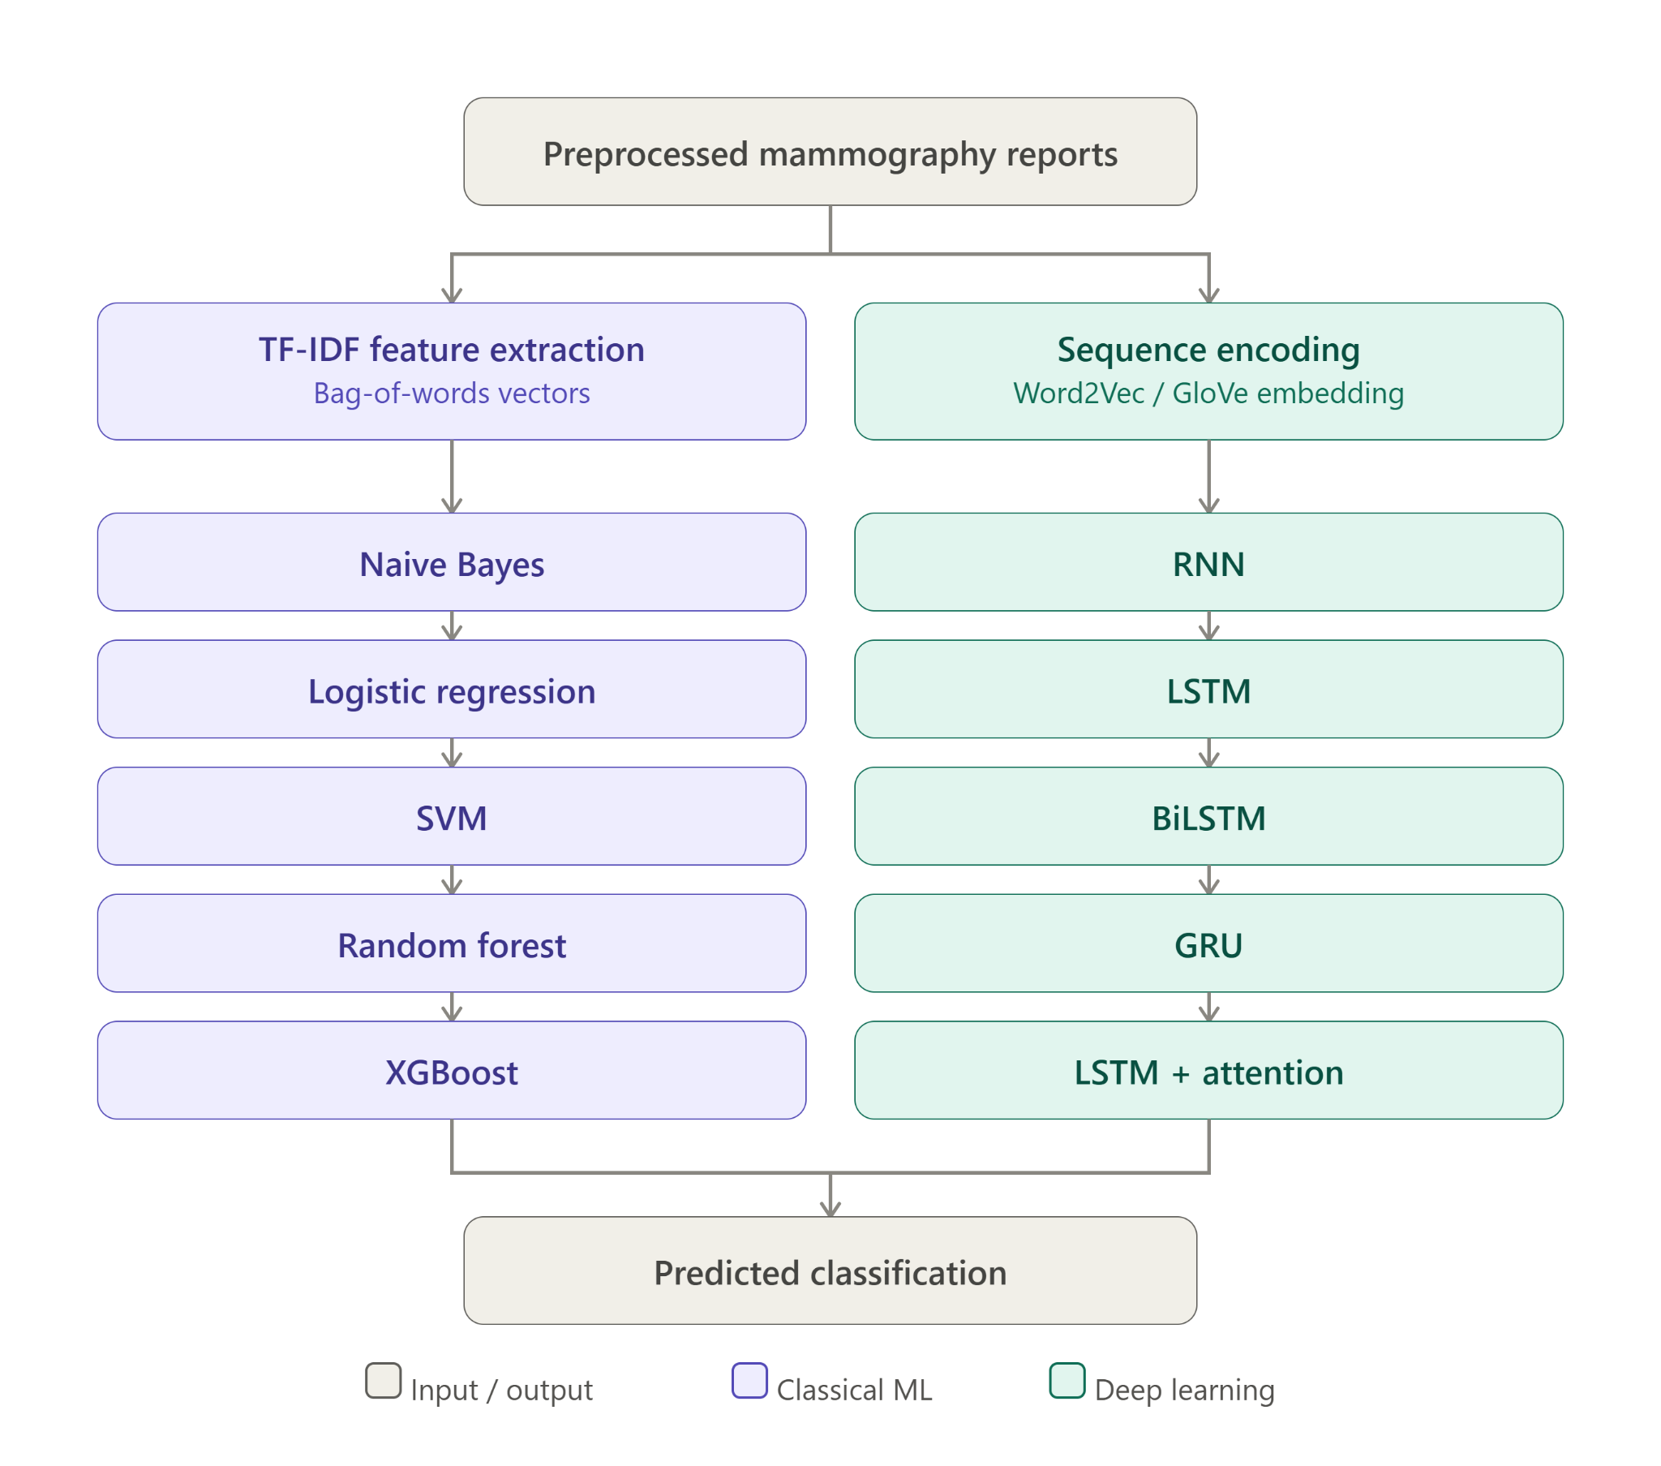

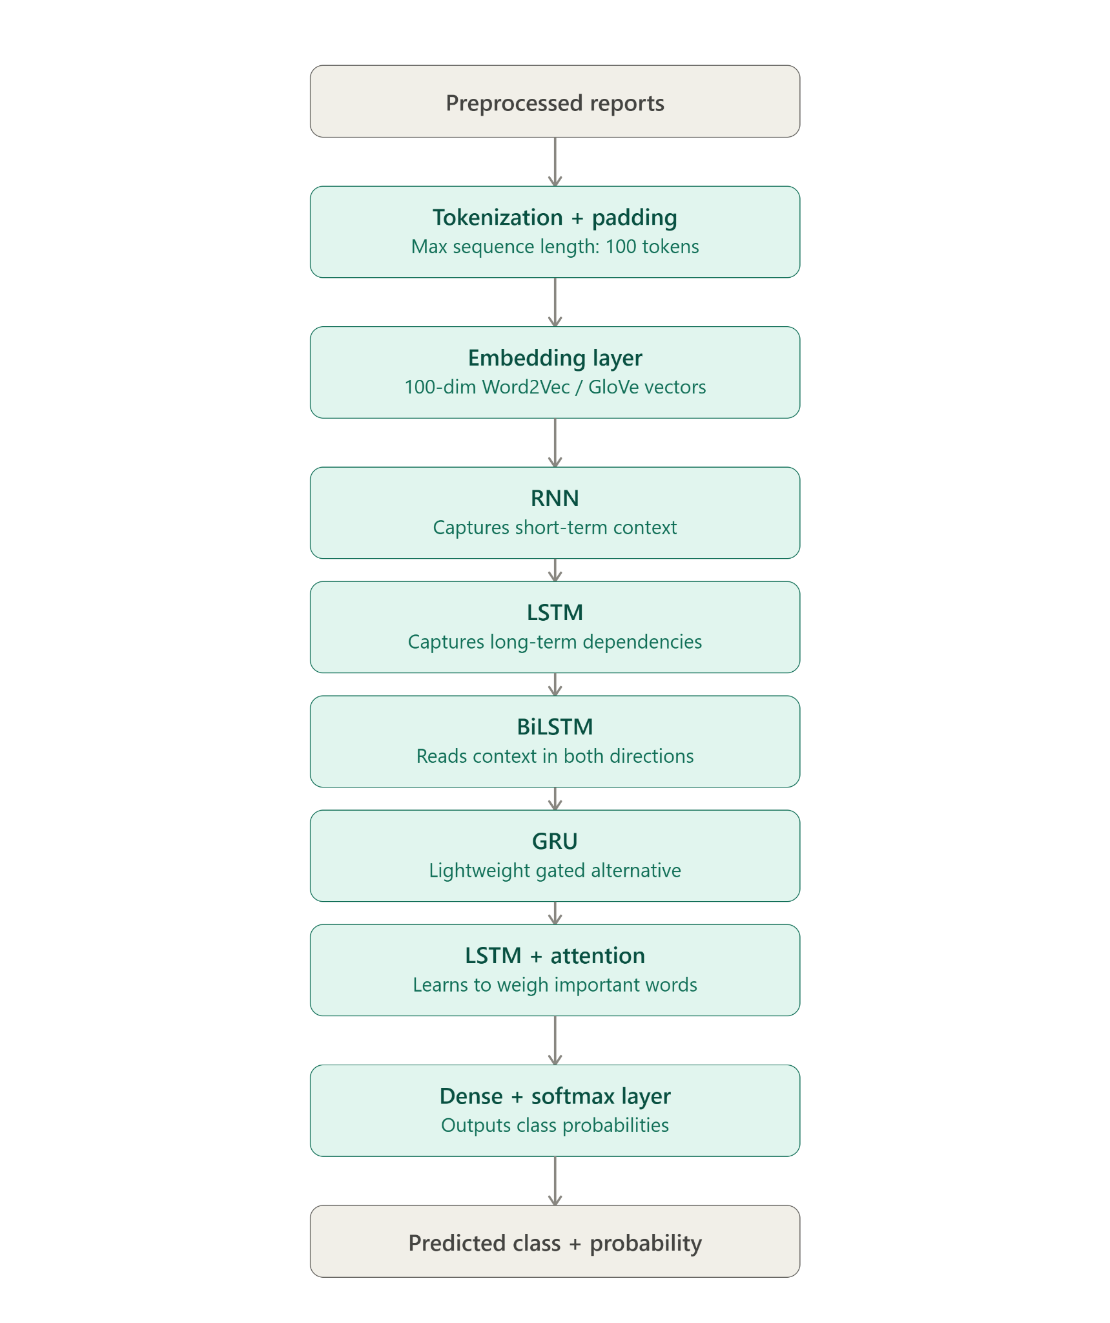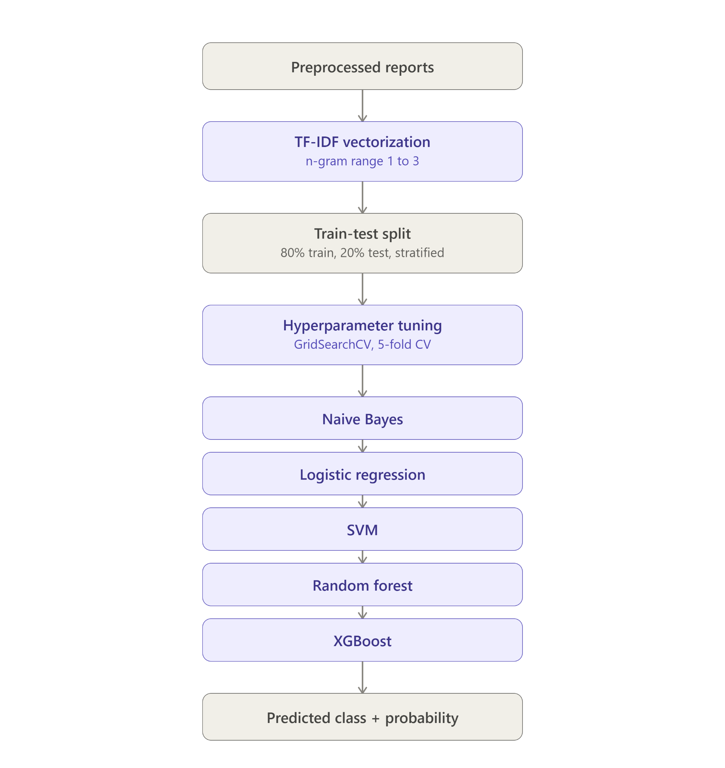

SPR2026 Mammography Dataset
│
▼
Domain-Aware Data Preparation & Preprocessing
│
┌───────────────────────────┼────────────────────────────┐
│ │ │
▼ ▼ ▼
┌─────────────────┐ ┌───────────────────┐ ┌────────────────────┐
│ Probabilistic │ │ Classical Machine │ │ Deep Learning │
│ N-Gram │ │ Learning Pipeline │ │ Pipeline │
│ Classifier │ │ │ │ │
└─────────────────┘ └───────────────────┘ └────────────────────┘
│ │ │
▼ ▼ ▼
N-Gram Generation TF-IDF / Count Tokenization &
(Uni/Bi/Tri/Combined) Vectorization Embedding Layer
│ │ │
▼ ▼ ▼
Class-wise Probability LR • SVM • RF • RNN • LSTM •
Language Models XGBoost • LightGBM BiLSTM
│ │ │
▼ ▼ ▼
Bayesian Classification ML Predictions DL Predictions
└───────────────┬───────────────┬────────────────────────┘
▼
Unified Model Evaluation
Accuracy • Precision • Recall • Macro F1
Confusion Matrix • Computational Analysis
│
▼
Explainable AI Analysis
SHAP • LIME • Important N-Grams • Error Analysis
│
▼
Comparative Analysis & Final Conclusions

