Explainable AI for Military Supply Chain Optimization using SAR Images
In propose work we are employing Artificial Intelligence CNN2D algorithm to optimize military supply chain. CNN2D get trained on SAR images with different areas and location and delivery person camera will capture SAR images and then feed to CNN2D algorithm to predict routes which are ahead and based on that predicted area he will optimize his route for delivery.
SAR images provide essential information about terrain features such as rough surfaces, obstacles, and weather impacts, even under low visibility conditions. By training machine learning models on SAR data, the system identifies optimal routes and resource allocation strategies. To ensure transparency in AI-driven decisions, XAI techniques like LIME (Local Interpretable Model-Agnostic Explanations) are integrated, enabling military logisticians to understand and trust the recommendations.
To implement this project we have used Sentinel SAR images dataset which consists of locations showing in below screen
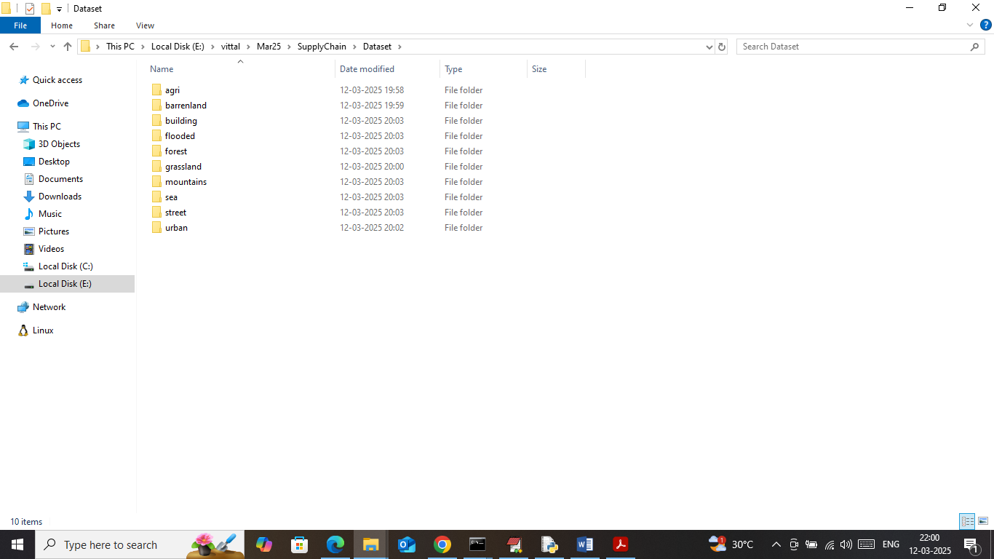
In above screen can see dataset contains 9 different folders and go inside any folder to view related images like below page
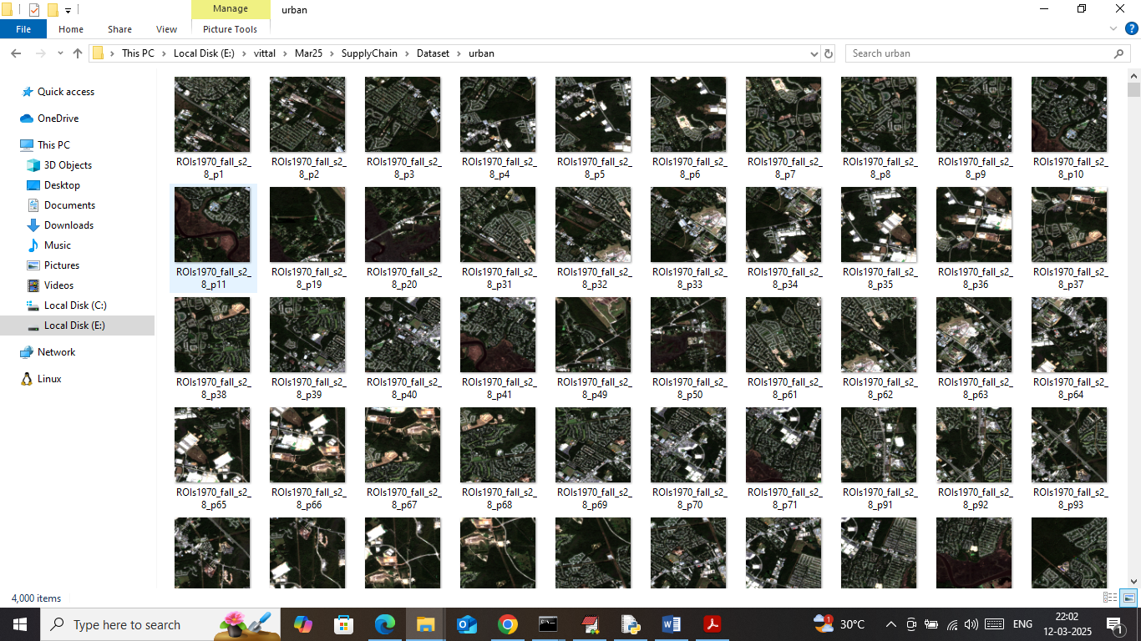
So by using above images dataset will train CNN algorithm to predict supply chain route.
LIME explanation is using to describe which features in image making model to predict particular location.
SCREEN SHOTS
We have done image processing, training and explanation using JUPYTER notebook and then route prediction is executing through web framework by uploading image.
In below screens showing JUPYTER code and output with blue colour comments
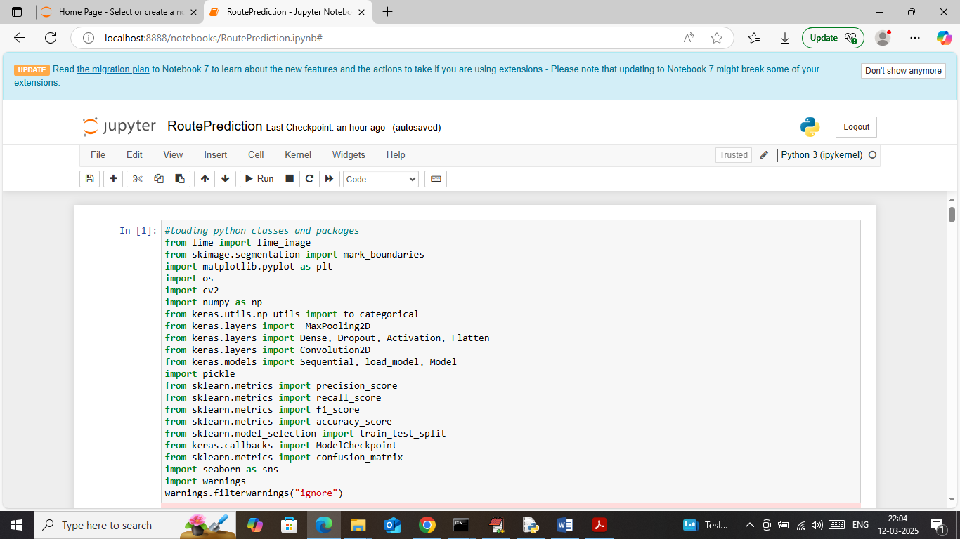
In above screen importing required python classes and packages
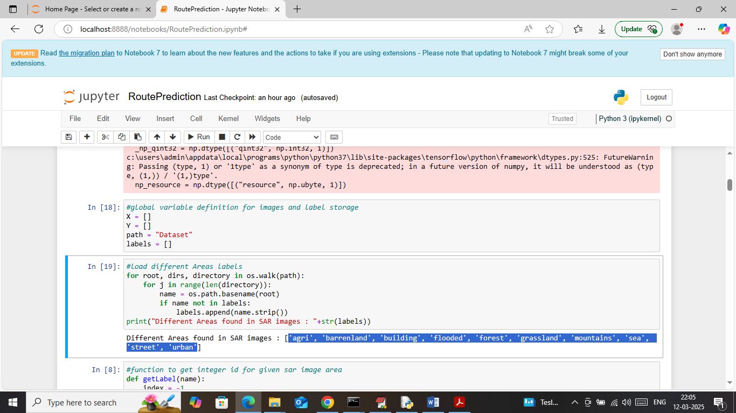
In above screen looping dataset to get different area names as labels which are available in dataset
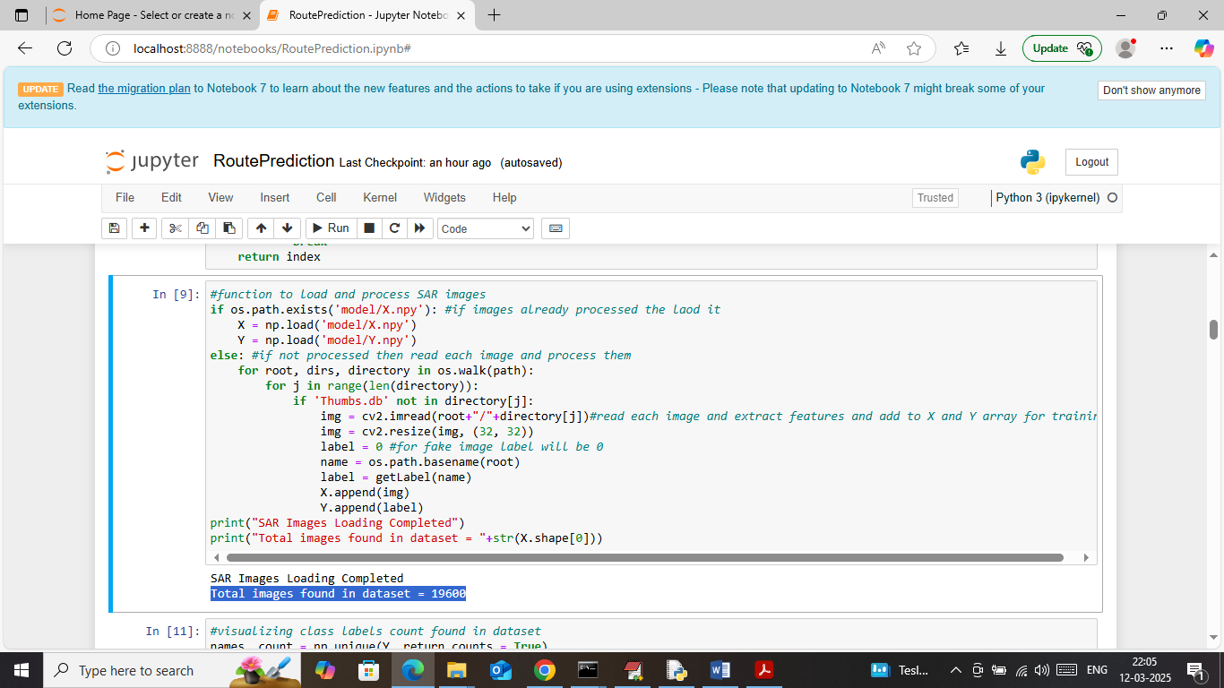
In above screen looping and reading each image and then extracting features and adding to training X and Y array. After loading we can see dataset contains more than 19000 images
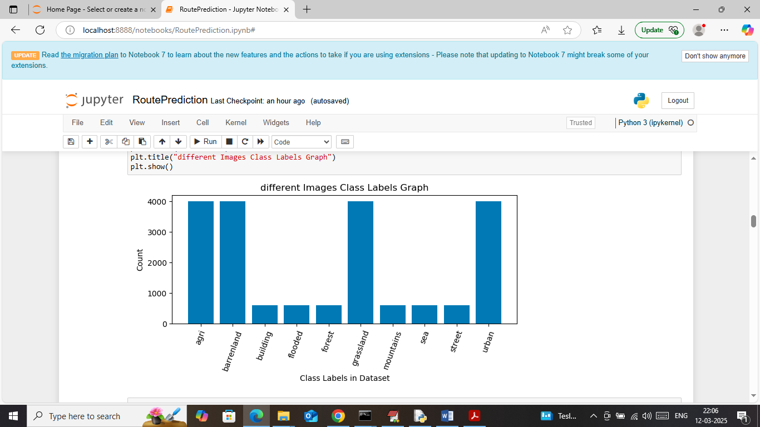
In above screen visualizing graph of number of images available in different areas in dataset. In above graph x-axis represents ‘Area Name’ and y-axis represents number of images
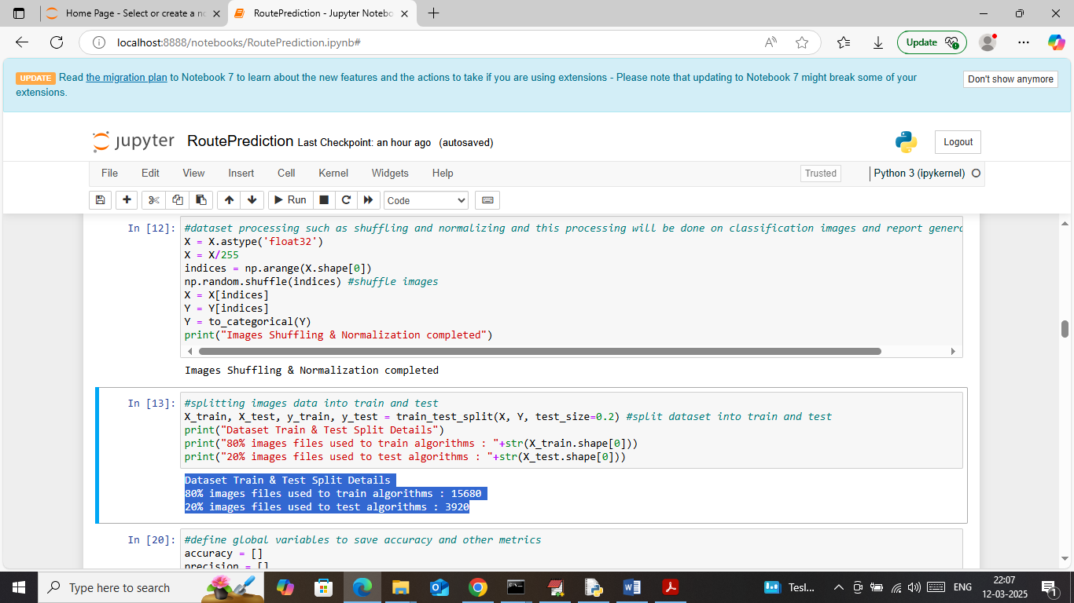
In above screen in first block applying dataset shuffling and normalization and then in next block splitting dataset into train and test where application using 80% images for training and 20% for testing. In blue text can see train and test data size
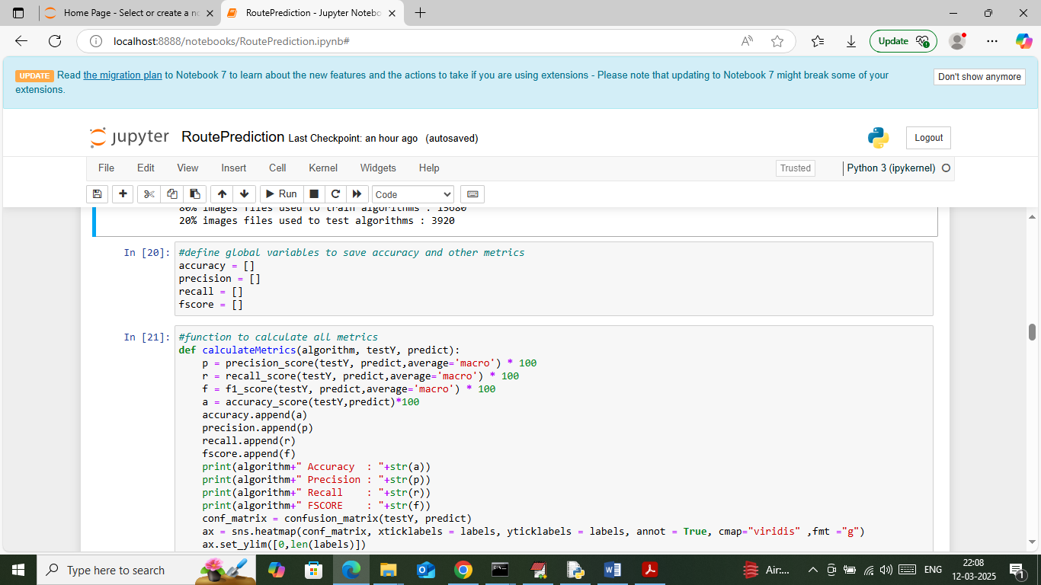
In above screen defining function to calculate accuracy and other metrics
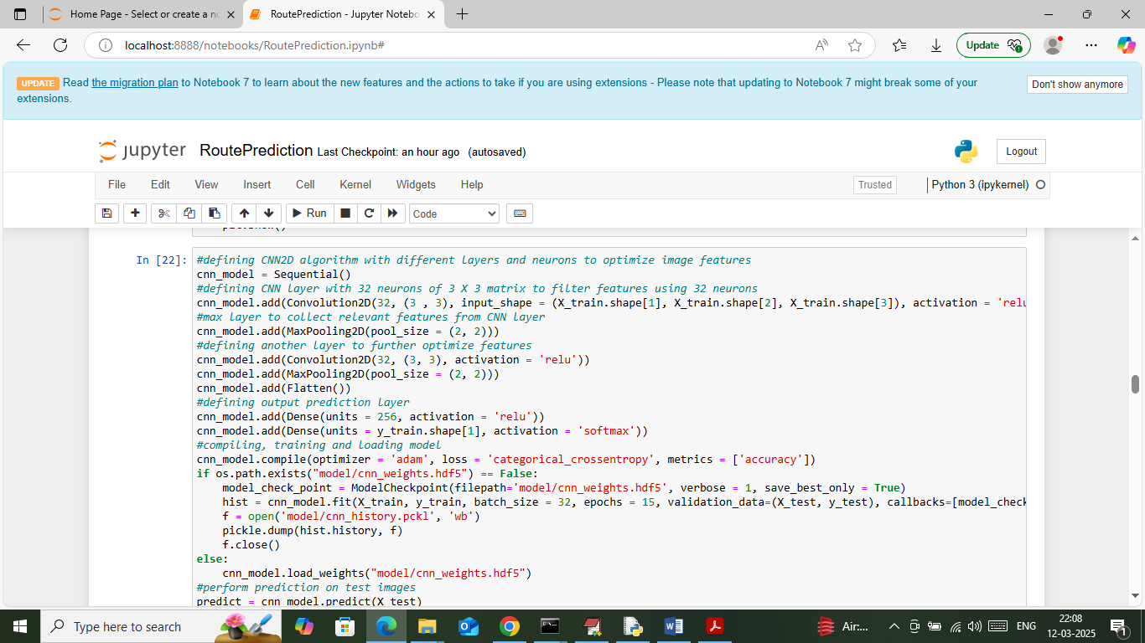
In above screen defining CNN algorithm to train on 80% training data and then performing prediction on 20% test data and after executing this model will get below output
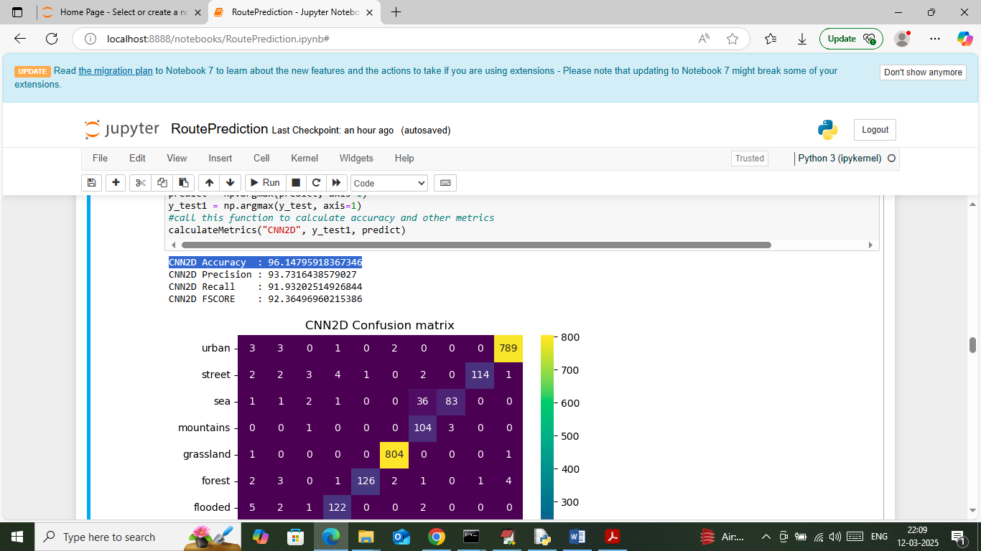
In above screen CNN got 96% accuracy on test data prediction and can see other metrics like precision, recall and FSCORE. In below screen can see prediction confusion matrix graph
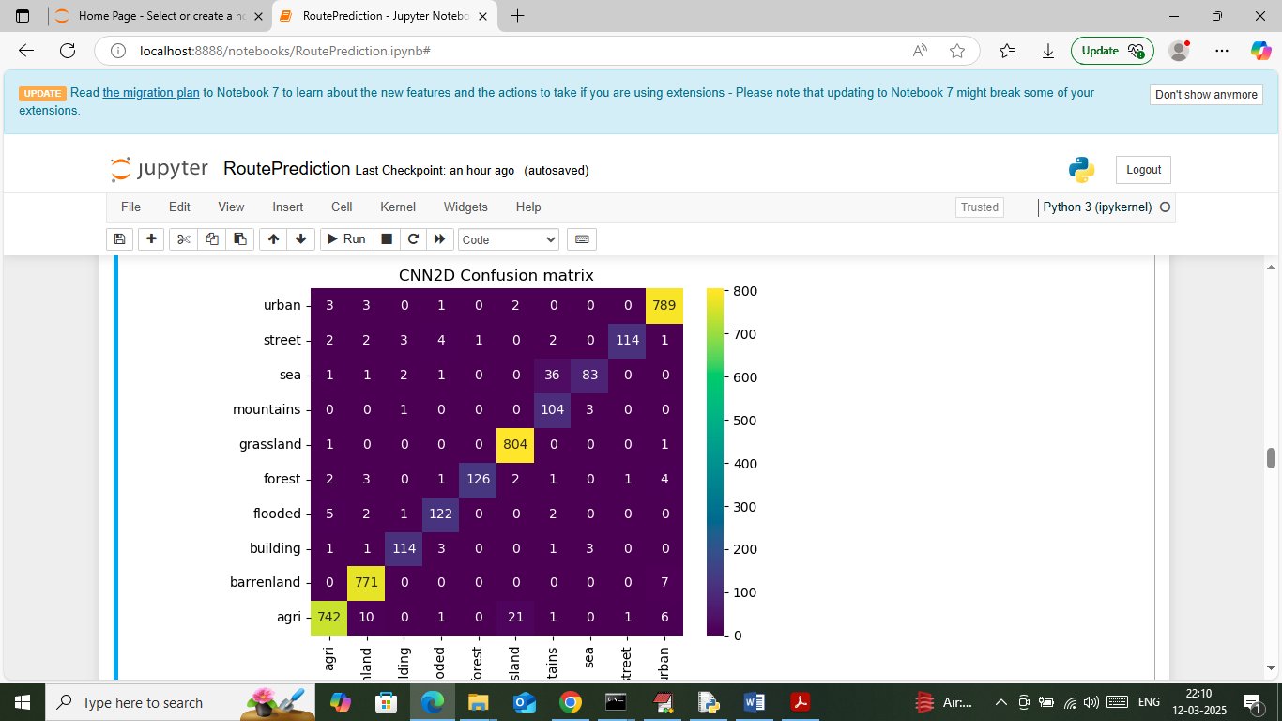
In above graph x-axis represents predicted labels and y-axis represents true labels and then all different colour boxes in diagonal represents correct prediction count and remaining all blue boxes represents incorrect prediction count which are very few
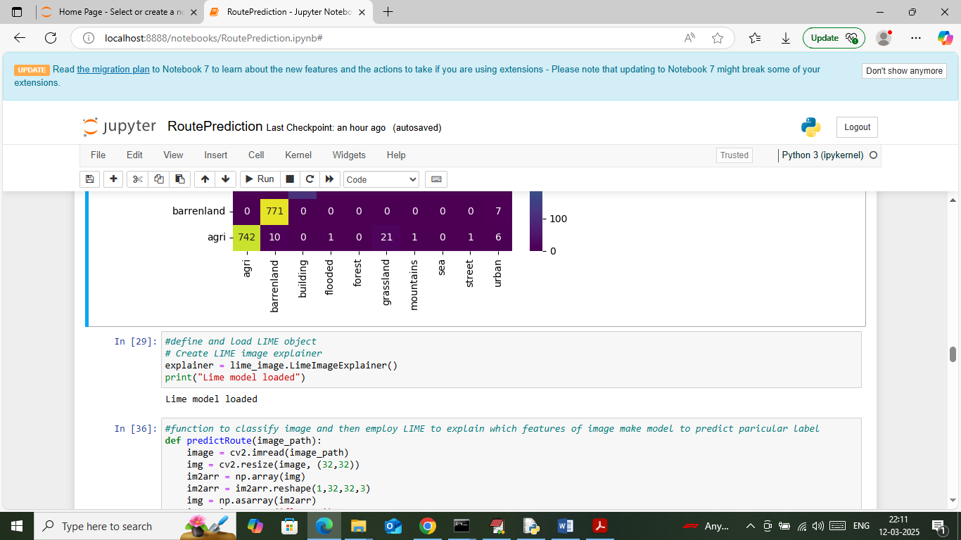
In above screen initializing and loading LIME explanation object. Note: SHAP will not work with CNN so we are not using SHAP
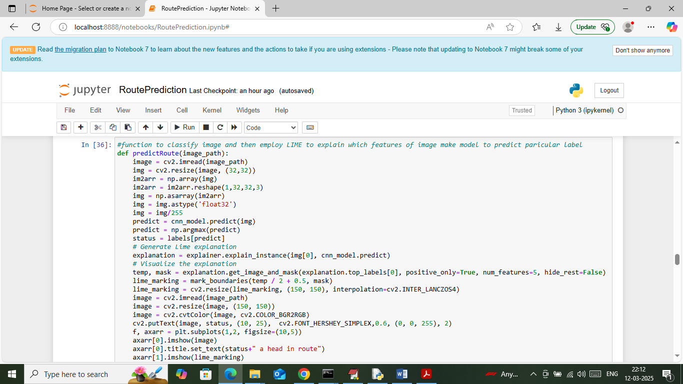
In above screen defining function to read input image and then predict route which are ahead and then apply LIME to explain about those features which help model in predicting route
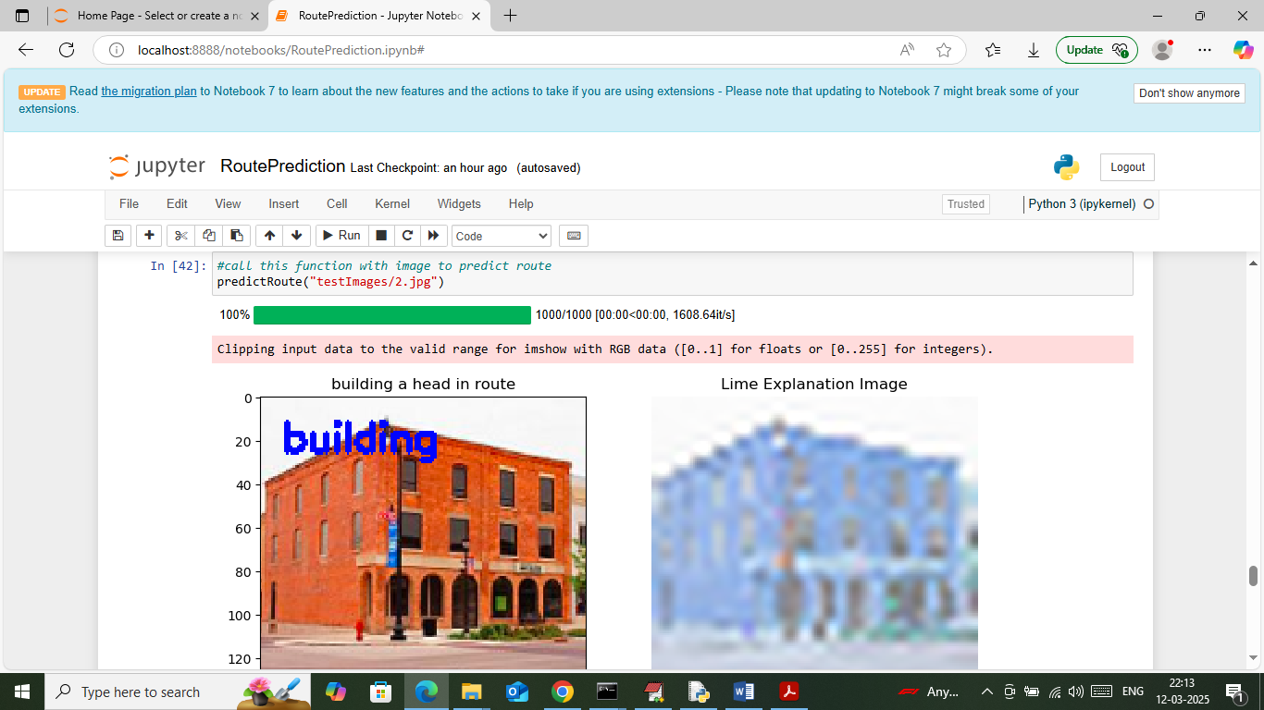
In above screen we are calling ‘predict Route’ function with input image path and then CNN predicting that route ahead as ‘building’ in first image. Second image is the LIME explanation image where pixels with dark colour are the features which contribute most in making prediction
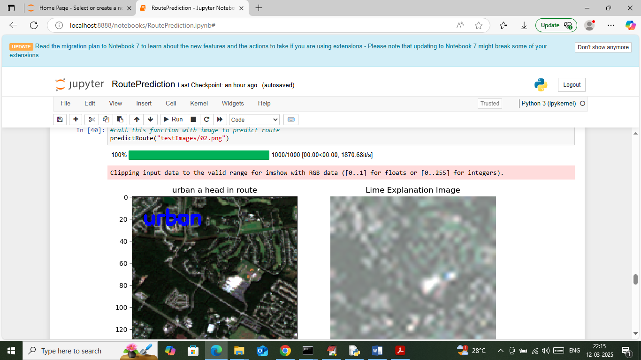
In above screen another image is predicted as ‘Urban’ route
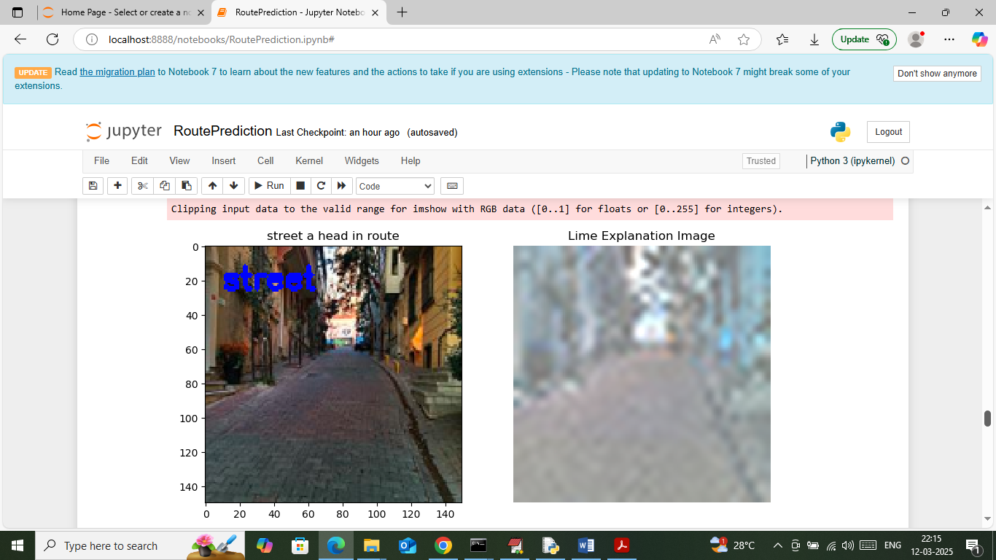
In above screen another image predicted as ‘Street’
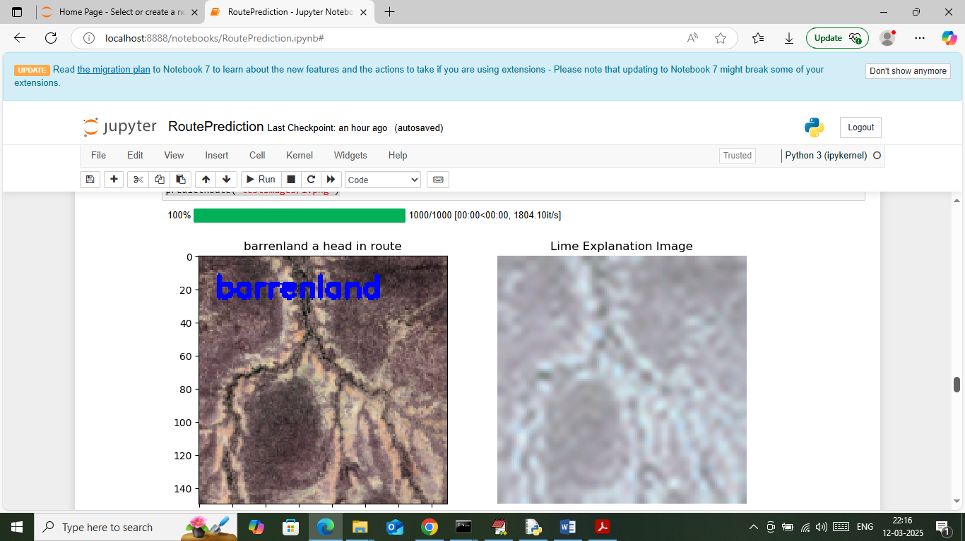
Above image is predicted ‘Barren Land’
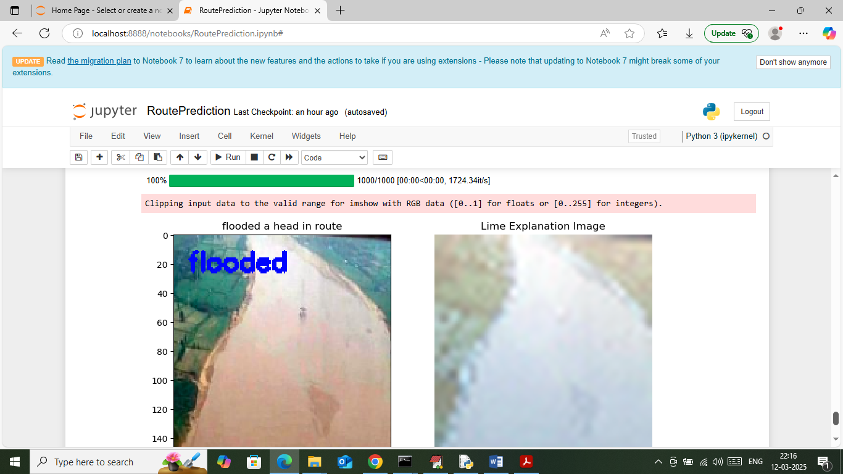
Above image predicted as Flooded.
Same above output you can run through web application by double click on ‘runServer.bat’ file and then will get below page
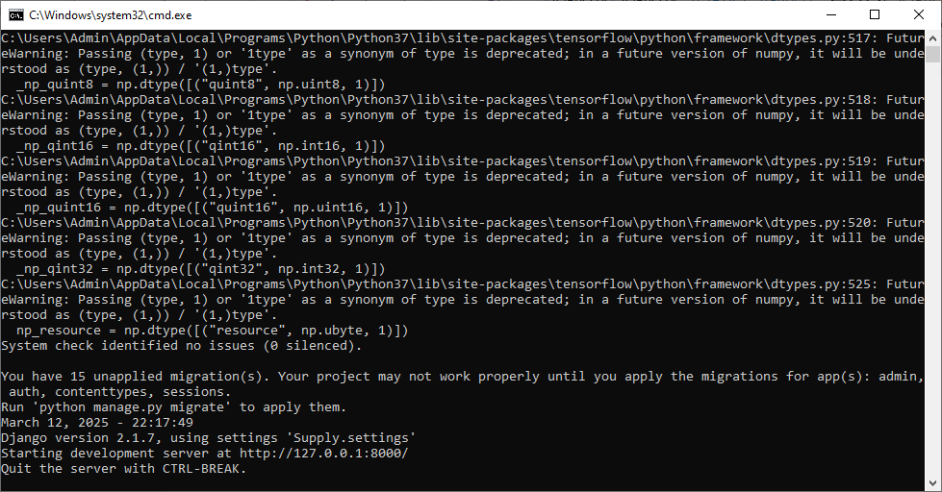
In above screen server started and now open browser and enter URL as http://127.0.0.1:8000/index.html and then press enter key to get below page
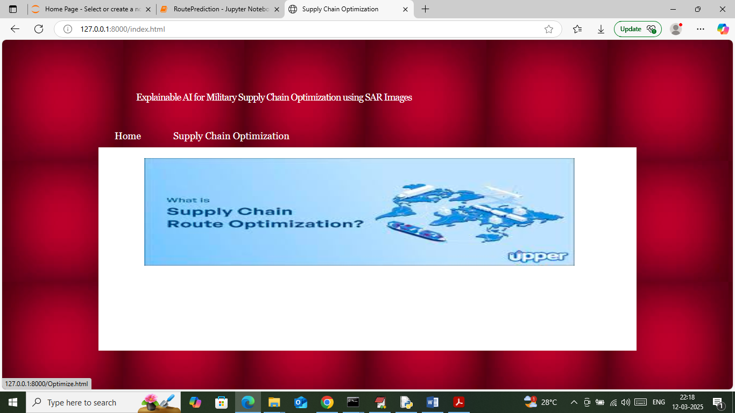
In above screen click on ‘Supply Chain Management’ link to get below page
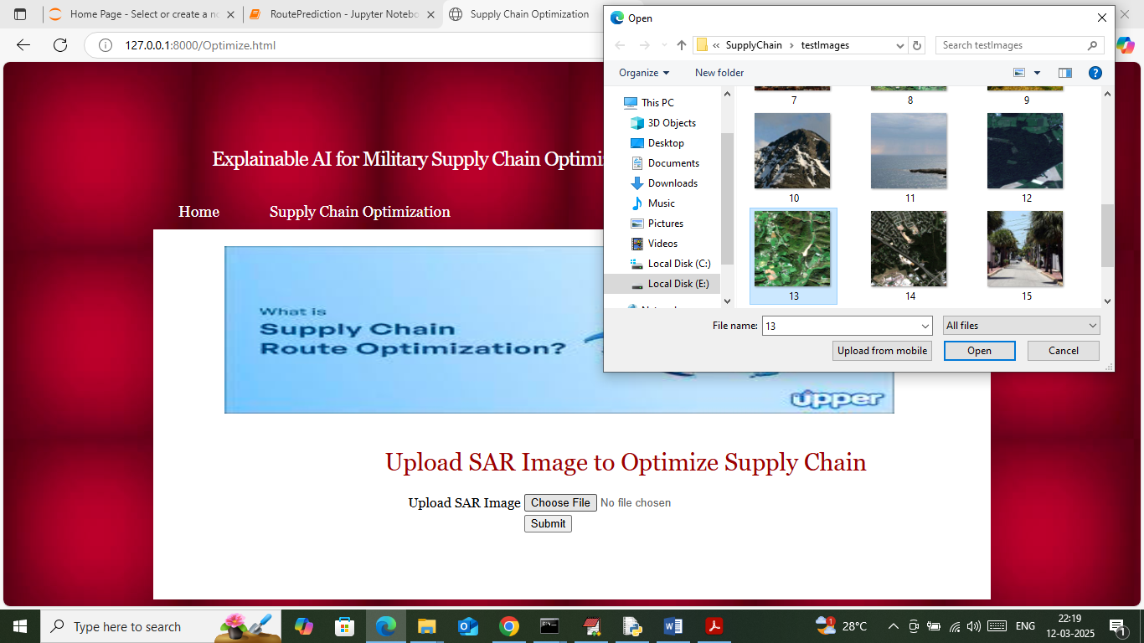
In above screen selecting and uploading test image and then will get below page
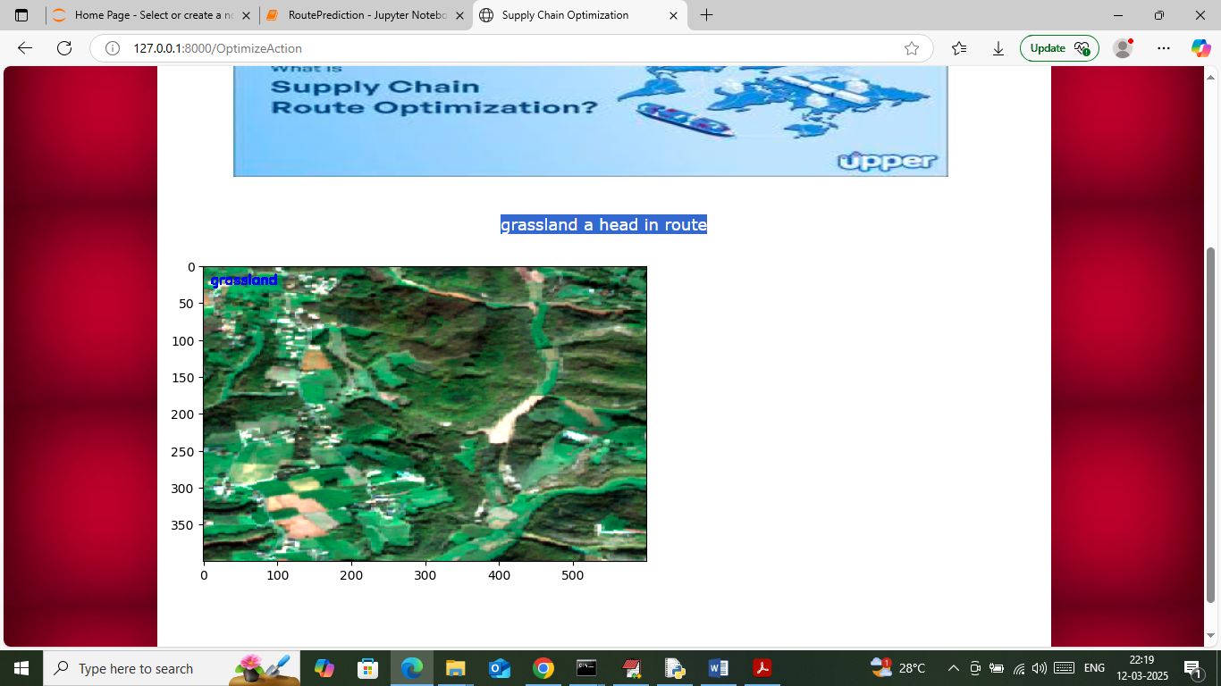
In above screen in blue text can see ‘Grass land’ route detected and similarly you can upload and test other images
Above image is predicted as ‘Urban’ land
